ONLINE MENTORING SYSTEM

A Report Submitted to
The School of Engineering and Computing

National University

In Partial Fulfillment of the Requirements
For the Degree of Master of Science in Computer Science
By,
Vani Priya, Pingili
Arthisha Reddy, Vaddi
Lakshmi Durga Priyanka, Manigandla
Muneendar, Muthyala
Sri Krishna Pujitha, Paruchuri
Aug 04,2017

ONLINE MENTORING SYSTEM

A report submitted to the School of Engineering and Computing, National University, in partial fulfillment of the requirements for the Degree of Master of Science in Computer Science by:
Team Members:
Vani Priya Pingili ____________________
Arthisha Reddy Vaddi ____________________
Lakshmi Durga Priyanka Manigandla ____________________
Muneendar Reddy Muthyala ____________________
Sri Krishna Pujitha Paruchuri ____________________

The report hereby approved by:
________________________________
Pradip Peter Dey, Ph.D.
Professor, School of Engineering and Computing
National University

Date: ________________________________

Table of Contents
- Abstract………………………………………………………………………………...7
- Project Plan…………………………………………………………………………….8
- Introduction………………………………………………………………………….........14
  - Why Organizations Implement Mentoring Programs…………………………............14
  - Formal and Informal Mentoring Programs……………………………………………16
  - Benefits of Mentoring for the Mentor…………………………………………………16
  - Benefits of Mentoring for the Student………………………………………………... 17
  - Online Mentoring Programs…………………………………………………………...17
  - Purpose…………………………………………………………………………………20
  - Scope…………………………………………………………………………………...20
  - Definitions, Acronyms and Abbreviations…………………………………………….21
- Software Requirement Specification……………………………………………………..23
2.1 Purpose………………………………………………………………………………….23
2.2 System Configurations………………………………………………………………….23
2.2.1 Hardware Requirements……………………………………………………………24
2.2.2 Software Requirements……………………………………………………….........24
2.3 Architectural Representation……………………………………………………….......24
2.3.1 Understanding Anomaly Detection System Through UML……………………….24
2.4 Unified ModelingLanguage(UML)………………………………………………........25
2.5 UML Views…………………………………………………………………………….25
2.5.1. Structural Clasification……………………………………………………………26
2.5.2. Dynamic Behavior……………………………………………………………......26
2.5.3. Physical Deployment ………………………………………………………….27
2.5.4. Model Management………………………………………………………………27

3. Architectural Goals and Constraints…………………………………………………….28
3.1. Technical Platform………………………………………………………………… .28
3.1.1. Java Platform………………………………………………………………..…28
3.1.2. Working of Java……………………………………………………………….29
3.2. Literature survey…………………………………………………………………….29
3.3. Functional and Non-Funcional Requirements…………………………………........29
3.3.1. Functional Requirements……………………………………………………..29
3.3.2. Non-Functional Requirements…………………………………………...…..30
3.4. Requirements Engineering Components……………………………………….......31
3.4.1. Requirements Gathering……………………………………………………....31
3.4.2. Requirements Analysis………………………………………………………..31
3.4.3. Requirements Specification…………………………………………………...31
3.5. System Requirements……………………………………………………………....33
- Database Design………………………………………………………………………33
  - Entity Relationship Diagram……………………………………………………....40
  - Relational Schema Diagram…………………………………………………….....41

- Software Design Description………………………………………………………....42
  - Purpose……………………………………………………………………………..42
  - Design………………………………………………………………………………42
5.3 Use caseView…………………………………………………………...……….....42
5.3.1 Use Case Diagram…………………………………………………………… 43
5.4 Activity View………………………………………………………………….…...44
5. 4.1 Activity Diagram……………………………………………………………..45
  - Static View………………………………………………………………………....46
5. 5.1. Class Diagram……………………………………………………………....47
5.6 Interaction View…………………………………………………………………....48
5. 6.1. Sequence Diagram…………………………………………………………..49
5.7 Collaboration Diagram……………………………………………………………..53
5.8 State Machine View………………………………………………………………..54
5.8.1 State machine Diagram……………………………………………………….55
- Implementation…………………………………………………………………………………………………………….55
6.1 Screen Captures……………………………………………………………………56
- Test Plan……………………………………………………………………………....62
  - Introduction………………………………………………………………………..62
    - Objective…………………………………………………………………...62
  - Relationship with other documents………………………………………………..62
    - Relationship between SRS and Test plan………………………………….62
    - Relationship between SDD and Test plan………………………………63
  - Features to be tested and Features not to be tested………………………………..64
    - Features to be tested…………………………………………………….....64
    - Features not to be tested………………………………………………....64
  - Pass/Fail Criteria…………………………………………………………………...64
    - System Level……………………………………………………………….64
    - Integration testing………………………………………………………….64
    - Unit testing…………………………………………………………………65
  - Approach…………………………………………………………………………...65
    - Testing Level……………………………………………………………….65
    - Unit Testing (Manual TestCases)…..………………………………………65
    - System/IntegrationTesting……………………………….............................67
    - Acceptance/Installation Testing…………………………………………….67
    - Regression Testing………………………………………………………….67
  - Roles and Responsibilities………………………………………………………….68
  - Suspension and Resumption……………………………………………………….68
    - Suspension Criteria…………………………………………………….......68
    - Resumption Requirements…………………………………………………69
  - Dependencies………………………………………………………………………69
  - Risks and Assumptions……………………………………………………….........69
    - Risks………………………………………………………………………..69
    - Assumptions………………………………………………………………..69
- Software Quality Assurance Plan…………………………………………………....70
  - Overview...................................................................................................................70
7.1.1 Scope…………………………………………………………………………70
  - Definitions.................................................................................................................70
  - Purpose......................................................................................................................71
  - Reference documents................................................................................................71
  - Management..............................................................................................................71
  - Documentation..........................................................................................................73
  - Standards, practices, conventions, and metrics.........................................................73
  - Reviews and audits...................................................................................................74
  - Tests and Problem Reporting and Corrective Action...............................................74
  - Tools, Techniques, and Methodologies..............................................................75
  - Records collection, maintenance, and retention.................................................75
  - Risk Management................................................................................................75
References………………………………………………………………………………….....76

ABSTRACT
College students may or may not need mentors. Those who get guidance and advice from family members, they may not need other mentors. Those who need mentoring service, they may like to have the service online from experienced friendly students.
In this paper, we present a system in which the mentors are graduate students who can guide college seniors in their academics as well as in their careers. This system helps the college seniors interact with their mentors in a flexible way in order to get advice and guidance in an informal way. They will not hesitate to ask questions any number of times because they may feel the system as a friendly environment as they are dealing with their mentors. Further survey tells that college seniors feel free to converse with their mentors regarding their questions than the faculty because of their restricted availability. This system allows the college seniors to post a query, get answer to that query, search the information and view the information at any time.

Revision History
- Project plan
Communication Plan
Who-Stakeholders | What info they needed | How will they get it
Professor – Pradip Peter Dey (Project Manager) | Project Plan, Project Proposal, Operational Scenario, Software Architecture Document, Application Software | Email and Blackboard
Team Members | High level understanding of functionality and software development skills | Discussions through Email
End Users | Use the application and understanding the communication between Mentors and college senior | Web Application

Work Plan
S. No | Task Name | Resource | Hours
1 | Project Proposal | Vani Priya | 3
2 | Project Plan | Arthisha | 10
3 | Requirements Specification | All | 20
4 | Creating Use-cases | All | 03
5 | Use-case Diagrams | Priyanka | 03
6 | Activity Diagram | Pujitha | 05
7 | Data Flow Diagram | Muneendar | 03
8 | ER Diagram | Vani priya | 03
9 | Deployment Diagram | Arthisha | 02
10 | UI Screen Creation | All Members | 06
11 | Coding | All Members | 75
12 | Software Testing | All Members | 75
13 | Black box and White box Testing | Vani Priya Muneendar | 20
14 | Performance and Load Testing | Arthisha, Muneendar | 20
15 | Manual Testing | Priyanka, Pujitha | 35
16 | Deployment | All Members | 06

Milestones
Milestone | Tasks | Hours | Deadline
Discovery | Requirements Analysis/Feasibility Study | 05 | 5/17/2017
Discovery | Project Plan | 06 | 5/17/2017
Discovery | Project Proposal | 03 | 5/17/2017
Analysis | Operational Scenarios | 04 | 5/17/2017
Design | Software Architecture Document | 40 | 5/17/2017
Develop | Software Development | 40 | 7/20/2017
Testing | Software Testing: Black box and White box Testing, Performance and Load Testing, Manual Testing | 60 | 7/25/2017
Deployment | Application Development | 10 | 7/28/2017

- Operational Scenario Templates

List of Tables
- Definitions, Acronyms and Abbreviations table
- Client Requirements table
- Server Requirements table
- System Requirements table
- Data base tables

- INTRODUCTION
Several types of mentoring systems are used in academic, industry and government. “Inside the Federal government, mentoring is regularly a segment of various sorts of improvement, including exhaustive profession advancement programs like the Senior Executive Service Candidate Development Program (SESCDP), the Executive Leadership Program (ELP) and the Presidential Administration Fellowship (PMF) Program” (Smith, Howard & Harrington, 2005). The capacity of mentoring inside these projects is to advice the mentee to improve territories and to encourage them to complete the program. While these mentoring connections can create positive formative and organizational results, in some cases, both mentoring programs and connections between the modules can cause issues (e.g., absence of support, no administration association, lack of foresight, and doubtful desires). For effective mentoring programs, they require proper guidance on every aspect like planning, understanding, and implementation (Smith, Howard & Harrington, 2005).
“As per benefits of mentoring system, on October 30, 2004, the President marked the Federal Workforce Flexibility Act of 2004, Public Law 108-411, into law. The Act makes huge improvements in the law governing by training of Federal workers, and administrators. In this program, collaboration with the Department of State, Department of Vitality, Nuclear Regulatory Commission, Environmental Protection Agency, National Air transportation and Space Administration, Alcohol, Tobacco and Firearms, and Corporation for National and Community Service, noted for their inventive mentoring projects and best practices” (Lee, Dennis & Campbell, 2007). According to research done in the past, people had developed this document as a tool to assist agencies by creating a business case for mentoring and as an outline of the critical steps in developing and implementing a formal mentoring program.
1.1 Why Organizations Implement Mentoring Programs
Increasing number of associations are creating formal mentoring programs for different reasons like career development. However, effective mentoring programs do not simply happen because it is a very long process. First, associations should make a strong business case to exhibit why the association should commit the time, consideration and assets that are required to make a formal mentoring process work. For example, an agency forecasting the tremendous development in a specific occupation may need a mentoring system to build high-potential representatives for future administrative positions in that arrangement. Additionally, an association arranging reorganization may be interested on a mentoring system to build organizational performance and execution. Here are some reasons why organizations chose mentoring programs (Linney, 2011).
• Boarding process: Mentoring helps new recruits, trainees or graduates to settle into the organization.
• Skills Enhancement: Mentoring enables highly efficient staffs to pass their requirement on others who need to acquire specified skills.
• Professional Identity: If younger generations are early in their careers, they need help for understanding what is professional in their working environment. Professionals realize the values of self-motivating and self-regulating so they behave like a mentor and play a key role in defining professional behavior for new employees.
• Career Development: Mentoring help to develop, and manage their careers in an organization. It also helps them become more proficient, more self-reliant, and more responsible in their careers as self-directed learners.
• Leadership and Management Development: Mentoring encourages the development of leadership by providing examples, guided practice and by experience person.
• Education Support: Mentoring helps like a bridge between the theory and practice. Formal education and training are gained by a experience person.
• Organizational Development: Mentoring can help by communicating the values, vision and mission of the organization. It is a one-to-one relationship, which helps employees to understand the organizational culture and make any necessary changes.
• Customer Service: Mentoring program encourage the development of organization in support of customer service, and provide rights.
• Recruitment: Mentoring can enhance recruitment goals by offering additional incentives and benefits to employees.
• Knowledge Management: Mentoring provides a facility to interchange information between members of different organizations (Linney, 2011).
1.2 Formal and Informal Mentoring Programs
Formal mentoring programs structured with specific organizational goals. For example, some agencies assign mentors to hire a candidate and give the opportunity to a new work environment. Informal mentoring has no structure or specific goal. It is normally for personal, but can also promote career development. However, the success of a type of mentoring greatly depends upon clearly defined roles and expectations in addition to the participant’s awareness of the benefits of participating in the mentoring program (Lee, Dennis & Campbell, 2007). There are mainly four types of mentors; they are:
• Career Guidance: Mentor who promotes to develop career guidance, and give counseling.
• Information Source Mentor: Provides information about formal and informal things.
• Friend: Interacts with their friends socially and provides information about people.
• Intellectual Guide: Provide an equal relationship with everyone, and give information on research projects. Mentor also provides feedback and criticism on their work (Sosik & Lee, 2002).
1.3 Benefits for the Mentor in a mentoring system:
- A mentor gets a better understanding of the problems experienced at lower levels of the association.
- Enhances abilities in instructing, advising, listening, and demonstrating.
- Develops and practices a more individual style of authority.
- Demonstrates ability and offers information, and
- Increases generational awareness.
There are benefits for both online and face-to-face mentoring systems. An advantage for online mentoring is that it allows participation of mentors and mentees separated by distance or social circumstances. For example, in some fields of study where gender inequality exists, it is easier online than in person (Sosik & Lee, 2002).
1.4 Benefits of Mentoring for the Student
Students often need help and guidance from someone other than their teachers and friendly mentors can provide such help in a timely manner. A friendly mentor can play a satisfying social role by providing helpful guidance to someone who needs it.
- A student who are mentored by someone usually receives good guidance for learning and career success that may be useful to the student.
- A student can discuss with his mentors other suggestions or views that he or she received from other sources.
- A student who receives the mentoring service can properly evaluate mentor’s perspectives or interpretations before acting on them.
- May develop new and additional alternate skills due to mentoring.
- Gets help with the thought processes.
- Receives new information about job market trends or internships from mentors
- Increases profession organizes and gets more opportunities (Sosik & Lee, 2002).
1.5 Online Mentoring Programs
Nowadays one to one relationships are encouraged through the Internet because world is changing with new techniques and it leads to get professional mentoring system. In the past, the formal education is most famous because it is one to one dialogue between student and mentor but nowadays everything has changed in their own way by providing classes online. The Internet is a e-learning process which made mentoring useful and cost-effective (Gary, 2009).
In the last century, mentor-student relationship looks like the worst kind of study because the price of admission to the craft was like bidding of the master. However, in today’s world, mentoring model is as obsolete as writing a dissertation on a typewriter (Lee, Dennis, & Campbell, 2007).
The landscape of twentieth-century graduate education is much different, and the population is very less due to this no one has invented new teaching system. As the population increases people are getting to know more education and this became the quantity of knowledge has exploded, the boundaries between disciplines have blurred, and advances in both the resources and methods available for study and research fuel both phenomena (Lee, Dennis, & Campbell, 2007).
Another key development has been the vastly larger pool from which the people engaged in graduate teaching, learning and research are increasingly drawn, which has helped an association expansion of appropriate areas for scholarly investigation. Those people who were rarely included in higher education in the nineteenth century are in the majority now (Gary, 2009). They bring strong experiences and perspectives to the enterprise, but they also face challenges.
Some faculty limits the responsibilities of mentoring to simply discharging their role as advisor. While allocated partners can positively be experts, and effective mentoring requires a great sector in the improvement of a future guide. The role of mentor is to advance the student’s career through an interpersonal engagement that facilitates sharing guidance, experience and expertise (Lee, Dennis, & Campbell, 2007).
Like a one to one relationship, the one between mentor and student will involve over time, with its attendant share of time adjustments. The fact that today’s students come from an increasingly diverse background may add a layer of complexity.
New undergraduate students post their problems in the page and the mentors who knows the exact information or who are continuing their education in organization will give information by giving comments to that post. This confirms the important point for students that he is a good mentor even if mentor and student do not share similar backgrounds. Of course, each mentoring relationship should organized to the student’s needs in their education and in career like job.
Every student has different learning styles, skill sets and attitudes for that reason mentors differentiated according to them. This guide surveys practices and approaches that have demonstrated their value. Mentors intent is to help students to choose a good career in their own way (Lee, Dennis, & Campbell, 2007).

Develop A Professional Relationship:
While under graduate students deserve support and attention, the specific needs of a first-year student just learning the ropes and getting trouble about the long and challenging road ahead are different from those of a student who is nearing completion of the dissertation and has refocused on career decisions.
The greatest challenge that mentor face is giving correct information about the international colleges for under graduate students for helping them make the transition from the format of graduate education, the short-term goals, predictable closure and tight structure of course work to the unfamiliar, loosely structured, and relatively open-ended world of lab, research and dissertation. Mentors need to give a good decision to the graduate students in choosing a good career (Tenenbaum, Crosby, & Gliner, 2001).
As students become more proficient with the basic information, good mentors pay increasing attention to their progress as a researcher. The work of admin is managing the accounts of both college students and mentors and he view all the information.
Good mentor is a person for helping students gradually to understand how their goals are suitable into the graduate degree program, departmental life, and postgraduate options. As the relationship evolves, mentors expect and encourage their students to choose a correct path in their career, and mentors need to understand that it is much harder today for their students to find a best international college or even, in many fields, any full-time position regarding jobs. This makes the mentor’s guidance fulfill, and make promotion of the student more critical than ever. If the relationship of mentor and college senior become strong, then opportunities to provide such assistance do not end with the completion of the degree. By this method, every student can have a network to be success in his or her life (Tenenbaum, Crosby, & Gliner, 2001).
In some fields, most of graduate students will pursue non-academic positions. In communicating with the mentor’s the student’s career path goes freely. Therefore, the mentor must be open minded about the students’ career interests and paths, and help them to explore those options outside the academic world (Tenenbaum, Crosby, & Gliner, 2001).
The Project is about developing an application, which can help college senior of every college by Mentors. It provides good communication, guidance and opportunities in various aspects like finding job, finding best international colleges and guidance on career. It makes them eligible to take up the tasks in chosen domain.
1.6 Purpose:
The purpose of this project is to help the college senior of every college located in India. It provides a good communication between college senior and mentor by solving their doubts in online. Here, the mentor may locate in different countries so that they can guide their college senior in every aspect to reach their goals.
1.7 Scope:
This Online Mentoring System provides a friendly environment in which students mentor students. It designed for providing academic or career guidance to college students by graduate students at more advanced level. This system will help the college students to understanding trends in technology, disciplines and job market; they can ask questions to their mentors.
Existing system
Conventional method of sending course materials through postal systems and e-mail services in which the students can communicate each other regarding the given topic is old-fashioned way of educating themselves. Traditional systems create a huge time lag between the Mentors and college senior. Physical presence of both the participants is required.
Issues with the Existing System
Traditionally face to face mentoring brought few issues. First, it ruled out many potential volunteers who did not feel they had the adaptability in their timetables to make the sort of duty to mentor which is very important rule in mentoring system.
Second, the traditional model made some trouble for mentoring projects to improve in the most underserved and separated groups, by these model similar groups are getting more profitable.
Third, adult-child mentor relationships are not only logistically challenging, but it is risk for child. (Gary, 2009).
Proposed system
In this system, we propose a system in which the mentor can guide their college senior in their academics as well as in their careers. It is an online interaction between mentor and college senior. The college senior can post questions and Mentors has to answer them. The information can transferred easily. This results in improving the academic performance.
1.8 Definitions, Acronyms and Abbreviations
The following table provides the definitions of terms used in the document.
Term | Definition
Mentoring System | Online Mentoring System to promote and encourage students actively participate in activities. It is an interaction between Senior and Junior. It may be providing online training or can be providing opportunities of interest.
javabean | In computing based on the Java Platform, JavaBeans are classes that encapsulate many objects into a single object.
end user | - The person who uses the system.
java | A Programming Language expressly designed for use in the distributed environment of the Internet
platform | The type of processor and/or other hardware on which a given operating system or application program runs.  The type of operating system on a computer.  The combination of the type of hardware and the type of operating system running on it.

The following table explains the acronyms and abbreviations used in the document.
Acronym/Abbreviation | Explanation
API | Application Programming Interface
GUI | Graphical User Interface
OSI | Open Systems Interconnection
OMS | Online Mentoring System
Println | Print Stream class
SAD | Software Architecture Document
SRS | Software Requirement Specification
UI | User Interface
UML | Unified Modeling Language
VM | Virtual Machine

- SOFTWARE REQUIREMENT SPECIFICATION
2.1 Purpose:
The purpose of this document is to present a detailed description of “Online mentoring system” application. It will explain the purpose and features of the system that it will provide, constraints under which it must operate and how the system will react. The document also describes the nonfunctional requirements of the system.
  - System Configuration:
2.2.1 Hardware Requirements:
Processor - Dual Core
RAM - 256 MB (min)
Hard Disk - 100 GB
CLIENT
OPERATING SYSTEM | SOFTWARE | PROCESSOR | RAM | Hard disk
Windows/Linux | Any Advanced Browser. Chrome/Opera | Intel/AMD processor | 256 Mb | 160 GB
Table: Client Requirements
SERVER
OPERATING SYSTEM | SOFTWARE | PROCESSOR | RAM | HARD DISK
Windows/Linux | Any Browser.  JDK 1.7 or above  Apache 7  MySQL 5.0 above | Intel/AMD processor | 256Mb | 160 GB
Table: Server Requirements
2.2.2 Software Requirements:
Operating System : Windows family
Technology : Java (1.7/1.8)
Web Technologies : Html, JavaScript, CSS.
Web Server : Apache Tomcat 7/8
Server side Lang : J2EE (Servlets, JDBC), JSP
Database : My SQL5.5
IDE : Net Beans 8.1
  - ARCHITECTURAL REPRESENTATION
To better understand and elaborate the use of online mentoring system can be understand by unified modeling language (UML) diagrams will be presented on this document which details the architectural representation of this document.
2.3.1 Understanding Online Mentoring System through UML
Programming based Online Mentoring has been widely used recently but the use of UML modeling tool focusing on object-oriented analysis and design can certainly come with huge advantages too. “UML tools help identify what could possibly go wrong in the system and have the capability of rectifying those situations by means of diagrammatic analysis and design. Identification of potential attacks on the system or control the breach of information post attacks can be done through pre-design analysis, agile development principles and UML capabilities” (Perry & Wolf, 1992).

  - UML (Unified Modeling Language):
Unified modelling language (UML) is a widely used modern day general use software-modeling tool. UML is not a programming language but a visual modeling language predominantly used in software engineering for specification, documentation and construction of the artifacts of the software systems (David & Mary, 1994). Object oriented problem-solving approach focused through UML, which also regarded as a blueprint language for software analysts, designers, and programmers. UML views represented through diagrammatic notation or pictures and textual data. There are nine types of UML diagrams namely use case, class, object, sequence, communication, state chart, activity, component and the deployment diagrams used to simplify and visualize software system problems. UML views express static as well as dynamic behavior of the system involved. Static views presented through structural diagrams and dynamic views presented through behavioral diagrams (David & Mary, 1994).
- Advantages of UML models:
  - Easily understood and less complex.
  - Clear visibility of certain parts of the system not obtained through real software systems.
  - Provides standard for software development
  - Reduces development time and cost of developing systems.
  - User stories feedback oriented (Schildt, 2014).

- Disadvantages:
  - Lack of universality- some languages cannot expressed in terms of UML.
  - Lack of programming capability- Programming concepts is only obtainable through class diagrams (Schildt, 2014).
  - UML Views
A view is simply a subset of UML modeling constructs that represent one aspect of a system. This document will present the architectural understanding of the Online Mentoring System by means of unified modeling language (UML) views, which are subset of UML, modeling constructs that represent one aspect of the system. UML views divided into following areas:
    - Structural Classification
Structural Classification describes the things in the system and their relationships to other things. Classifiers include classes, use cases, actors, collaborations, components, and nodes. Classifiers provide the basis on top of which dynamic behavior build. This area represents different objects in a system from static standpoint. This forms the main structure of the system and may represent real world, abstract and implementation concepts. System involves different elements coordinating with each other for a meaningful purpose (Philippe, 1995). Structural views consist of the following views together with its corresponding diagrams and its concepts:
- Static View
  - Class diagram – Association, class, dependency, generalization, interface, realization
- Design View
  - Internal Structure diagram – Connector, interface, part, port, provided interface, role, required interface
  - Collaboration diagram – Connector, collaboration, collaboration use, role
  - Component diagram – Component, dependency, port, provided interface, realization, required interface, subsystem
- Use case view
  - Use case diagram – Actor, association, extend, include, use case, and use case generalization (Philippe, 1995).
    - Dynamic Behavior
Dynamic Behavior describes the behavior of a system over time. Behavior can described as a series of changes to snapshots of the system drawn from the static view. The UML behavioral diagrams organized around the major ways, which can model the dynamics of a system. Dynamic Behavior views include the following:
- State machine view
  - State machine diagram – Completion transition, do activity, effect, event, region, state, transition, trigger
- Activity view
  - Activity diagram – Action, activity, control flow, data flow, exception, expansion region, fork, join, object node, pin
- Interaction view
  - Sequence diagram – Occurrence specification, execution specification, interaction, interaction fragment, interaction operand, lifeline, message, signal
  - Communication diagram – Collaboration, guard condition, message, role, sequence number (Philippe, 1995).
    - Physical Deployment
A deployment diagram represents the deployment of run-time artifacts on nodes. An artifact is a physical implementation unit, such as a file. A node is a run-time resource, such as a computer, device, or memory. An artifact may be a manifestation of one or more components. This view permits the consequences of distribution and resource allocation to access.
- Deployment view
  - Deployment diagram – Artifact, dependency, manifestation, node (Philippe, 1995).
    - Model Management
Model Management describes the organization of the models themselves into hierarchical units. The model management view crosses the other views and organizes them for development work and configuration control. Package is a generic organizational unit for models. Special packages include models and subsystems.
- Model management view (Model management area)
  - Package diagram – Import, model, package
- Profile view (Model management area)
  - Package diagram – Constraint, profile, stereotype, tagged value (Philippe, 1995).

- ARCHITECTURAL GOALS AND CONSTRAINTS
This section describes the software requirements and objectives that have some significant impact on the architecture.
  - Technical Platform
This part of the document identifies the platform used for the system. A platform is the hardware or software environment in which a program runs. Most platforms can described as a combination of the operating system and hardware.
3.1.1 Java Platform
The Java platform differs from most other platforms. A software-only platform runs on top of other hardware-based platforms. Java platform has two components:
- The Java virtual machine (Java VM)
Java VM is the base for the Java platform and ported onto various hardware platforms.
- The Java application programming interface (Java API)
The Java API is a large collection of ready-made software components that provide many useful capabilities, such as graphical user interface (GUI) widgets. The Java API grouped into libraries of related classes and interfaces; these libraries known as packages (Sierra, Bates & Rajca, 2011).
In figure, it illustrates a program that is running on the Java platform. As the figure shows, the Java API and the virtual machine insulate the program from the hardware.
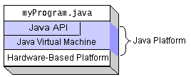

Figure1: The Java Platform
After compiling a code, it known as the native code. It is the compiled code runs on a specific hardware platform. As a platform-independent environment, the Java platform can be a bit slower than native code. However, smart compilers, well-tuned interpreters, and just-in-time byte code compilers can bring performance close to that of native code without threatening portability (Sierra, Bates, & Rajca, 2011).
3.1.2 Working of Java
Those who are not familiar with object-oriented programming, the concept of a class will be new to you. Condensed, a class is the definition for a segment of code that can contain both data and functions. When the interpreter executes a class, it seeks for a particular method by the name of main, which will sound familiar to C programmers. The main method is passed as a parameter an array of strings (similar to the arg[] of C), and is declared as a static method (Schildt, 2014).
To output text from the program, execute the println method of system, out, which is java has output stream. UNIX users will appreciate the theory behind such a stream, as it is standard output. For those who are instead used to the Wintel platform, it will write the string passed to it to the user’s program (Schildt, 2014).
3.2 Literature Survey
The most important step in software development process is literature survey. It is necessary to determine the time factor, economy and company strength before developing the tool. After satisfying these things, the next step is to determine which operating system and language can used for developing the tool. Once the programmers start building the tool, the programmers need lot of external support. This support can acquired from senior programmers, from book or from websites. Prior to building the system, the consideration taken into account for developing the proposed system (Schildt, 2014).
  - Functional Requirements and Non-Functional Requirements
3.3.1 Functional Requirements
- Admin
Admin will also have to login into the application with help of their credentials and once he login, he will have different sets of features or functionality provided under him. The admin is the owner of this web application, and the admin will have option to accept/reject members, view members, and view comments in this website.
- Mentors
Mentor is the main person here in this application, registered by admin. If he wants to use this application: firstly, he should register with his/her credentials and then he should login to this web application, then he will see the doubts which are posted by college senior regarding best international colleges, jobs. Mentor will give response to students, and the communication takes place between mentor and college senior. Here mentor may be an already studied student in that college.
- College Senior
College Senior is the main person here in this application, registered by admin. If he wants to use this application: firstly, he should register with his/her credentials and then he should login to this web application, then he will post doubts and view best international colleges, jobs.
    - Non-Functional Requirements
Performance measured in terms of the output provided by the application. Requirement specification plays an important part in the analysis of a system. Only when the requirement specifications are properly given, it is possible to design a system, which will fit into required environment. It rests largely in the part of users of the existing system to give the requirement specifications because they are the people who finally use the system. The requirement specification for any system can broadly state as given below:
- The system should be able to interface with the existing system.
- The system should be accurate.
- The system should be better than existing system.
- Portability: It should run on specified platforms successfully. To achieve this we should test the product on all platforms before launching the product. If our project runs successfully on different platforms then our system is portable in nature.
- Reliability: The system should perform its intended functions under specified conditions. If our system satisfies all the specified conditions then it is Reliable in nature.
- Reusability: The system should be extremely reusable as a whole or part. Make the system modularize and make sure that modules coupled. This project is having reusability nature because we can reuse whole or part of this project on other systems.
- Robustness: The system should be robust enough to perform well under different circumstances without any inconsistencies.
- Testability: The product of a given development phase should satisfy the conditions imposed at the start of that phase.
- Usability: It should be perfect and comfortable for users to work.
- Security: The system completely based on the security. This system will provide a security base on the password.
  - Requirements Engineering Components
To ensure the consistency, completeness and relevance of this system, the document provides the use of systematic and repeatable techniques of requirements engineering, which includes the following:
    - Requirements gathering
Also known as “requirements elicitation”, this helps to identify what is required in the system. This establishes the system requirements to accomplished, how the system will fit into the needs of the business, and how the system will used on a day-to-day basis.
    - Requirement analysis
This method of requirement engineering is to refine and modify the gathered requirements.
    - Requirement specification
This approach consists of documenting the system requirements in a semiformal or formal manner to ensure clarity, consistency, and completeness.

3.5 System Requirements
Identifier | Priority | Requirement
REQ1 | 5 | The system should register all members.
REQ2 | 5 | The system shall receive doubts by college senior.
REQ3 | 4 | The system should reply doubts by the mentor.
REQ4 | 4 | The system shall respond to every member.
REQ5 | 3 | The system shall have logging and logout.
REQ6 | 4 | The system should recognize every member by login details and password.
REQ7 | 2 | The system should have address manually through admin.
REQ8 | 3 | The system has to save data in database.
REQ9 | 2 | The system should login whenever user required.
REQ10 | 4 | The system should save data of jobs.
REQ11 | 4 | The system should save college details for further use.
REQ12 | 1 | The system should save the comment and rating given by college senior.
REQ13 | 1 | The system should show the comments to admin.
REQ14 | 1 | The system should search whatever the member required.

- DATABASE DESIGN
Introduction
MySQL is a trademark of MySQL AB. This software is user-friendly software it as the features like working fastest in real time. It is also known as multi-threaded software, and robust SQL database server. This server has heavy- load production systems, and it well known for embedding data easily. MySQL is “The software has Dual Licensing, which means user can use the software free of charge under the Public License (http://www.gnu.org/licenses/). This software can be purchase with commercial MySQL licenses from MySQL AB and if user do not wish to be bound by the terms of GPL then they can go through the web site (http://www.mysql.com/), which provides the latest information about the MySQL software” (DuBois, 2005). This software is like user-friendly.
What Is MySQL?
MySQL is a relational database management system. A relational database stores data in separate tables by this method the software adds speed and flexibility to the execution. The tables are interring linked by defined relations and make user combine data from several tables on request. As the entire user, know that the SQL part of “MySQL” stands for “Structured Query Language” the most common standardized language used to access databases on every operating system (DuBois, 2005).
Why use the MySQL Database Server?
By using this server, user feels it as easy to use. It also has a practical set of features developed in cooperation with users. While coming to performance comparison between MySQL Server and some other database, the technical features of MySQL Server has advanced technical information. Software known as client/server system that consists of different features, which supports different back ends, and several different client programs. This software creates own libraries and has administrative tools which can easily accessible by the user at any time (DuBois, 2005).

MySQL RDBMS
Name
Onlinementoringsystem
Table: MySQL Database
Table: register
Columns
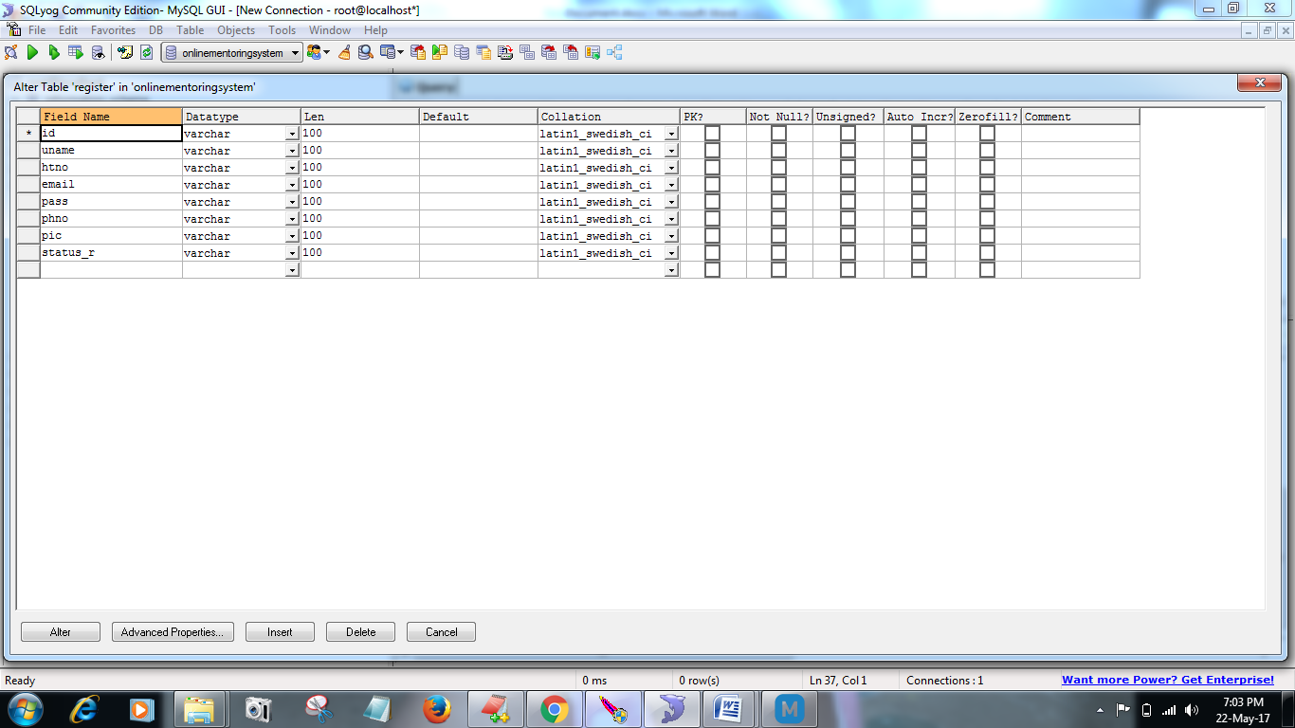
Table: Structure of register table of MySQL Database

Definition
CREATE TABLE `register` (
`id` varchar(100) DEFAULT NULL,
`uname` varchar(100) DEFAULT NULL,
`htno` varchar(100) DEFAULT NULL,
`email` varchar(100) DEFAULT NULL,
`pass` varchar(100) DEFAULT NULL,
`phno` varchar(100) DEFAULT NULL,
`pic` varchar(100) DEFAULT NULL,
`status_r` varchar(100) DEFAULT NULL
) ENGINE=InnoDB DEFAULT CHARSET=latin1

Table: mregister
Columns
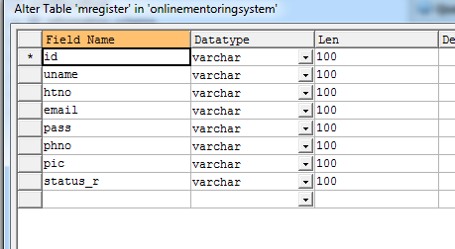
Table: Structure of mregister table of MySQL Database
Definition
CREATE TABLE `mregister` (
`id` varchar(100) DEFAULT NULL,
`uname` varchar(100) DEFAULT NULL,
`htno` varchar(100) DEFAULT NULL,
`email` varchar(100) DEFAULT NULL,
`pass` varchar(100) DEFAULT NULL,
`phno` varchar(100) DEFAULT NULL,
`pic` varchar(100) DEFAULT NULL,
`status_r` varchar(100) DEFAULT NULL
) ENGINE=InnoDB DEFAULT CHARSET=latin1

Table: doubt
Columns
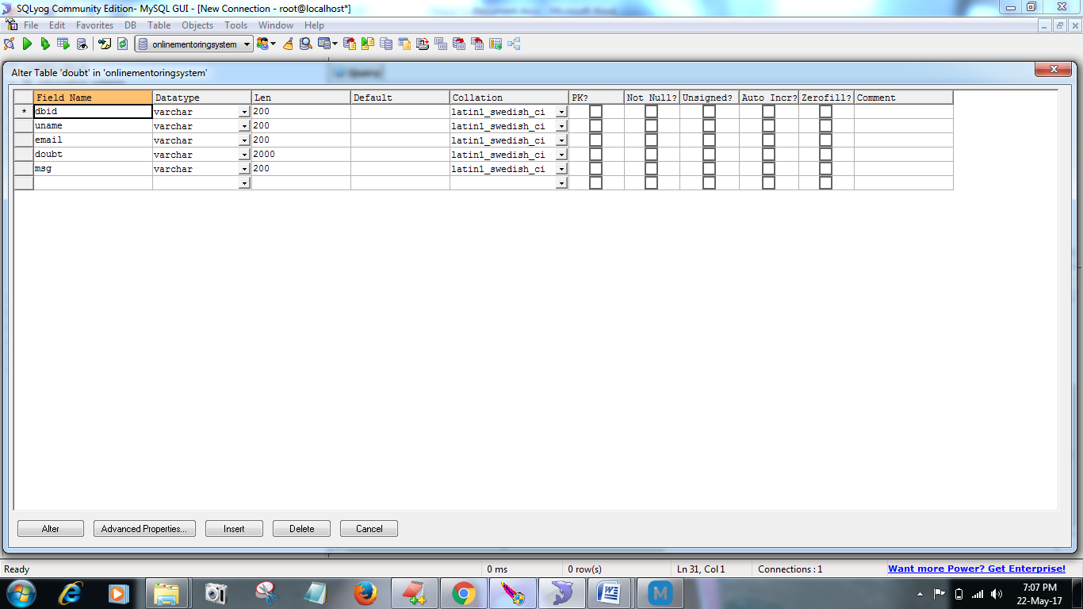
Table: Structure of doubt table of MySQL Database
Definition
CREATE TABLE `doubt` (
`dbid` varchar(200) DEFAULT NULL,
`uname` varchar(200) DEFAULT NULL,
`email` varchar(200) DEFAULT NULL,
`doubt` varchar(2000) DEFAULT NULL,
`msg` varchar(200) DEFAULT NULL
) ENGINE=InnoDB DEFAULT CHARSET=latin1

Table: college
Columns

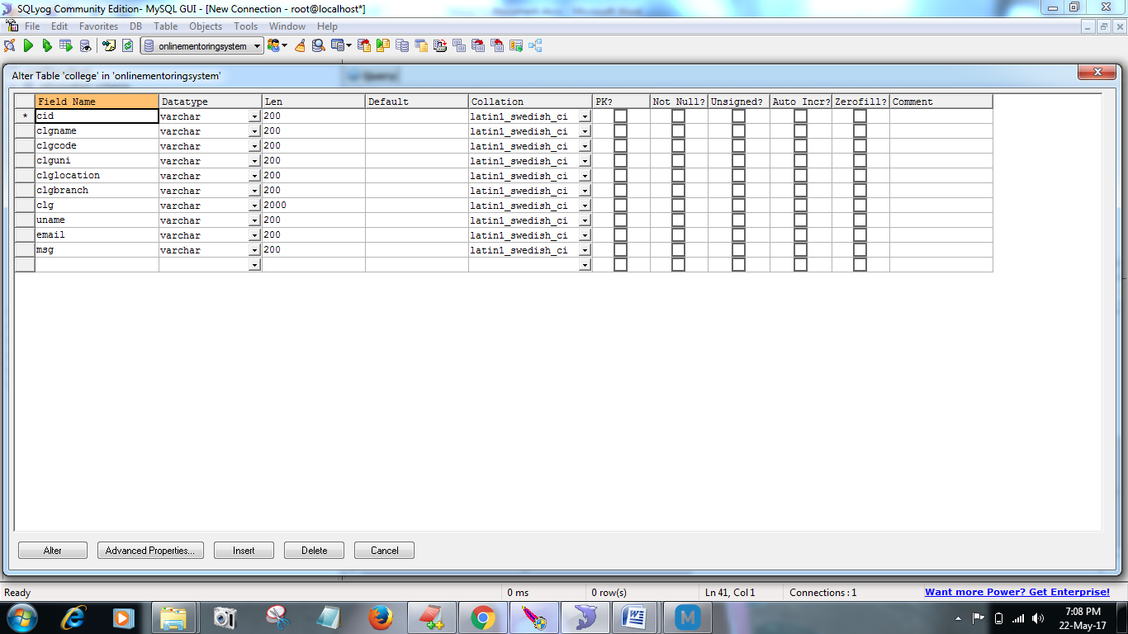
Table: Structure of college table of MySQL Database
Definition
CREATE TABLE `college` (
`cid` varchar(200) DEFAULT NULL,
`clgname` varchar(200) DEFAULT NULL,
`clgcode` varchar(200) DEFAULT NULL,
`clguni` varchar(200) DEFAULT NULL,
`clglocation` varchar(200) DEFAULT NULL,
`clgbranch` varchar(200) DEFAULT NULL,
`clg` varchar(2000) DEFAULT NULL,
`uname` varchar(200) DEFAULT NULL,
`email` varchar(200) DEFAULT NULL,
`msg` varchar(200) DEFAULT NULL
) ENGINE=InnoDB DEFAULT CHARSET=latin1
Table: job
Columns
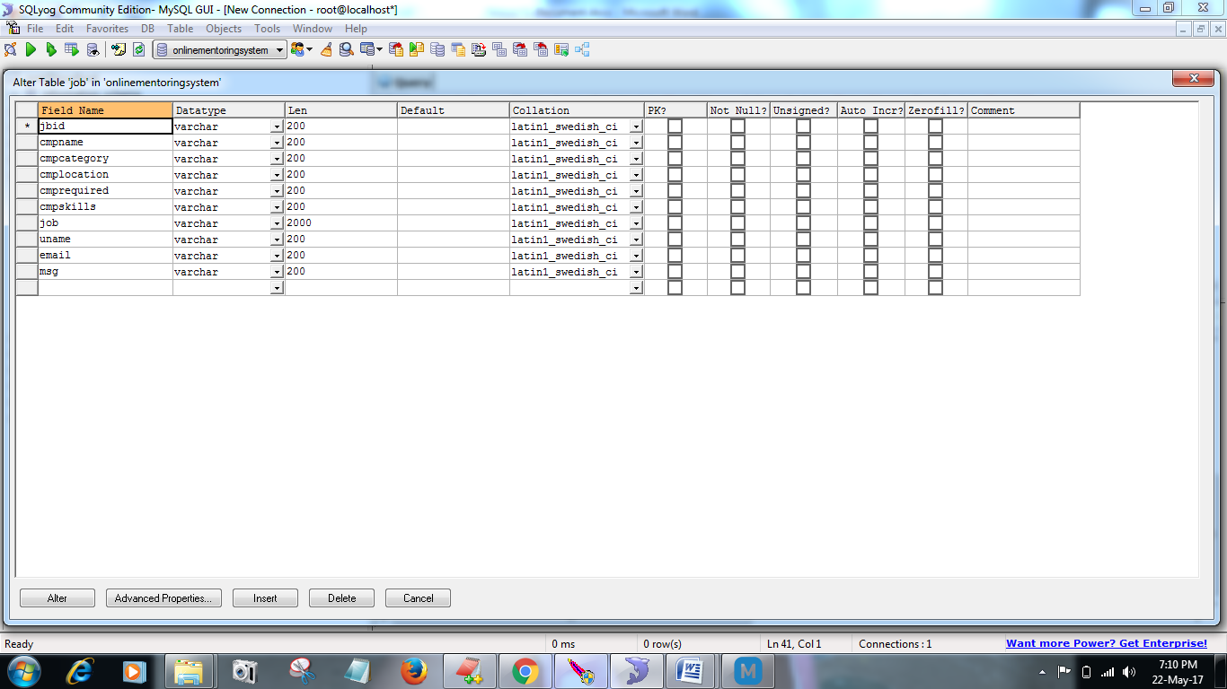
Table: Structure of job table of MySQL Database
Definition
CREATE TABLE `job` (
`jbid` varchar(200) DEFAULT NULL,
`cmpname` varchar(200) DEFAULT NULL,
`cmpcategory` varchar(200) DEFAULT NULL,
`cmplocation` varchar(200) DEFAULT NULL,
`cmprequired` varchar(200) DEFAULT NULL,
`cmpskills` varchar(200) DEFAULT NULL,
`job` varchar(2000) DEFAULT NULL,
`uname` varchar(200) DEFAULT NULL,
`email` varchar(200) DEFAULT NULL,
`msg` varchar(200) DEFAULT NULL
) ENGINE=InnoDB DEFAULT CHARSET=latin1
Table: reply
Columns
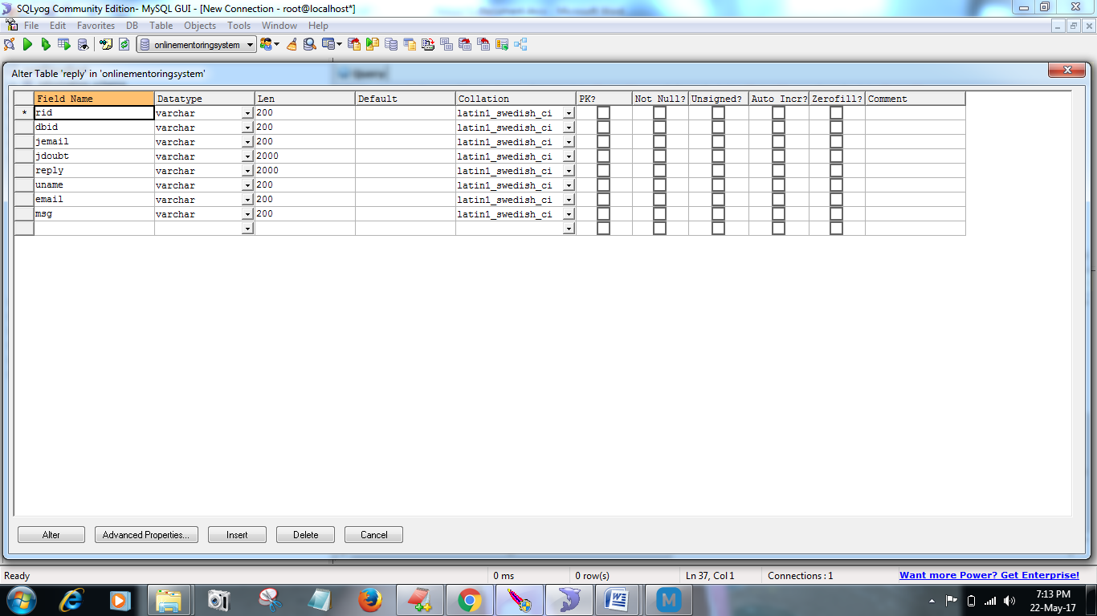

Table: Structure of reply table of MySQL Database
Definition
CREATE TABLE `reply` (
`rid` varchar(200) DEFAULT NULL,
`dbid` varchar(200) DEFAULT NULL,
`jemail` varchar(200) DEFAULT NULL,
`jdoubt` varchar(2000) DEFAULT NULL,
`reply` varchar(2000) DEFAULT NULL,
`uname` varchar(200) DEFAULT NULL,
`email` varchar(200) DEFAULT NULL,
`msg` varchar(200) DEFAULT NULL
) ENGINE=InnoDB DEFAULT CHARSET=latin1

4.1 Entity Relationship(ER) Diagram
Figure: ER Diagram

4.2 Relational Schema Diagram

Admin
Login | Accept | View Member | View Comments | Logout | Register

Mentor
Register | Login | View/Reply doubt | Post jobs | Post best College | Logout

Clear doubt
View/Reply doubt | Post doubt

College Senior
Register | Login | Post doubts | View Replies | View jobs | View best college | logout

Figure: Relational Schema Diagram

5. SOFTWARE DESIGN DESCRIPTION
5.1 Purpose:
An SDD (Software design description) is a representation of a software system that used as a medium for communicating software design information.
5.2 Design:
Requirements gathering followed by careful analysis leads to a systematic Object-Oriented Design (OOD). Various activities been identified and are represented using Unified Modeling Language (UML) diagrams. UML used to specify, visualize, modify, construct and document the artifacts of an object-oriented software-intensive system under development.
5.3 Use Case View
A use case is a set of scenarios that describing an interaction between a user and a system. In this section of the document, the use case diagram show the relationship among actors and use cases for the Online Mentoring System.
5.3.1. Use Case Diagram:
A use case diagram displays the relationship among actors and use cases. The two main components of a use case diagram are use cases and actors. A use case is a set of scenarios that describes an interaction between a user and a system. An actor represents a user or another system that will interact with the system you are modeling. The purpose of use case view is to list the actors and use cases and show which actors participate in each use case. The behavior of use cases expressed using dynamic views, particularly the interaction view (Pressman, 2010).
Contents of Use Case Diagram
- Use cases
- Actors
- Dependency, Generalization, and association relationships
- System boundary
In the use case diagram illustrated in Figure, the Admin, Mentor, and college senior are actors. Additionally, the Admin is the primary or initiating actor starting the process and the rest are participating actors helping to finish off the process.

Figure3: Use Case Diagram

5.4 Activity View
This will show the flow of control among the computational activities involved in performing a calculation or a workflow of the Online Mentoring System.
5.4.1 Activity Diagram:
For describing the dynamic aspects of the system this activity diagram is important diagram in UML. It used to represent the flow from one activity to another activity. This diagram consists of different types of elements such as fork and joins control.
The basic purpose of this diagram is like another UML diagrams. These UML diagrams used to show the flow from one state to another state. However, this activity diagram used to show message flow from one activity to another activity. This activity diagram looks like flowchart but it is not a flowchart diagram (Pressman, 2010). The purpose:
- To draw the flow from one activity to another activity of the system.
- To describe the sequence from one activity to another.
- To describe the parallel, branched and concurrent flow of the system.
Figure shows the activity diagram of the Online Mentoring System that illustrates the flow between the Admin, college senior, and Mentors.

Figure4: Activity Diagram

5.5 Static View
This section explains the static view models concepts in the application domain as well as internal concepts of the Online Mentoring System. The view is static because it does not describe the time-dependent behavior of the system. The main constituents of the static view are classes and their relationships: association, generalization, and various kinds of dependency. A class is the description of a concept from the application domain or the application solution. Classes are the center of the class view. The static view displayed in class diagrams as focus is on the description of classes.
5.5.1 Class Diagram:
A class diagram in the UML is a type of static structure diagram that used to model the structural aspects of the system by showing the system’s classes, its attributes (fields) and interrelationships between the classes. Class diagrams used for domain modeling as well as for detailed design modeling. Class diagrams are arguably the most used UML diagram type. The class diagram is the main building block of object-oriented modelling (Pressman, 2010). Classes represented with boxes that contain three compartments:
- The top compartment contains the name of the class.
- The middle compartment contains the attributes of the class.
- The bottom compartment contains the operations the class can execute.
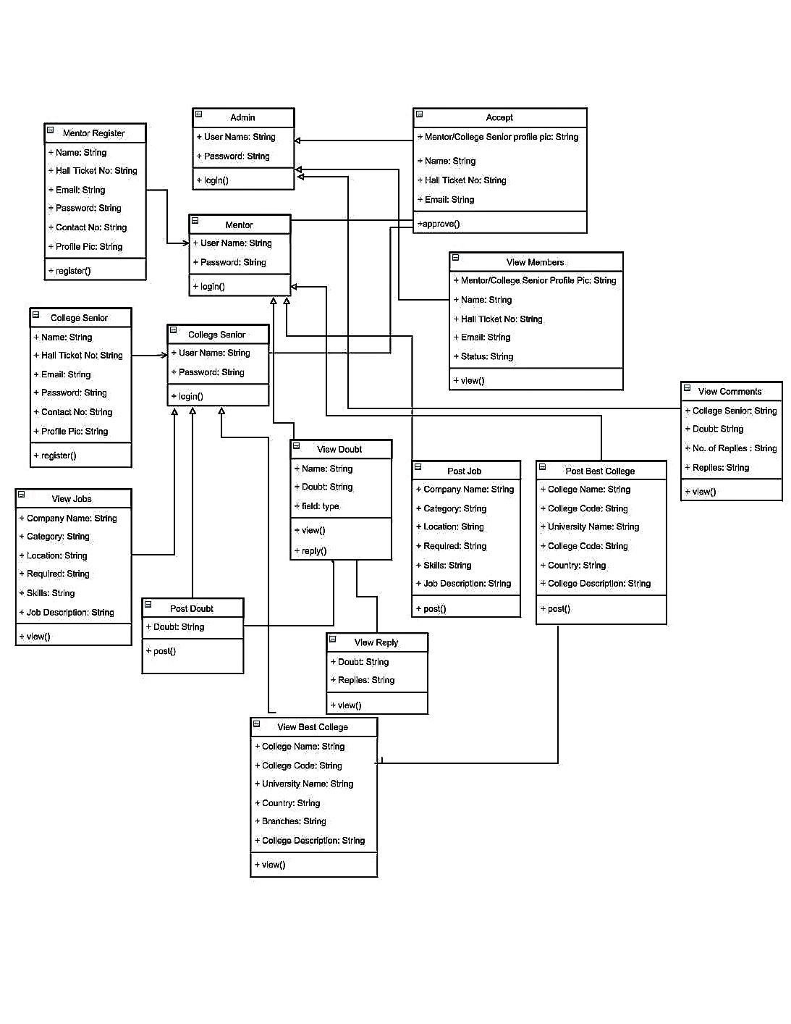

  - Interaction View
In this section, it will describe the sequences of message exchanges among parts of the Online Mentoring System. It will provide an interaction, based on a structured classifier or collaboration. A role is a slot filled by objects in a particular use of an interaction. This view provided a holistic view of behavior in a system and the flow of control across many objects.
    - Sequence Diagram:
A Sequence diagram is an interaction diagram that shows how objects operate with one another and in what order. A sequence diagram shows a set of messages arranged in a time sequence. It is a construct of a Message Sequence Chart. Sequence diagrams called as event diagrams or event scenarios. Each classifier role shown as a lifeline i.e. a vertical line that represents the role over time through the entire interaction. Messages shown as arrows between lifelines. A sequence diagram can show a scenario – an individual history of a transaction (James, Ivar, & Grady, 2005).
The sequence diagram shows Online Mentoring System. It consists of Admin as actor, which communicates with the objects, that is the instances of classes and arranged horizontally. Here the objects for Admin are login, accept, View Members, View Comments, and Logout. The dashed vertical line, the lifeline indicates the existence of object overtime. The rectangular box indicates that object is performing an action. The message indicates communication between the Admin (actor), objects and in between the objects. Figure will show other sequence diagrams and its corresponding uses.

Figure5: Sequence Diagram for Admin

The sequence diagram shows Online Mentoring System. It consists of Mentors as actor, which communicates with the objects, that is the instances of classes and arranged horizontally. Here the objects for Mentors are Register, Login, View Doubt, Post Job, Post Best College, and Logout. The dashed vertical line, the lifeline indicates the existence of object overtime. The rectangular box indicates that object is performing an action. The message indicates communication between the Mentors (actor), objects and in between the objects.

Figure 6: Sequence Diagram for Mentors
The sequence diagram shows Online Mentoring System. It consists of college senior as actor, which communicates with the objects, that is the instances of classes and arranged horizontally. Here the objects for college senior are Register, Login, Post Doubt, View Replies, View Job, View Best College, and Logout. The dashed vertical line, the lifeline indicates the existence of object overtime. The rectangular box indicates that object is performing an action. The message indicates communication between the college senior (actor), objects and in between the objects.

Figure7: Sequence Diagram for College Senior

5.7 Collaboration Diagram:
Collaboration diagram is the best suited for the simple interactions among relatively small numbers of objects. As the number of messages and objects grows, a collaboration diagram can become difficult to read. Several software’s are for creating and editing collaboration diagrams (James, Ivar, & Grady, 2005).

Figure8: Collaboration Diagram for Admin
Figure9: Collaboration Diagram for Mentor

Figure10: Collaboration Diagram for College Senior

5.8 State Machine View
The state machine view used on this software architecture document to describe the dynamic behavior of objects over time by modeling the lifecycles of objects of each class for Online Mentoring System.
5.8.1 State chart Diagram:
A state machine diagram is a tool used to represent a system as a series of states and related activities, display the interrelationships among the states. State machine diagram is similar to activity diagrams although notations and usage changes a bit. They sometimes known as state diagrams or start chart diagrams. State diagrams used to give an abstract description of the behavior of a System. A state machine attach to a class and describes the response of an instance of the class to events that it receives. It may also attach to operations, use cases and collaborations to describe their execution. It is a model of all possible life histories of an object of a class (Pressman, 2010).
Figure11: State Chart Diagram
6 IMPLEMENTATION
package database;
import java.sql.*;
public class databasecon
{
static Connection con;
public static Connection getconnection()
{try
{
Class.forName("com.mysql.jdbc.Driver");
con = DriverManager.getConnection("jdbc:mysql://localhost:3306/OnlineMentoringSystem","root","root");
}
catch (Exception e)
{
System.out.println("class error" + e);
}
return con;
}
}

Screen Captures
6.1 Welcome Screen

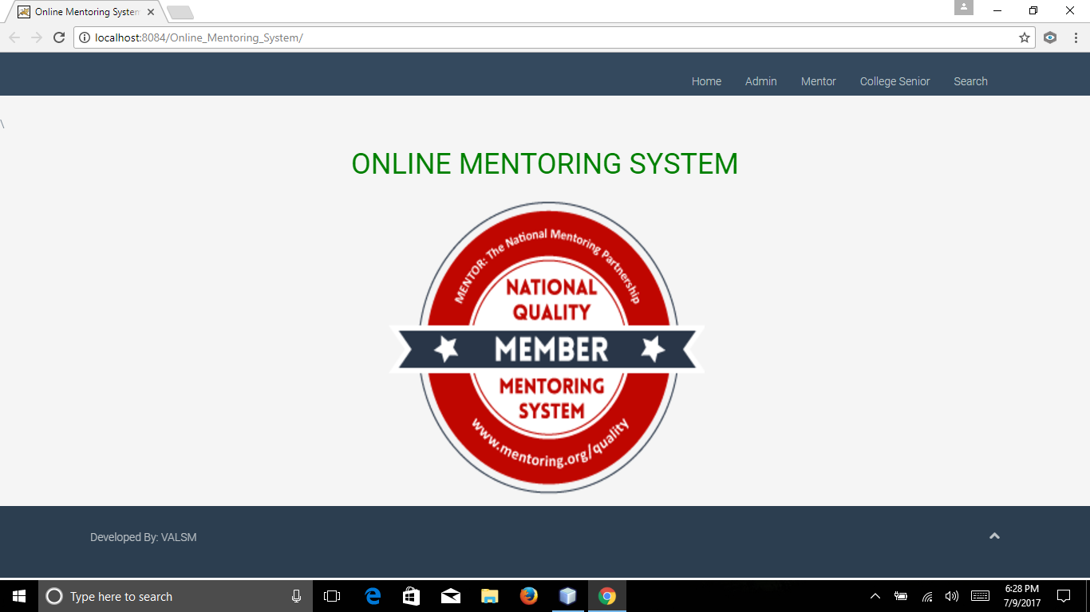

Description: After launching the application, a Welcome message will come into view.

6.2 Registration

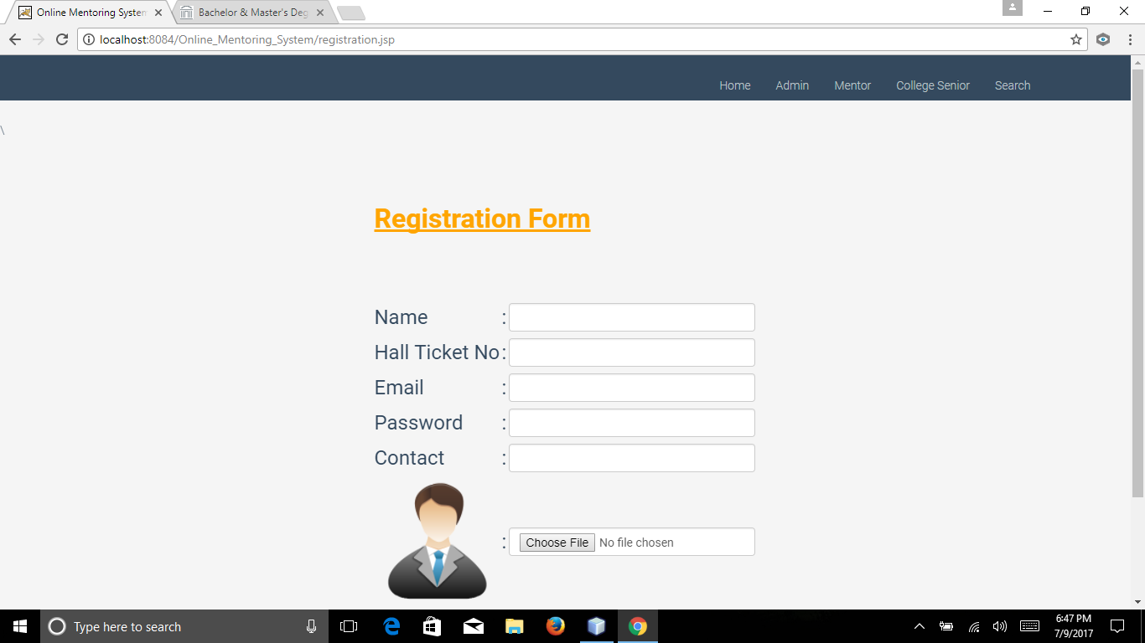

Description: In this activity is useful for the new mentor or junior to register themselves by giving their valid details such as email id, user name, Phone number, etc. The user has to fill all the details else, message displayed to the user.

6.3 Login Screen for Admin

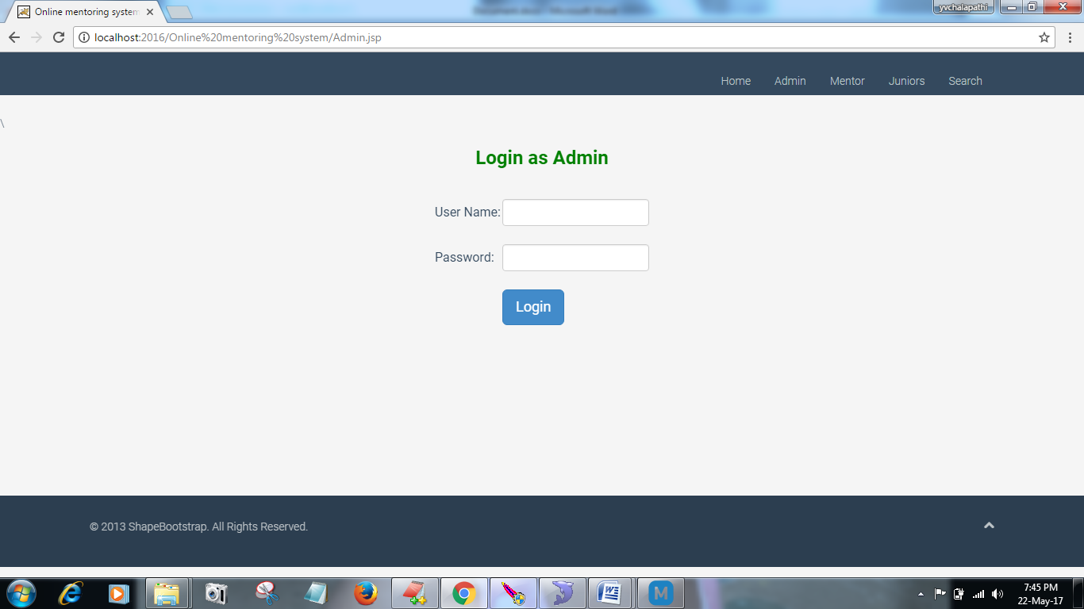

Figure: Login Activity

Description: The application has an Admin login, which used to start the application to prevent authenticity infringement.

6.4 College Senior Welcome Page


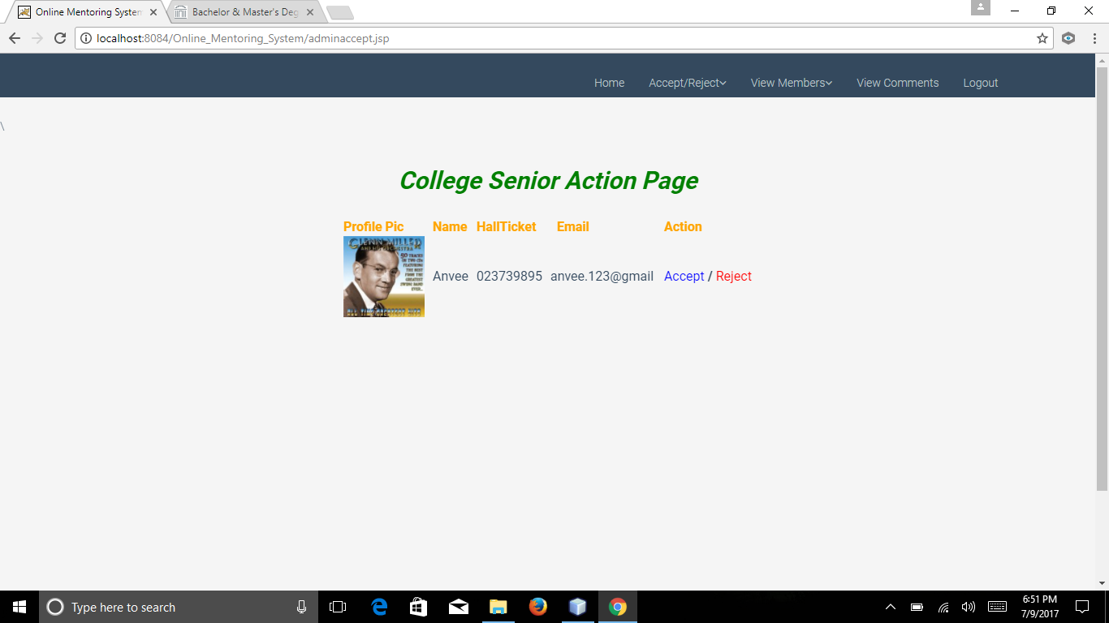

6.6 College Senior Doubt Page

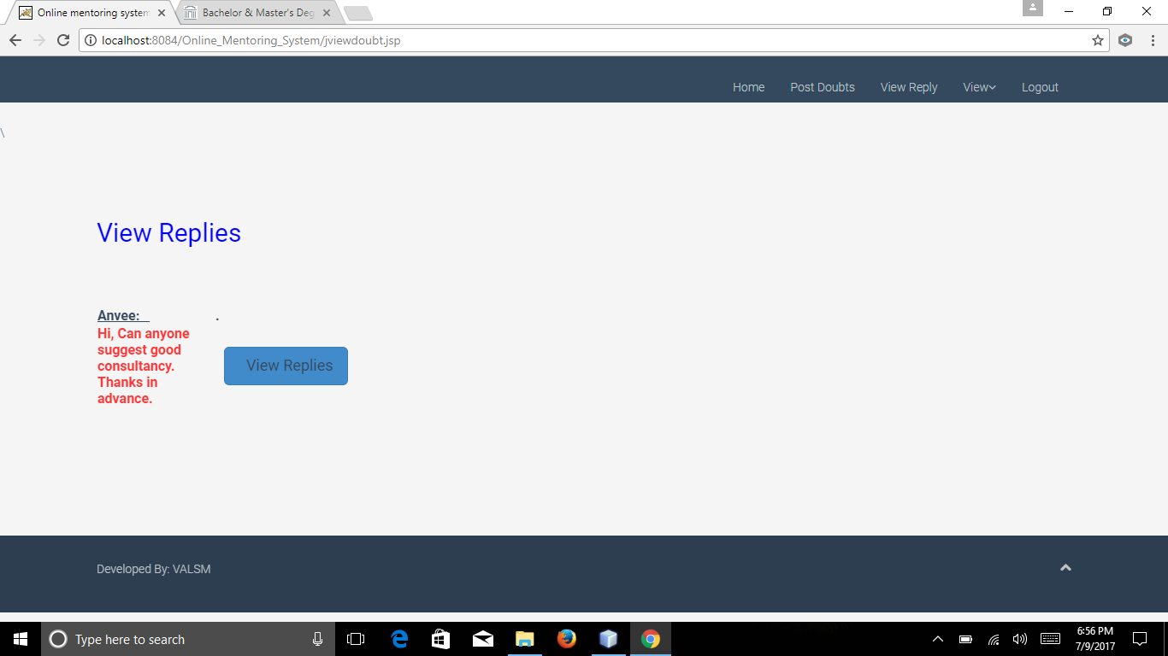

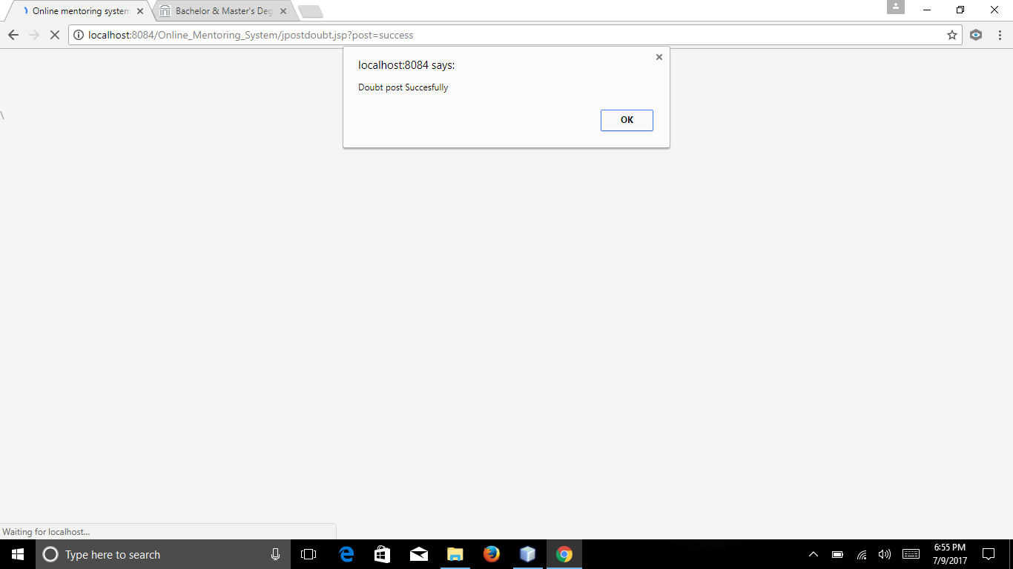

View Jobs
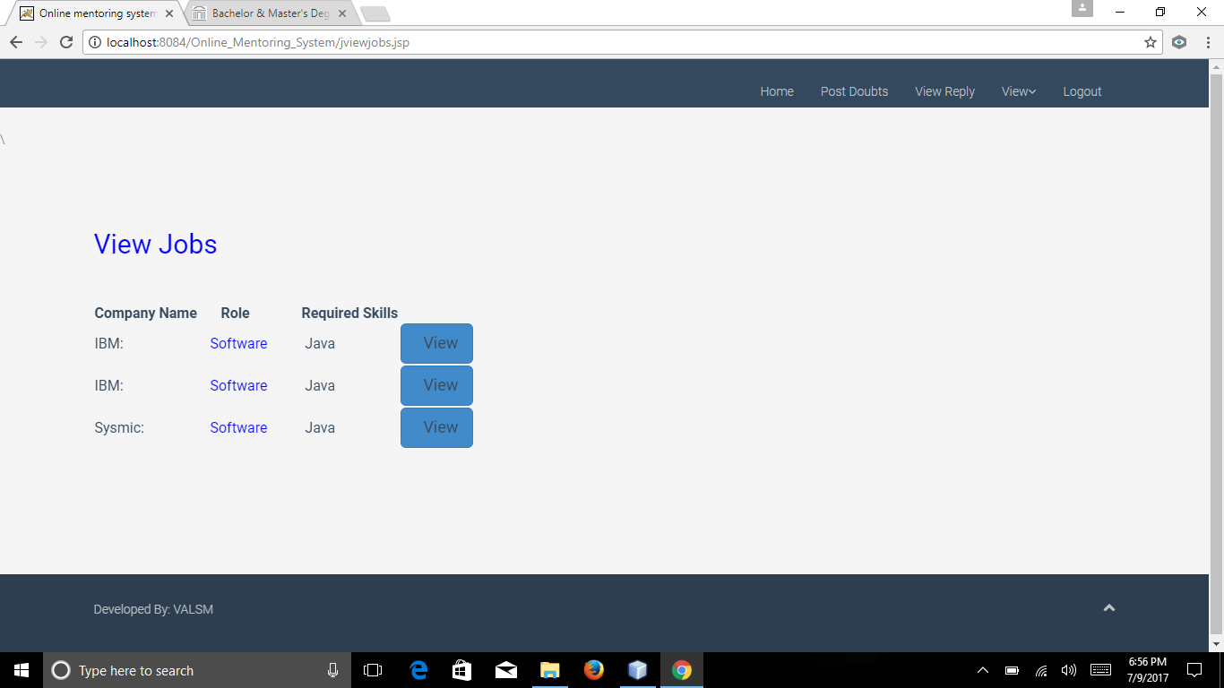

7. TEST PLAN
7.1 Introduction
The purpose of Test plan document for Online Mentoring System is to describe the details of testing for our project. The goal of the Test Plan is to identify the items to be tested, and tasks to perform. In this document, every member personally responsible for each task, and the risks associated with it.
7.1.1 Objective:
The main objective of test plan document in this project is as follow:
- First, identify the features of online mentoring system that will tested.
- Define all the activities, which are necessary to conduct the test process on OMS.
- Define pass/fail criteria for each use case in the system.
- Identify all deliverables of OMS.
- Define suspension criteria and resumption techniques.
- Discuss testing techniques of OMS.
7.2 Relationship with other document:
Test plan document based on software requirement specification, software architecture design and Implementation.
7.2.1 Relationship between SRS and Test plan
Functional Requirement Test:
Use cases of online mentoring system are mapped in software requirement document which are mentioned below as functional use cases
Functional Use Case | Test Case ID
Register | TC001
Login | TC002
Accept | TC003
Post Doubt | TC004
View Doubt | TC005
View Members | TC006
View comments | TC007
Post best colleges | TC008
Post Jobs | TC009
View Replies | TC010
View jobs | TC011
View best college | TC012
Search | TC013
Logout | TC014

7.2.2 Relationship between SDD and Test Plan:
Software Design Description is a sub system where Integration testing was done for this system.
Design Test Case | Test Cases
UI Interface Subsystem | TCUI_014
Admin | TCUI_01  TCUI_02  TCUI_03  TCUI_04  TCUI_05
Mentor | TCUI_01  TCUI_02  TCUI_03  TCUI_04  TCUI_05  TCUI_06
College Senior | TCUI_01  TCUI_02  TCUI_03  TCUI_04  TCUI_05  TCUI_06  TCUI_07

7.3 Features to be tested and Features not to be tested:
7.3.1 Features to be tested
- Weather the Admin and other actors of the system can log in successfully after authenticated with their username and password.
- Once they login to the system then an event is successful.
- If two actors, access the system simultaneously the system should allow this to happen.
- The system should tested to for delivering the outputs for both mentor and junior.
- The report created by the Admin, is it available to be view at any time.
- Particular information once updated by mentor that information should reflect to junior.
- System should show the information at any time when user logged into it.
- College senior can also give comments and rating which can tested.
7.3.2 Features not to be tested:
- Information posted by mentor cannot tested.
- If system has high load then it cannot tested.
- This system cannot tested on other platform called UNIX for time being.
7.4 Pass/Fail Criteria:
7.4.1 System Level:
The test process will be complete if the user is able to operate, which processed by the admin and he is successfully able to login and post or reply the doubts. This is what we call as the pass criteria. If any case problem occurs in entire process then it is termed as system failure, which also called as Fail criteria. However, a successful test is termed as if it can make the system fail.
7.4.2 Integration testing
When testing the integration, the services offered by the sub-systems should tested. These services invocated and if the service results in completion of expected tasks then it is the success. If the sub-system fails to perform a task it intended to do then it is a failure. The whole concept of successful testing described in the previous section is applicable here too.
7.4.3 Unit testing
In unit testing the pass and fail criteria for each sub-system depends on the functionality of those sub-system. If pre conditions and post conditions are satisfied then it is the (Black box) success otherwise failure. White box testing goes more into the execution paths of the program.
7.5 Approach
7.5.1 Testing Levels:
- Unit testing
- Integration testing
- User Acceptance testing
- Regression testing
7.5.2 Unit Testing:
Each Use case will tested using some data while code has written. Unit tests will written and conducted manually and recorded. Once a system has passed a unit test then the application can progress to the next level of unit testing. The next level will be integration with other actors that have also passed individual unit tests.

Manual Test Cases:
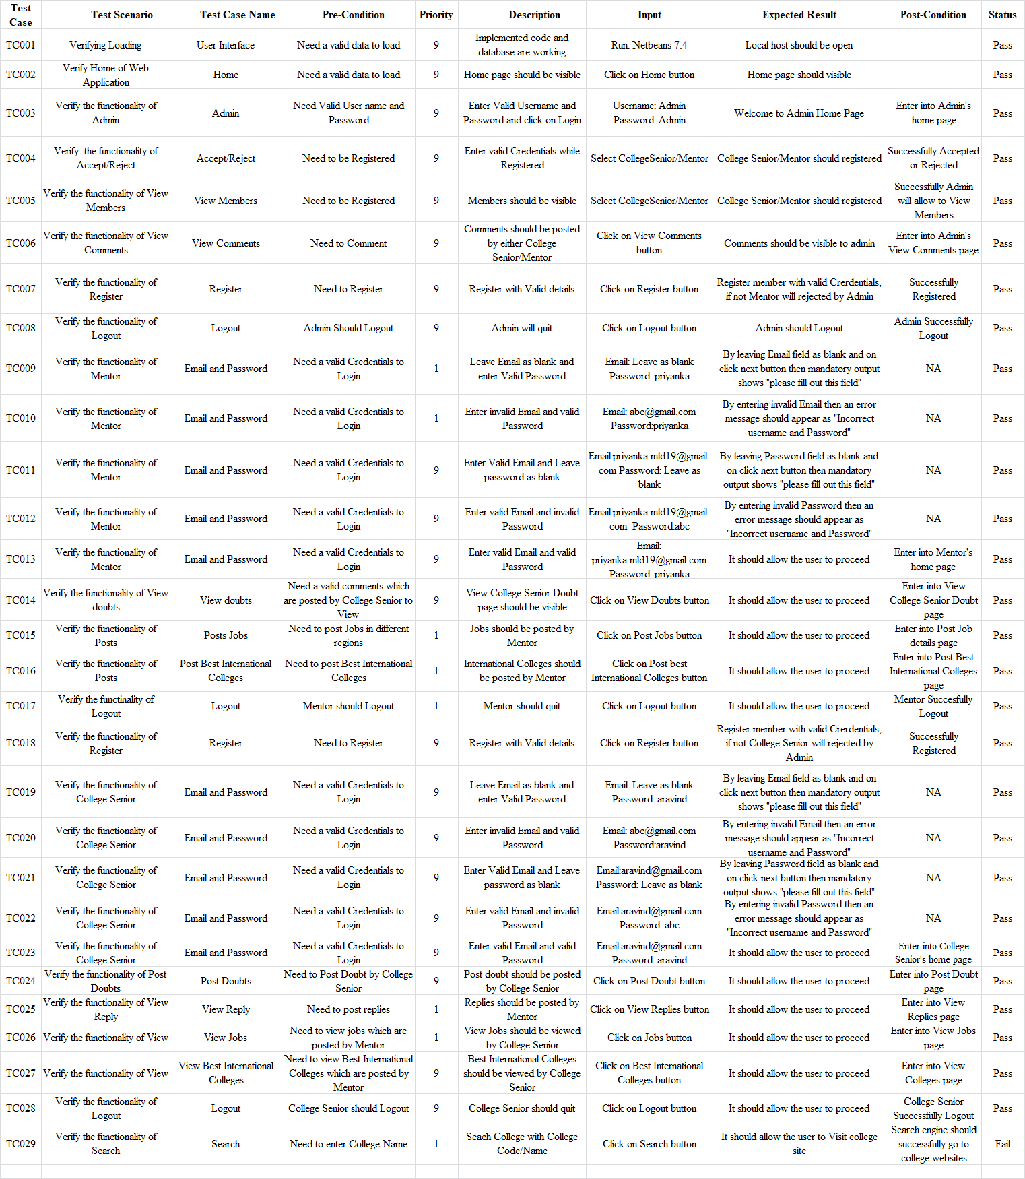
7.5.3 Integration Testing:
Integration testing is a next level of unit testing. Modules will be integrated and tested together to ensure that the functional requirements of the application are similar. As mentioned above in SDD document the functionalities tested manually like registering, login, and more (Belete, Voinov, & Laniak, 2017).
7.5.4 Acceptance testing
Here in a testing the individuals and groups will navigate through the prototype and they give comments if necessary. Their feedback will documented and taken into consideration, but the following questions will asked to every individual participating:
- Does the application crash anywhere?
- Does all the registration accept by the admin?
- Can the user use the software anywhere?
- Do they have trouble while using application?
- What would make the application easier to use?
- What features would enhance the application?
7.5.5 Regression testing:
During regression testing, the selective strategy will tested. The selective strategy uses a subset of the existing test cases and it covers can changed if necessary. The challenge is to identify the dependencies between a test case and the program entities it covers.
The regression testing steps will be as follows:
- Identifying the program components.
- When selected test cases satisfy then the application passed.
- Once regression testing done, it is necessary to update and store the test information.

7.6 Roles and Responsibilities:
S. No | Task Name | Resource | Hours
1 | Project Proposal | Vani Priya | 3
2 | Project Plan | Arthisha | 10
3 | Requirements Specification | All | 20
4 | Creating Use-cases | All | 03
5 | Use-case Diagrams | Priyanka | 03
6 | Activity Diagram | Pujitha | 05
7 | Data Flow Diagram | Muneendar | 03
8 | ER Diagram | Vani priya | 03
9 | Deployment Diagram | Arthisha | 02
10 | UI Screen Creation | All Members | 06
11 | Coding | All Members | 75
12 | Software Testing | All Members | 75
13 | Black box and White box Testing | Vani Priya Muneendar | 20
14 | Performance and Load Testing | Arthisha, Muneendar | 20
15 | Manual Testing | Priyanka, Pujitha | 35
16 | Deployment | All Members | 06

7.7 Suspension and Resumption
7.7.1 Suspension Criteria:
The application is a prerequisite to the operation of all use cases and must operate successfully in order pass information. If in case the application does not perform as predicted, then the test will suspended.

7.7.2 Resumption Requirements:
Testing will resume if it suspended. The developers again begin testing and develop by new versions of the Application Entities have been submitted to the testing group. .
7.8 Dependencies
As it is internal academic project and requirements are clear, there are no many dependencies but the deadlines are exit.
7.9 Risks and Assumptions:
7.9.1 Risks:
The expertise of the resources is limited as all team members are learning and curving, this may have affect project with deadlines.
7.9.2 Assumptions:
Assumed that all resources are available for testing the application as per scheduled.

- SOFTWARE QUALITY ASSURANCE PLAN
8.1. Overview
In this paper, we propose a system in which the mentor can guide their college senior in their academics as well as in their careers. This system will help the college senior gather information until they understand it. They will not hesitate to ask queries any number of times because they may feel the system as a friendly environment since they are dealing with their mentors. We want to develop a website using Java JSP, Tomcat, and MySQL.
8.1.1 Scope:
This Online Mentoring System provides a friendly environment in which students mentor students. It designed for providing academic or career guidance to college students by graduate students at more advanced level. This system will help the college students to understanding trends in technology, disciplines and job market; they can ask questions to their mentors.
8.2 Definitions:
Software Quality: Software quality is a degree of excellence which typically defined by set of attributes (William, 2009).
Specification Quality: Specification is a starting point in software quality. It defined by product or service provider.
Design Quality: In design quality, it determines how well the product designed. It has two phases, conceptual and engineering designs (Chemuturi, 2011).
Development Quality: Software quality development can achieved through coding, style guides (Chemuturi, 2011).
Conformance Quality: It deals with how well the company ensures the quality of product using other dimensions. It makes sure how the quality control carried out the organization by using set of quality metrics (Chemuturi, 2011).
Software Testing: A systematic process of finding undiscovered defects and it is a form of creative destruction whose purpose is to break software and get it repaired.
Verification: It refers to the set of activities that ensure that software correctly implements a specific function.
Validation: It refers to a different set of activities that ensure that the software been build is traceable to customer requirements.
8.3 Purpose:
The purpose of this document is to define all the procedures, and system of methods used in the project to assure delivery of the software that meets specified requirements within a project resources. Software Quality Assurance of this project involves reviewing and auditing the software products, activities to verify that they comply with the applicable specifications that are provide by developers of the software project and other appropriate managers give the view or results for these reviews and audits.
8.4. Reference Documents:
- Software architecture and specification requirements of OMS 1.0
- Vision Document 1.0
- IEEE standard for Software Quality Assurance plans, IEEE STD 730-1998
8.5 Management:
8.5.1 Organization and Responsibilities:
The organization consists of head of computer science department, Major Professor, developers, and technical inspector.
Head of computer science department:
- Dr. Peter Day
The members of computer science department are responsible for attending the presentations, reviewing the document at the end of each phase, give feedback, and suggestions for the project.
Major Professor:
- Dr. Peter Dey
The professor will be responsible evaluating the work and check the progress done by the developers.
Developer:
- Lakshmi Manigandla
- Pujitha Paruchuri
- Vani Priya Pingili
The developers should submit the project specifications and the functionalities on time to the professor.
Technical Inspectors:
- Muneendar Muthyala
- Arthisha Reddy Vaddi
The technical inspectors are responsible for the architecture design and requirements of the project. They should submit a report based on their findings in SRS document.
Technical Inspection Checklist:
Inspected Item | Status | Comments
The symbols, which used in the class diagram, based on the UML standards. | Pass | -
Class in the class diagram is clear and represents to design document. | Pass | -
The process, which used in the sequence diagram that have similarity to UML model. | Pass | -
Sequence diagram matchup the Class diagram. | Pass | -
Class in the use case model are shown in the class diagram | Pass | -
Multiplicities of use case model are illustrated in the class diagram | Pass | -
The requirements used in the SRS document have been involved in the design document. | Pass | -

7.5.2 Tasks:
All tasks to perform in the Software architecture and the specification requirements 1.0. After submitting the document, the required changes should discussed with the developers by the professor.
7.6 Documentation:
Has per above mentioned documents, Software requirement specification, Design description, and software verification and validation plan are satisfied to build website.
  - Standards, Practices, Conventions and Metrics
- Documentation Standard:
The IEEE standards used as a reference for online Mentoring system project.
IEEE Standard for Software Quality Assurance Planning used for SQA1.0
- Coding Standard:
The project-coding standard follows java because it developed in java platform by developers of our project.
- Testing Standard: The various type of testing perform, mentioned in the test plan document.
8.8. Review and Audits:
Review:
All the deliverables in this project are review by the head of computer science department and major professor. At every level of project, they provided their valuable comments on software and given their suggestion to add more requirements specification to improve the standard of project. In our project, two formal inspectors have taken responsible on architecture.
Functional Audit:
The Requirement of this project is equal to the software requirement specification, which can deliver to market.
Physical Audit:
Documentation and software of this project verified by the committee and it can delivered to the market without any rejection.
In-Process Audit:
- Coding written according to the design.
- The specification of this project are working properly (Hardware/Software)
- Design implementation satisfies the functional implementation
- According to functional requirements the testing process done.
8.9. Test and Problem Reporting
Test: All the testing procedure of this project that mentioned in software validation and verification. Test plan of this project helps the user to understand easily.

Problem Reporting:
The result of this project will reviewed and the unsolved problems will reported to the CS department and the major professor.
8.10. Tools, Techniques and Methodologies
The following tools, techniques and method used to establish online mentoring system.
Coding: Java, JSP, Html, Net beans 7.4, My SQL, Apache Tomcat 7.0
Testing: Junit
Documentation: MS Word, MS Visio, Creately
8.11. Record collection, Maintenance, and Retention
Three sets of documentations will submitted to the head of department, library, and the major professor. The source code, documentation and webpages can be kept in a folder and submitted to the professor's email or can be copied to a CD drive.
8.12. Risk Management
Risk Management process helps our project from many injuries like environmental effect, or human effect so that it can sort the risk if necessary. In online mentoring system there are no such risk as found; it is a very simple project, and anyone can use via online.

References
Ammann, P., & Offutt, J. (2017). “Introduction to software testing”. Cambridge University
Press. ISBN 978-1-107-17201-2. Cambridge, United Kingdom.
Belete, G. F., Voinov, A., & Laniak, G. F. (2017). An overview of the model integration process:
From pre-integration assessment to testing. “Environmental Modelling & Software”, 87, 49-63. Retrieved from
http://www.sciencedirect.com/science/article/pii/S1364815216308805
Beckert, B., & Huisman, M. (2015). “Deductive Verification of Concurrent Programs and its
Application to Secure Information Flow for Java”.
Chemuturi, M. (2011). “Mastering Software Quality Assurance”. Fort Lauderdale, FL: Ross
Publishing. ISBN-13: 978-0132729949
DuBois, P. (2005). “MySQL: the definitive guide to using, programming, and administering
MySQL 4.1 and 5.0”. Indianapolis, IN: Sams Pub.
David, G. & Mary, S. (1994). “An introduction to Software Architecture”.
World Scientific Publishing Company.
Gary, A., (2009). “Online Memtoring Programs”. The Association for Computing Machinery.
Retrieved from
http://elearnmag.acm.org/featured.cfm?aid=162073
James R., Ivar, J., & Grady, B. (2005). “The Unified Modeling Language
Reference Manual”. Pearson Company. ISBN 0-321- 24562-8
Linney, B.J. (2011). “Characteristics of Good Mentors”. Physician Executive, 70-72.
Retrieved from
https://www.opm.gov/policy-data-oversight/training-and-development/career-development/bestpractices-mentoring
Lee, A., Dennis, C., & Campbell, P. (2007). “Nature’s guide for mentors”. Nature, 447,
791-797. Retrieved from
http://www.rackham.umich.edu
Pressman, R (2010). “Software Engineering: A practitioner’s Approach”.
Boston Mc.GrawHill. ISBN 9780073375977
Perry, D.E & Wolf, A.L. (1992). “Foundations for the study of software architecture”.
Philippe, K. (1995). “Architecture Blueprints – The ‘4+1’ View Model of Software
Architecture”. IEEE Software 12(6).
Schildt, H. (2014). “Java, Sixth Edition”. Beginners Guide Series. Mc.Graw-Hill Professional
Publishing: ISBN 9780071809252
Sierra, K., Bates, B., & Rajca, P. (2011). “Java”. Gliwise: Helion. Head First series. 2nd Edition
Publishing: O’Reily Media, Incorporated. ISBN 9780596009205
Smith, W.J., Howard, J.T., & Harrington K.V. (2005). “Essential Formal Mentoring
Characteristics and Functions in Governmental and Non-Governmental Organizations
from the Program Administrator’s and Mentor’s Perspective”. Public Personnel
Management. 34.1, 1-28.
Sosik, J.J., & Lee, D.L. (2002). “Mentoring in Organizations”. A Social Judgment
Perspective for Developing Tomorrow’s Leaders. Retrieved from
https://www.opm.gov/policy-data-oversight/training-and-development/career-
development/bestpractices-mentoring.
Software Test Plan, 1998. “Software Test Plan”. IEEE Standard for Software Test
Documentation STD: 829-1998. Retrieved from
https://www.ieee.org
Tenenbaum, H. R., Crosby, F. J., & Gliner, M. D. (2001). “Mentoring relationships in graduate
School”. Journal of Vocational Behavior, 59, 326-341. Retrieved from
http://www.rackham.umich.edu
William E. Lewis (2009). “Software Testing Cont. Quality Improvement”. (3rd ed).
Auerbach Publications Inc. ISBN-13: 978-4200- 8073-5

