1. **Advanced SQL Exercises for Online Retail Store**

**Exercise 1: Ranking and Window Functions**

**1. Use ROW_NUMBER() to assign a unique rank within each category.**

SELECT

ProductID,

ProductName,

Category,

Price,

ROW_NUMBER() OVER (PARTITION BY Category ORDER BY Price DESC) AS RowNum

FROM Products;

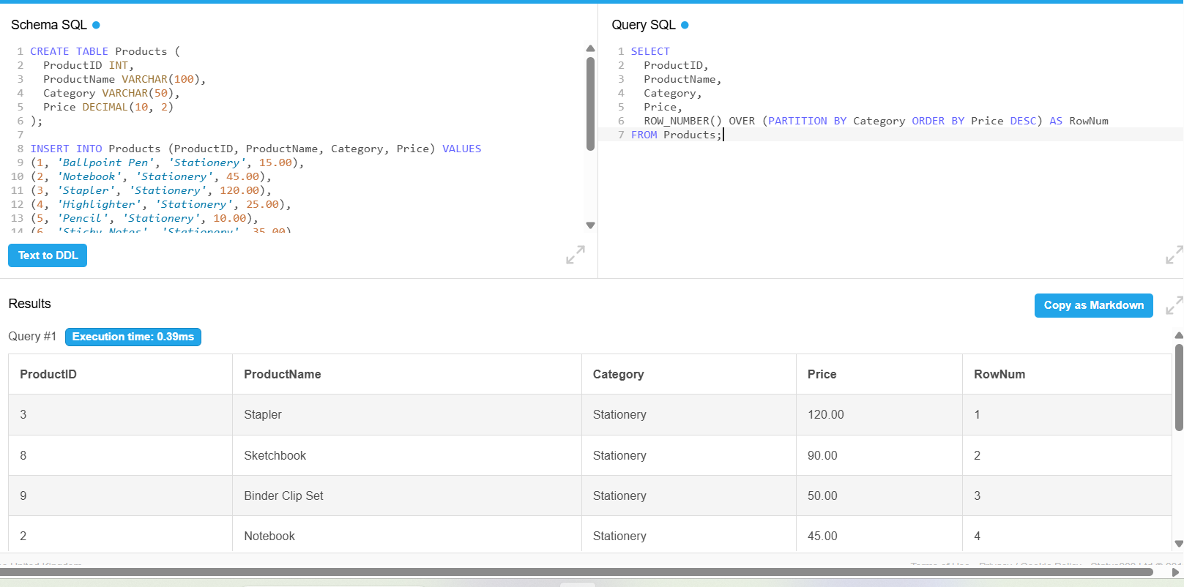

**2. Use RANK() and DENSE_RANK() to compare how ties are handled.**

WITH RankedProducts AS (

SELECT

ProductID,

ProductName,

Category,

Price,

RANK() OVER (PARTITION BY Category ORDER BY Price DESC) AS PriceRank

FROM Products

)

SELECT *

FROM RankedProducts

WHERE PriceRank <= 3;

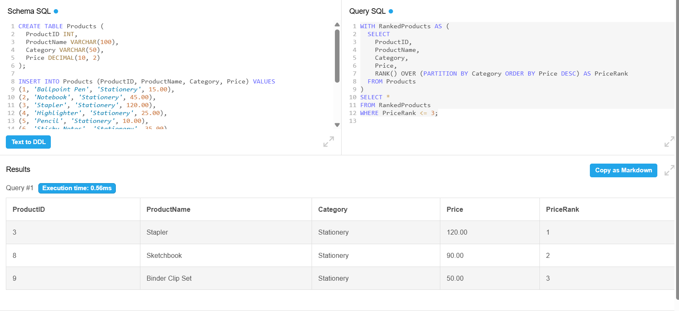

**3. Use PARTITION BY Category and ORDER BY Price DESC**

WITH RankedProducts AS (

SELECT *,

ROW_NUMBER() OVER (PARTITION BY Category ORDER BY Price DESC) AS RowNum

FROM Products

)

SELECT *

FROM RankedProducts

WHERE RowNum <= 3;

