**ER DIAGRAM**

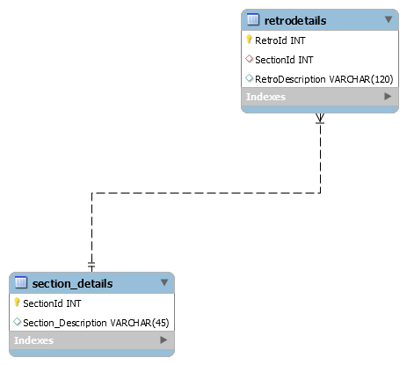

**Structural Diagram**

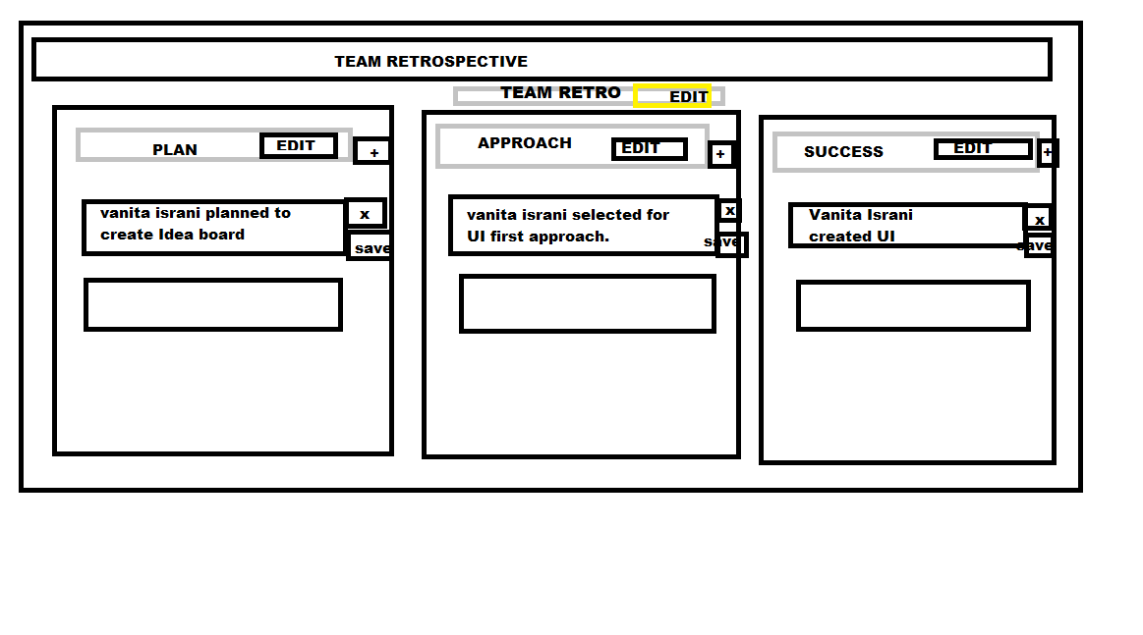

API Creation

TESTED STRUCTURE UI

AND DATABASE

FLOW CHECK

HARD STOP AT 10:30 AM

Service layer

Retro-app-svc.js

Express and mysql installation

Get method

'/retro/retrodescription

/:sectionno'

Post method1

'/retro/newsection'

Post Method 2

‘/retro/newretro’

Tested service using postman

Api Creation

AGILE WORKFLOW

Enhancing UI Structure

Database members creation.

UI interaction

Textfeildtoggle()

Isviewmode()

Creating events.

Binding Functions to UI.

Testing functions

Applications Available.

Team retrospective structure.

Team Retro Structure.

Structure selection:

(UI first Approach)

Selection and creating Component.

Identity Simple and Complex data members.

Section1[],Section2[],

Section3[].description[]

SPRINT 3

6th MAY (6- 10 PM)

SPRINT 2

6th MAY (12- 4 PM )

SPRINT 1

5TH MAY (12- 5PM )

SPRINT 4

7th MAY (7-12 AM)