**Assignment 4 Creating Website page**

**Step 1. Design and structure.**

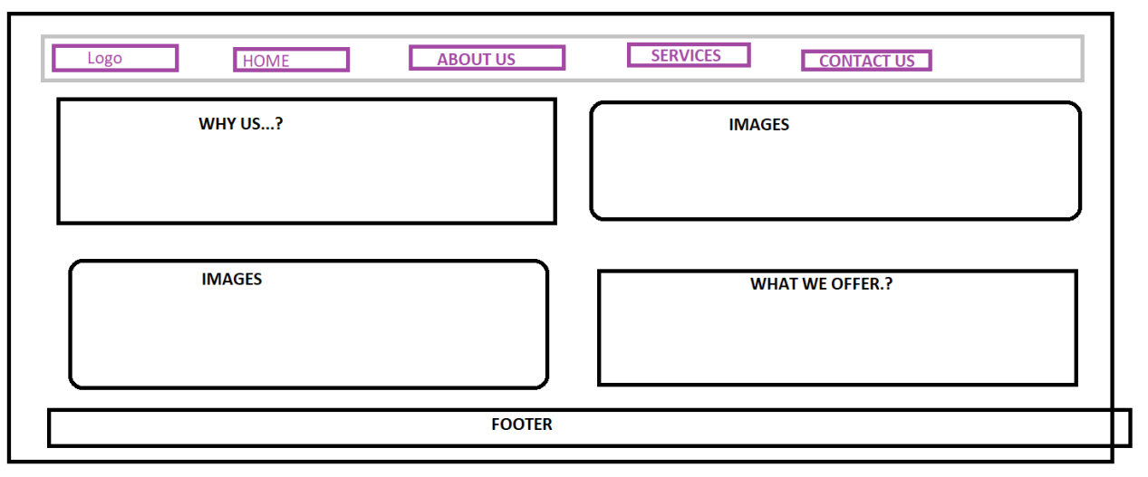

**Step 2. Tags which shall be considered while designing.**

heading h1 - h6  
p  
div  
list -> ol ul dl  
anchor <a>  
img <img>

**Step 3: HTML code**

<!DOCTYPE html>

<html lang="en">

<head>

<meta charset="UTF-8">

<meta http-equiv="X-UA-Compatible" content="IE=edge">

<meta name="viewport" content="width=device-width, initial-scale=1.0">

<link rel="stylesheet" href="style.css">

<title>Document</title>

</head>

<body>

<header>

<div class="main">

<!--<div class="logo">

<img src="image3.jpg" alt="">

</div>-->

<div class="logo">

<img src="Mastek_logo.png">

</div>

<ul>

<li class="active"><a href="#">Home</a></li>

<li><a href="#">About</a></li>

<li><a href="#">Services</a></li>

<li><a href="#">Careers</a></li>

<li><a href="#">Contact Us</a></li>

</ul>

</div>

<div class="title">

<h1><b>MASTEK</b>

<br>

<q>The difference between

What is and What could be...</q>

</h1>

</div>

</header>

</body>

</html>

Step4: Adding CSS.

*{

margin :0;

padding: 0;

}

header

{

background-image: url(imagebg.jpg);

height: 100vh;

background-size: cover;

background-position: center;

}

ul{

float: right;

list-style-type: none;

margin-top: 25px;

}

ul li{

display: inline-block;

}

ul li a{

text-decoration: none;

color: #fff;

padding: 5px 20px;

border: 1px solid #fff transparent;

transition: 0.6s ease;

}

ul li a:hover{

background-color: #fff;

color: black;

}

.logo img

{

float: left;

width: 150px;

height: auto;

}

.main

{

max-width:1200px;

margin:auto;

}

.title

{

position:absolute;

top:50%;

left:70%;

transform: translate(-50%,-50%);

}

.title h1

{

color: #fff;

font-size: 35px;

}

**Step4: Outpu**t

