1.Write a class to calculate the uber price .

var basefee=.44
var cities=["chennai","tiruvallur","tiruvottiyur"]
var uberRates=[5,15,10]
var customerName="Anu"
var customerCity="tiruvottiyur"
console.log("Hello",customerName+",welcome to the Uber Rate Program")
function getRate(customerCity){
function uberRate(customerCity,index){
var finalRate=(uberRates[index])*basefee
return finalRate
}
console.log(customerCity,"rate is:",uberRate(customerCity,cities.indexOf(customerCity)))
}
getRate(customerCity)

output:

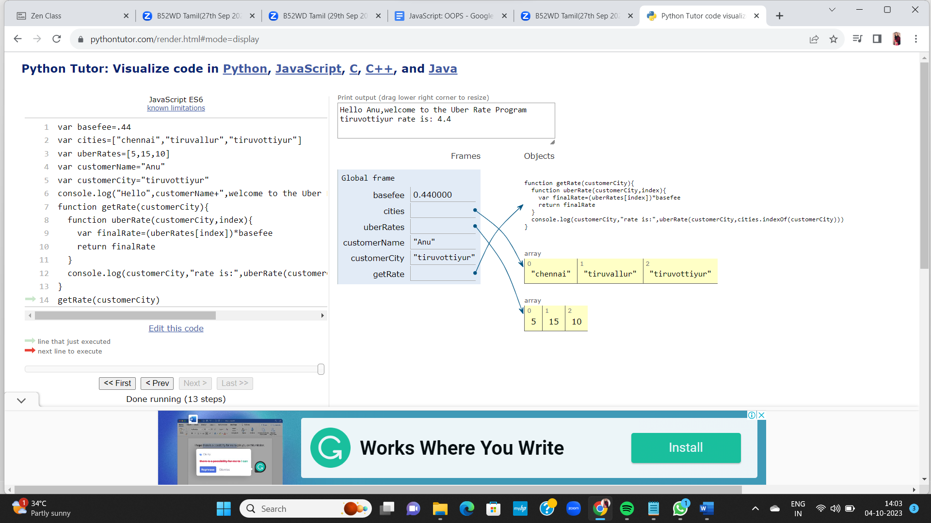

2.Write a person class to hold all the details .

class Person {
constructor(firstName, lastName, age, country, city) {
this.firstName = firstName
this.lastName = lastName
this.age = age
this.country = country
this.city = city
this.score = 0
this.skills = []
}
getFullName() {
const fullName = this.firstName + ' ' + this.lastName
return fullName
}
get getScore() {
return this.score
}
get getSkills() {
return this.skills
}
set setScore(score) {
this.score += score
}
set setSkill(skill) {
this.skills.push(skill)
}
}

const person1 = new Person('Asabeneh', 'Yetayeh', 250, 'Finland', 'Helsinki')
const person2 = new Person('Lidiya', 'Tekle', 28, 'Finland', 'Espoo')

person1.setScore = 1
person1.setSkill = 'HTML'
person1.setSkill = 'CSS'
person1.setSkill = 'JavaScript'

person2.setScore = 1
person2.setSkill = 'Planning'
person2.setSkill = 'Managing'
person2.setSkill = 'Organizing'

console.log(person1.score)
console.log(person2.score)

console.log(person1.skills)
console.log(person2.skills)
output:



