1. DESIGN A WEB SKELITON IN THE Following requirements

1. a left navigation(200PX,COLOR #2381ff),RIGHT NAVIGATION(200PX COLOR #8123AA), CONTENT AREA

HEADER (300PX),FOOTER(100PX),REMAINING CONTENT AREA.

1. ALL THE SECTIONS SHOWN ABOVE ARE TO BE STYLED APPROPIATELY USING CSS

HTML

<!DOCTYPE html>

<html>

<head>

<title>Basic 3 Column Layout</title>

<link rel="stylesheet" href="STY.CSS" type="text/css" />

</head>

<body>

<div id="container">

<div id="header">

<b>This is Header

</b>

</div>

<div>

<nav>

This is Navigation Bar

</nav>

</div>

<div id="sidebar-left">

<h2>Sidebar Left</h2>

<p>this is the side bar-left</p>

</div>

<div id="content">

<h1>Content</h1>

<p>this is the content bar</p>

</div>

<div id="sidebar-right">

<h2>Sidebar Right</h2>

<p>this is the sidebar right </p>

</div>

<div id="footer">

<h3>Footer</h3>

<p>this is the footer </p>

</div>

</div>

</body>

</html>

CSS

body {

text-align: center;

}

#container {

margin: 0 auto;

text-align: left;

width: 960px;

}

#header {

width: 300px;

}

#navigation li {

display: inline;

}

#content {

float: left;

width: 560px;

}

#sidebar-left {

float: left;

width: 200px;

}

#sidebar-right {

float: right;

width: 200px;

}

#footer {

clear: both;

width: 100px;

}

body {

background-color: #eee;

color: white;

border-style:solid;

border-color:black;

}

#container {

background-color:pink;

}

#header {

background-color: aqua;

height: 100%;

width:100%;

text-align:center;

font-size:50px;

}

#content {

background-color: red;

height: 100%;

position:relative;

}

nav{

background-color:pink;

height: 100%;

font-size:30px;

text-align:center;

position:relative;

}

#sidebar-left {

background-color: green;

height:100%;

position:relative;

padding-top:13px;

}

#sidebar-right {

background-color: blue;

height: 100%;

position:relative;

padding-top:13px;

}

#footer {

background-color: purple;

width: 100%;

}

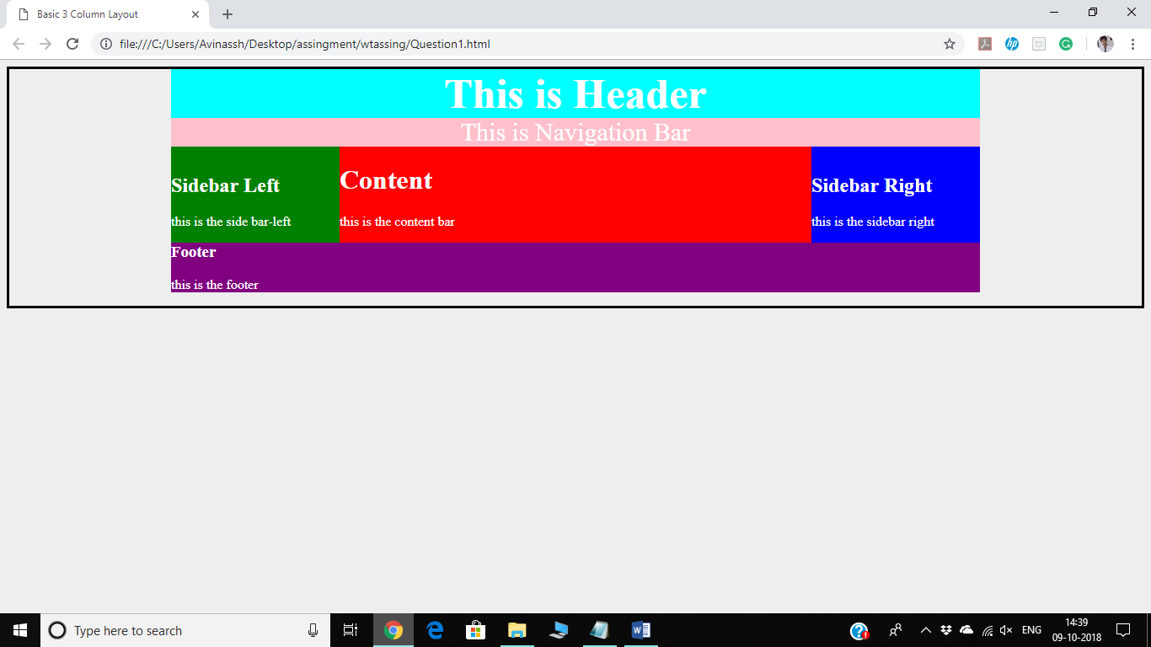

2) DEMOSTRATE THE USE OF CSS POSITIONING ELEMENTS STATIC ABSOLUTE,RELATIVE AND FIXED

<!DOCTYPE html>

<html>

<head>

<style>

div.static {

position:static;

border:3px solid grey;

}

div.fixed{

position:fixed;

bottom:0;

right:0;

width:300px;

border:3px solid red;

}

div.relative {

position: relative;

width: 400px;

height: 200px;

border: 3px solid pink;

}

div.absolute {

position: absolute;

top: 80px;

right: 0;

width: 200px;

height: 100px;

border: 3px solid yellow;

}

div.sticky{

position: -webkit-sticky;

position:sticky;

top:0;

padding:5px;

border: 3px solid green;

</style>

</head>

<body>

<div class="static">normal</div>

<div class="relative">relative</div>

<div class="fixed">fixed</div>

<div class="absolute">absolute</div>

<div class="sticky">sticky</div>

</body>

</html>

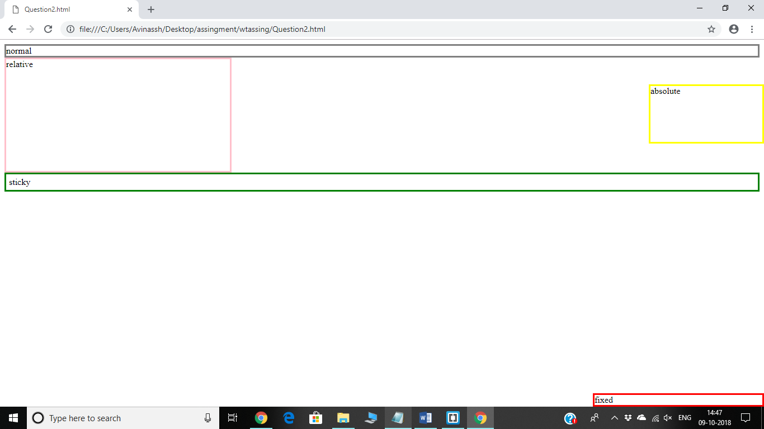

3) CREATE A HTML5 FORM AND VALIDATE THE FORM CONTROLS USING

"pattern" attribute.Form must contain the following elements

a. Email

b. a text field

c. number field

d. range

e. min length,max length

f. alpha-numeric

HTML

<!DOCTYPE html>

<html>

<head>

<style>

body{

text-align:center;

background-color:;

}</style>

</head>

<body>

<header>

<h1>SignUp Form</h1>

</header>

<div style="">

<form method="POST">

<label>Email id</label><br>

<input id="textbox" type="text" name="email" pattern="[a-z0-9._%+-]+@[a-z0-9.-]+\.[a-z]{2,3}$" required><br>

<label>Password</label><br>

<input type="password" name="password" pattern="(?=.*\d)(?=.*[a-z])(?=.*[A-Z]).{8,}" required><br>

<label>Age</label><br>

<input type="number" name="age" pattern="[10-50]{1,2}$" required><br>

<label>Enter text here</label><br>

<input type="text" name="text" required><br>

<label>Number</label><br>

<input type="text" name="number" pattern="[0-9]{10}" required><br>

<label>Range bar</label><br>

<input type="range" min="1" max="100" value="50" pattern="[0-100]"><br>

<label>Password</label><br>

<input type="password" name="password" pattern="[a-z0-9]{8,}" required><br>

<input type="submit" name="submit"><br>

</form>

</div>

</body>

</html>

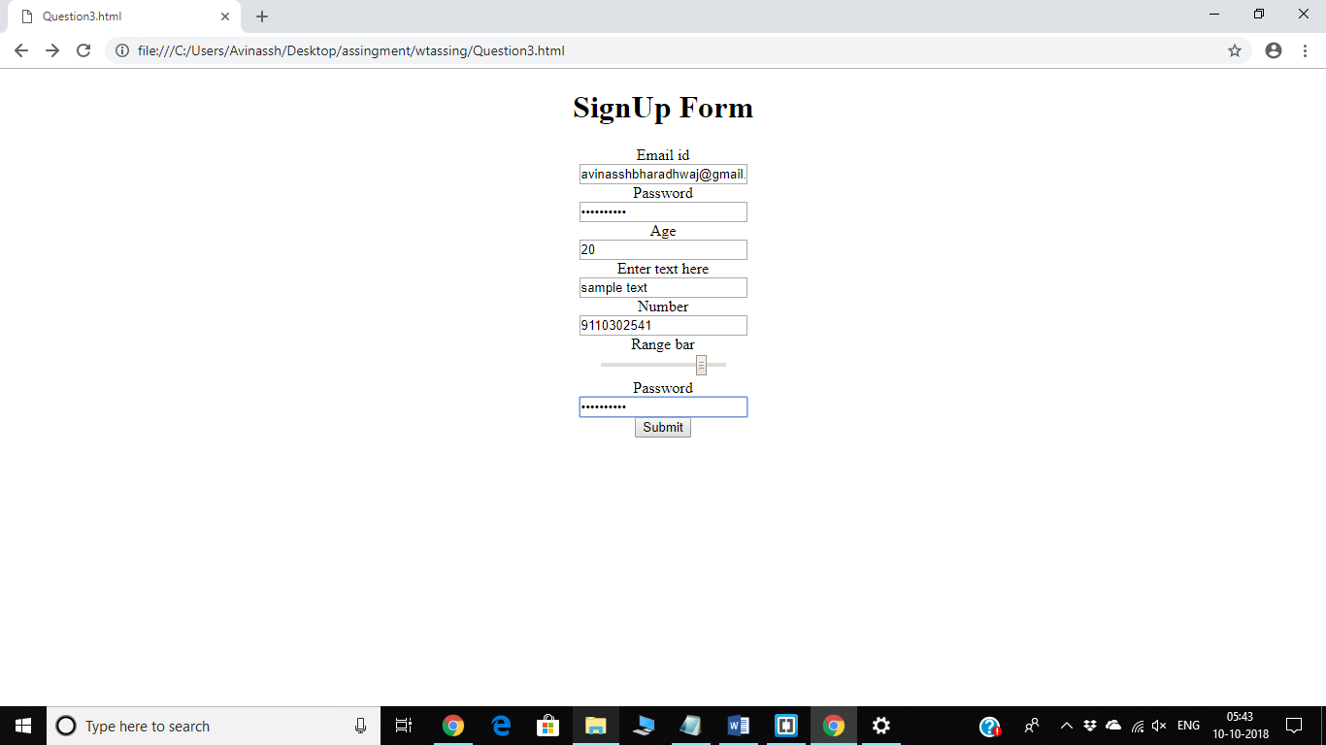

4) Write a DTD for Aadhar registration process and write a well formed and valid XML for the above created DTD.

<?xml version="1.0"?>

<!DOCTYPE AADHAR_REG [

<!ENTITY ISSUER "Government of India">

<!ENTITY COMPANY "UDAAI">

<!ENTITY EMAIL "ADHAARINDIA.com">

<!ELEMENT ISSUER (ACARD+)>

<!ELEMENT ACARD

(NAME+,EMAIL+,NUMBER+,ADDRESS+,BIOMETRIC?)>

<!ELEMENT NAME (#PCDATA)>

<!ELEMENT EMAIL (#PCDATA)>

<!ELEMENT NUMBER (#PCDATA)>

<!ELEMENT ADDRESS (#PCDATA)>

<!ELEMENT BIOMETRIC (#PCDATA)>

]>

<ISSUER>

<ACARD>

<NAME>Avinassh</NAME>

<EMAIL>avinasshbharadhwaj@gmail.com</EMAIL>

<NUMBER>9110302541</NUMBER>

<ADDRESS>10-30232/2/A/9,Venkatadri nagar.</ADDRESS>

</ACARD>

</ISSUER>

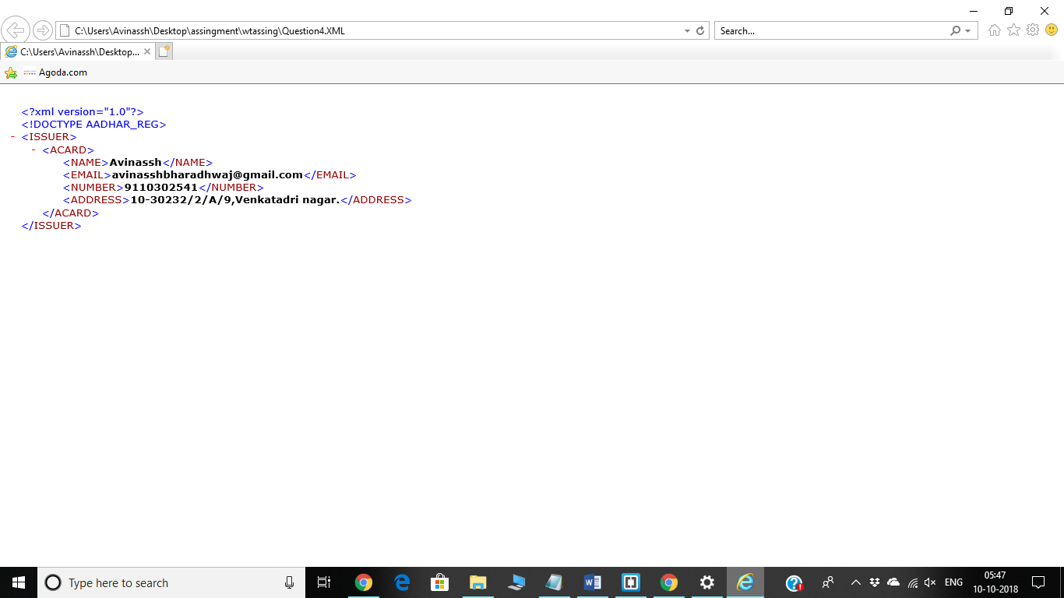

5) Write a XML schema for library management system and write a valid and well formed XML example.

XSD

<?xml version="1.0"?>

<xs:schema>

<xs:element name="Issue">

<xs:complexType>

<xs:sequence>

<xs:element name="to" type="xs:string"/>

<xs:element name="toid" type="xs:integer"/>

<xs:element name="bookid" type="xs:string"/>

<xs:element name="dateissue" type="xs:date"/>

<xs:element name="datereturn" type="xs:date"/>

</xs:sequence>

</xs:complexType>

</xs:element>

</xs:schema>

XML

<?xml version="1.0"?>

<Issue xmlns:xsi="http://www.w3.org/2001/XMLSchema-instance"

xsi:schemaLocation="Libman.xsd">

<to>Student</to>

<toid>160116737086</toid>

<bookid>500017</bookid>

<dateissue>1-10-2018</dateissue>

<datereturn>15-10-2018</datereturn>

</Issue>

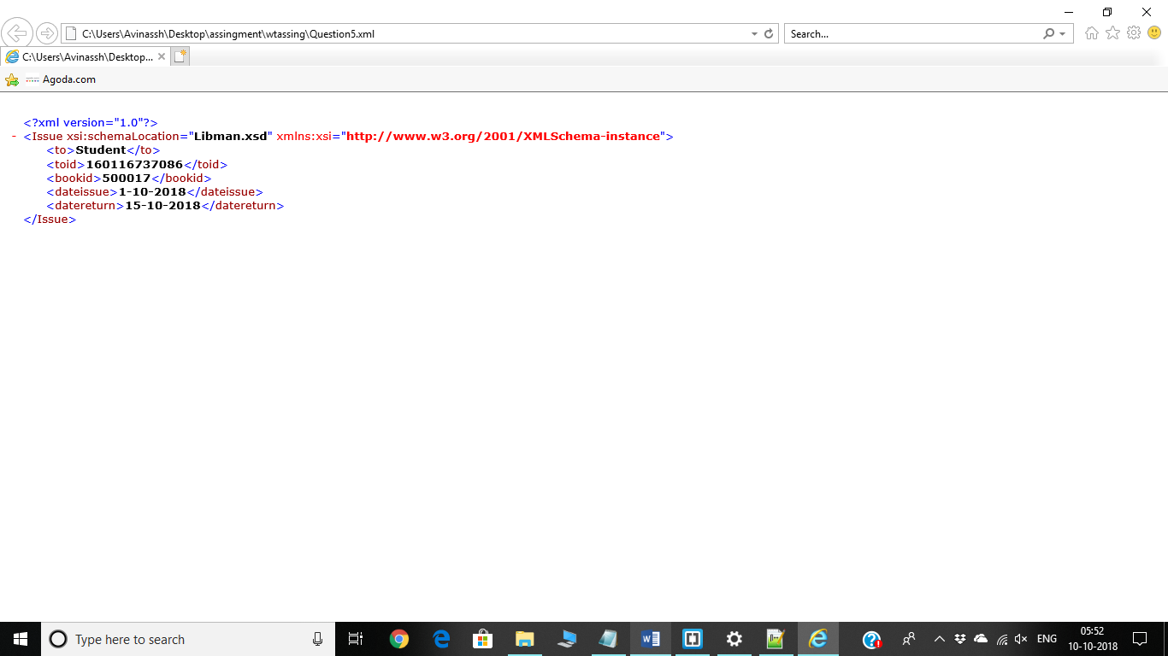

8.Write a simple servlet program that displays HelloWorld message

import java.io.*;

import javax.servlet.*;

import javax.servlet.http.*;

public class NewServlet extends HttpServlet

{

public void doGet(HttpServletRequest request,HttpServletResponse response) throws ServletException,IOException

{

response.setContentType("text/html");

PrintWriter pw = response.getWriter();

pw.println("<html>");

pw.println("<head><title>Hello World</title></title>");

pw.println("<body>");

pw.println("<h1>Hello World</h1>");

pw.println("</body></html>");

}

}

9.Write a jsp program to print the first name and last name of user from a html form

NewServlet1.java

import java.io.*;

import javax.servlet.*;

import javax.servlet.http.*;

// Extend HttpServlet class

public class NewServlet1 extends HttpServlet {

public void doGet(HttpServletRequest request, HttpServletResponse response)

throws ServletException, IOException {

// Set response content type

response.setContentType("text/html");

PrintWriter out = response.getWriter();

String title = "Using GET Method to Read Form Data";

String docType =

"<!doctype html public \"-//w3c//dtd html 4.0 " + "transitional//en\">\n";

out.println(docType +

"<html>\n" +

"<head><title>" + title + "</title></head>\n" +

"<body bgcolor = \"#f0f0f0\">\n" +

"<h1 align = \"center\">" + title + "</h1>\n" +

"<ul>\n" +

" <li><b>First Name</b>: "

+ request.getParameter("first_name") + "\n" +

" <li><b>Last Name</b>: "

+ request.getParameter("last_name") + "\n" +

"</ul>\n" +

"</body>" +

"</html>"

);

}

}

Index.html

<html>

<body>

<form action = "NewServlet1" method = "GET">

First Name: <input type = "text" name = "first_name">

<br />

Last Name: <input type = "text" name = "last_name" />

<input type = "submit" value = "Submit" />

</form>

</body>

</html>

10.Write a Servlet program on Reading of checkbox data.

import java.io.*;

import javax.servlet.*;

import javax.servlet.http.*;

// Extend HttpServlet class

public class NewServlet3 extends HttpServlet {

// Method to handle GET method request.

public void doGet(HttpServletRequest request, HttpServletResponse response)

throws ServletException, IOException {

// Set response content type

response.setContentType("text/html");

PrintWriter out = response.getWriter();

String title = "Reading Checkbox Data";

String docType =

"<!doctype html public \"-//w3c//dtd html 4.0 " + "transitional//en\">\n";

out.println(docType +

"<html>\n" +

"<head><title>" + title + "</title></head>\n" +

"<body bgcolor = \"#f0f0f0\">\n" +

"<h1 align = \"center\">" + title + "</h1>\n" +

"<ul>\n" +

" <li><b>Maths Flag : </b>: "

+ request.getParameter("maths") + "\n" +

" <li><b>Physics Flag: </b>: "

+ request.getParameter("physics") + "\n" +

" <li><b>Chemistry Flag: </b>: "

+ request.getParameter("chemistry") + "\n" +

"</ul>\n" +

"</body>"

"</html>"

);

}

// Method to handle POST method request.

public void doPost(HttpServletRequest request, HttpServletResponse response)

throws ServletException, IOException {

doGet(request, response);

}

}

Checkbox.html

<html>

<body>

<form action = "NewServlet3" method = "POST" target = "_blank">

<input type = "checkbox" name = "maths" checked = "checked" /> Maths

<input type = "checkbox" name = "physics" /> Physics

<input type = "checkbox" name = "chemistry" checked = "checked" />

Chemistry

<input type = "submit" value = "Select Subject" />

</form>

</body>

</html>

11.Write a Program for implementing GenericServlet

import java.io.*;

import javax.servlet.*;

public class Generic extends GenericServlet{

public void service(ServletRequest req,ServletResponse res)

throws IOException,ServletException{

res.setContentType("text/html");

PrintWriter out=res.getWriter();

out.print("<html><body>");

out.print("<b>hello generic servlet</b>");

out.print("</body></html>");

}

}

12.Write A Jsp program to display today’s date

<%@page contentType="text/html" pageEncoding="UTF-8"%>

<!DOCTYPE html>

<html>

<head>

<meta http-equiv="Content-Type" content="text/html; charset=UTF-8">

<title>JSP Page</title>

</head>

<body>

<h1>Hello World!</h1>

<p>Today's date: <%= (new java.util.Date())%></p>

</body>

</html>

7. Wap to insert values into a table in database using prepared statement

import java.sql.*;

public class Insert {

    public static void main(String args[])

    {

        try{

            Class.forName("com.mysql.jdbc.Driver");

            Connection con=DriverManager.getConnection("jdbc:mysql://localhost:3306/webtech1","root","");

            Statement st=con.createStatement();

            PreparedStatement stmt=con.prepareStatement("insert into emp values(?,?,?)");

            stmt.setInt(1,086);

            stmt.setString(2,"Avinassh");

            stmt.setInt(3,16);

            stmt.executeUpdate();

            con.close();

        }

        catch(Exception e)

        {

            System.out.println(e);

        }

    }

}

13**) A program on standard actions using JSP**

package action;

public class NewClass {

private String message = "No message specified";

public String getMessage() {

return(message);

}

public void setMessage(String message) {

this.message = message;

}

}

Actions.jsp

<html>

<head>

<title>Using JavaBeans in JSP</title>

</head>

<body>

<center>

<h2>Using JavaBeans in JSP</h2>

<jsp:useBean id = "test" class = "action.NewClass" />

<jsp:setProperty name = "test" property = "message"

value = "Hello JSP..." />

<p>Got message....</p>

<jsp:getProperty name = "test" property = "message" />

</center>

</body>

</html>

14. **Program to print welcome msg using scriptlets**

<html>

<body>

<% out.print("welcome to jsp"); %>

</body>

</html>

15. **A JSP program to display name**

Name.html

<html>

<body>

<form action="newjsp3.jsp">

<input type="text" name="uname">

<input type="submit" value="go"><br/>

</form>

</body>

</html>

newjsp3.jsp

<html>

<body>

<%

String name=request.getParameter("uname");

out.print("welcome "+name);

%>

</form>

</body>

</html>

16. **JSP program to perform arithmetic operations**

newjsp7.jsp

<%@ page language="java"%>

<%@ page import="java.lang.*"%>

<html>

<body>

<H1><center>Result for <%=request.getParameter("a1")%></center></H1>

<%

int i=Integer.parseInt(request.getParameter("t1"));

int j=Integer.parseInt(request.getParameter("t2"));

int k=0;

String str=request.getParameter("a1");

if(str.equals("add"))

k=i+j;

if(str.equals("mul"))

k=i*j;

if(str.equals("div"))

k=i/j;

%>

Result is <%=k%>

</body>

</html>

Arithematic.html

<html>

<title>Sample Example </title>

<body>

<h1> <center> Example of JSP </center> </h1>

<b> Mathematics</b>

<hr>

<form method="post" action="newjsp7.jsp">

<font size=5 face="Times New Roman">

<input type="radio" name="a1" value="add" checked>Addition</input><br>

<input type="radio" name="a1" value="mul" >Multiplication</input><br>

<input type="radio" name="a1" value="div" >Division</input><br>

</font>

<br><br>

Enter first Value &nbsp &nbsp &nbsp<input type="text" name="t1" value=""><br>

Enter second Value &nbsp<input type="text" name="t2" value=""><br>

<input type="submit" name="result">

</form>

</body>

</html>

6.WAP to retrive data from a table in database

**import** java.sql.*;

**class** MysqlCon{

**public** **static** **void** main(String args[]){

**try**{

Class.forName("com.mysql.jdbc.Driver");

Connection con=DriverManager.getConnection(  "jdbc:mysql://localhost:3306/sonoo","root","root");

Statement stmt=con.createStatement();

ResultSet rs=stmt.executeQuery("select * from emp");

**while**(rs.next())

System.out.println(rs.getInt(1)+"  "+rs.getString(2)+"  "+rs.getString(3));

con.close();

}**catch**(Exception e){ System.out.println(e);}

}