**Burger Point**

‘’Satisfy your appetite from burger point’’

# Description

A burger point is a food app that specially provides burgers like zinger burger , grill burger etc. This app can be used by an active person who are able to see mobile screen and click on that. This app is live on smartphone.

# App Functions

The user will be able to:

1. Show different burger along with cold drink.
2. Search for burger for your own choice.
3. Display list of selected items.
4. Add an food item with different Payment method.

# Target user groups

The target user groups for Burger Point are:

* Young adults
* Professional workers
* Burger lovers
* Middle class families

## Sample user profile/persona

Sadia ,27 years old

* Lives in Islamabad
* Belongs to a noble family
* Works as software engineer in Techno Soft company
* Likes to cook food
* Likes playing badminton ,gardening

## Client/designer goals

* Provide burger to customer with their own choice
* Increase profit and revenue
* Provide new Menu items
* Provide fully intuitive interface to users

## Related apps/products

### Howdy

Howdy provides high quality burgers in Pakistan . At Howdy ,you will find a combination of excellent burgers, sandwiches and a lot more items. The purpose is not only to serve great food but also make it a delightful experience for the guests.

### Burger O’ Clock

Burger O’ Clock is a modern restaurant that exists to delight passionate burger lovers. These burgers are made of high-quality meats and handmade sauces. These sauces have a secret recipe made from rich spices and herbs. This fast-food chain has a variety of chicken and beef burgers.

### KFC

KFC is a fast-food franchise that cooks food native from south. It provides different family deals . KFC is famous in all over the world. it provides zinger burger, grill burger and crunch burger etc. KFC is always trying to make it easier for our guest to enjoy our chicken.

## Prototype Summary

In the clickable prototype, users will be prompted to complete the following functions:

1. Search for burger for your own choice.
2. Add an food item with different payment method.

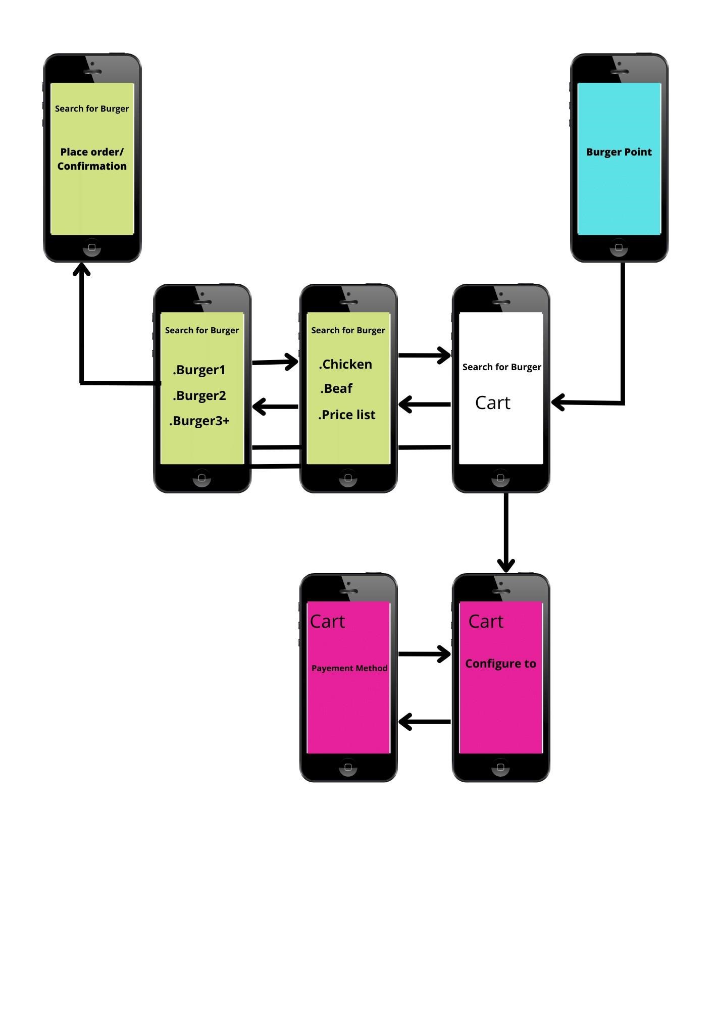

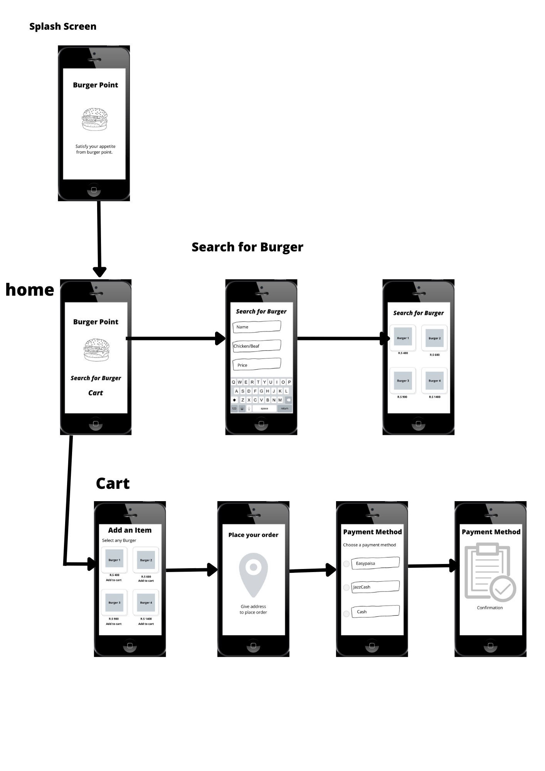

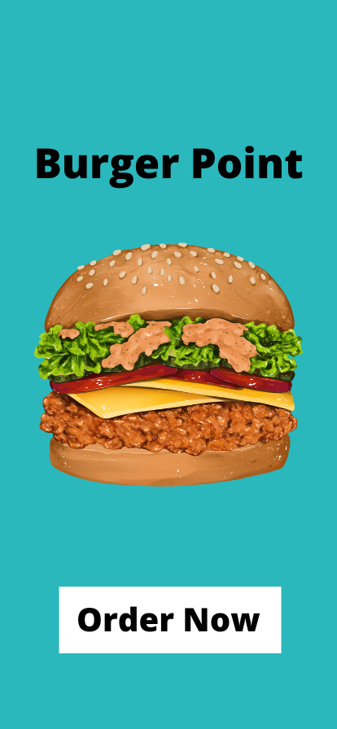

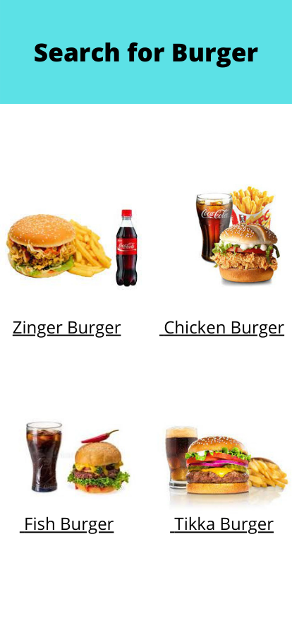

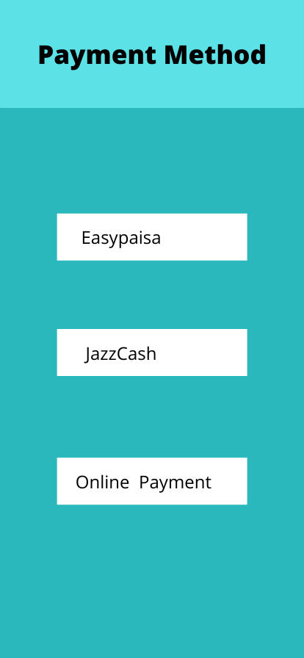 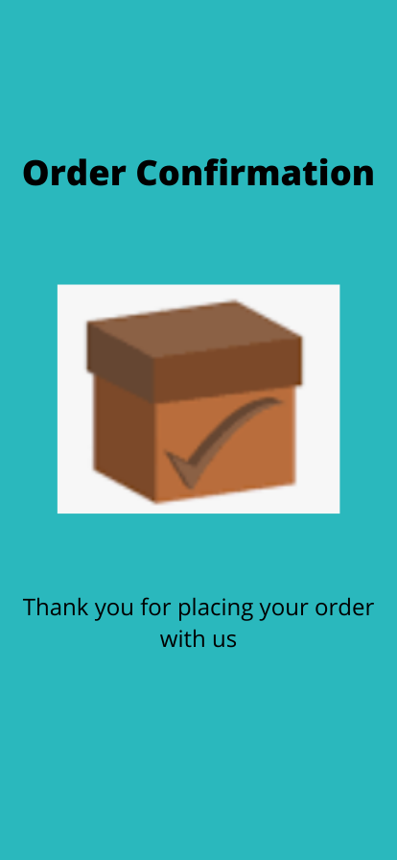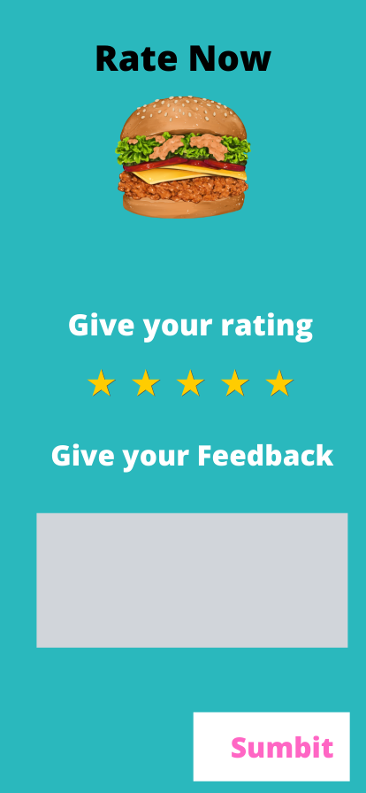

Summary of Functions:

In the clickable prototype, users will be prompted to complete the following

functions:

1. Search for burger for your own choice.
2. Add an food item with different Payment method.

Link to Prototype:

https://www.canva.com/design/DAE9zHtphnE/tuZNguzSlJ_AOptKtfHvQA/edit?utm_content=DAE9zHtphnE&utm_campaign=designshare&utm_medium=link2&utm_source=sharebutton