ASSIGNMENT-14.1
HT NO:2303A51706
Batch No:28
Course:AI Assisted Coding
Task 1 : Portfolio Website Design
You are building a personal portfolio website to showcase your work.
Requirements:
- Create sections for About Me, Projects, and Contact.
- Use AI to:
- Suggest color palettes and typography.
- Create a responsive layout with Grid/Flexbox.
- Add smooth scrolling navigation.
Prompt:
Generate a complete single-file HTML code for a personal portfolio website that I can run in VS Code.
Requirements:
- Sections: About Me, Projects, Contact
- Use CSS Flexbox or Grid for layout
- Suggest a modern color palette and typography
- Add a navigation bar with smooth scrolling between sections
- Keep HTML, CSS, and JavaScript in the same file
- The code should be clean and easy for beginners
Code:

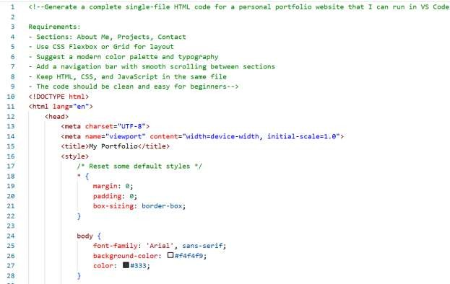
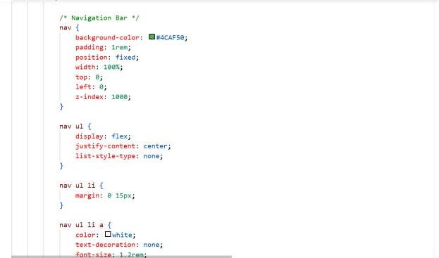

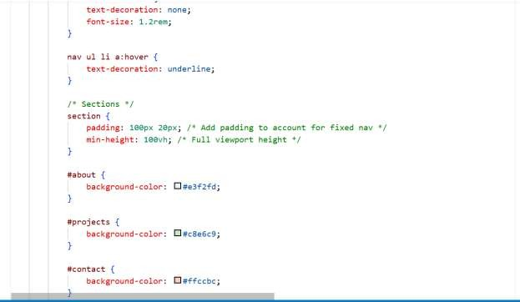
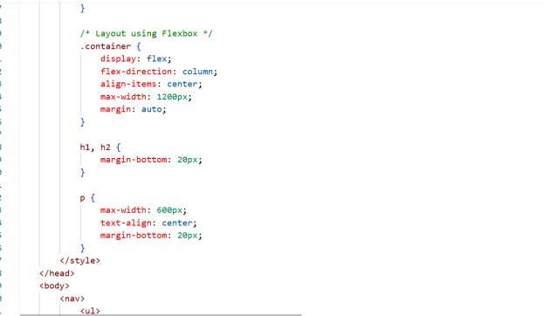

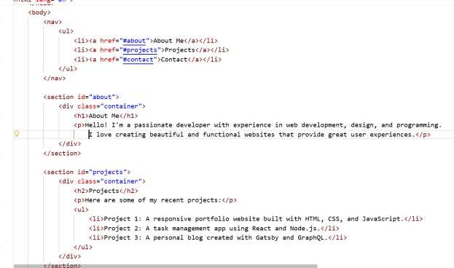
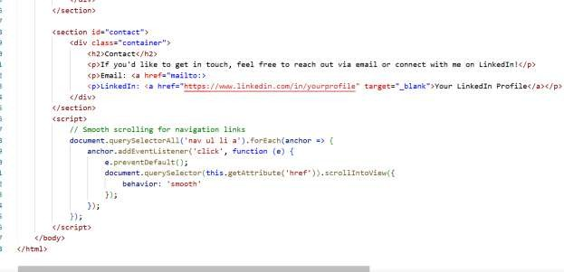
Output:

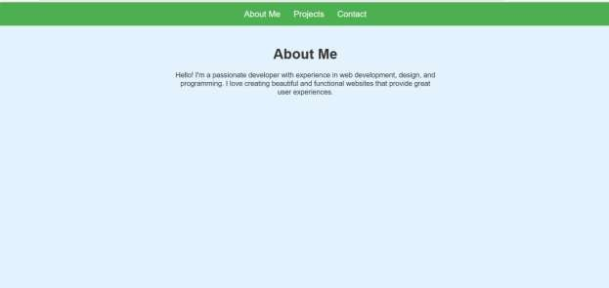
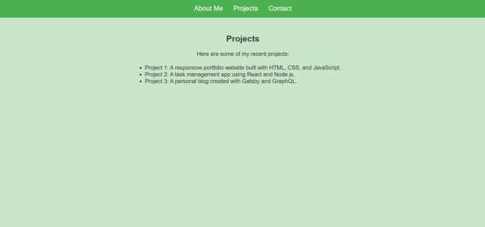

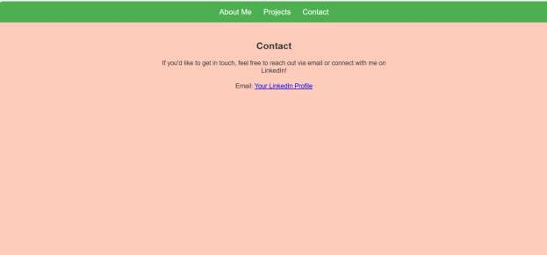
Justification:

- The portfolio website helps showcase personal skills, projects, and contact details in a structured way.
- Separate sections like About, Projects, and Contact improve organization and readability.
- Using Flexbox or Grid creates a responsive layout that adapts to different screen sizes.
- A consistent color palette and typography improve visual appeal and professionalism.
- Smooth scrolling navigation enhances user experience.
- Overall, the design makes the portfolio easy to navigate and visually attractive.

Task 2 :Online Store Product Page
Design a product display page for an online store. Requirements:
  - Display product image, title, price, and "Add to Cart" button.
  - Use AI to:
- Style with BEM methodology.

- Make layout responsive.
- Add hover effects and "Add to Cart" alert.
Prompt:
Generate a single HTML file for a responsive online store product page that can run in VS Code. Requirements:
- Display product image, title, price, and an "Add to Cart" button
- Use BEM naming methodology in CSS classes
- Add hover effects on the product card and button
- When the "Add to Cart" button is clicked, show a JavaScript alert
- Include HTML, CSS, and JavaScript in the same file
Code:
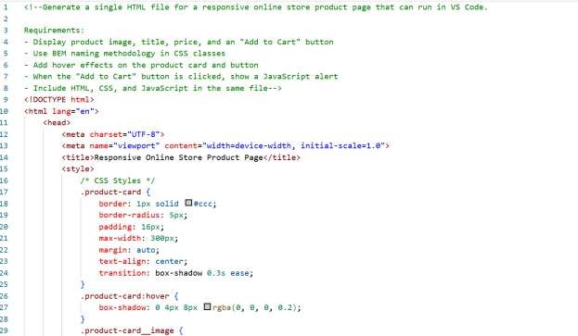

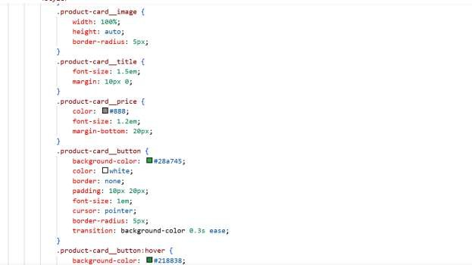
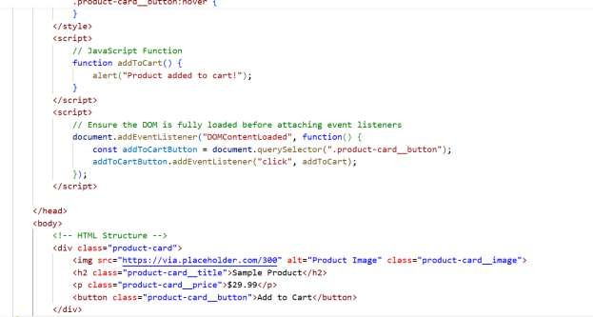

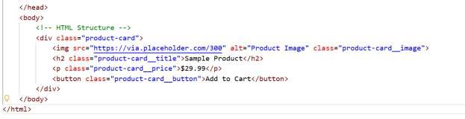

Output:


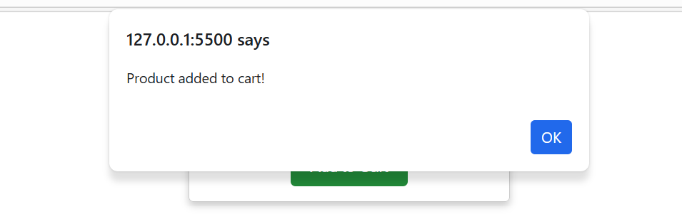

Justification:

- The product page displays essential product information such as image, title, and price.
- The "Add to Cart" button allows basic interaction for users.
- Using BEM methodology improves CSS structure and maintainability.
- Responsive design ensures the page works on both mobile and desktop devices.
- Hover effects provide visual feedback when users interact with elements.
- The alert message confirms that the product has been added to the cart.

Task 3 :Event Registration Form
Build an event registration form for a conference. Requirements:
  - Collect name, email, phone number, and session selection.
  - Use AI to:
- Add form validation with JavaScript.
- Make the form accessible with labels and ARIA.
- Style with a professional look
Prompt:
Generate a single HTML file for an event registration form that I can run in VS Code. Requirements:
- Fields: Name, Email, Phone Number, Session Selection
- Add JavaScript form validation
- Use labels for accessibility and simple ARIA attributes
- Style the form with a professional design
- Include HTML, CSS, and JavaScript in one file
Code:

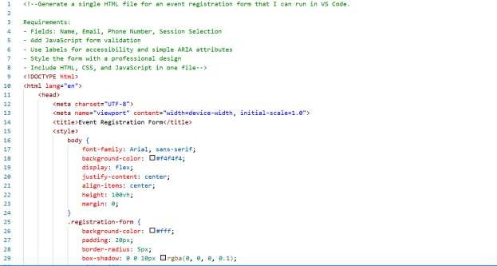
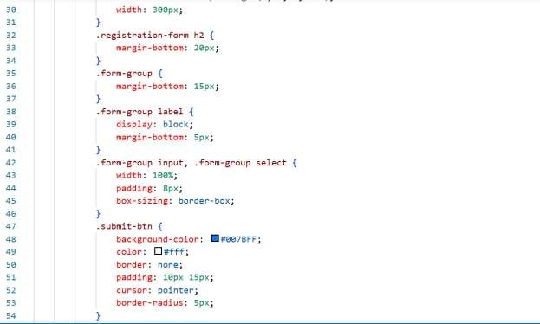

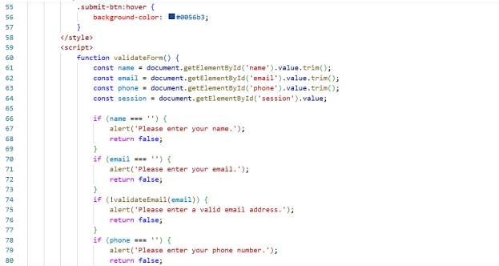
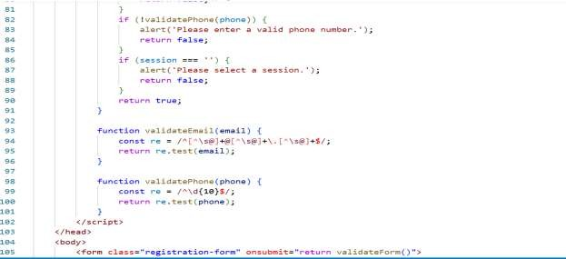

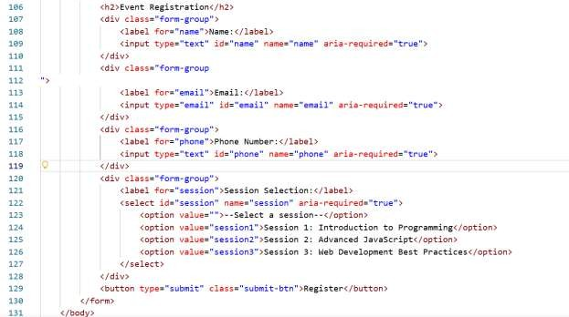
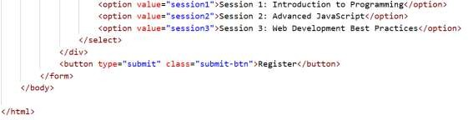

Output:

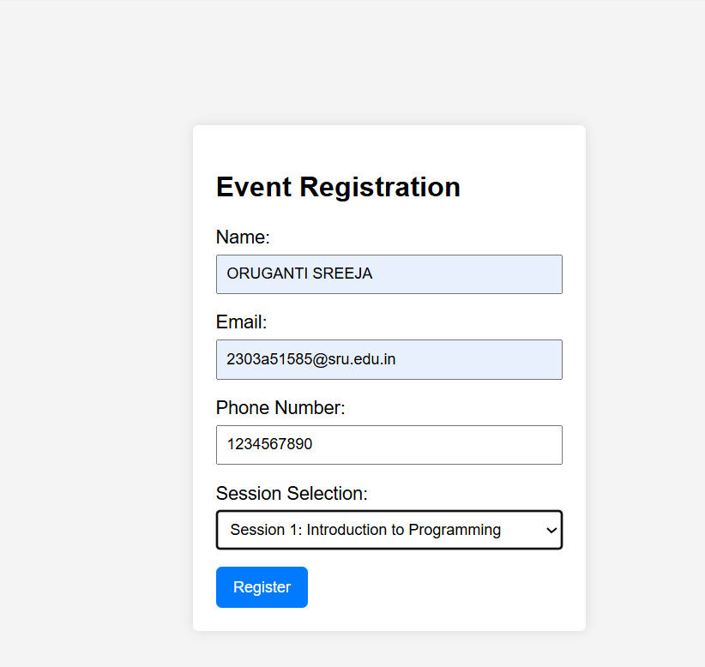
Justification:

- The registration form collects important participant details for an event.
- Fields like name, email, phone number, and session help organize attendee information.
- JavaScript validation ensures that users enter correct and required data.
- Using labels and ARIA attributes improves accessibility for all users.
- A clean and professional design makes the form easy to use.
- This improves both usability and data accuracy.

Task 4 : Resume Website

Build a one-page online resume. Requirements:
  - Sections: Profile Summary, Skills, Education, Experience.
  - Use AI to:
- Propose professional typography styles.
- Align sections using CSS Grid.
- Add smooth scroll navigation between sections.
Prompt:
Generate a single HTML file for a one-page resume website that can run in VS Code. Requirements:
- Sections: Profile Summary, Skills, Education, Experience
- Use professional typography
- Align sections using CSS Grid
- Add a navigation menu with smooth scrolling
- Include HTML, CSS, and JavaScript in the same file
Code:

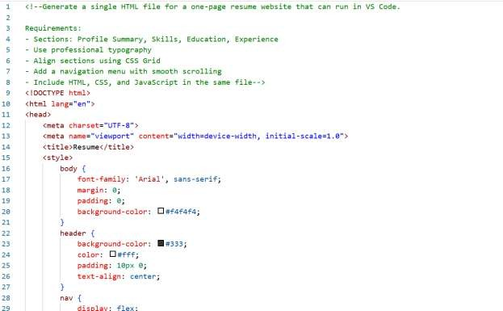
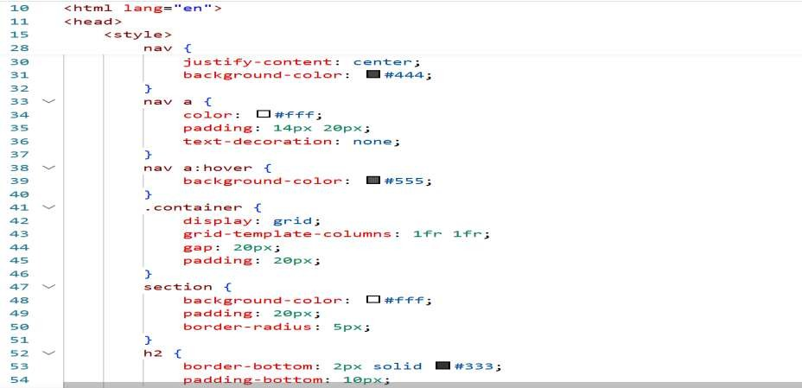

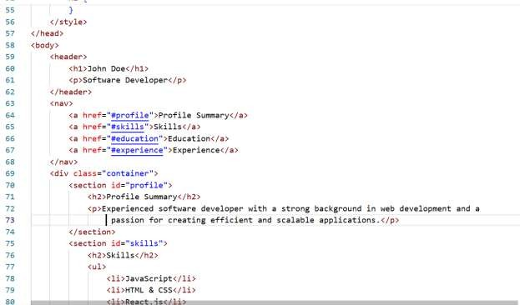
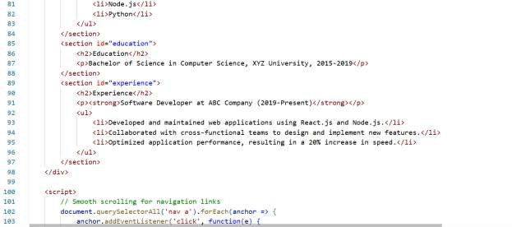

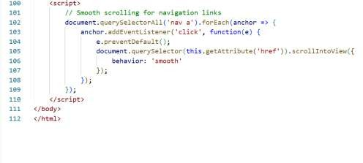
Output:
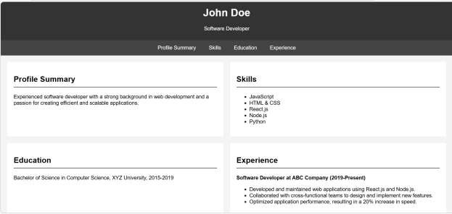
Justification:

- The one-page resume website presents professional information in a structured format.
- Sections like Profile, Skills, Education, and Experience help organize content clearly.
- Professional typography improves readability and presentation.
- CSS Grid helps align sections neatly across the page.
- Smooth scrolling navigation allows users to quickly move between sections.
- This format creates a modern and accessible online resume.

Task 5 : Restaurant Menu Page
Design a digital menu page for a restaurant. Requirements:
  - Display menu items with name, description, and price.
  - Use AI to:
- Suggest a food-friendly color palette.
- Design a responsive card-based layout.
- Add hover effects on menu items.
Prompt:
Generate a single HTML file for a restaurant digital menu page that I can run in VS Code. Requirements:
- Show menu items with name, description, and price
- Use a food-friendly color palette
- Design a responsive card-based layout
- Add hover effects to menu cards
- Include HTML and CSS in the same file
Code:

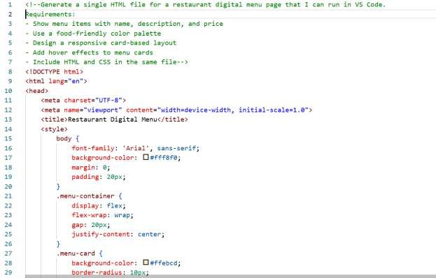
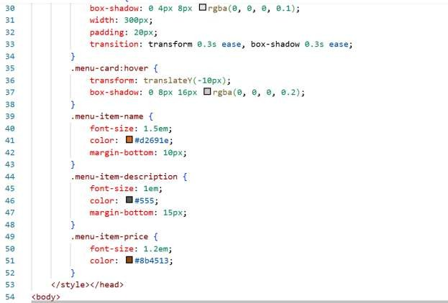

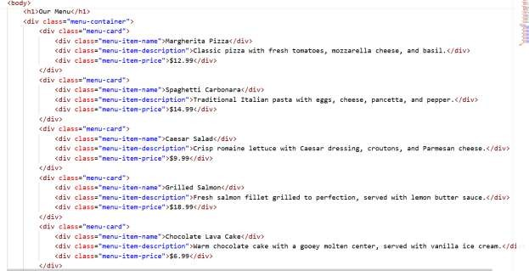
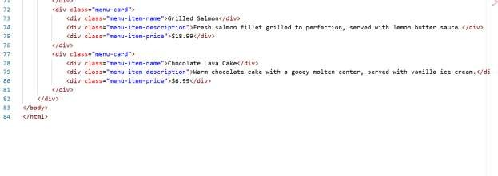
Output:
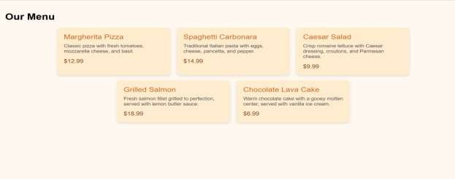

Justification:

- The digital menu page allows restaurants to present menu items online.
- Each item includes name, description, and price for clear information.
- A food-friendly color palette enhances the visual appeal of the page.
- Card-based layout organizes menu items neatly and improves readability.
- Hover effects provide interactive feedback for users.
- Responsive design ensures the menu works well on phones, tablets, and desktops

