ASSIGNMENT-11.1
HT NO:2303A51706
Batch No:28
Course :AI Assisted Coding
Task Description 1:Stack Implementation
Task: Use AI to generate a Stack class with push, pop, peek, and is_empty methods.
Sample Input Code:
class Stack:
pass
Prompt:
Improve the Stack implementation by adding meaningful comments and explaining the time complexity of each method.
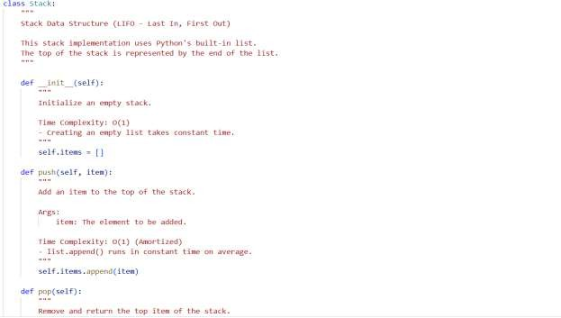
Python code:

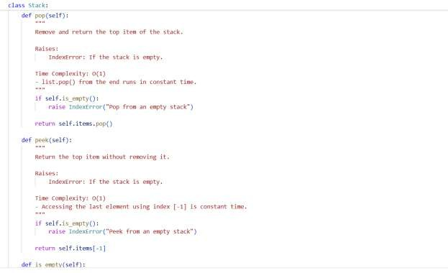
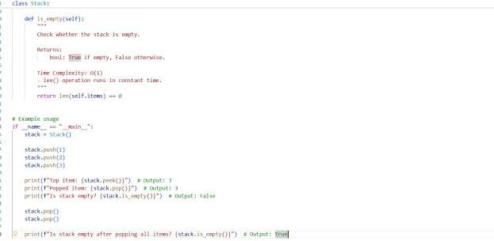
Output:
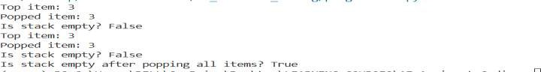

Justification:
- A Stack follows the LIFO principle — the last element added is removed first.
- push() adds an element to the top of the stack.
- pop() removes and returns the top element.
- peek() returns the top element without removing it. 5.is_empty() checks whether the stack contains any elements.

Task Description 2: Queue Implementation
Task: Use AI to implement a Queue using Python lists. Sample Input Code:
class Queue:
pass
Prompt:

Suggest a more efficient alternative to list-based queue implementation and explain why it is better.
Python Code:

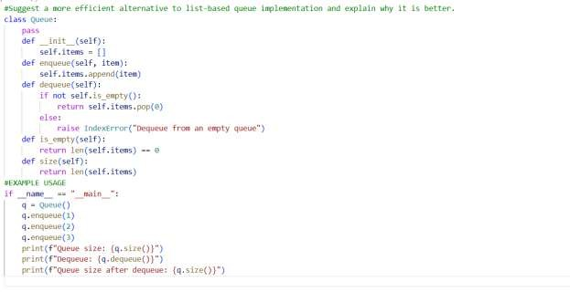

Output:
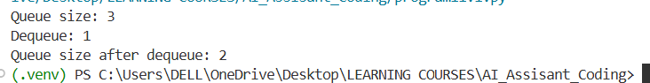

Justification:
- Queue follows FIFO order — first inserted element is removed first. 2.enqueue() adds elements to the rear of the queue.
- dequeue() removes elements from the front.
- peek() returns the front element without removing it.
- size() returns the total number of elements in the queue.
Task Description 3 : Linked List
Task: Use AI to generate a Singly Linked List with insert and display methods.
Sample Input Code:

class Node:
pass
Prompt:
Improve the linked list implementation by adding method-level docstrings and explaining time complexity.
Python Code:
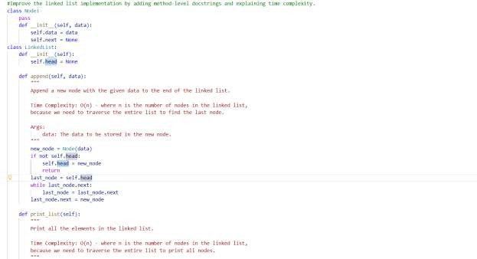
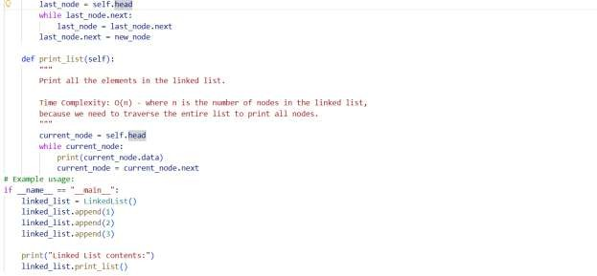

Output:
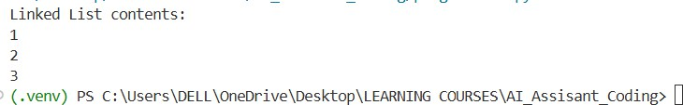

Justification:
1.A singly linked list consists of nodes connected using pointers.
- Each node contains data and a reference to the next node.
- insert() adds a new node (typically at the end). 4.display() traverses the list from head to end.
5.Dynamic memory allocation allows flexible size management.
Task Description 4 : Binary Search Tree (BST)
Task: Use AI to create a BST with insert and in-order traversal methods. Sample Input Code:
class BST:
pass
Prompt:
Create a Binary Search Tree class in Python with recursive insert() and inorder() traversal methods.
Ensure proper object-oriented structure and add docstrings.
Python Code :

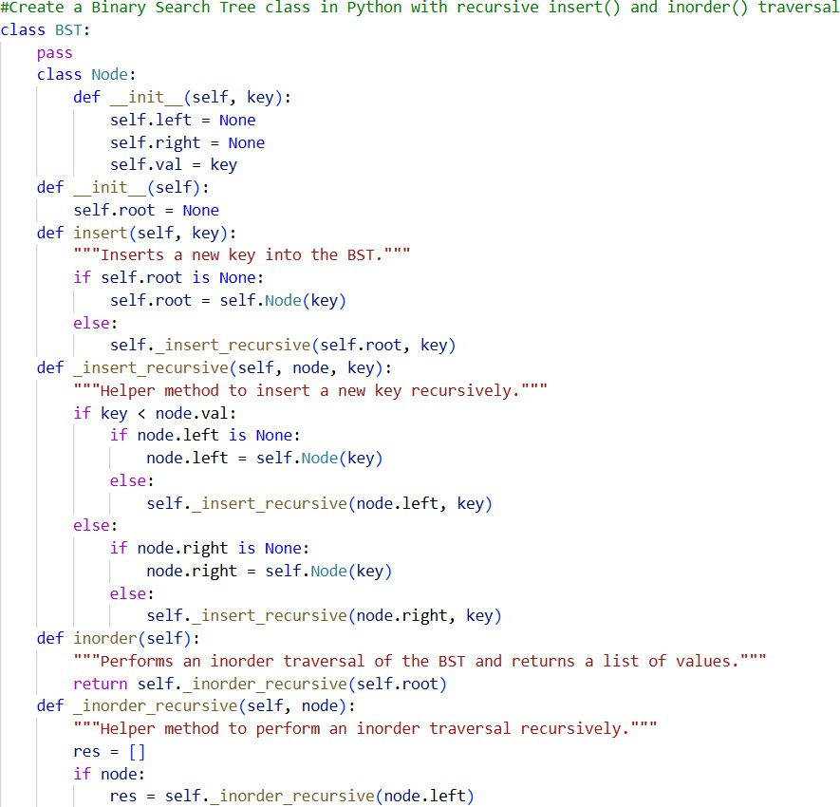

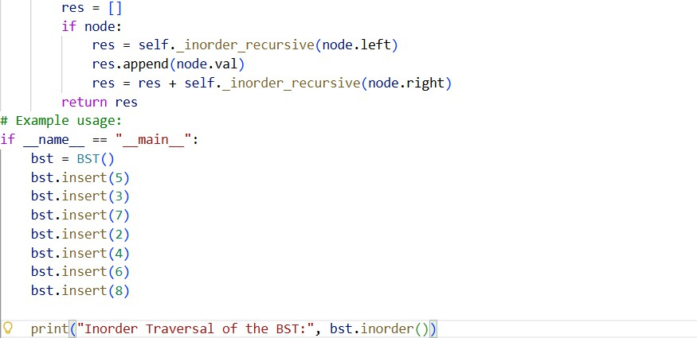

Output:

Justification:
- BST is a hierarchical data structure with left and right children.
- Left subtree contains values smaller than the root.
- Right subtree contains values greater than the root. 4.Recursive insert() maintains BST property.
5.In-order traversal prints elements in sorted order.

Task Description 5 : Hash Table
Task: Use AI to implement a hash table with basic insert, search, and delete methods.
Sample Input Code:

class HashTable:
pass
Prompt:
Implement a Hash Table in Python using chaining for collision handling. Include methods insert(), search(), and delete().
Use a simple hash function and explain collision handling clearly in comments.
Python Code :
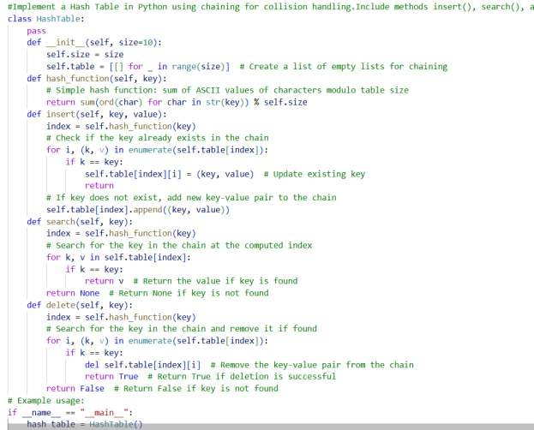

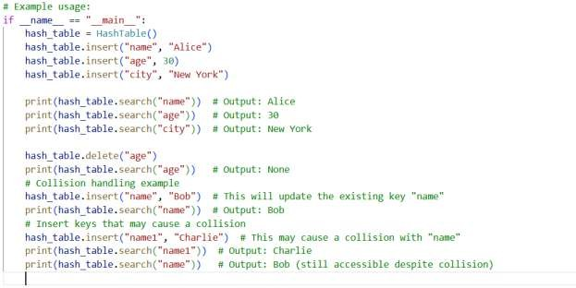

Output:
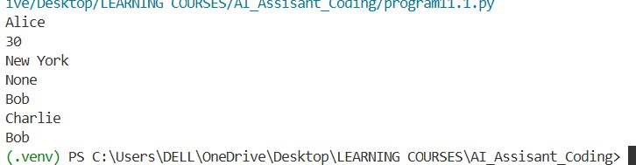

Justification:
- Hash table stores data using key-value pairs.
- A hash function converts keys into index positions.
- Chaining handles collisions using lists at each index.
- search() retrieves values quickly using keys.
- delete() removes key-value pairs efficiently.
Task Description 6 : Graph Representation

Task: Use AI to implement a graph using an adjacency list. Sample Input Code:
class Graph:
pass

Prompt:
Implement a Graph using an adjacency list in Python.
Include methods: add_vertex(), add_edge(), and display(). Add clear comments explaining how adjacency lists work.
Python Code :
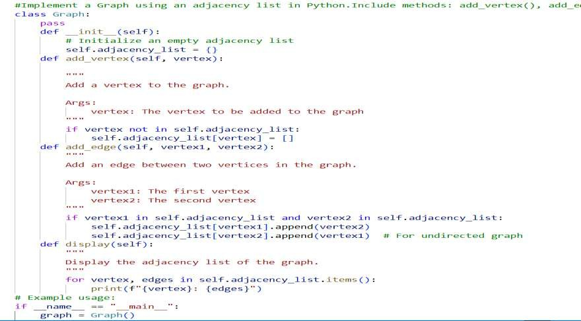

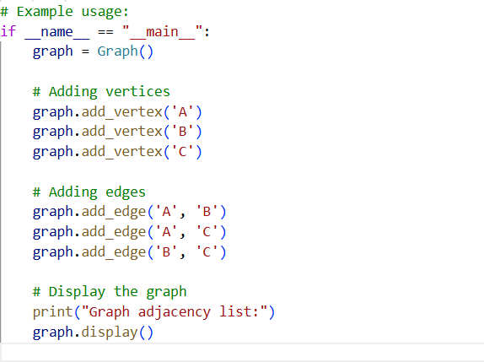

Output:
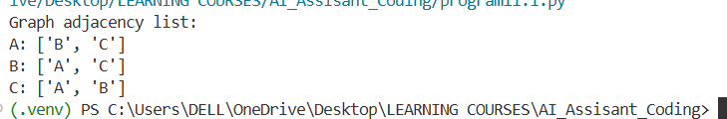

Justification:
- Graph consists of vertices (nodes) and edges (connections). 2.Adjacency list stores neighbors of each vertex.
- add_vertex() creates a new node in the graph.
- add_edge() connects two vertices.

- Efficient for representing sparse graphs.
Task Description 7 : Priority Queue
Task: Use AI to implement a priority queue using Python’s heapq
module
Sample Input Code:
class PriorityQueue:
pass
Prompt:
Implement a Priority Queue in Python using the heapq module.
Include methods enqueue(priority, item), dequeue(), and display(). Add documentation explaining how a min-heap works.
Python Code :
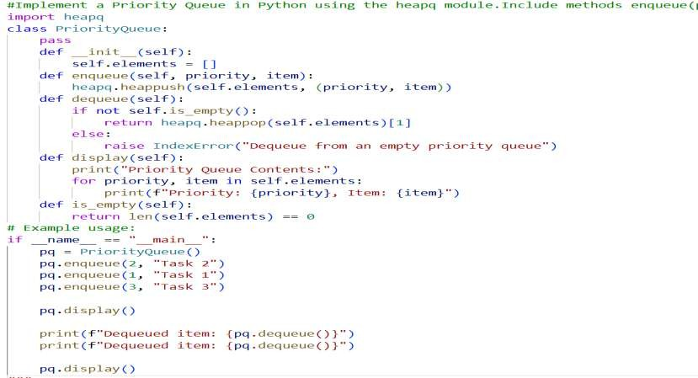

Output:
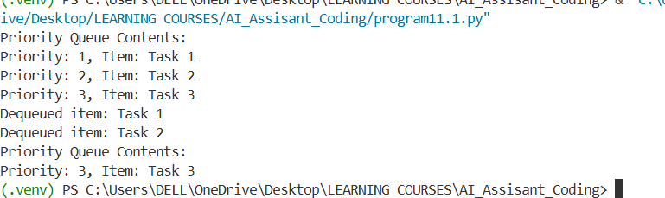

Justification:
- Priority Queue removes elements based on priority, not order.
- Lower (or higher) priority value determines removal order. 3.enqueue() inserts element with priority.
- dequeue() removes highest-priority element.
- Heap structure ensures efficient insertion and deletion.
Task Description 8 : Deque
Task: Use AI to implement a double-ended queue using collections.deque.
Sample Input Code:
class DequeDS:
pass
Prompt:
Implement a double-ended queue using collections.deque in Python. Include methods to insert and remove elements from both ends.
Add proper docstrings.
Python Code :

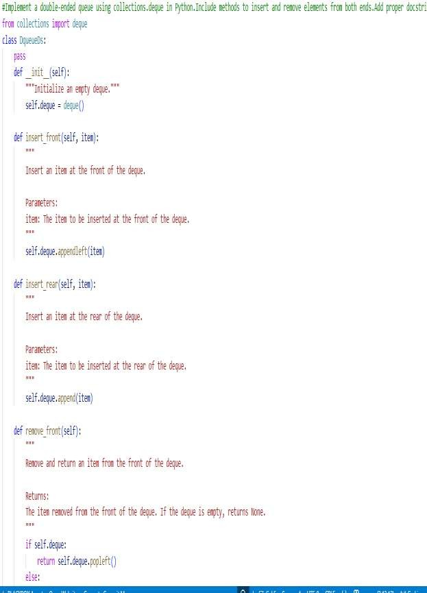

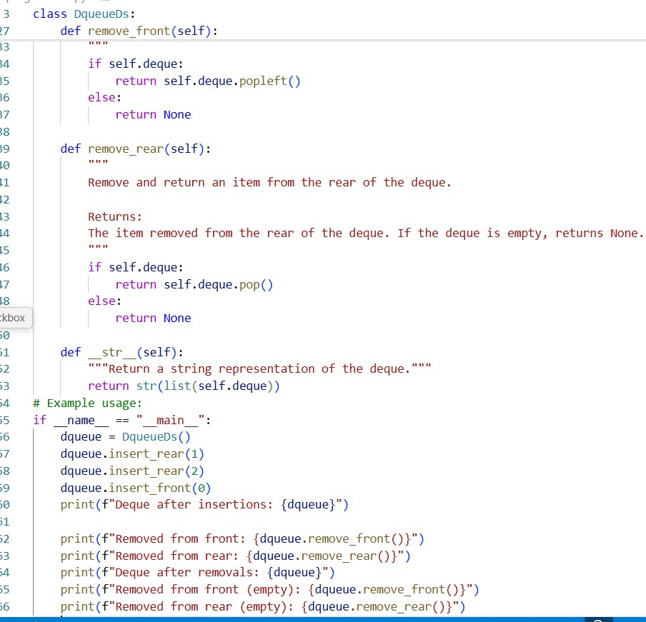
Output:
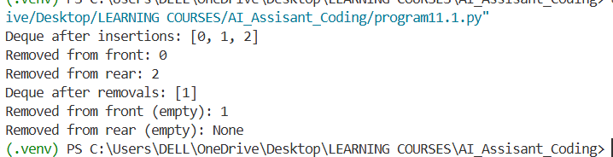

Justification:
- Deque allows insertion and deletion at both front and rear.
- Combines features of stack and queue. 3.Efficient O(1) operations at both ends.
- Useful for sliding window problems.
- Flexible data structure for bidirectional processing.
Task Description 9: Real-Time Application Challenge – Choose the Right Data Structure
Scenario:
Your college wants to develop a Campus Resource Management System that handles:
- Student Attendance Tracking – Daily log of students entering/exiting the campus.
- Event Registration System – Manage participants in events with quick search and removal.
- Library Book Borrowing – Keep track of available books and their due dates.
- Bus Scheduling System – Maintain bus routes and stop connections.
- Cafeteria Order Queue – Serve students in the order they arrive.
Prompt:
Generate a complete Python program for a Campus Resource Management System feature using an appropriate data structure.
Choose ONE of the following features and implement it fully:

- Student Attendance Tracking
- Event Registration System
- Library Book Borrowing
- Bus Scheduling System
- Cafeteria Order Queue Requirements:
  - Select the most suitable data structure (Stack, Queue, Priority Queue, Linked List, BST, Graph, Hash Table, or Deque).
  - Implement a class-based solution.
  - Include methods required for real-world functionality (add, remove, search, display, etc.).
  - Add proper docstrings and comments.
  - Include example usage at the bottom.
  - Code should be clean, beginner-friendly, and well-structured.
Python Code :
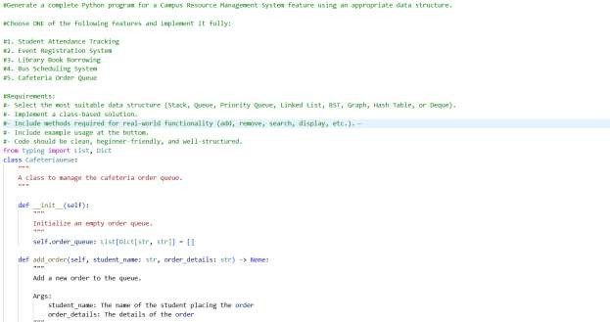

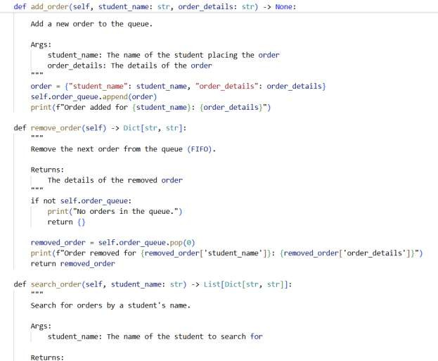

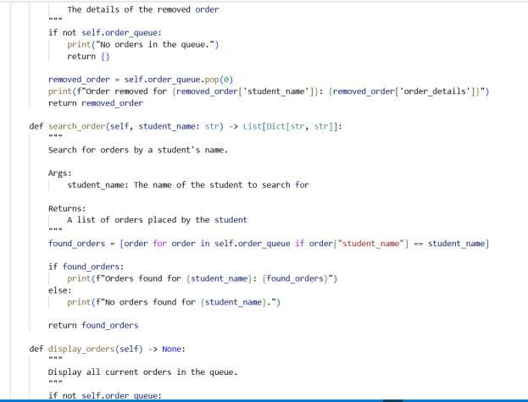

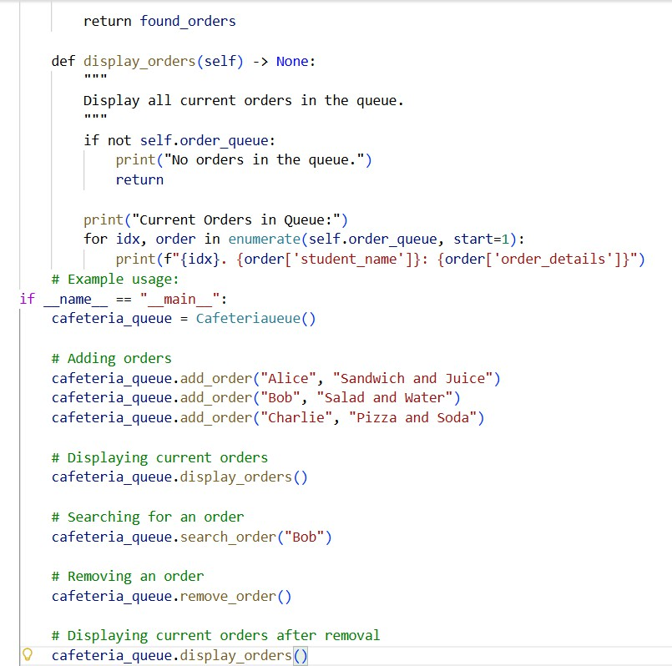

Output:

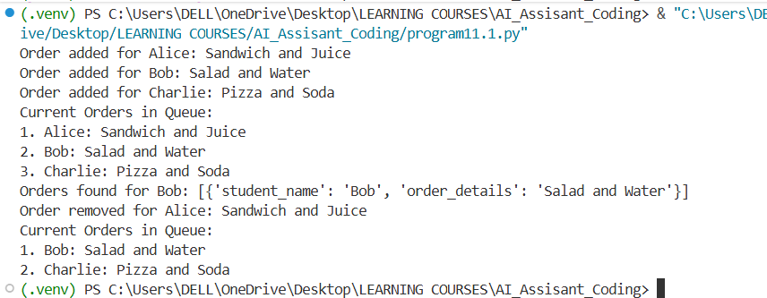

Justification:

Feature | Chosen Data Structure | Justification
Student Attendance Tracking | Deque | Students may enter and exit from multiple points. A deque allows insertion and removal from both ends efficiently.
Event Registration System | Hash Table | Quick lookup, insertion, and deletion of participants by ID is essential, which hash tables provide in O(1) average time.
Library Book Borrowing | Binary Search Tree (BST) | BST allows ordered storage of books, fast search by book ID, and easy tracking of due dates through in-order traversal.
Bus Scheduling System | Graph | Routes and stops are naturally modeled as vertices and edges, enabling path finding and route management.
Cafeteria Order Queue | Queue | Orders must be served in the order they arrive; a queue ensures FIFO behavior perfectly.

Task Description 10: Smart E-Commerce Platform – Data Structure Challenge An e-commerce company wants to build a Smart Online Shopping System with:
- Shopping Cart Management – Add and remove products dynamically.
- Order Processing System – Orders processed in the order they are placed.

- Top-Selling Products Tracker – Products ranked by sales count.
- Product Search Engine – Fast lookup of products using product ID.
- Delivery Route Planning – Connect warehouses and delivery locations.
Student Task:
  - For each feature, select the most appropriate data structure from
the list below:
- Stack
- Queue
- Priority Queue
- Linked List
- Binary Search Tree (BST)
- Graph
- Hash Table
- Deque
  - Justify your choice in 2–3 sentences per feature.
  - Implement one selected feature as a working Python program with
AI-assisted code generation.
Prompt:
Generate a Python program for one feature of a Smart Online Shopping System. Features to choose from:
- Shopping Cart Management
- Order Processing System
- Top-Selling Products Tracker

- Product Search Engine
- Delivery Route Planning Requirements:
  - Choose the most appropriate data structure (Stack, Queue, Priority Queue, Linked List, BST, Graph, Hash Table, or Deque)
  - Implement a class-based solution with relevant methods (add, remove, search, display, etc.)
  - Include proper docstrings and comments
  - Provide example usage at the end
  - Ensure the code is clean, efficient, and beginner-friendly
Python Code :
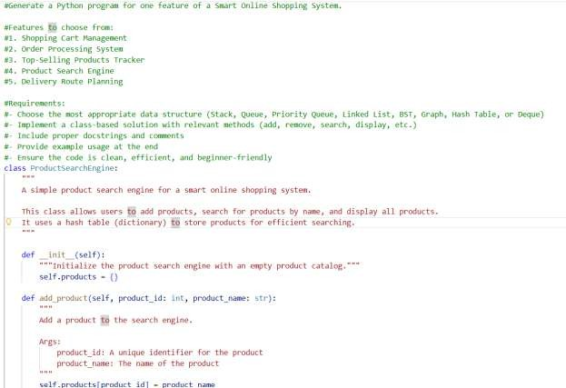

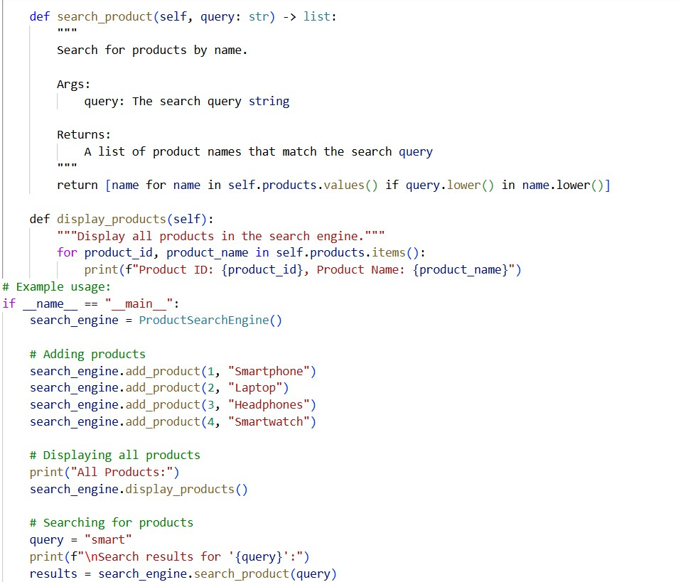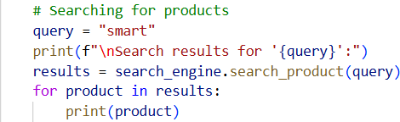

Output:

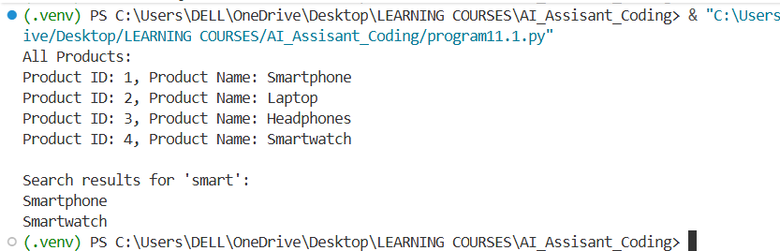

Justification:

Feature | Chosen Data Structure | Justification
Shopping Cart Management | Linked List | Users can dynamically add/remove items; linked lists allow flexible insertion and deletion without shifting elements.
Order Processing System | Queue | Orders are fulfilled in the sequence they are placed, making a FIFO queue the natural choice.
Top-Selling Products Tracker | Priority Queue | Products need to be ranked by sales count; a priority queue allows efficient retrieval of top-selling items.
Product Search Engine | Hash Table | Fast lookup of products by ID is critical; hash tables provide O(1) average search time.
Delivery Route Planning | Graph | Warehouses and delivery locations are nodes; roads/routes are edges. Graphs allow route optimization and pathfinding.

