Assignment-1
HT No :2303A51706
Batch No:28
Task1: AI-Generated Logic Without Modularization (Fibonacci Sequence Without Functions)
Prompt: Write a Python program to print Fibonacci sequence up to n terms without using functionsWrite a Python program to print Fibonacci sequence up to n terms without using functions
Code:
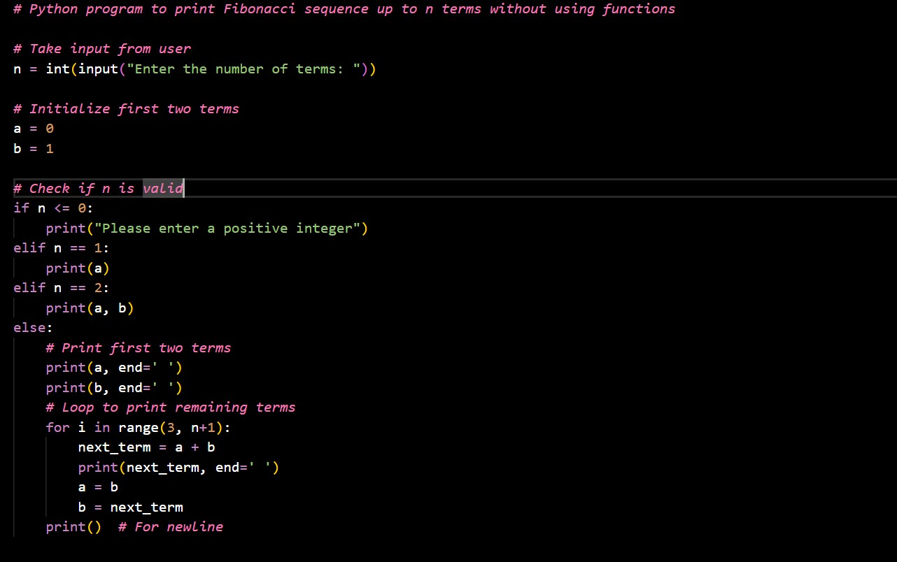
Output:

Justification

- Uses direct logic to clearly demonstrate Fibonacci sequence generation.

- Avoids functions to keep the code simple and easy to understand.
- Suitable for quick testing and learning basic looping concepts.

- Helps beginners focus on algorithm flow without modular complexity.

- Ensures minimal overhead for a small, single-use program.

- Ideal for rapid prototyping scenarios.

Task2 : AI Code Optimization & Cleanup (Improving Efficiency)

Prompt: Optimize the Fibonacci code Simplify variable usage Make it more readable

Code:
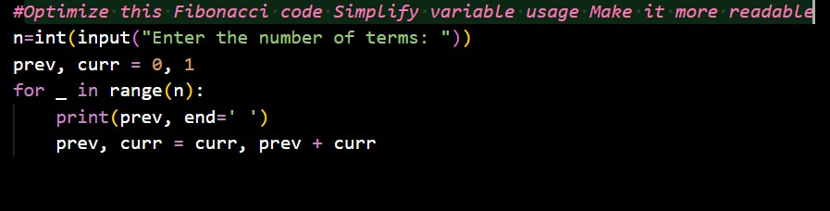
Output:
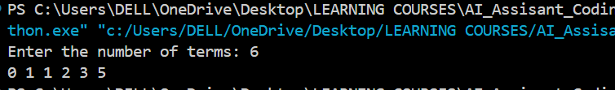
Justification:

- Eliminates unnecessary variables to reduce memory usage.

- Simplifies loop logic for better readability and maintainability.

- Produces the same output with cleaner and shorter code.

- Improves performance by avoiding redundant computations.

- Makes the code easier to review and modify.

- Demonstrates AI-assisted code refinement.

Task3: Modular Design Using AI Assistance (Fibonacci Using Functions) Prompt: Create a Python function to generate Fibonacci sequence up to n terms with comments
Code:
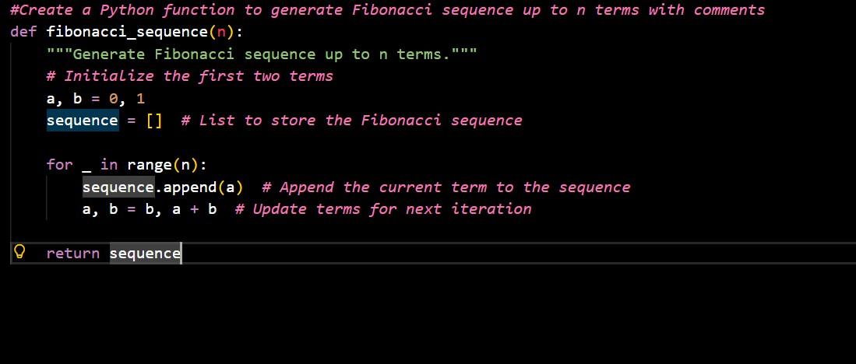
Output:
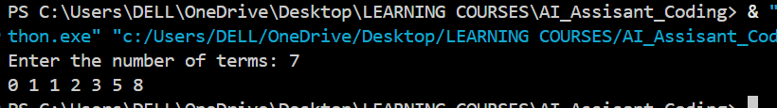

Justification:

- Encapsulates logic inside a function for reuse.

- Improves code organization and readability.

- Simplifies debugging by isolating Fibonacci logic.

- Allows the function to be used in multiple modules.

- Enhances maintainability for future changes.

- Aligns with best practices in software development.

Task4: Comparative Analysis – Procedural vs Modular Fibonacci Code

Prompt: Generate two Python programs for the Fibonacci sequence, one written procedurally without using any user-defined functions and the other using a user-defined function. After generating the code, review and compare both implementations by explaining the differences in code readability, reusability, ease of debugging, scalability, and suitability for large applications.

Code:
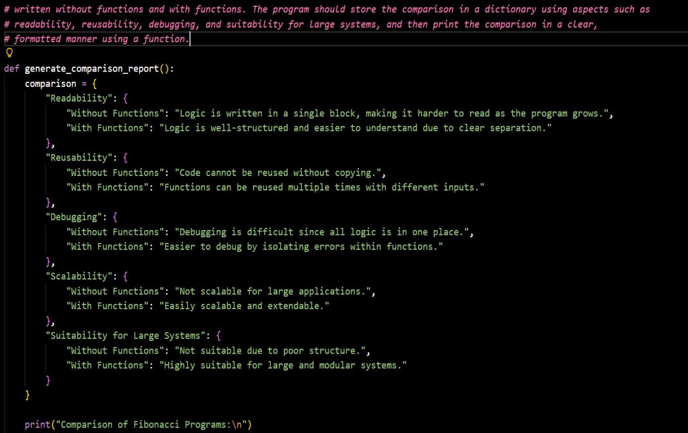

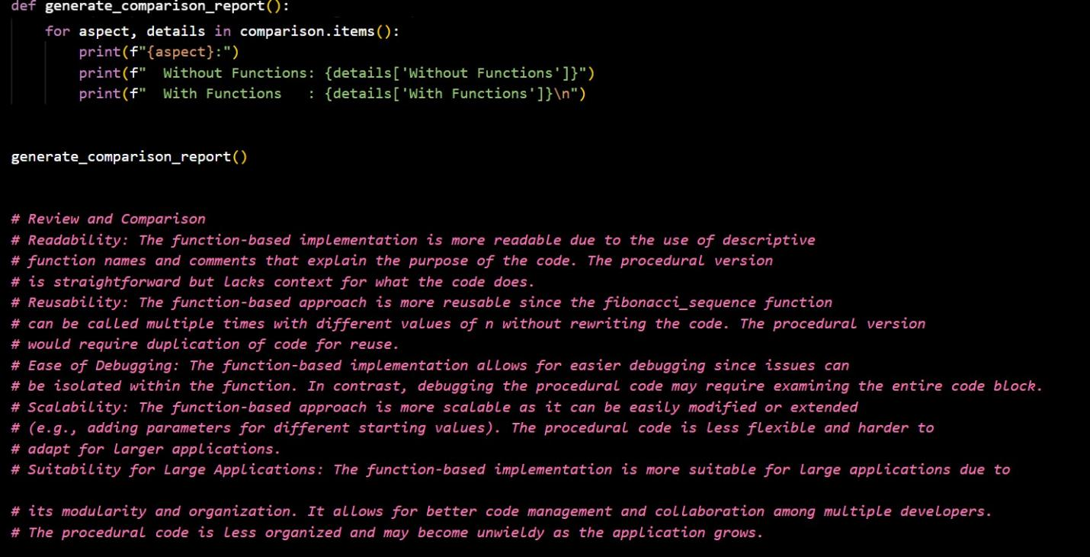

Output:
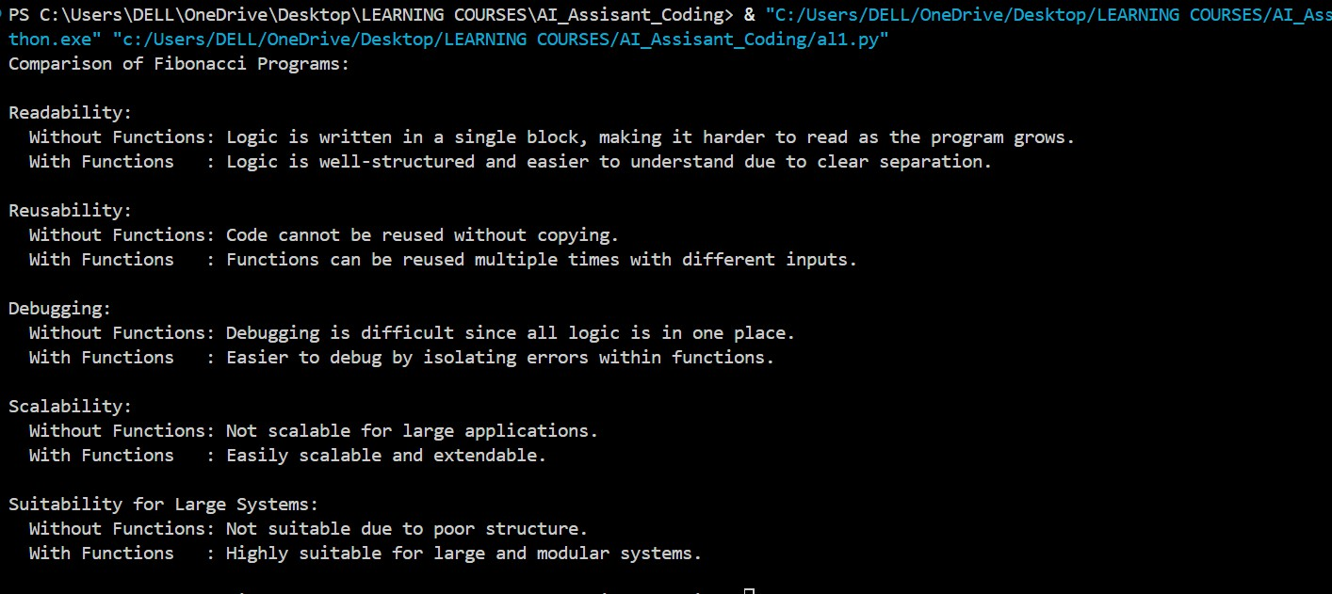

Justification:
- Understanding Code Structure Differences
This task helps in understanding the structural difference between procedural code and modular code. By comparing Fibonacci implementations with and without functions, it becomes clear how code organization affects clarity and flow. Procedural code places all logic in one block, while modular code separates logic into meaningful units.

- Importance of Readability and Maintainability
The comparison highlights that function-based code is easier to read and maintain. Descriptive function names and clear separation of logic make the program understandable even for new developers. Procedural code may become confusing as the program size increases.

- Reusability of Code
This task justifies why modular programming is preferred in real applications. Function-based Fibonacci logic can be reused multiple times without rewriting code, whereas procedural code requires duplication, increasing the chance of errors.

- Ease of Debugging and Testing
Debugging is simpler in modular code because errors can be isolated within a specific function. In procedural code, identifying issues is harder since the entire logic is written in one place. This comparison emphasizes the role of modularity in efficient debugging.

- Scalability for Large Applications
The analysis shows that modular code is more scalable and adaptable for large systems. Additional features or modifications can be added easily without affecting the existing code. Procedural code is less flexible and difficult to extend.

Task5: AI-Generated Iterative vs Recursive Fibonacci Approaches (Different Algorithmic Approaches for Fibonacci Series)
Prompt: Generate Python functions to compute the Fibonacci sequence iteratively and recursively. Show line-by-line suggestions with explanations. Requirements:

- Iterative function named fibonacci_iterative that takes n as input, returns a list of Fibonacci numbers, uses a loop, includes clear variable names and comments.

- Recursive function named fibonacci_recursive that takes n as input, returns a list of Fibonacci numbers, uses recursion, handles base cases, and includes meaningful comments.

Provide each line suggestion step by step with reasoning for why it is written that way.

Code:

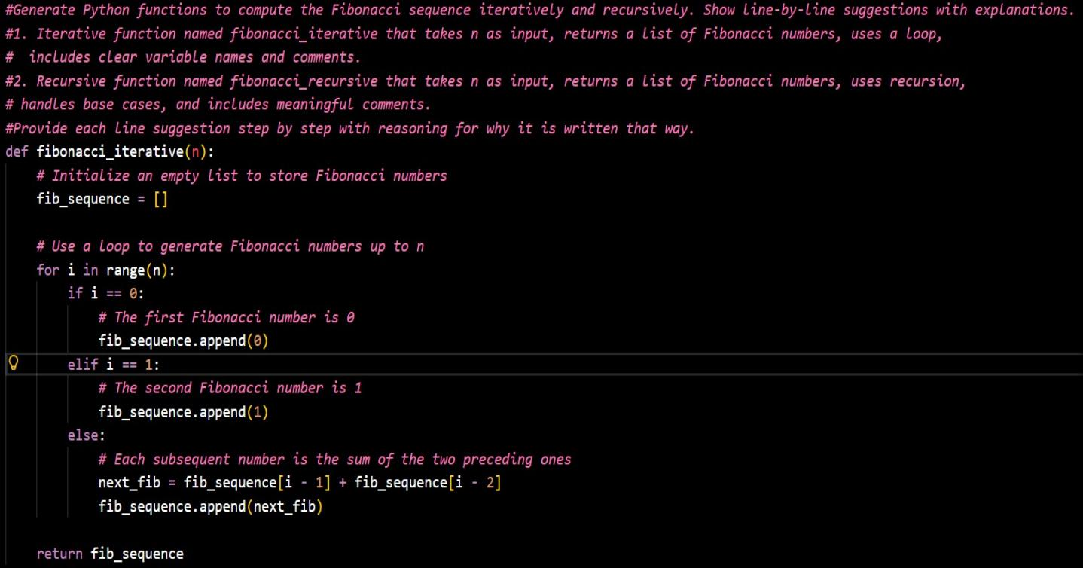
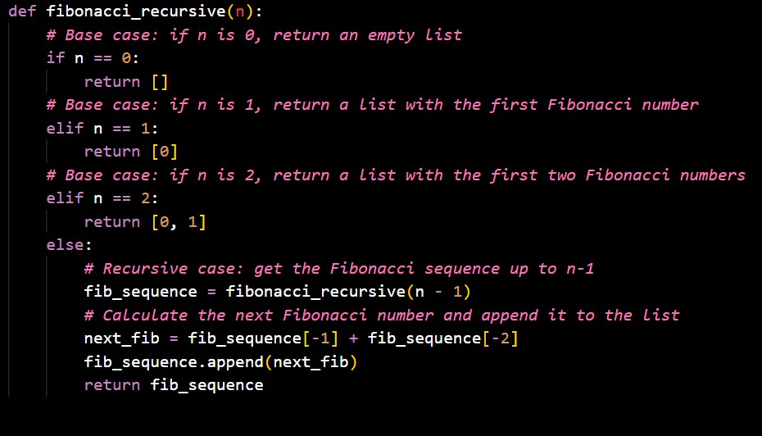

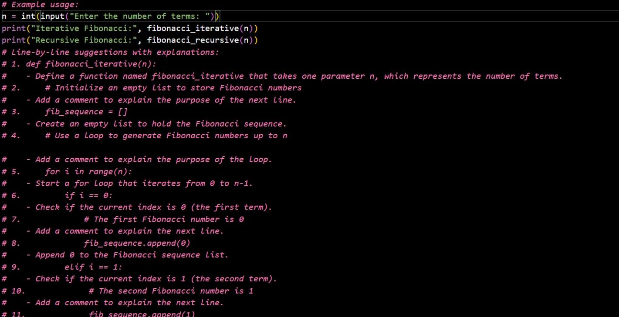
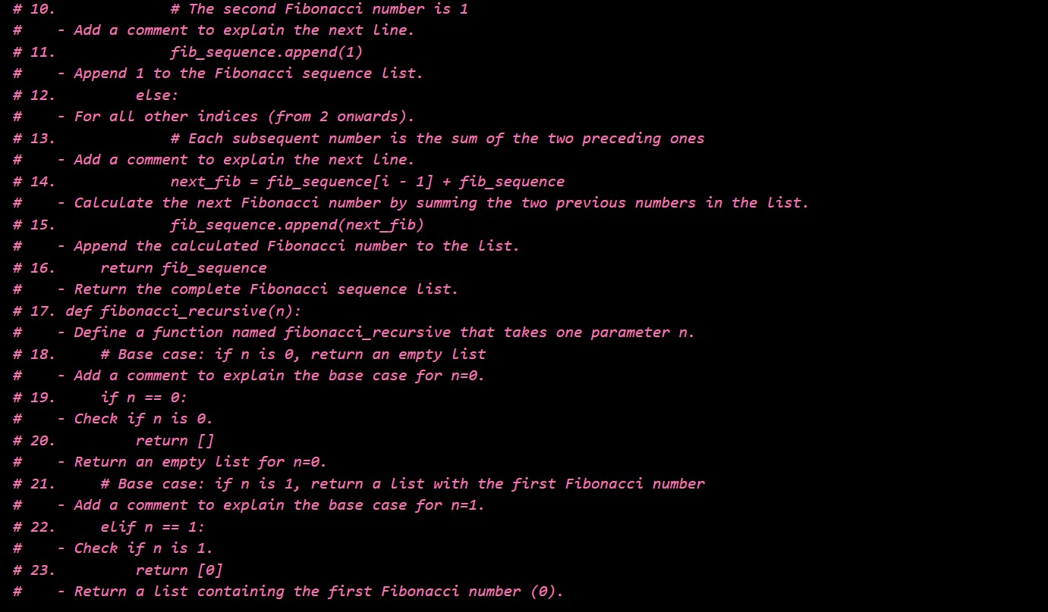

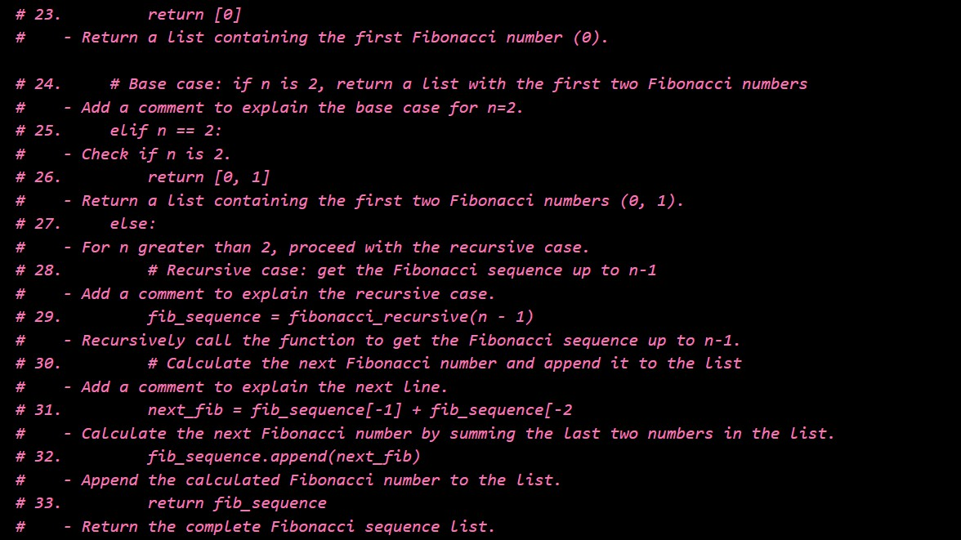

Output:
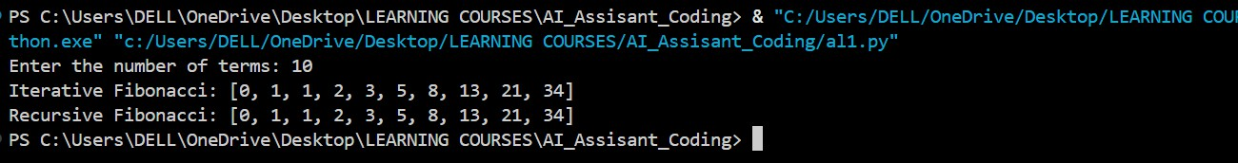

Justification:
- The iterative function efficiently generates the Fibonacci sequence using a loop, minimizing memory overhead and avoiding recursion depth limits.

- The recursive function demonstrates a clear, step-by-step approach that builds the sequence using base cases and recursive calls, which helps in understanding recursion.

- Both functions return a list of Fibonacci numbers, making the outputs reusable in other parts of a program or for further computations.

- Comments and meaningful variable names improve code readability, making it easier for others to follow the logic line by line.

- The iterative approach is better suited for larger values of n due to lower time and space complexity, while the recursive approach is useful for small inputs and educational purposes.

- Providing line-by-line explanations helps learners understand each operation, including initialization, base cases, loop logic, and recursive computation.

