

MOHD. RAZIA
V VIJAY
2520030387
CSE
CO-3

Case Study Topic: Campus Building Navigation using BFS and DFS in CampusFlow

CampusFlow is a University Campus Resource Management System that helps students and staff navigate different campus buildings and facilities efficiently. A graph-based campus structure was implemented, and BFS (Breadth First Search) and DFS (Depth First Search) algorithms were used to traverse and explore campus locations systematically.

Problem Statement
A university campus consists of multiple interconnected buildings and facilities. Efficient navigation is required for students and staff to locate resources quickly.
The challenge is to:
• Traverse campus locations efficiently.
• Visit all buildings without repetition.
• Improve campus navigation.
• Support resource discovery.

Proposed Solution

A graph structure is used to represent campus buildings, and BFS and DFS algorithms are applied for traversal.
Implementation Details:
Algorithms Used
BFS (Breadth First Search)
DFS (Depth First Search)
Operations Performed
- Create campus graph structure.
- Perform BFS traversal.
- Perform DFS traversal.
- Display traversal order.
- Analyze campus navigation paths

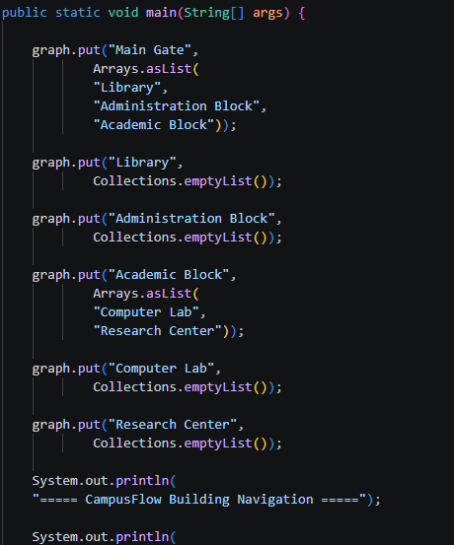

Result: Screenshots/Output

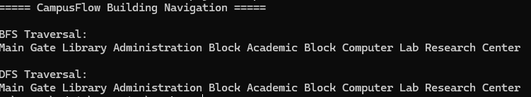

- Campus graph was created successfully.
- BFS traversed buildings level by level.
- DFS traversed buildings depth-wise.
- All campus locations were visited successfully.

GitHub Link:

https://github.com/VankaVijay84/CampusFlow-University-Campus-Resource-Management-System

