

MOHD. RAZIA
V VIJAY
2520030387
CSE
CO-1

Case Study Topic: Student Resource Indexing using AVL Tree in CampusFlow

CampusFlow is a University Campus Resource Management System that manages classrooms, laboratories, libraries, and other campus resources efficiently. As resources are continuously added and updated, quick identification and retrieval of resource information is required. An AVL Tree was implemented to store and manage resource IDs. The self-balancing property of AVL Trees ensures efficient searching, insertion, and retrieval of resources.
Problem Statement
The CampusFlow system maintains hundreds of campus resources. If resource IDs are inserted in sorted order into a normal BST, the tree becomes skewed, resulting in slower search operations.
The challenge is to:
• Maintain balanced resource indexing.
• Support fast resource retrieval.
• Handle continuous resource updates.
• Improve campus resource management efficiency.

Proposed Solution

An AVL Tree is used to maintain resource information.

Implementation Details:
Algorithm Used
AVL Tree
Operations Performed
- Insert resource IDs.
- Perform AVL rotations.
- Search resources.
- Display final AVL Tree.
- Perform inorder traversa

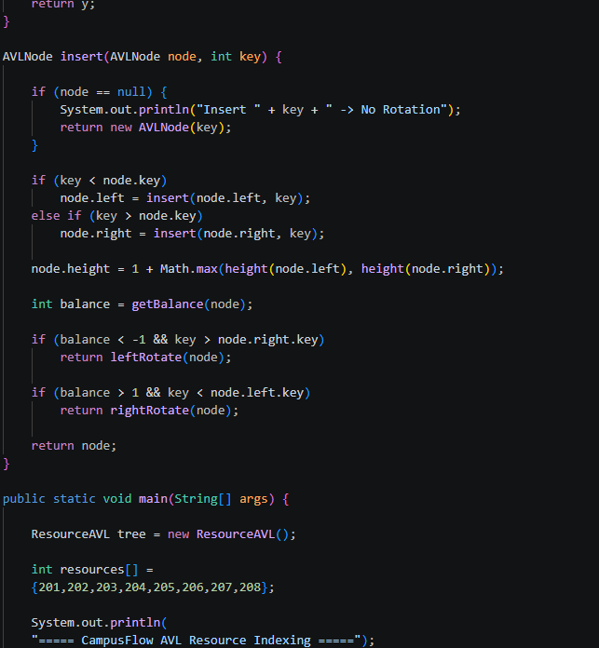

Result: Screenshots/Output

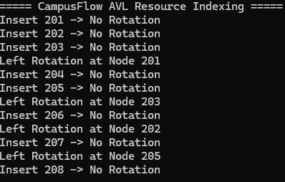

- AVL Tree maintained balance successfully.
- Resource retrieval was efficient.
- Rotations prevented tree skewness.
GitHub Link:

https://github.com/VankaVijay84/CampusFlow-University-Campus-Resource-Management-System

