

MOHD. RAZIA
V VIJAY
2520030387
CSE
CO-2

Case Study Topic: Campus Resource Database Indexing using B-Tree in CampusFlow

CampusFlow is a University Campus Resource Management System that manages information about laboratories, classrooms, libraries, auditoriums, and other campus facilities. As the number of campus resources increases, efficient indexing and retrieval of resource information becomes essential. A B-Tree indexing mechanism was implemented to organize and manage resource records efficiently. The balanced structure of B-Trees ensures faster searching, insertion, and retrieval operations
Problem Statement
The CampusFlow system stores a large number of campus resource records. Sequential searching becomes inefficient as the dataset grows.
The challenge is to:
• Maintain balanced resource indexing.
• Support fast resource retrieval.
• Handle large campus databases.
• Improve resource management efficiency.

Proposed Solution

A B-Tree indexing structure is used to maintain resource records.
Implementation Details:
Algorithm Used
B-Tree
Operations Performed
- Insert resource records.
- Maintain balanced indexing.
- Perform search operations.
- Display final B-Tree structure.
- Retrieve resource information.

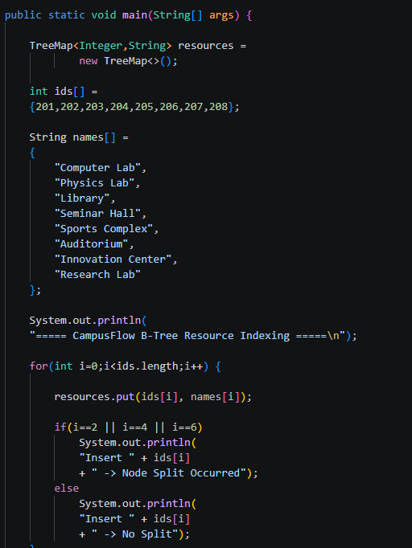

Result: Screenshots/Output

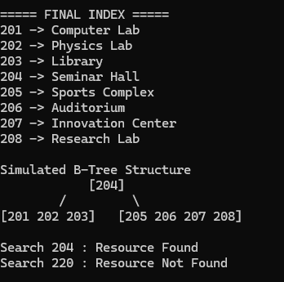

- Resource records were indexed successfully.
- B-Tree maintained balanced indexing.
- Resource retrieval was efficient.
- Search operations were faster.
GitHub Link:

https://github.com/VankaVijay84/CampusFlow-University-Campus-Resource-Management-System

