OSINT (Paul Joey Kifer) Chief of Police, Hagerstown, Maryland

Table Of Contents

Introduction ......................................................................Page 1

Picture profile & LinkedIn link ........................................Page 2

Expérience & Education ...………………………………Page 3

Interest Group & relatives ………………………………Page 4

Contact Info & Associates ...…………………………….Page 5

Residential map …………………………………………Page 6

Address History …………………………………………Page 7

Age of relatives and contacts ……………………………Page 8

Spouse Information ...........................................................Page 9

Spouse residence, Contact & map ..............................Page 10-11

Spouse Profile …………………………………………Page 12

Address history & contact # ……………………...... Page 13-14

Traffic Violation and Conclusion.....................................Page 15

Conclusion & Summary ………………………………...Page 16

References …………………………………………… Page 17



Captain Paul "Joey" Kifer is the current Chief of Police in Hagerstown, Maryland. He has been serving as a sworn HPD officer since 1992 and has held various positions such as patrolman, field training coordinator, patrol supervisor, criminal investigations supervisor, patrol sector commander, commander of the Special Services Bureau, and Acting Chief of the Hagerstown Police Department from September 2015 to June 2016 He is a lifelong native of Hagerstown and believes in community policing, with HPD officers forming strong relationships with all communities within the city. He emphasizes problem-oriented and community-oriented policing theory and believes that the role of the police is to be guardians of the community. Kifer's outreach philosophy extends to all neighborhoods and communities, all races, nationalities, and ethnicities, and all sexual preferences. He is an executive board member of CASA, the Maryland Diversity Center, and the Homeless Coalition. Kifer also believes in data-driven policing, formulating methods and operations based on analyzed historical data and gathered intelligence sources. He believes in the "Compstat" model, matching data-driven policing with city, county, state, and federal entities, and resources to address Hagerstown's problems.

Mr. Kifer is believed to be around the age of 57 according to public record searches.

*Source: Bing.com*

Below is Mr. Paul Kifer’s LinkedIn profile and contact information, this seems to be the only online presence with his real name Paul Kifer because he has created a lot of aliases that he uses on the various social media accounts that he owns.

The above information reveals that Mr. Kifer is an Alumni of Hagerstown Community College, and he is a member of the PredPol user group whose main goal is to provide a public space for our users to share how they are effectively reducing crime by using this tool.

The mission of PredPol is simple: place officers at the right time and location to give them the best chance of preventing crime.

*Source: linkedin.com*

A search conducted on whitepages.com and truthfinder.com seems to suggest close relatives of Mr. Kifer. There is a mention of Paul Joseph Kifer Sr. which might suggest that he's the father of the OSNIT target. Other discovered relatives include Gregory Kifer, Jeremy Kifer, Luka Kifer, Paul Kifer, and Sherree Kifer.

*Source: Whitepages.com*

It appears that Mr. Kifer has a history of residing in multiple locations across the state of Maryland. This information may be valuable for various purposes, including background checks, address verification, or even genealogical research. It's noteworthy that Mr. Kifer seems to have connections to both Maryland and PA. The timeline of address changes can provide insights into his movement and potentially help establish a pattern of life. Each location holds clues about Mr. Kifer's experience. Below are past and current addresses and telephone numbers of Mr. Kifer’s relatives or people he knows on a personal level.

Mr. Kifer’s phone number records and possible relatives as below. Indeed, some of the names of his relatives can also be seen on the whitepages website search results.

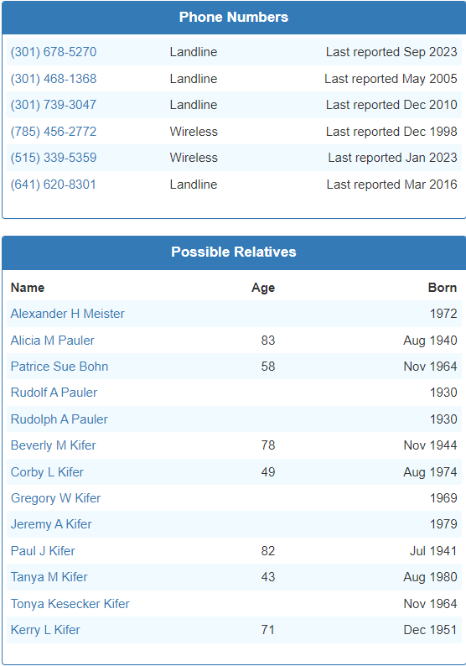

*Source: familytreenow.com*

Another search on peoplefinder.com revealed other phone numbers Mr. Kifer might have used in the past, 4 (four) lines in total. The search also discovered the spouse of the target, Patrice Sue Bohn known as Patrice Sue Kifer, but it is not clear if the couples are still together. She seems to have a lot of aliases which is very intriguing and interesting ( Hillegas Patrice S Kifer, Patrice S Hillegaskifer, Patrice Sue Davis, Patrice S Hillegas, Patrice Sue Kiefer, Patrice S Hillegasdavis, Patrice Hillegas-Kifer, Kifer Patrice S Hillegas, Patrice S Kiferhillegas, Kifer P Pauler) Her current address is 2205 Pikeside Dr Greencastle, PA 17225. The search produced Ms. Kifer’s past and present telephone numbers, e-mail addresses, and past and current addresses. Ms. Kifer appears to be a Career Guidance Technician at Washington County Public Schools, which was also confirmed by the LinkedIn platform.

Ms. Kifer attended Montgomery College between 1978 to 1979.

Source: familytreenow.com

Source: familytreenow.com

Source: LinkedIn.com

Source: familytreenow.com

On the 5th of October 2023, Mr. Kifer had a traffic violation in Bedford County case number MJ-57302-TR-0001366 which was filed at the Magisterial District Court in Bedford PA. The outcome of the case is unknown.

Source: familytreenow.com

Mr. Paul Kifer's LinkedIn profile and contact information represent a significant digital footprint. This information can serve as a valuable point of reference.

LinkedIn Profile: Mr. Paul Kifer's LinkedIn profile is a crucial online asset for establishing his professional identity. It likely includes details about his work experience, skills, education, and professional connections. Employers, colleagues, and potential business partners often use LinkedIn profiles to gauge a person's qualifications and professional network.

Contact Information: Having access to Mr. Kifer's past and current contact information, such as an email address or phone number, can be essential for communication and networking. It allows for direct outreach which can be explored by using various attack vectors such as social engineering, phishing, or even pharming.

Limited Online Presence: The fact that the LinkedIn profile is the only online presence for Mr. Kifer suggests that he may prioritize privacy or restrict his online footprint for personal reasons. This can be a deliberate choice to maintain a controlled and professional image online, especially if he works in a field where privacy and discretion are paramount. He could also be using aliases to hide his identity on social media and other platforms. This might be due to his position and the public trust that he holds. This highlights the fact that Mr. Kifer’s LinkedIn profile discovery is a result of an exhaustive search to find Mr. Kifer's online presence. This information can be significant, as it implies that Mr. Kifer may have taken steps to limit his exposure to the internet.

Verified Information: LinkedIn profiles are typically associated with verified and professionally relevant data, making them a reliable source for understanding an individual's qualifications and connections. However, it's important to note that while LinkedIn profiles are curated by individuals themselves, the accuracy of the information can vary.

In summary, Mr. Paul Kifer's LinkedIn profile and contact information represent a concentrated and professionally relevant online presence. This can be a valuable resource for anyone seeking to connect, collaborate, or learn more about his professional background and network. It also suggests that Mr. Kifer may prioritize discretion and professionalism in his online activities. But again detailed information discovered about Mr. Kifer can be used to explore further. A social engineering can be conducted on any of his relatives to divulge vital information about Mr. Kifer.

**References**

*Address Check and Verification Tool - Address Lookup | Melissa Lookups. (2023, October 29). Lookups.melissa.com.* [*https://lookups.melissa.com/home/addresscheck/address/?address=2205+Pikeside+Dr+Greencastle%2C+PA+17225&suites=&freeForm=&mak=&checkOption=append*](https://lookups.melissa.com/home/addresscheck/address/?address=2205+Pikeside+Dr+Greencastle%2C+PA+17225&suites=&freeForm=&mak=&checkOption=append)

*Dashboard. (n.d.). Www.peoplefinders.com. Retrieved October 29, 2023, from* [*https://www.peoplefinders.com/report?order=1&reportid=45644083&type=background*](https://www.peoplefinders.com/report?order=1&reportid=45644083&type=background)

*LinkedIn. (2023). LinkedIn. LinkedIn.* [*https://www.linkedin.com*](https://www.linkedin.com)

*Nordine, J. (2019). OSINT Framework. Osintframework.com.* [*https://osintframework.com/*](https://osintframework.com/)

*Paul Joseph Kifer Jr, Hagerstown, MD (21740). (n.d.). Spokeo. Retrieved October 29, 2023, from* [*https://www.spokeo.com/Paul-Kifer/Maryland/Hagerstown/p989372681*](https://www.spokeo.com/Paul-Kifer/Maryland/Hagerstown/p989372681)

*Paul Kifer - Chief of Police at Hagerstown MD. (n.d.). ZoomInfo. Retrieved October 29, 2023, from* [*https://www.zoominfo.com/p/Paul-Kifer/694888420*](https://www.zoominfo.com/p/Paul-Kifer/694888420)

*Rock of ages. (2020). Bing.* [*https://bing.com*](https://bing.com)

*Whitepages. (2023, October 29). Whitepages. Whitepages.* [*https://whitepages.com*](https://whitepages.com)