

Gaming Shop

Website

Ivan Vasilev | WEB1 | 19.02.2018

# WEB APPLICATION TOPIC

We are really keen on playing games and building gaming computers, so we decided to take all of our knowledge and with that create a global website for all the gamers out there in need of a game, a pc part or an accessory. We strive to be the greatest on the market!

# Target Audience

Our website is aimed towards people of all ages, that is the great thing about the gaming community, there are players of all ages, from babies even till really old people, everybody could enjoy games equally! People who visit our website can purchase various games to play on their PCs or consoles, also they could build a computer from scratch by buying all the parts from our website, also you can purchase all the accessories you could ever want!

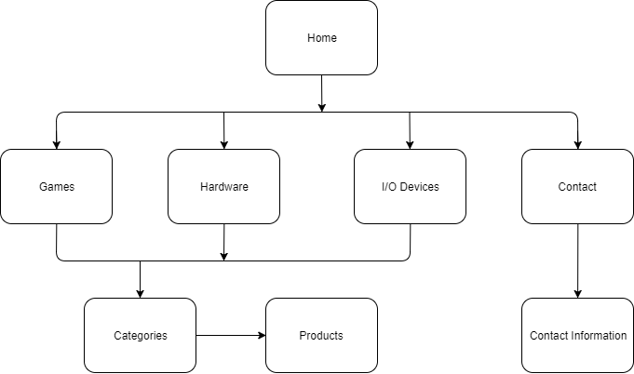Sitemap

Wireframe

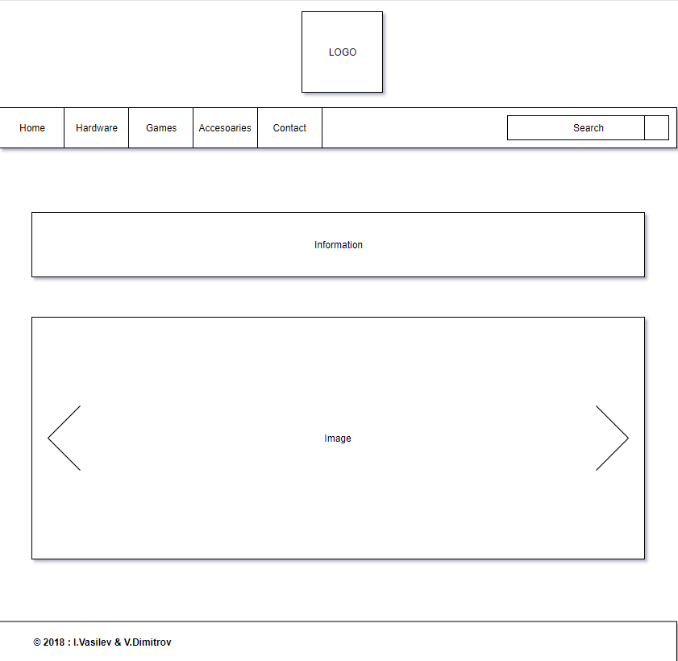

Visual Design

