DAY-2 ASSIGNMENT(29-12-2025)
1) create database InsuranceDB;
use InsuranceDB;

2)
--customers table creation

create table customers(
customerid int identity primary key,
firstname varchar(50),
lastname varchar(50),
dob date,
phone varchar(10),
email varchar(30) unique
);

--policies table creation

create table policies(
policyid int identity(200,1) primary key,
policyname varchar(50),
policytype varchar(50),
premiumamount decimal(10,2),
durationyears int);

--agents table creation

create table agents(
agentid int identity(300,1) primary key,
agentname varchar(50),
phone varchar(10),
city varchar(50));

--policyassignments table creation

create table policyassignments(
assignmentid int identity(1,1) primary key,
customerid int,
policyid int,
agentid int,
startdate date,
enddate date,
constraint fk_customer_id foreign key (customerid) references customers(customerid),
constraint fk_policy_id foreign key(policyid) references policies(policyid),
constraint fk_agent_id foreign key(agentid) references agents(agentid)
);

--claims table creation

create table claims(
claimid int identity(400,1) primary key,
assignmentid int,
claimdate date,
claimmoney decimal(10,2),
claimstatus varchar(50),
constraint fk_assignment_id foreign key(assignmentid) references policyassignments(assignmentid)
);

3)
--insertion of data into customers

INSERT INTO customers (firstname, lastname, dob, phone, email) VALUES
('Rahul', 'Sharma', '1995-04-12', '9876543210', 'rahul@gmail.com'),
('Anita', 'Verma', '1998-08-20', '9123456789', 'anita@gmail.com'),
('Suresh', 'Kumar', '1990-01-15', '9988776655', 'suresh@gmail.com'),
('Priya', 'Singh', '1997-06-10', '9090909090', 'priya@gmail.com'),
('Amit', 'Patel', '1993-11-25', '9555666777', 'amit@gmail.com');

--insertion of data into policies

INSERT INTO policies (policyname, policytype, premiumamount, durationyears) VALUES
('Health Secure', 'Health', 12000.00, 5),
('Life Shield', 'Life', 15000.00, 10),
('Car Protect', 'Vehicle', 8000.00, 3),
('Home Safe', 'Property', 10000.00, 7),
('Travel Guard', 'Travel', 5000.00, 1);

--insertion of data into agents

INSERT INTO agents (agentname, phone, city) VALUES
('Ramesh Rao', '8888888888', 'Hyderabad'),
('Sunita Das', '7777777777', 'Bangalore'),
('Kiran Mehta', '6666666666', 'Mumbai'),
('Neha Jain', '9999999999', 'Delhi'),
('Arjun Nair', '5555555555', 'Chennai');

--insertion of data into policyassignments

INSERT INTO policyassignments (customerid, policyid, agentid, startdate, enddate) VALUES
(1, 200, 300, '2023-01-01', '2028-01-01'),
(2, 201, 301, '2022-05-15', '2032-05-15'),
(3, 202, 302, '2024-03-10', '2027-03-10'),
(4, 203, 303, '2021-09-20', '2028-09-20'),
(5, 204, 304, '2024-01-05', '2025-01-05');
--insertion of data into claims

INSERT INTO claims (assignmentid, claimdate, claimmoney, claimstatus) VALUES
(1, '2024-02-10', 50000.00, 'Approved'),
(2, '2023-11-05', 100000.00, 'Pending'),
(3, '2024-06-18', 20000.00, 'Rejected'),
(4, '2022-12-25', 75000.00, 'Approved'),
(5, '2024-08-01', 15000.00, 'Pending');

4.1) select * from customers;

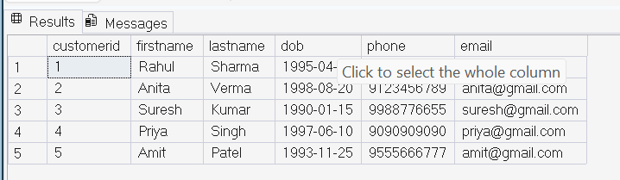

4.2) select customerid,policyid,startdate,enddate from policyassignments;

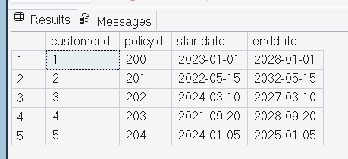

4.3) select *from policies
where policytype='health';

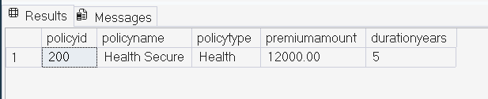

4.4) select * from policies
where premiumamount>10000 and durationyears=1;


4.5) select distinct city from agents;

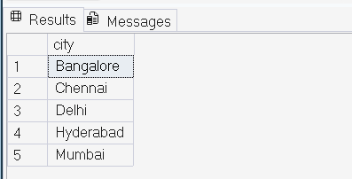

4.6) select * from policies
where policytype='Life' or policytype= 'Health' or policytype='Motor';

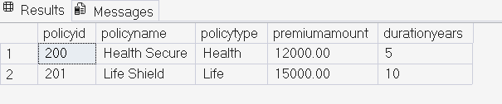

4.7) select * from policies
where policytype in ('Life','Health','Motor');

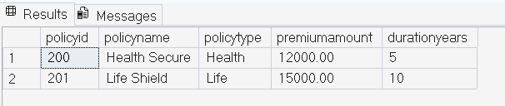

4.8) select * from customers
where dob>='2001-01-01'
and dob<='2020-12-30';

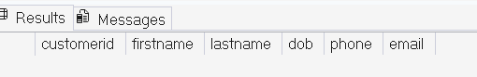
4.9) select * from customers
where dob between '2001-01-01'
and '2020-12-30';

4.10) select * from claims
where claimstatus='rejected';

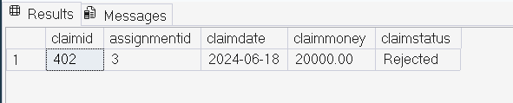

4.11) select * from agents
where city like '_a%';

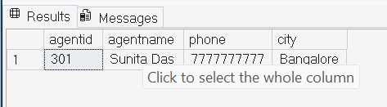

4.12) SELECT
MIN(claimmoney) AS lowest_claim_amount,
MAX(claimmoney) AS highest_claim_amount
FROM claims;

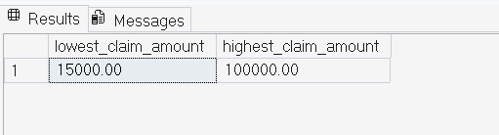

4.13) select * from claims where
claimdate=(select max(claimdate) from claims);
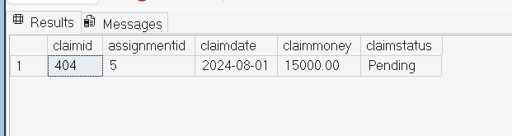

4.14) update policies
set premiumamount=premiumamount*1.10
where policytype='Health';
select * from policies
where policytype='Health';

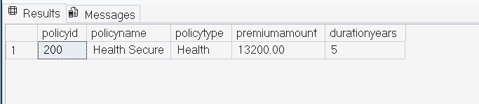

4.15) delete from claims
where assignmentid in (
select assignmentid
from policyassignments
where enddate < cast(getdate() as date)
);

delete from policyassignments
where enddate < cast(getdate() as date);

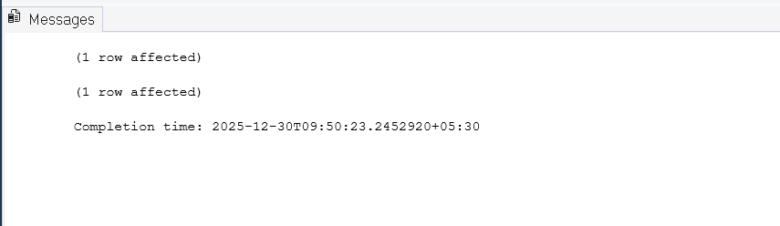

4.16) select count(*) as rejected_claims_count
from claims
where claimstatus='Rejected';

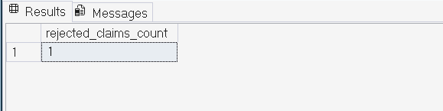

4.17) select policyid,policyname,premiumamount,
premiumamount*0.06 as local_tax,
premiumamount*1.06 as premium_amount_with_tax,
(premiumamount*1.06)/12 as monthly_premium_amount
from policies;

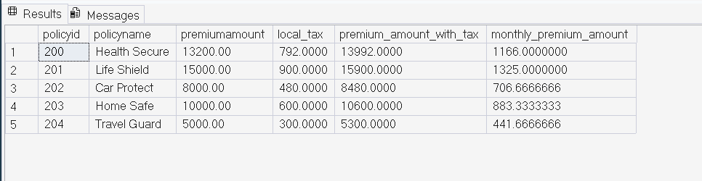

4.18) alter table customers
add address varchar(50),
city varchar(50);
select * from customers;

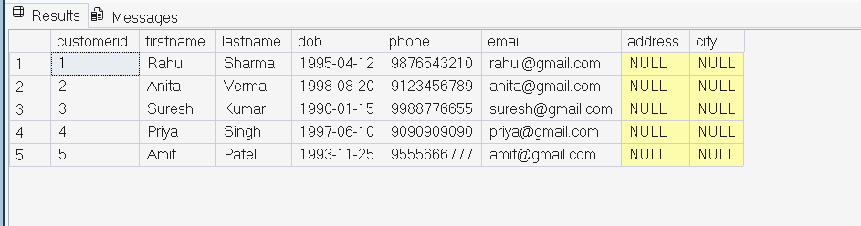

4.19) alter table agents
add devofid int;
select * from agents;

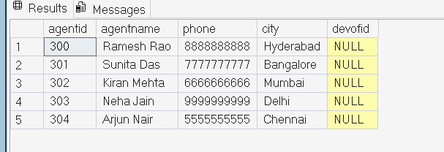

4.20) alter table agents
add constraint fk_devofid_agents
foreign key(devofid) references
agents(agentid);

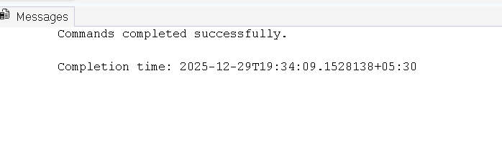
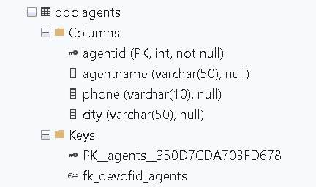

5.1) select
p.policyid,
p.policyname,p.policytype,p.premiumamount,p.durationyears
from policies p join policyassignments pa
on p.policyid=pa.policyid
where pa.customerid=5;

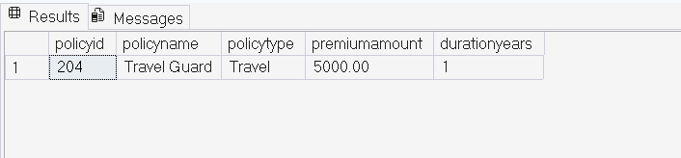

5.2) select
c.firstname+' '+c.lastname as customer_name,
p.policyname from customers c
join policyassignments pa on
c.customerid=pa.customerid
join policies p on p.policyid=pa.policyid;

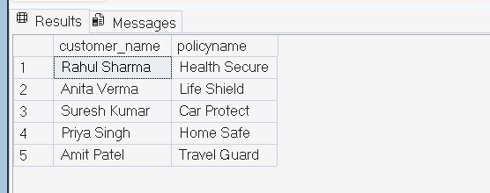

5.3) select c.customerid,c.firstname+' '+c.lastname as customer_name,
cl.claimid,cl.claimdate,cl.claimmoney,cl.claimstatus from policyassignments pa
join claims cl on pa.assignmentid=cl.assignmentid
join customers c on c.customerid=pa.customerid;

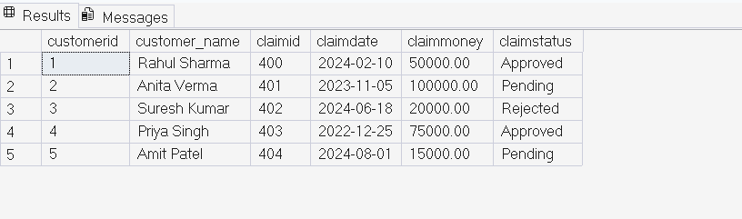

5.4) select c.firstname,p.policyname,a.agentname,pa.startdate,pa.enddate
from policyassignments pa join customers c
on pa.customerid=c.customerid
join policies p on pa.policyid=p.policyid
join agents a on a.agentid=pa.agentid
order by pa.startdate;

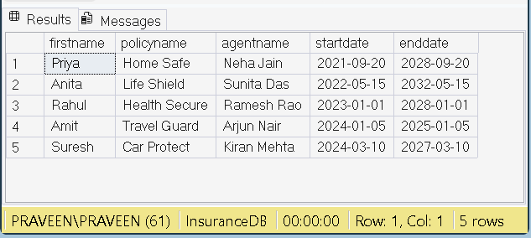

5.5) select c.firstname,p.policyname,cl.claimmoney,cl.claimstatus,cl.claimdate
from claims cl join policyassignments pa on
cl.assignmentid=pa.assignmentid
join customers c
on pa.customerid=c.customerid
join policies p
on pa.policyid=p.policyid
order by cl.claimdate desc;

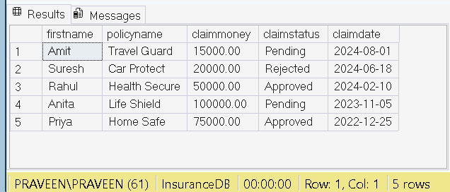

5.6) select c.customerid,c.firstname+' '+c.lastname as full_name,
p.policyid,p.policyname,p.policytype,p.premiumamount
from customers c left join policyassignments pa
on pa.customerid=c.customerid left join
policies p on pa.policyid=p.policyid
order by c.customerid;

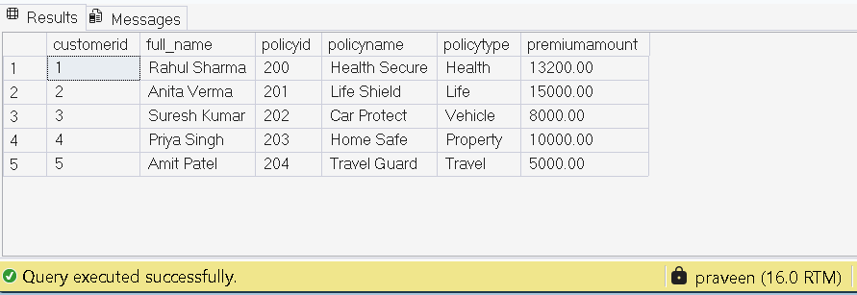

5.7) select distinct
c.customerid,c.firstname+' '+c.lastname as customer_name
from customers c
left join policyassignments pa
on c.customerid=pa.customerid
left join claims cl
on pa.assignmentid=cl.assignmentid
where cl.claimid is null;

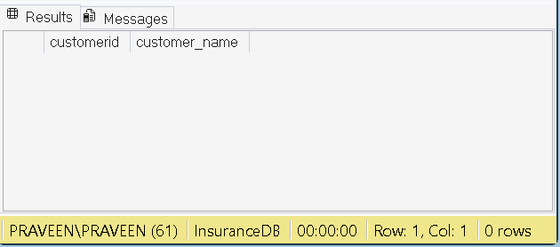

5.8) select c.firstname+' '+c.lastname as customer_name,
sum(cl.claimmoney) as total_claim_amount
from customers c join
policyassignments pa on
pa.customerid=c.customerid
join claims cl on
cl.assignmentid=pa.assignmentid
by c.firstname,c.lastname;

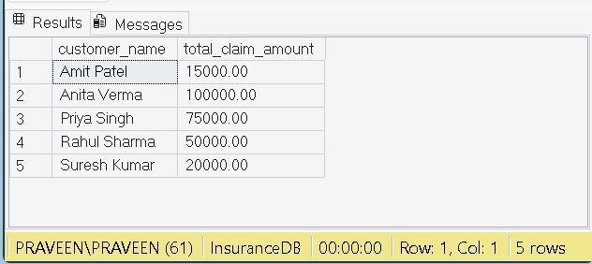

5.9) select c.firstname+' '+c.lastname as customer_name,
sum(cl.claimmoney) as total_claim_amount
from customers c join
policyassignments pa on
pa.customerid=c.customerid
join claims cl on
cl.assignmentid=pa.assignmentid
group by c.firstname,c.lastname
having sum(cl.claimmoney)>50000;
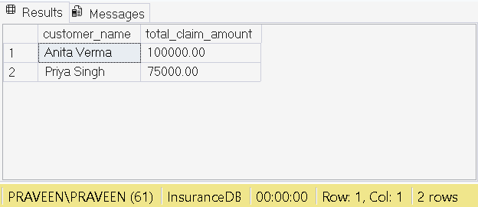

5.10) select a.agentname ,count(pa.policyid) as policy_count
from agents a left join policyassignments pa
on a.agentid=pa.agentid
group by a.agentname;

