This is your character

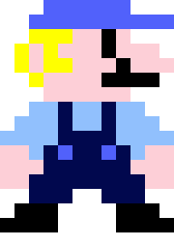

Press space to jump. If you double jump, you cannot jump again until you reach the ground. Avoid obstacles, including shrubs on the ground and minions in the sky.



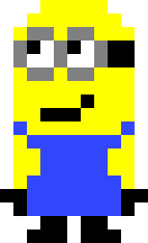

Collect coins to increase your score.

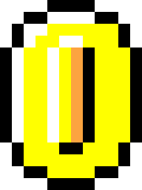

Collecting a star will make your character invisible for three seconds

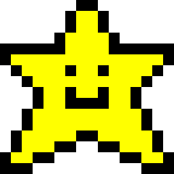

When you die, your score is shown and you have the option to replay



(Note: Because of the super randomized nature of the game, it does happen that two objects [such as a coin and a shrub] are taking up the same space at the same time. If you hit this space, it will be like you hit both. This is good if you hit both a coin and a star, but bad if you hit, say, a star and a shrub.)