**22VC003 - INTRODUCTION TO TAILWIND CSS**

**Vannamathi G – 22ISR056**

Exercise 2:

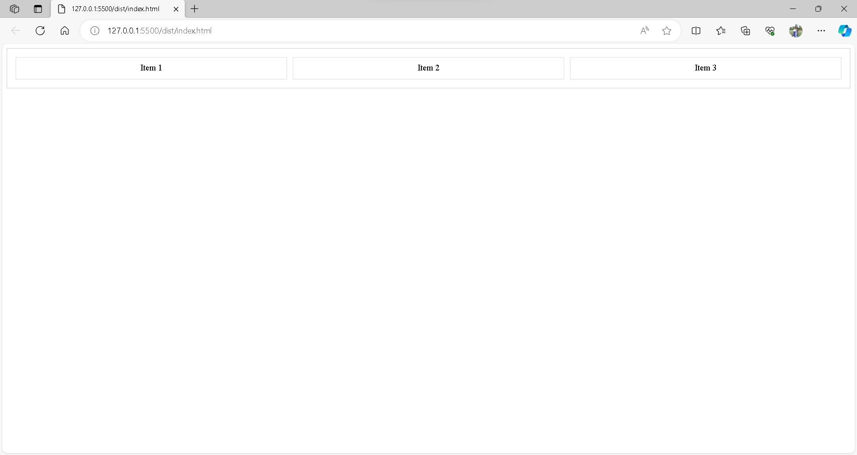

**Source Code:**

<!DOCTYPE html>

<html lang="en">

<head>

<meta charset="UTF-8">

<meta name="viewport" content="width=device-width, initial-scale=1.0">

<style>

/* Flex container */

.flex-container {

display: flex;

justify-content: space-between;

align-items: center;

border: 1px solid #ccc;

padding: 10px;

}

/* Flex items */

.flex-item {

flex: 1;

text-align: center;

padding: 10px;

border: 1px solid #ddd;

margin: 5px;

}

</style>

</head>

<body>

<!-- Flex container -->

<div class="flex-container">

<!-- Flex items -->

<div class="flex-item">Item 1</div>

<div class="flex-item">Item 2</div>

<div class="flex-item">Item 3</div>

</div>

</body>

</html>

Exercise 3:

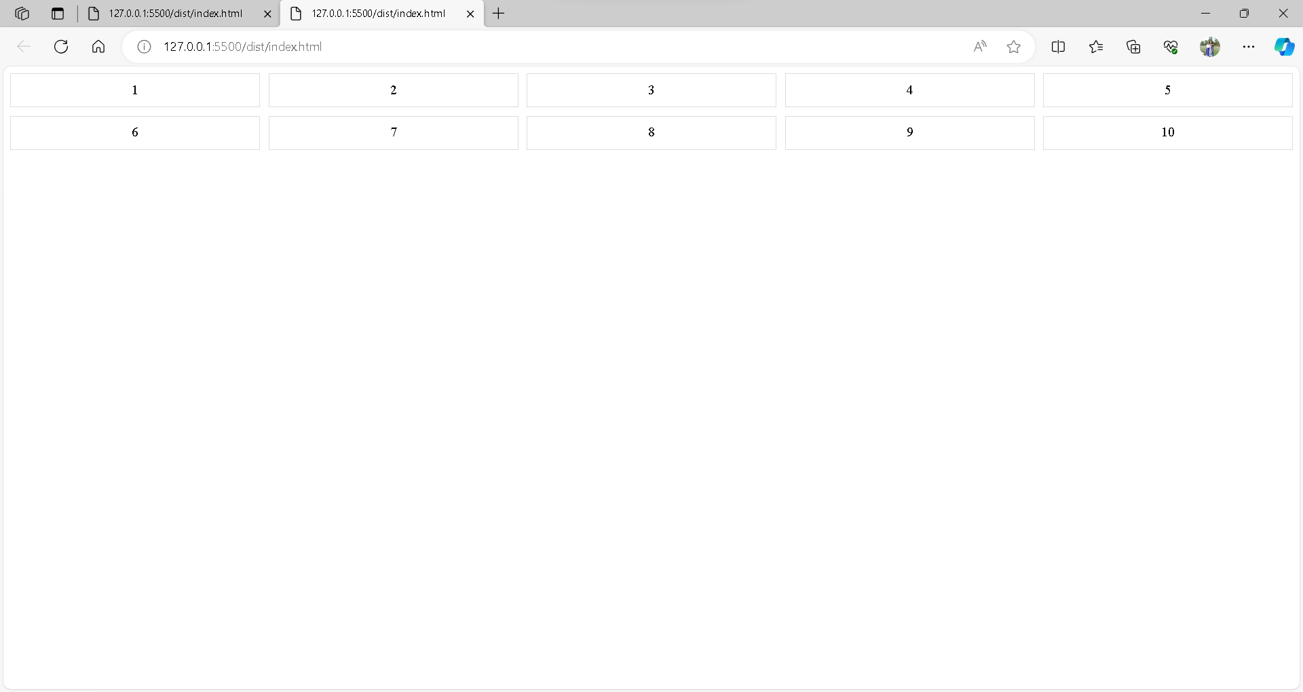

**Source Code:**

<!DOCTYPE html>

<html lang="en">

<head>

<meta charset="UTF-8">

<meta name="viewport" content="width=device-width, initial-scale=1.0">

<style>

/* Define the grid container */

.number-grid {

display: grid;

grid-template-columns: repeat(5, 1fr); /* 5 columns with equal width */

gap: 10px; /* Gap between grid items */

}

/* Style for grid items */

.grid-item {

border: 1px solid #ddd;

padding: 10px;

text-align: center;

}

</style>

</head>

<body>

<!-- Grid container for natural numbers -->

<div class="number-grid">

<!-- Grid items with natural numbers -->

<!-- You can generate these dynamically using JavaScript if needed -->

<div class="grid-item">1</div>

<div class="grid-item">2</div>

<div class="grid-item">3</div>

<div class="grid-item">4</div>

<div class="grid-item">5</div>

<div class="grid-item">6</div>

<div class="grid-item">7</div>

<div class="grid-item">8</div>

<div class="grid-item">9</div>

<div class="grid-item">10</div>

<!-- Add more grid items as needed -->

</div>

</body>

</html>

Exercise 4:

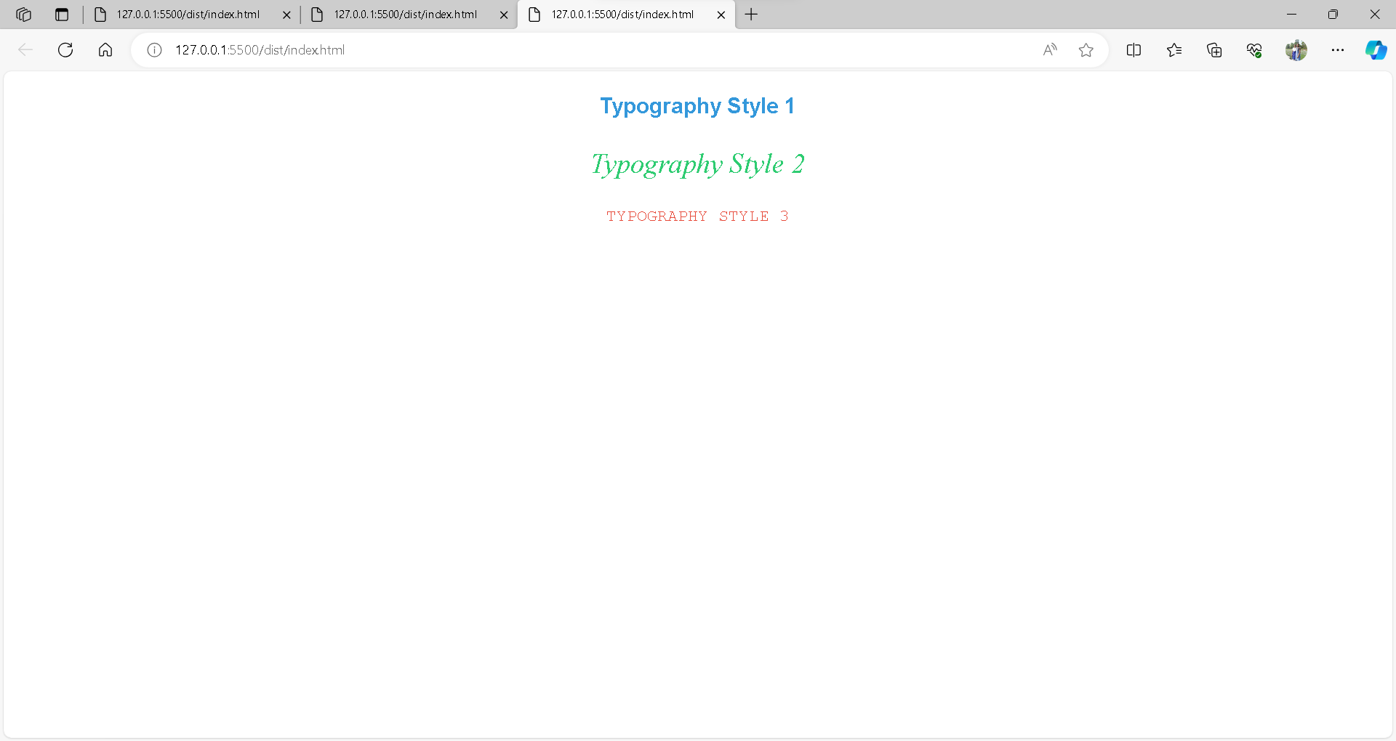

**Source Code:**

<!DOCTYPE html>

<html lang="en">

<head>

<meta charset="UTF-8">

<meta name="viewport" content="width=device-width, initial-scale=1.0">

<style>

/* Typography styles */

.text-photo {

text-align: center;

margin-bottom: 20px;

}

.style1 {

font-family: 'Arial', sans-serif;

font-size: 24px;

font-weight: bold;

color: #3498db;

}

.style2 {

font-family: 'Times New Roman', serif;

font-size: 30px;

font-style: italic;

color: #2ecc71;

}

.style3 {

font-family: 'Courier New', monospace;

font-size: 18px;

text-transform: uppercase;

color: #e74c3c;

}

</style>

</head>

<body>

<!-- Text Photographs -->

<div class="text-photo">

<p class="style1">Typography Style 1</p>

<p class="style2">Typography Style 2</p>

<p class="style3">Typography Style 3</p>

</div>

</body>

</html>

Exercise 5:

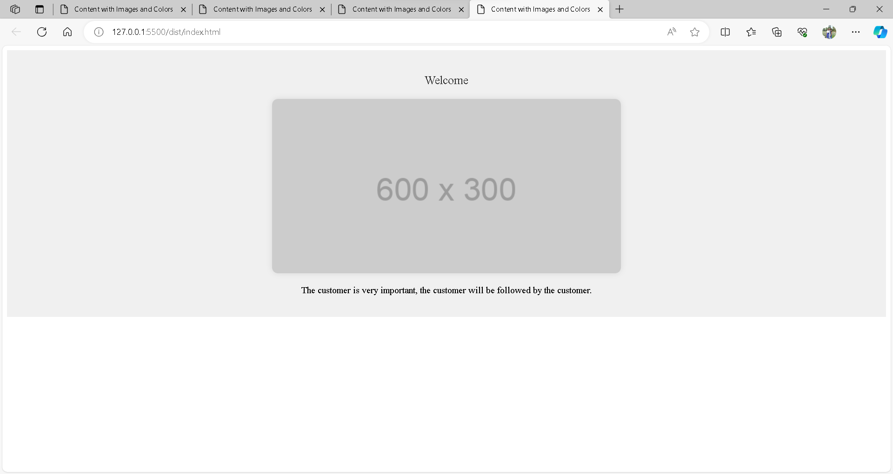

**Source Code:**

<!DOCTYPE html>

<html lang="en">

<head>

<meta charset="UTF-8">

<meta name="viewport" content="width=device-width, initial-scale=1.0">

<title>Content with Images and Colors</title>

<style>

/* Styles for the container */

.content-container {

text-align: center;

background-color: #f0f0f0;

padding: 20px;

}

/* Styles for text */

.main-text {

color: #333;

font-size: 20px;

margin-bottom: 20px;

}

/* Style for the image */

.main-image {

max-width: 100%;

height: auto;

border-radius: 10px;

box-shadow: 0 0 10px rgba(0, 0, 0, 0.1);

}

</style>

</head>

<body>

<!-- Content Container -->

<div class="content-container">

<!-- Main Text -->

<p class="main-text">Welcome to our website! Enjoy the content and explore the features.</p>

<!-- Image -->

<img class="main-image" src="https://via.placeholder.com/600x300" alt="Sample Image">

<!-- Additional Content -->

<p>Customer</p>

</div>

</body>

</html>

Exercise 6:

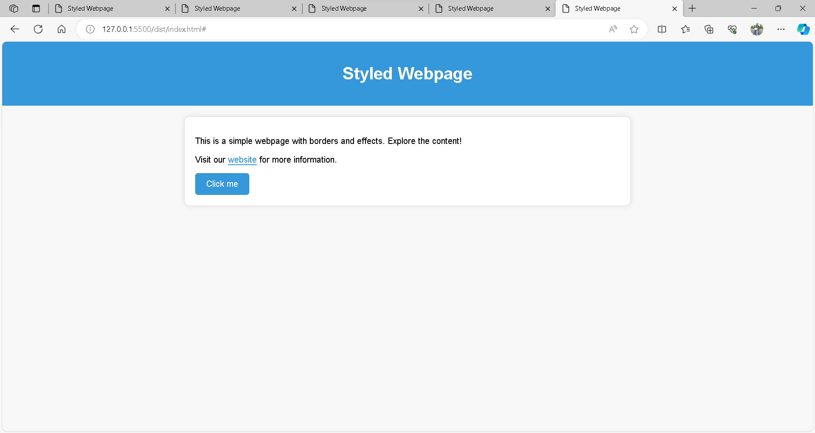

**Source Code:**

<!DOCTYPE html>

<html lang="en">

<head>

<meta charset="UTF-8">

<meta name="viewport" content="width=device-width, initial-scale=1.0">

<title>Styled Webpage</title>

<style>

/* Body styles */

body {

font-family: 'Arial', sans-serif;

margin: 0;

padding: 0;

background-color: #f8f8f8;

}

/* Header styles */

header {

background-color: #3498db;

color: #fff;

text-align: center;

padding: 20px;

}

/* Container styles */

.container {

max-width: 800px;

margin: 20px auto;

padding: 20px;

background-color: #fff;

border: 1px solid #ddd;

border-radius: 10px;

box-shadow: 0 0 10px rgba(0, 0, 0, 0.1);

}

/* Link styles */

a {

color: #3498db;

text-decoration: none;

border-bottom: 2px solid #3498db;

transition: border-bottom 0.3s ease;

}

a:hover {

border-bottom: 2px solid #2980b9;

}

/* Button styles */

.styled-button {

display: inline-block;

padding: 10px 20px;

background-color: #3498db;

color: #fff;

text-decoration: none;

border: 1px solid #2980b9;

border-radius: 5px;

transition: background-color 0.3s ease;

}

.styled-button:hover {

background-color: #2980b9;

}

</style>

</head>

<body>

<!-- Header -->

<header>

<h1>Styled Webpage</h1>

</header>

<!-- Content Container -->

<div class="container">

<p>This is a simple webpage with borders and effects. Explore the content!</p>

<!-- Link with Border Effect -->

<p>Visit our <a href="#">website</a> for more information.</p>

<!-- Styled Button -->

<a href="#" class="styled-button">Click me</a>

</div>

</body>

</html>

Exercise 7:

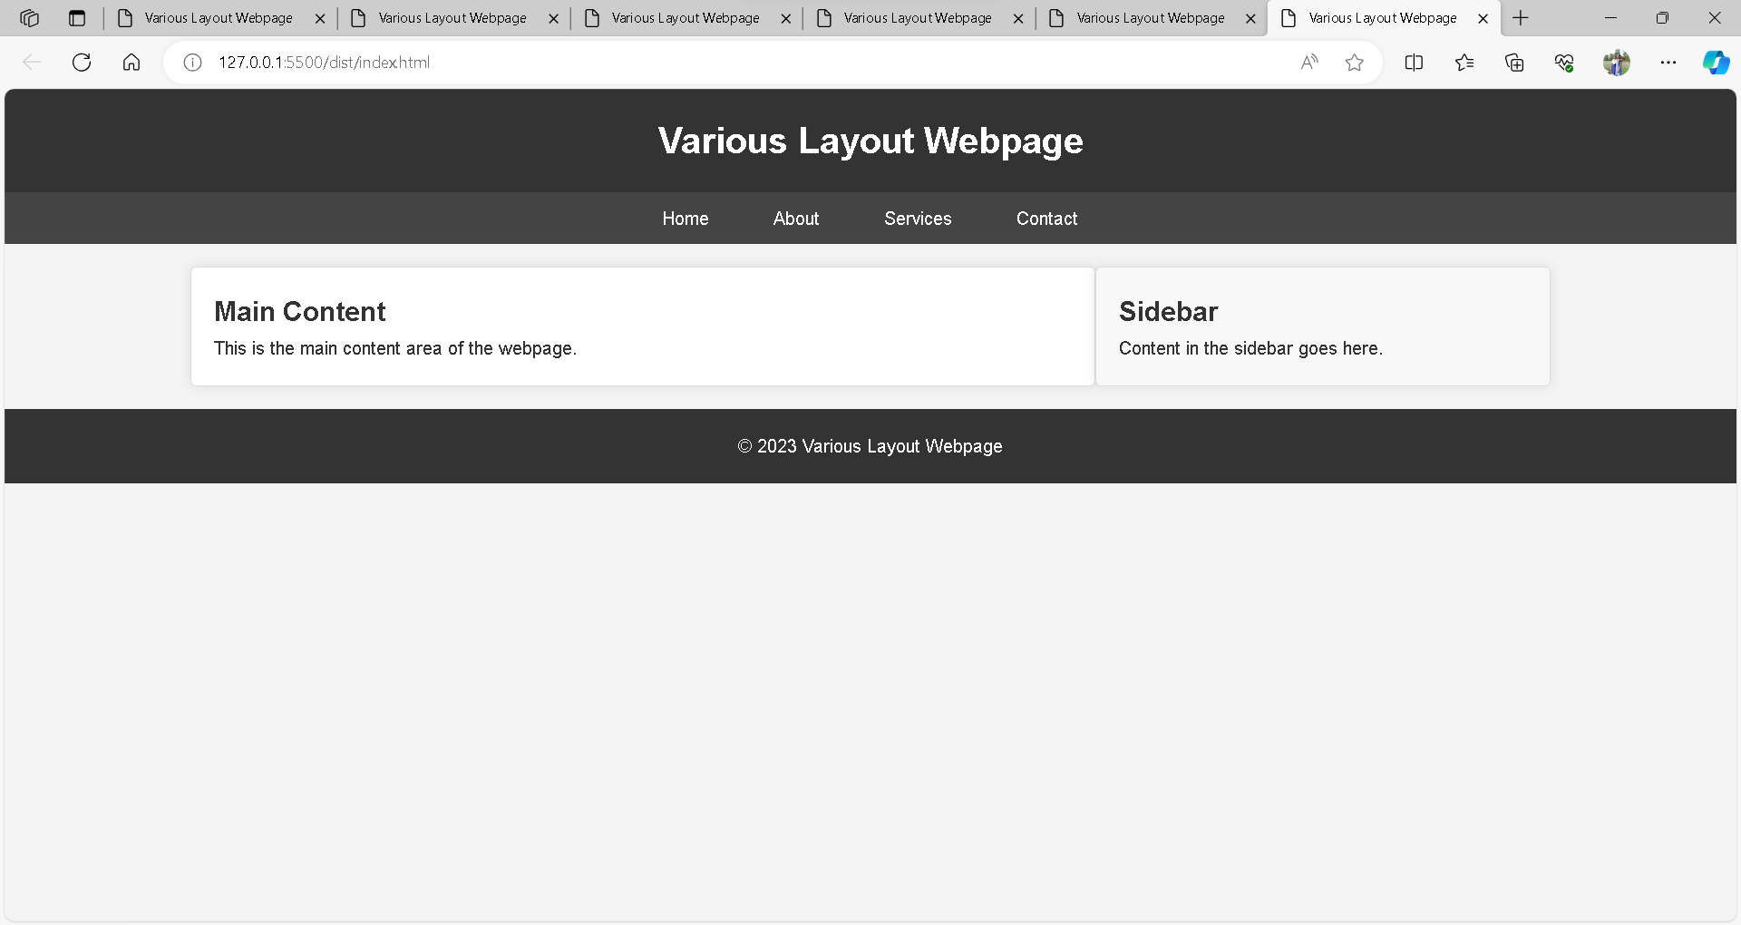

**Source Code:**

<!DOCTYPE html>

<html lang="en">

<head>

<meta charset="UTF-8">

<meta name="viewport" content="width=device-width, initial-scale=1.0">

<title>Various Layout Webpage</title>

<style>

/* Reset some default styles for better consistency */

body, h1, h2, p, ul, li {

margin: 0;

padding: 0;

}

/* Body styles */

body {

font-family: 'Arial', sans-serif;

line-height: 1.6;

background-color: #f4f4f4;

color: #333;

}

/* Header styles */

header {

background-color: #333;

color: #fff;

text-align: center;

padding: 20px;

}

/* Navigation bar styles */

nav {

background-color: #444;

padding: 10px;

text-align: center;

}

nav a {

color: #fff;

text-decoration: none;

padding: 8px 16px;

margin: 0 10px;

border-radius: 5px;

transition: background-color 0.3s ease;

}

nav a:hover {

background-color: #555;

}

/* Main Content Container */

.main-container {

max-width: 1200px;

margin: 20px auto;

display: flex;

justify-content: space-between;

}

/* Content Area */

.content {

flex: 1;

padding: 20px;

background-color: #fff;

border: 1px solid #ddd;

border-radius: 5px;

box-shadow: 0 0 10px rgba(0, 0, 0, 0.1);

}

/* Sidebar */

.sidebar {

flex-basis: 30%;

padding: 20px;

background-color: #f8f8f8;

border: 1px solid #ddd;

border-radius: 5px;

box-shadow: 0 0 10px rgba(0, 0, 0, 0.1);

}

/* Footer styles */

footer {

text-align: center;

padding: 20px;

background-color: #333;

color: #fff;

}

</style>

</head>

<body>

<!-- Header -->

<header>

<h1>Various Layout Webpage</h1>

</header>

<!-- Navigation Bar -->

<nav>

<a href="#">Home</a>

<a href="#">About</a>

<a href="#">Services</a>

<a href="#">Contact</a>

</nav>

<!-- Main Content Container -->

<div class="main-container">

<!-- Content Area -->

<div class="content">

<h2>Main Content</h2>

<p>This is the main content area of the webpage.</p>

</div>

<!-- Sidebar -->

<div class="sidebar">

<h2>Sidebar</h2>

<p>Content in the sidebar goes here.</p>

</div>

</div>

<!-- Footer -->

<footer>

<p>&copy; 2023 Various Layout Webpage</p>

</footer>

</body>

</html>

Exercise 8:

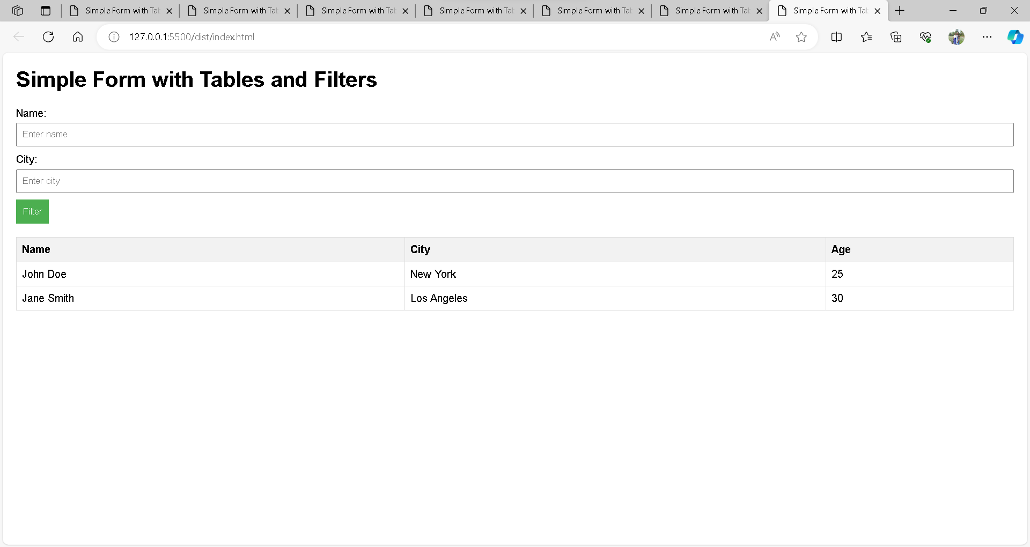

**Source Code:**

<!DOCTYPE html>

<html lang="en">

<head>

<meta charset="UTF-8">

<meta name="viewport" content="width=device-width, initial-scale=1.0">

<title>Simple Form with Tables and Filters</title>

<style>

/* Basic styling for layout */

body {

font-family: 'Arial', sans-serif;

margin: 20px;

}

/* Table styling */

table {

border-collapse: collapse;

width: 100%;

}

th, td {

border: 1px solid #ddd;

padding: 8px;

text-align: left;

}

th {

background-color: #f2f2f2;

}

/* Form styling */

form {

margin-bottom: 20px;

}

label {

display: block;

margin-bottom: 5px;

}

input[type="text"], select {

width: 100%;

padding: 8px;

margin-bottom: 10px;

box-sizing: border-box;

}

button {

background-color: #4caf50;

color: #fff;

padding: 10px;

border: none;

cursor: pointer;

}

button:hover {

background-color: #45a049;

}

</style>

</head>

<body>

<h1>Simple Form with Tables and Filters</h1>

<!-- Form for Filters -->

<form id="filterForm">

<label for="nameFilter">Name:</label>

<input type="text" id="nameFilter" placeholder="Enter name">

<label for="cityFilter">City:</label>

<input type="text" id="cityFilter" placeholder="Enter city">

<button type="button" onclick="filterTable()">Filter</button>

</form>

<!-- Table with Data -->

<table id="data-table">

<thead>

<tr>

<th>Name</th>

<th>City</th>

<th>Age</th>

</tr>

</thead>

<tbody>

<tr>

<td>John Doe</td>

<td>New York</td>

<td>25</td>

</tr>

<tr>

<td>Jane Smith</td>

<td>Los Angeles</td>

<td>30</td>

</tr>

<!-- Add more rows as needed -->

</tbody>

</table>

<script>

function filterTable() {

// Get input values

var nameFilter = document.getElementById('nameFilter').value.toUpperCase();

var cityFilter = document.getElementById('cityFilter').value.toUpperCase();

// Get the table and rows

var table = document.getElementById('data-table');

var rows = table.getElementsByTagName('tr');

// Loop through all table rows, and hide those that don't match the search query

for (var i = 1; i < rows.length; i++) {

var name = rows[i].getElementsByTagName('td')[0].textContent.toUpperCase();

var city = rows[i].getElementsByTagName('td')[1].textContent.toUpperCase();

if (name.includes(nameFilter) && city.includes(cityFilter)) {

rows[i].style.display = '';

} else {

rows[i].style.display = 'none';

}

}

}

</script>

</body>

</html>

Exercise 9:

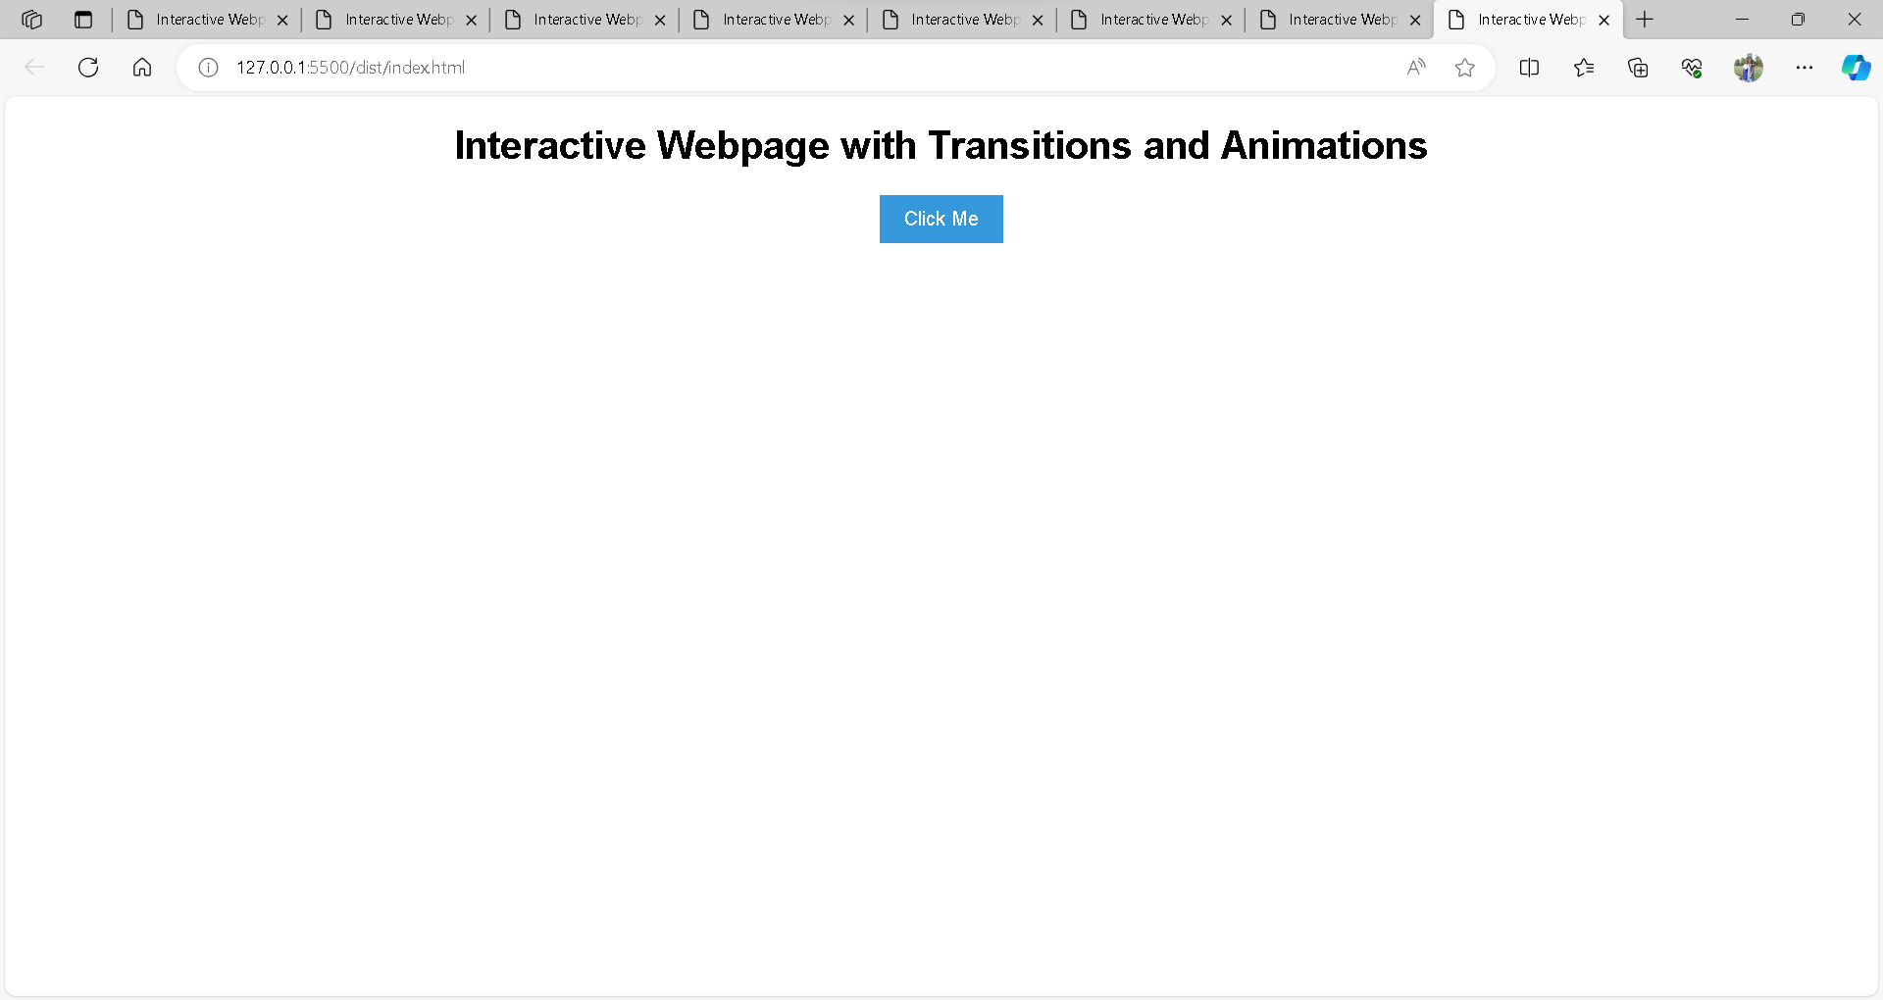

**Source Code:**

<!DOCTYPE html>

<html lang="en">

<head>

<meta charset="UTF-8">

<meta name="viewport" content="width=device-width, initial-scale=1.0">

<title>Interactive Webpage with Transitions and Animations</title>

<style>

/* Basic styling for layout */

body {

font-family: 'Arial', sans-serif;

margin: 20px;

text-align: center;

}

/* Button styling */

button {

padding: 10px 20px;

font-size: 16px;

background-color: #3498db;

color: #fff;

border: none;

cursor: pointer;

transition: background-color 0.3s ease, transform 0.3s ease;

}

button:hover {

background-color: #2980b9;

}

/* Animation keyframes */

@keyframes bounceAnimation {

0%, 20%, 50%, 80%, 100% {

transform: translateY(0);

}

40% {

transform: translateY(-20px);

}

60% {

transform: translateY(-10px);

}

}

/* Apply animation to the button when the 'animateButton' class is added */

.animateButton {

animation: bounceAnimation 1s ease infinite;

}

</style>

</head>

<body>

<h1>Interactive Webpage with Transitions and Animations</h1>

<!-- Button with Transition and Animation -->

<button id="interactiveButton" onclick="animateButton()">Click Me</button>

<script>

function animateButton() {

var button = document.getElementById('interactiveButton');

// Toggle the 'animateButton' class to trigger the animation

button.classList.toggle('animateButton');

// Add a delay to reset the animation after it completes

setTimeout(function () {

button.classList.toggle('animateButton');

}, 1000); // Adjust the time based on your animation duration

}

</script>

</body>

</html>

Exercise 10:

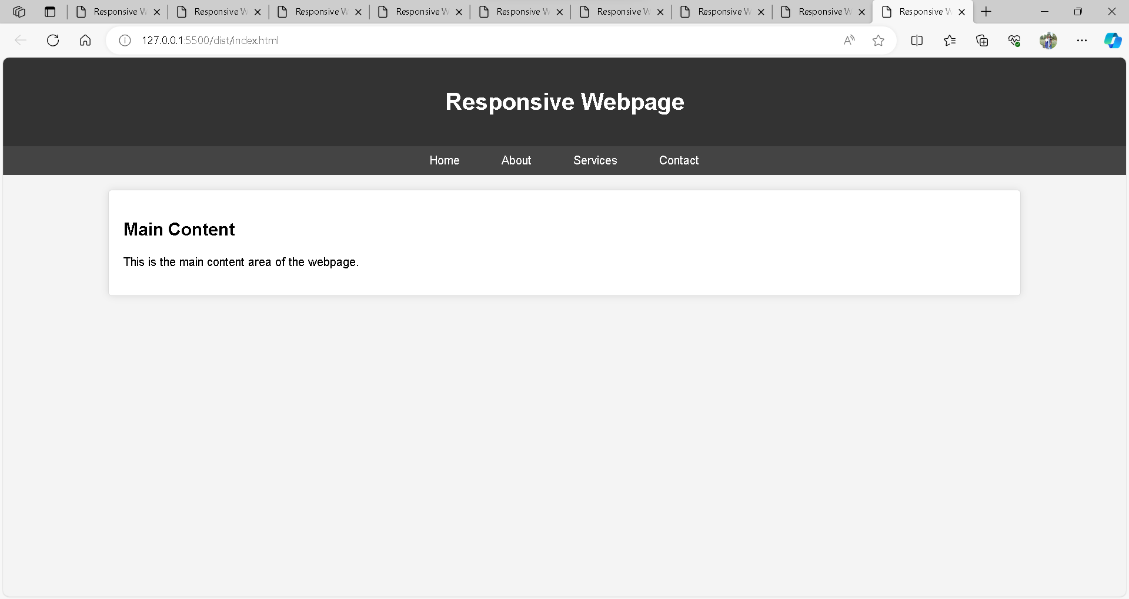

**Source Code:**

<!DOCTYPE html>

<html lang="en">

<head>

<meta charset="UTF-8">

<meta name="viewport" content="width=device-width, initial-scale=1.0">

<title>Responsive Webpage</title>

<style>

/* Basic styling for layout */

body {

font-family: 'Arial', sans-serif;

margin: 0;

padding: 0;

background-color: #f4f4f4;

}

/* Header styling */

header {

background-color: #333;

color: #fff;

text-align: center;

padding: 20px;

}

/* Navigation bar styling */

nav {

background-color: #444;

text-align: center;

padding: 10px;

}

nav a {

color: #fff;

text-decoration: none;

padding: 8px 16px;

margin: 0 10px;

border-radius: 5px;

transition: background-color 0.3s ease;

}

nav a:hover {

background-color: #555;

}

/* Main Content Container */

.main-container {

max-width: 1200px;

margin: 20px auto;

padding: 20px;

background-color: #fff;

border: 1px solid #ddd;

border-radius: 5px;

box-shadow: 0 0 10px rgba(0, 0, 0, 0.1);

}

/* Responsive Layout - Adjustments for smaller screens */

@media screen and (max-width: 600px) {

nav {

display: block;

}

nav a {

display: block;

margin: 5px 0;

}

}

</style>

</head>

<body>

<!-- Header -->

<header>

<h1>Responsive Webpage</h1>

</header>

<!-- Navigation Bar -->

<nav>

<a href="#">Home</a>

<a href="#">About</a>

<a href="#">Services</a>

<a href="#">Contact</a>

</nav>

<!-- Main Content Container -->

<div class="main-container">

<h2>Main Content</h2>

<p>This is the main content area of the webpage.</p>

</div>

</body>

</html>

Web Site:

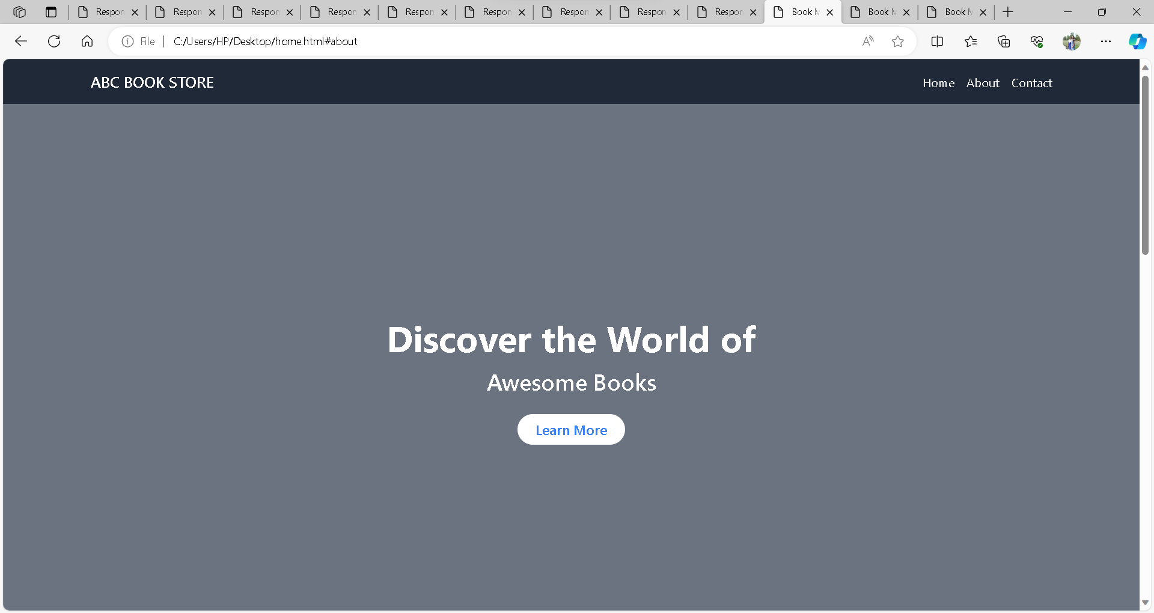

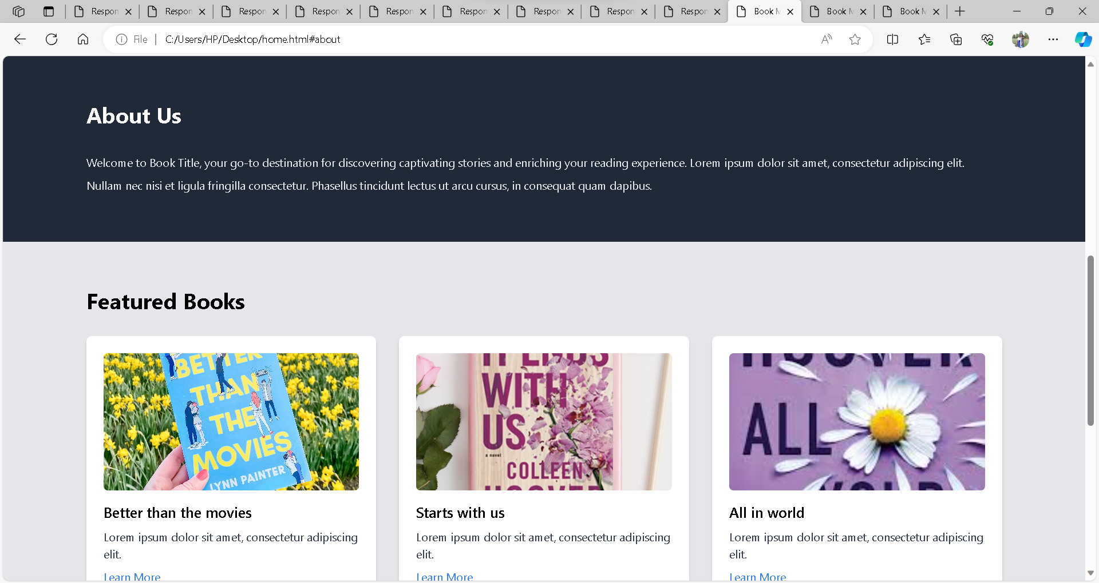

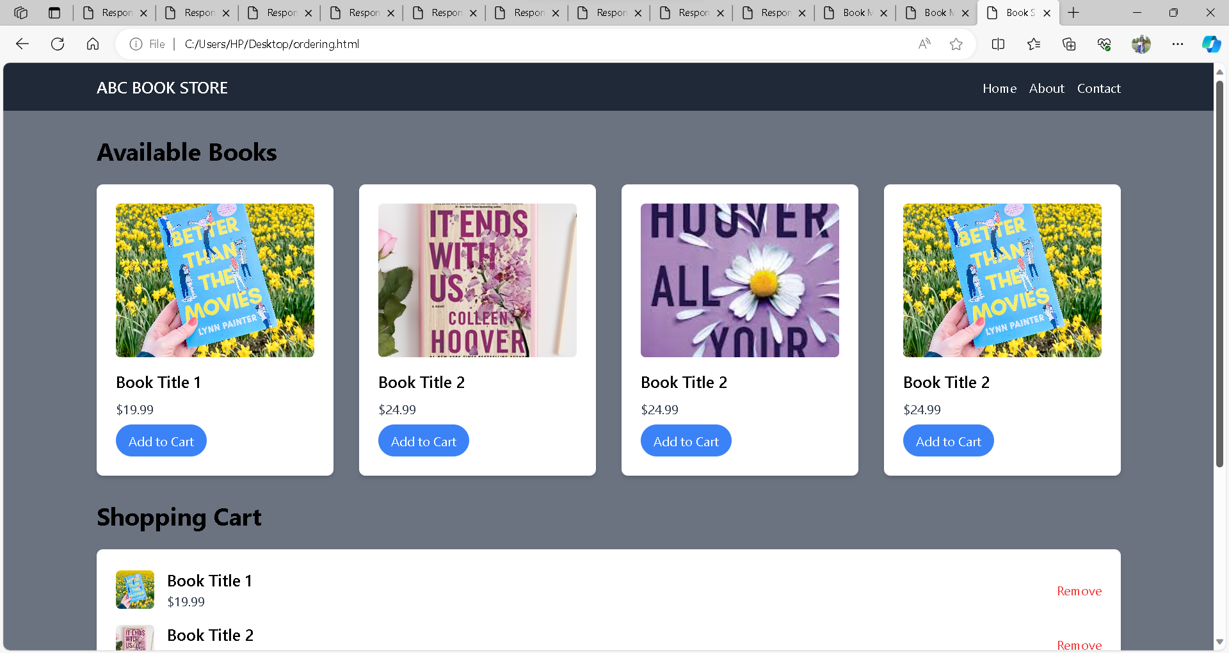

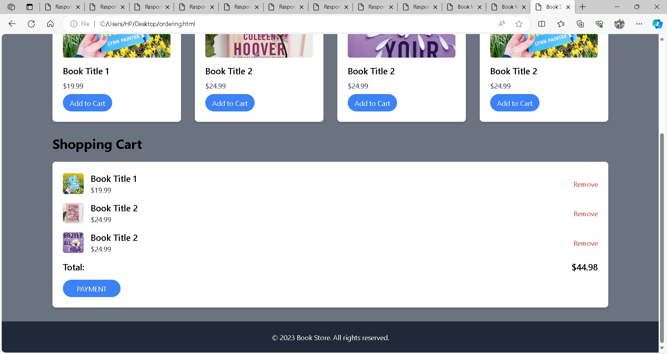

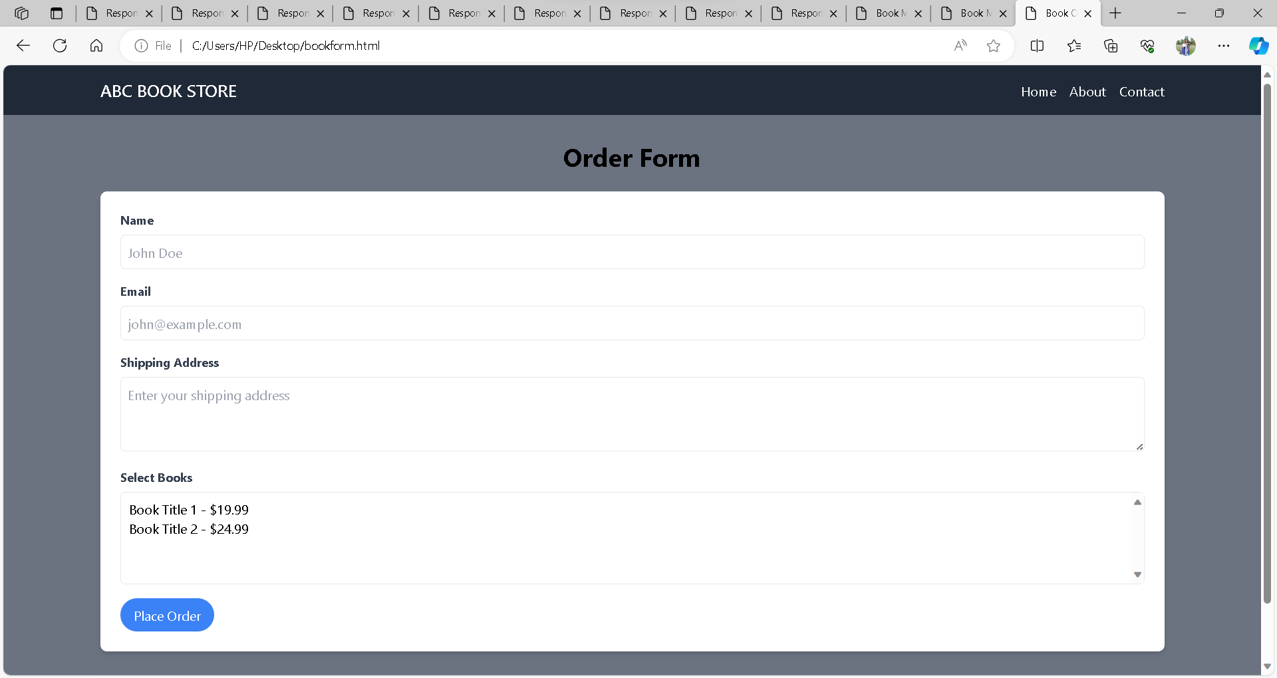

**Source Code:**

<!DOCTYPE html>

<html lang="en">

<head>

<meta charset="UTF-8">

<meta name="viewport" content="width=device-width, initial-scale=1.0">

<title>Book Order Form</title>

<link href="https://cdn.jsdelivr.net/npm/tailwindcss@2.2.19/dist/tailwind.min.css" rel="stylesheet">

</head>

<body class="bg-gray-500 font-sans">

<!-- Navigation -->

<nav class="bg-gray-800 p-4">

<div class="container mx-auto flex justify-between items-center">

<a href="#" class="text-white text-xl font-semibold">ABC BOOK STORE</a>

<ul class="flex space-x-4">

<li><a href="home.html" class="text-white">Home</a></li>

<li><a href="home.html" class="text-white">About</a></li>

<li><a href="home.html" class="text-white">Contact</a></li>

</ul>

</div>

</nav>

<!-- Order Form -->

<section class="container mx-auto my-8">

<h2 class="text-3xl font-bold mb-6 text-center">Order Form</h2>

<form action="#" method="post" class="bg-white p-6 rounded-lg shadow-md">

<!-- Customer Information -->

<div class="mb-4">

<label for="name" class="block text-gray-700 text-sm font-bold mb-2">Name</label>

<input type="text" id="name" name="name" class="w-full p-2 border rounded-md" placeholder="John Doe" required>

</div>

<div class="mb-4">

<label for="email" class="block text-gray-700 text-sm font-bold mb-2">Email</label>

<input type="email" id="email" name="email" class="w-full p-2 border rounded-md" placeholder="john@example.com" required>

</div>

<div class="mb-4">

<label for="address" class="block text-gray-700 text-sm font-bold mb-2">Shipping Address</label>

<textarea id="address" name="address" class="w-full p-2 border rounded-md" rows="3" placeholder="Enter your shipping address" required></textarea>

</div>

<!-- Book Selection -->

<div class="mb-4">

<label class="block text-gray-700 text-sm font-bold mb-2">Select Books</label>

<!-- Replace the book options and values with your actual book details -->

<select name="books[]" multiple class="w-full p-2 border rounded-md">

<option value="book1">Book Title 1 - $19.99</option>

<option value="book2">Book Title 2 - $24.99</option>

<!-- Add more book options as needed -->

</select>

</div>

<!-- Submit Button -->

<button type="submit" class="bg-blue-500 text-white px-4 py-2 rounded-full">Place Order</button>

</form>

</section>

<!-- Footer -->

<footer class="bg-gray-800 text-white py-6">

<div class="container mx-auto text-center">

<p>&copy; 2023 Book Store. All rights reserved.</p>

</div>

</footer>

</body>

</html>

<!DOCTYPE html>

<html lang="en">

<head>

<meta charset="UTF-8">

<meta name="viewport" content="width=device-width, initial-scale=1.0">

<title>Book Marketing</title>

<link href="https://cdn.jsdelivr.net/npm/tailwindcss@2.2.19/dist/tailwind.min.css" rel="stylesheet">

</head>

<body class="bg-gray-500 font-sans">

<!-- Navigation -->

<nav class="bg-gray-800 p-4">

<div class="container mx-auto flex justify-between items-center">

<a href="#" class="text-white text-xl font-semibold">ABC BOOK STORE</a>

<ul class="flex space-x-4">

<li><a href="#" class="text-white">Home</a></li>

<li><a href="#about" class="text-white">About</a></li>

<li><a href="#contact" class="text-white">Contact</a></li>

</ul>

</div>

</nav>

<!-- Hero Section -->

<header class="bg-cover bg-center h-screen flex items-center text-white" style="background-image: url('book_cover.jpg');">

<div class="container mx-auto text-center">

<h1 class="text-5xl font-bold mb-4">Discover the World of</h1>

<h2 class="text-3xl font-semibold mb-8">Awesome Books</h2>

<a href="#about" class="bg-white text-blue-500 px-6 py-2 rounded-full text-lg font-semibold transition duration-300 hover:bg-blue-500 hover:text-white">Learn More</a>

</div>

</header>

<!-- About Section -->

<section id="about" class="py-16 bg-gray-800" id="about">

<div class="container mx-auto">

<h2 class="text-3xl font-bold mb-8 text-white">About Us</h2>

<p class="text-gray-200 leading-loose">

Welcome to Book Title, your go-to destination for discovering captivating stories and enriching your reading experience.

Lorem ipsum dolor sit amet, consectetur adipiscing elit. Nullam nec nisi et ligula fringilla consectetur.

Phasellus tincidunt lectus ut arcu cursus, in consequat quam dapibus.

</p>

</div>

</section>

<!-- Featured Books Section -->

<section class="bg-gray-200 py-16">

<div class="container mx-auto">

<h2 class="text-3xl font-bold mb-8">Featured Books</h2>

<div class="grid grid-cols-1 md:grid-cols-2 lg:grid-cols-3 gap-8">

<!-- Featured Book 1 -->

<div class="bg-white p-6 rounded-lg shadow-md">

<img src="b1.jpg" alt="Book 1" class="mb-4 w-full h-48 object-cover rounded-md">

<h3 class="text-xl font-semibold mb-2">Better than the movies</h3>

<p class="text-gray-700">Lorem ipsum dolor sit amet, consectetur adipiscing elit.</p>

<a href="#" class="text-blue-500 mt-2 inline-block">Learn More</a>

</div>

<!-- Featured Book 2 -->

<div class="bg-white p-6 rounded-lg shadow-md">

<img src="b2.webp" alt="Book 2" class="mb-4 w-full h-48 object-cover rounded-md">

<h3 class="text-xl font-semibold mb-2">Starts with us</h3>

<p class="text-gray-700">Lorem ipsum dolor sit amet, consectetur adipiscing elit.</p>

<a href="#" class="text-blue-500 mt-2 inline-block">Learn More</a>

</div>

<!-- Featured Book 3 -->

<div class="bg-white p-6 rounded-lg shadow-md">

<img src="b3.jpeg" alt="Book 3" class="mb-4 w-full h-48 object-cover rounded-md">

<h3 class="text-xl font-semibold mb-2">All in world</h3>

<p class="text-gray-700">Lorem ipsum dolor sit amet, consectetur adipiscing elit.</p>

<a href="#" class="text-blue-500 mt-2 inline-block">Learn More</a>

</div>

</div>

<br>

<a href="ordering.html" class="bg-gray-500 text-white px-6 py-2 rounded-full text-lg font-semibold transition duration-300 hover:bg-blue-500 hover:text-white w-96 ml-96">Learn More</a>

</div>

</section>

<!-- Contact Section -->

<section class="py-16" id="contact">

<div class="container mx-auto">

<h2 class="text-3xl font-bold mb-8 text-center">Contact Us</h2>

<p class="text-gray-700 leading-loose mb-6 text-center">

Have questions or want to get in touch? <br>Feel free to contact us using the form below or through our email address.

<p class="text-center"><br>Contact: +91 897678923<br>Or<br>E-mail-Abcbookstore@gmail.com</p>

</p>

<form>

<!-- Your contact form goes here -->

</form>

</div>

</section>

<!-- Footer -->

<footer class="bg-gray-800 text-white py-6">

<div class="container mx-auto text-center">

<p>&copy; 2023 Book Title. All rights reserved.</p>

</div>

</footer>

</body>

</html>

<!DOCTYPE html>

<html lang="en">

<head>

<meta charset="UTF-8">

<meta name="viewport" content="width=device-width, initial-scale=1.0">

<title>Book Store - Online Ordering</title>

<link href="https://cdn.jsdelivr.net/npm/tailwindcss@2.2.19/dist/tailwind.min.css" rel="stylesheet">

</head>

<body class="bg-gray-500 font-sans">

<!-- Navigation -->

<nav class="bg-gray-800 p-4">

<div class="container mx-auto flex justify-between items-center">

<a href="#" class="text-white text-xl font-semibold">ABC BOOK STORE</a>

<ul class="flex space-x-4">

<li><a href="home.html" class="text-white">Home</a></li>

<li><a href="home.html" class="text-white">About</a></li>

<li><a href="home.html" class="text-white">Contact</a></li>

</ul>

</div>

</nav>

<!-- Book Items -->

<section class="container mx-auto my-8">

<h2 class="text-3xl font-bold mb-6">Available Books</h2>

<div class="grid grid-cols-1 md:grid-cols-2 lg:grid-cols-3 xl:grid-cols-4 gap-8">

<!-- Book 1 -->

<div class="bg-white p-6 rounded-lg shadow-md">

<img src="b1.jpg" alt="Book 1" class="mb-4 w-full h-48 object-cover rounded-md">

<h3 class="text-xl font-semibold mb-2">Book Title 1</h3>

<p class="text-gray-700">$19.99</p>

<button class="bg-blue-500 text-white mt-2 px-4 py-2 rounded-full">Add to Cart</button>

</div>

<!-- Book 2 -->

<div class="bg-white p-6 rounded-lg shadow-md">

<img src="b2.webp" alt="Book 2" class="mb-4 w-full h-48 object-cover rounded-md">

<h3 class="text-xl font-semibold mb-2">Book Title 2</h3>

<p class="text-gray-700">$24.99</p>

<button class="bg-blue-500 text-white mt-2 px-4 py-2 rounded-full">Add to Cart</button>

</div>

<!-- Book 3 -->

<div class="bg-white p-6 rounded-lg shadow-md">

<img src="b3.jpeg" alt="Book 2" class="mb-4 w-full h-48 object-cover rounded-md">

<h3 class="text-xl font-semibold mb-2">Book Title 2</h3>

<p class="text-gray-700">$24.99</p>

<button class="bg-blue-500 text-white mt-2 px-4 py-2 rounded-full">Add to Cart</button>

</div>

<!-- Book 2 -->

<div class="bg-white p-6 rounded-lg shadow-md">

<img src="b1.jpg" alt="Book 2" class="mb-4 w-full h-48 object-cover rounded-md">

<h3 class="text-xl font-semibold mb-2">Book Title 2</h3>

<p class="text-gray-700">$24.99</p>

<button class="bg-blue-500 text-white mt-2 px-4 py-2 rounded-full">Add to Cart</button>

</div>

<!-- Add more book items as needed -->

</div>

</section>

<!-- Shopping Cart -->

<section class="container mx-auto my-8">

<h2 class="text-3xl font-bold mb-6">Shopping Cart</h2>

<div class="bg-white p-6 rounded-lg shadow-md">

<!-- Display added items and total price here -->

<!-- Example: -->

<div class="flex justify-between items-center mb-4">

<div class="flex items-center">

<img src="b1.jpg" alt="Book 1" class="w-12 h-12 object-cover rounded-md mr-4">

<div>

<h3 class="text-xl font-semibold">Book Title 1</h3>

<p class="text-gray-700">$19.99</p>

</div>

</div>

<button class="text-red-500">Remove</button>

</div>

<div class="flex justify-between items-center mb-4">

<div class="flex items-center">

<img src="b2.webp" Book 2" class="w-12 h-12 object-cover rounded-md mr-4">

<div>

<h3 class="text-xl font-semibold">Book Title 2</h3>

<p class="text-gray-700">$24.99</p>

</div>

</div>

<button class="text-red-500">Remove</button>

</div>

<div class="flex justify-between items-center mb-4">

<div class="flex items-center">

<img src="b3.jpeg" Book 2" class="w-12 h-12 object-cover rounded-md mr-4">

<div>

<h3 class="text-xl font-semibold">Book Title 2</h3>

<p class="text-gray-700">$24.99</p>

</div>

</div>

<button class="text-red-500">Remove</button>

</div>

<!-- Display total price and checkout button -->

<div class="flex justify-between items-center">

<p class="text-xl font-semibold">Total:</p>

<p class="text-xl font-semibold">$44.98</p>

</div>

<a href="bookform.html"><button class="bg-blue-500 text-white mt-4 px-8 py-2 rounded-full">PAYMENT</button>

</div>

</section>

<!-- Footer -->

<footer class="bg-gray-800 text-white py-6">

<div class="container mx-auto text-center">

<p>&copy; 2023 Book Store. All rights reserved.</p>

</div>

</footer>

</body>

</html>