**Introduction**

The following documentation describes the process of setting up and using Minikube to run a Kubernetes cluster on a local development environment. This includes installing Minikube, starting the Minikube cluster, deploying an application, exposing the application via a service, and accessing the service.

**Code and Explanation:**

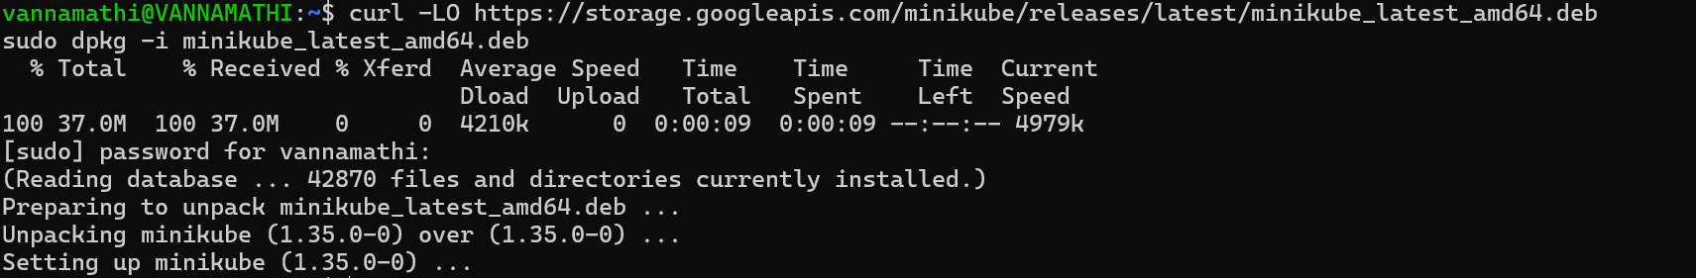

curl -LO https://github.com/kubernetes/minikube/releases/latest/download/minikube-linux-amd64

sudo install minikube-linux-amd64 /usr/local/bin/minikube && rm minikube-linux-amd64

**curl -LO**: Downloads the latest Minikube release for Linux.

**sudo install**: Installs Minikube to the /usr/local/bin directory.

**rm**: Removes the downloaded file after installation to clean up.

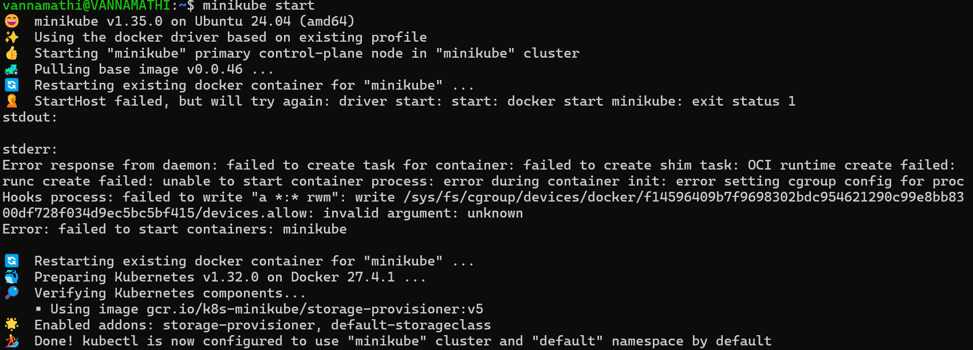

minikube start

**minikube start**: Initializes and starts a Minikube cluster using the Docker driver with the default configurations.



kubectl create deployment my-deployment --image=nginx

**kubectl create deployment**: Creates a new deployment named my-deployment using the Nginx image.

kubectl get pods

**kubectl get pods**: Lists all the pods in the default namespace, showing their current status and other information.



kubectl expose deployment my-deployment --type=NodePort --port=80

kubectl expose deployment: Exposes the deployment my-deployment as a service accessible on port 80 using NodePort.

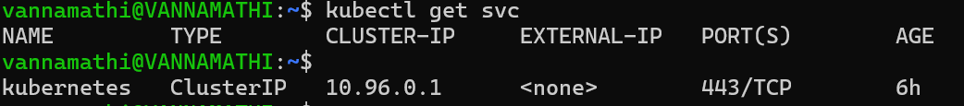

kubectl get svc

**kubectl get svc**: Lists all the services in the default namespace, showing their type, cluster IP, external IP, ports, and age.

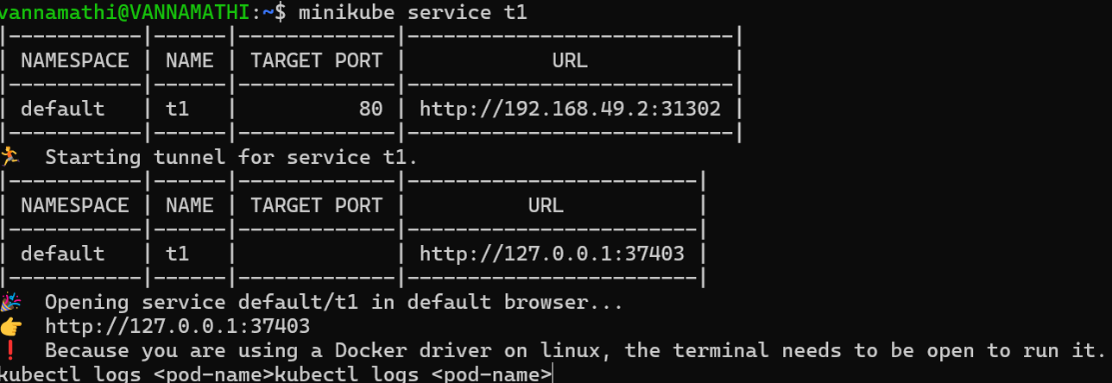

minikube service my-deployment

**minikube service**: Opens the service my-deployment in the default web browser, providing a URL to access it.

The command minikube service my-deployment --url is used to retrieve the URL for accessing a specific service running on a Minikube cluster. Here's a breakdown of each part of the command:

* **minikube**: This is the command-line tool for managing a local Kubernetes cluster using Minikube.
* **service**: This subcommand is used to interact with services in the Minikube cluster.
* **my-deployment**: This is the name of the service you want to access. It must match the name of the service you have created and exposed in your Minikube cluster.

**Output**

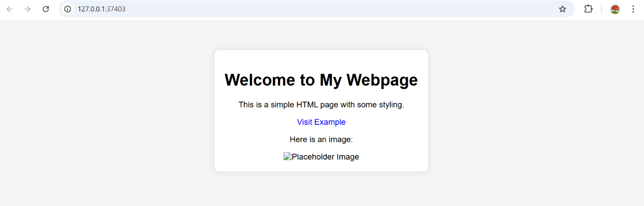

**Conclusion**

This documentation provides a step-by-step guide to setting up Minikube, creating a deployment, and exposing the deployment as a service. It covers the essential commands needed to start working with Minikube and Kubernetes in a local development environment.