***Project Ideas:***

***Why did we choose this project and why is it realistic?***

We have a lot of discussion toward the idea of what to choose as our project ideas and finally, we have ended up choosing to create an application with the topic of “smart home”. the main purposes of this apps are to keep track of expiry dates of the refrigerator’s food and at the same time help the user to reduce the food wastage by recommending some approachable options toward those foods, such as recommend cooking recipe and so on. And the application will be call Exp-food

Before actually choosing this project, we have done some research online and found out about the fact that this project is quite popular and the needs for a solution to this problem is quite substantial since most people usually fail to keep track with the expire a date of the food them bought, or sometimes they just completely forgot about the fact that they have already had that food at home and not until did they have bought a tons more of those food and brought those home did they realized that there have already been an abundant more of those things at home, and at the end of the day, most of the time when people encounter these situation, the scenario where those food being waste and went expired is almost inevitable.

Due to the urge of wanting to prevent this dilemma from disturbing the life of people any further, we have decided to take on this project idea.

The functionality of the application:

Our group believed that this invention will change people’s bad habits when it comes to grocery shopping and their food consumption. Exp-food will consist of a “my storage” section where it contains the food that the users have at home, a shopping list that will take the user input about their grocery buying list and this list will point out what food they have already have automatically based on the “my storage” section in case the user forgot to check it. After having bought all the product they need, exp-food will allow them to scan their shopping receipt and purchase information will be updated to the “my storage” section. Whenever an item is close to the expiry date, exp-food will send notification as well as the reminder to look at the “Recipes” section to know what to do with the nearly expired item.

When user access exp-food, what will be shown first is the calendar screen which will have a red mark on the date of which food will be expired and below the calendar is the mentioned above sections.

In the future, we also decided to add more features in order to make this app even more beneficial to users such as the information about the upcoming sales for the grocery store that they usually go to (they have to give us the information) because based on the online statistics, people is more interested in buying sale items and wanted to have this feature to the apps more than comparing to others additional feature such as health ratings, shopping list, etc…

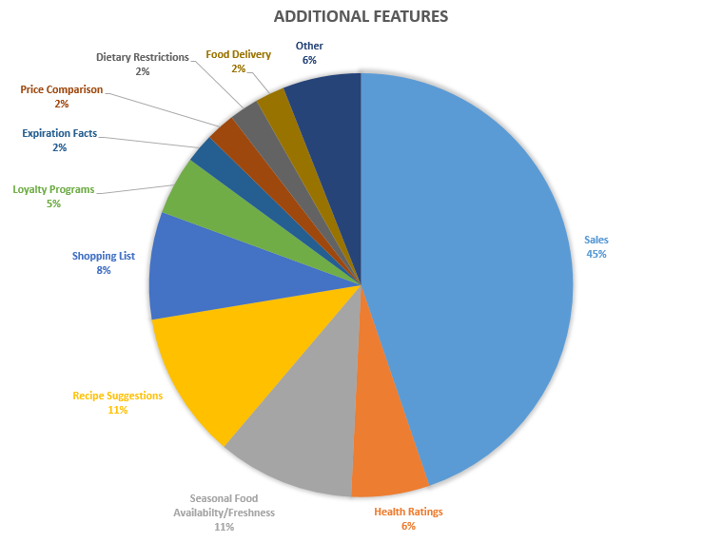

[Sierra Semel](https://challenges.openideo.com/profiles/57cca337e4f7f213101ee86a1473028921998), Additional features ,Accessed Oct 15, 2016:<https://media-openideo-rwd.oiengine.com/media/770/contribution/24891/2d8bf710-b551-4dbb-bedb-8960d0ce4433.png>