**SCOPE AND LIMITS**

The main theme of our game is a battle between player (a spacecraft) and a technologically advanced race of alien (we are considering to make these aliens look like food: pizza, donut, pickle etc.) who are intent on destroying Earth.

We are planning to develop 2 game modes in our game: Adventure and Survival. In adventure mode, there will have 150 waves in 10 levels across 15 planets, at the end of each chapter (planet) will have a boss which must be defeated in order to get to a new planet. Normal enemy will be flying around and shooting things (for example, pizza will shoot pepperoni), we will try to make different flying patterns so that the game won’t get tedious, we will also try to create some types of enemy that carrying gadget and slightly smarter than the rest, if possible.

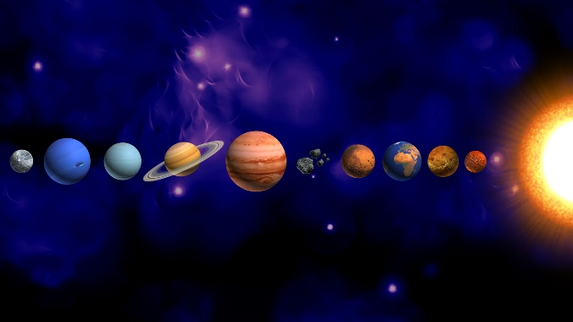 

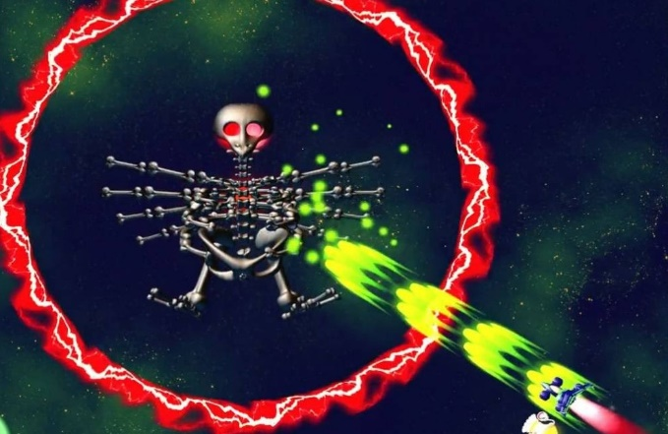

This game will have several different types of ammo that resemble boxes with the ammo`s logo on it, these boxes will be drop randomly while fighting with enemy. Player can upgrade their ammo by eating these boxes or the “power up”- might look like this:

We will also try to add some skills into the game for the player such as time manipulating, invincibility, etc. each skill can last for about 10 or 15 seconds (with some cool animation and art). Along with this, there will be some more features added to our game to make it more interesting such as customizing the spacecraft.

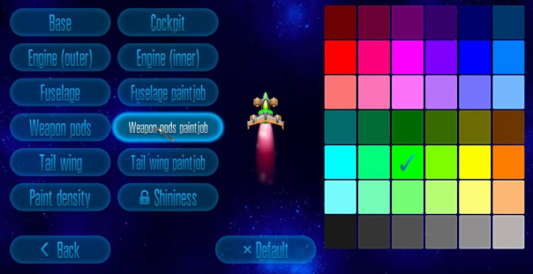

There will be a special feature in survival mode, the capability of the spacecraft to face in any direction (it can only face up in adventure mode). The gameplay will be endless, difficulty will increase each time player get to a new chapter: enemy will fly and shooting faster.

Our aim is to make a classic game just like old times, however, we still make something new so that our game can be more unique and interesting. The game can be described as “a combination of the old and the new”, a balance between classic and modern, and what is modern about this game is those mentioned features we are planning to add into our game in the near future.

That is our plan to develop our game in the future, as we don’t have enough time (and skills), the main goal for this game is that we are going to add these features into the game and then we will try to make stunning graphic for it. At present time, our game has just been 10% completed but we hope that we can develop our game just like we’ve wanted or even better, if possible we will try to make our own soundtrack for this game. We will develop the game based on the plan and after that we will stop upgrading this game as we want to try several more genres of offline game to gain experience, we still have a lot more to learn and we all agree that we need to try many more times before being able to make an actual proper one.