**Physical Training Documentation:**

* **Day1:**

**OpenLane Directory Structure:**

Below is pdk directory structure:

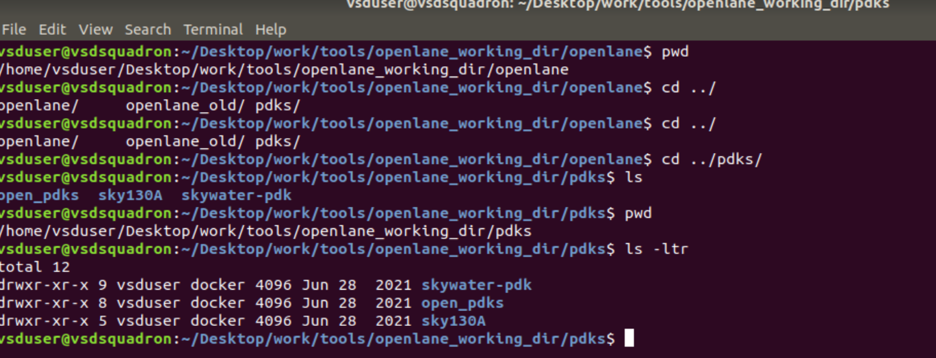

* Below is the openlane flow run area:

