Software Project Management Plan (SPMP)

Software Project Management Plan for

Rent Portal

Adebayo Abayomi

10/02/2020

Version Release Responsible Party Major Changes Date

0.1 Initial Document Release for Comment

# Table of Contents

* 1. Project Overview

The rent portal will be used by both tenants and apartment complexes. The tenants will be able to make rent, set up automatic payments, initiate work orders and lodge complaints with the leasing management. The apartment complex will be able to view complaints and address tenants via a separate email portal. In addition, they can change the status of work orders to completed as well as add fees such as late fees, party fees, fines etc. to tenant’s account.

* 1. Project Deliverables

Project Design Tasks 1-4(10/16/2020).

Individual Project Presentations Part I (11/24/2020).

Individual Project Presentations Part II (12/1/2020).

Source Code (12/1/2020).

* 1. Evolution of the SPMP

Changes will be made on Github through commits and pulls. New versions will be explained on Github Documents to.

* 1. Reference Materials
  2. Definitions and Acronyms

LO- Leasing Office.

SPMP - Software Project Management Plan.

RP – Rent Portal.

OOP – Object Oriented Programming.

# Project Organization

* 1. Process Model

Agile Life Cycle Model is used for this project. The project will be designed using AGILE approach to software design in order to tackle minor problems that might occur since the software is being built from scratch.

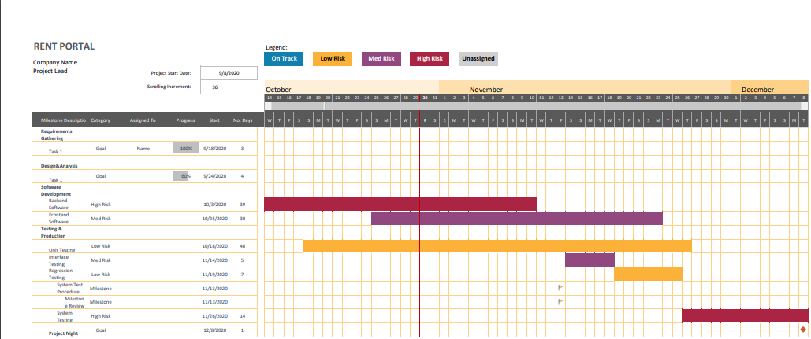

* 1. Organizational Structure

Private Contract, Contractor answers only to Client.

Figure F-2: Organization Chart

* 1. Organizational Interfaces

Organization Liaison Contact Information Customer: Dr.Broadwater Bayo School email.

Table F-1. Project Interfaces

* 1. Project Responsibilities

Role Description Person Developer Handles entire project Bayo

Table F-2. Project Responsibilities.

# Managerial Process

* 1. Management Objectives and Priorities

Laissez faire approach, project priority is given to Commercial functionality to ensure Tenants can pay LO.

|  |  |  |  |
| --- | --- | --- | --- |
| Project Dimension | Fixed | Constrained | Flexible |
| Cost |  | X |  |
| Schedule | X |  |  |
| Scope (functionality) |  |  | X |

Table F-3: Flexibility Matrix

* 1. Assumptions, Dependencies, and Constraints

-Program is made using OOP.

-Schedule is fixed, Deadline not flexible.

-$10 Budget for web hosting

* 1. Risk Management

-Client Acceptance (Ask Client what features they would like to see implemented in version 2).

-Project Size (Try to Scale down Project to core functionality).

-Requirements Creep (Implement regression testing to get rid of unnecessary functions).

* 1. Monitoring and Controlling Mechanisms

Client will be given access to GitHub to monitor changes.

Information From To Time Period Communicated

Weekly Deliverables Team Client Weekly

Table F-4: Communication and Reporting Plan

* 1. Staffing Approach.

Full Stack Developer (Python, Javascript, Django Framework, React.js Framework).

# Technical Process

* 1. Methods, Tools, and Techniques

OOP approach.

Regression testing with commercial functions given priority.

IDEs: Visual Studio Code, Netbeans.

BACKEND: Python, Django.

FRONTEND: Javascript, REACT.js.

HOSTING TOOL: Github

* 1. Software Documentation

-Documents will be in APA Format.

-Uploaded to Github.

-Regression Testing Documentation.

-Requirements Documentation.

To ensure that the implementation of the software satisfies the requirements, the following documentation is required as a minimum:

* 1. Project Support Functions

-Configuration Management plan will prevent others from uploading Documents/Editing Source code without Developer permission.

-Versioning will be implemented.

-Client can only view Source Code.

-Quality Assurance is ensured through daily regression tests with different inputs.

-Verification plan ensures User Authentication program is in place.

# Work Packages, Schedule, and Budget

* 1. Work Packages

Activity Oriented Decomposition.

* 1. Dependencies

Order of Work Package development

1. Requirements Gathering
2. Design & Analysis.
3. Software Development.
   1. Backend Software
      1. Database Implementation.
      2. Transaction Processing.
   2. Frontend Software

3.2.1 User Interface

1. Testing & Production.

4.1 System Testing