## 

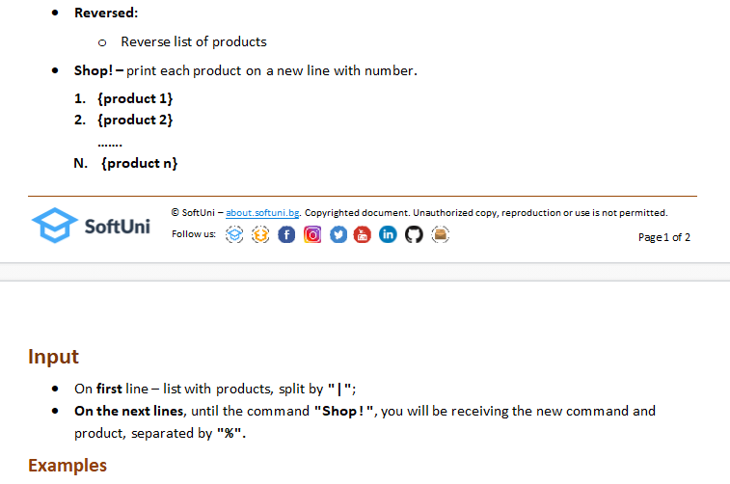

## Examples

|  |  |
| --- | --- |
| **Input** | **Output** |
| eggs|milk|bread|fish  Important%bread  Swap%eggs%tomato  Shop! | Product tomato missing!  1. bread  2. eggs  3. milk  4. fish |
| apple|cheese|salt|bananas  Remove%cheese  Swap%salt%bananas  Shop! | 1. apple 2. bananas 3. salt |

## JS Input / Output

The input will be an array of strings.

|  |  |
| --- | --- |
| **Input** | **Output** |
| (["eggs|milk|bread|fish",  "Important%bread",  "Swap%eggs%tomato",  "Shop!"]) | Product tomato missing!  1. bread  2. eggs  3. milk  4. fish |
| (["apple|cheese|salt|bananas",  "Remove%cheese",  "Swap%salt%bananas",  "Shop!"]) | 1. apple 2. bananas 3. salt |