**Beckhoff**

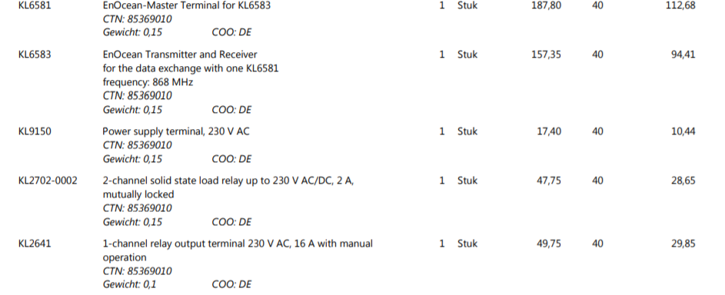

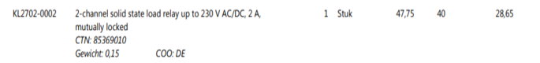

KL3022 2-channel analog input terminal 4…20 mA, differential input, 12 bit 2 stuk

EL3068 8-channel analog input terminal 0…10 V, single-ended, 12 bit, 1-wire system 1 stuk

3x Enocean iTRV MVA004