1. Title of the invention:

Technical System and Method for State-Bound Admission Control of Autonomous Recovery Operations

2. Field /Area of invention:
The invention concerns execution control in distributed computing systems, particularly replay and remediation of faults in retrieval-augmented generation and agent pipelines. It addresses the relationship between a recovery request, its recorded execution state, the authority of its evidence, and the worker permitted to execute it. The reference implementation is named DriftGuardX.

3. Prior Patents and Publications from literature (provide a table summarizing the prior art)
The following references identify relevant technical overlap. The proposed distinction is the specific admission and refusal relationship described in Sections 6 and 7. Novelty has not been established by this comparison. Publication and priority chronology must be assessed against the applicant's actual dates.
Reference | Relevant disclosure | Relationship to the proposed system
P1 CN121681201A  Published 17 March 2026 | Dependency topology, counterfactual root-cause selection, environment reconstruction and isolated replay repair. | The broad diagnosis and replay-repair workflow overlaps. The receipt claim requires a separate comparison of worker verification and lifecycle restrictions.
P2 EP4369195A1  Publication kind A1 | Parallel execution of audited privileged actions on worker nodes, with execution records and approval information. | Auditing and worker dispatch are established. An execution audit alone does not establish the proposed distinction.
P3 US8301779B2  Publication kind B2 | Timestamp-based resource reservation and detection of changes before shared-resource access. | Reservation, expiry and stale-state checks have prior art. Recovery-specific combinations still require inventive-step analysis.
P4 US20210271998A1  Published 2 September 2021 | Distributed provenance logs and probabilistic execution ordering for queries, replay and rollback. | Provenance with replay or rollback cannot alone support a novelty assertion.

A1 and A identify published applications; B2 identifies a granted publication. These identifiers do not determine enforceability, family scope or relevance to the applicant's priority date. Primary source links follow on the continuation page.
Reference | Relevant disclosure | Relationship to the proposed system
P5 CN121187728A | A versioned task plan containing task and resource information, scheduling constraints, rollback and audit information. | Binding execution, resource and rollback data in one plan is a close comparison area. The claim must specify how the recovery worker refuses mismatched state.
R1 Badanidiyuru, Kleinberg and Slivkins  Bandits with Knapsacks, 2013 | Sequential reward-seeking decisions subject to consumable resource constraints. | Budgeted candidate selection is established. The present disclosure does not claim a new bandit algorithm.
R2 Torres-Arias et al.  in-toto, USENIX Security 2019 | Verification of software supply-chain provenance from development through deployment. | Cryptographic provenance is established. An ordinary hash or signature is not the claimed contribution.

Primary sources
P1 Automatic data anomaly root cause positioning and replayable repairing method
P2 Parallel execution of audited privileged actions across worker nodes
P3 Shared-resource access using a single timestamp
P4 Distributed probabilistic eidetic querying, rollback, and replay
P5 Intent recognition-based task scheduling and execution
R1 Bandits with Knapsacks, arXiv 1305.2545
R2 in-toto, USENIX Security 2019, pp. 1393-1410

Search scope and unresolved comparison
The technical review examined published descriptions concerning counterfactual repair, resource reservation, audited execution, task-plan binding and provenance. The patent pages above reproduce published patent documents; translations and legal-status summaries require checking against the original records. No exhaustive Indian patent-family search, prosecution-history review or freedom-to-operate analysis has been completed.
The main unresolved question is whether an earlier disclosure combines complete worker-side verification, an evidence ceiling and a single-use recovery receipt. That combination is the proposed contribution. The implementation and its limits are described below.

4. Summary and background of the invention (Address the gap / Novelty)
A recovery operation can wait in a queue after a controller approves it. During that interval, the recorded trace, selected component version or replay configuration may change. If the worker executes the queued request without checking those conditions again, the operation may no longer correspond to the state that the controller evaluated. Duplicate delivery creates another risk: two workers can attempt the same admitted operation.
DriftGuardX associates the operation with a durable admission receipt. The receipt records the tenant, replay manifest, trace identity, intervention identity, source and target versions, policy reference, capsule reference, cost terms, evidence ceiling and expiry. Before replay construction, the worker loads execution records and submits the required bindings to a transactional verifier. The verifier refuses missing or changed values and permits only an unexpired receipt in the ISSUED state to become VERIFIED.
The receipt separates an admission decision from the later right to execute. A controller can prepare a proposed recovery action, but the action remains dormant until the worker presents the same state-bound identity to the receipt store. This arrangement places the refusal point before the replay executor creates a capsule or applies an action. The worker therefore receives a concrete authorization result rather than relying on an earlier queue message as continuing proof that execution is safe.
The candidate technical contribution is this relationship between a durable receipt, a complete worker-side comparison and a single successful claim. The mechanism is intended to stop stale or duplicate recovery work at dispatch. Hashing, optimistic concurrency, reservations and audit trails are individually established techniques; the potentially protectable subject is the specific recovery-control arrangement, subject to comparison with the references in Section 3.
The implemented scope is narrower than a complete distributed transaction protocol. Receipt state and event records are durable, while budget reservation and reconciliation remain in a process-local ResourceContext. The replay worker reconstructs trace and intervention identities, but some other bindings are stored references or caller-supplied values. These distinctions affect the scope of any claim and are described in Section 7.
In practical terms, the technical problem is a stale authorization crossing an asynchronous boundary. The technical means is a database-backed, state-bound receipt that can be claimed once only after the worker provides a complete binding set. The intended technical effect is to prevent a worker from dispatching a recovery operation when the recorded state no longer agrees with the state on which the admission was based. The tests in Section 8 support specific refusal and contention behavior; they do not establish a production-wide failure-rate reduction.

5. Objective(s) of Invention
- Associate each replay admission with the exact recorded tenant, trace, manifest and intervention versions evaluated for that operation.
- Reject incomplete, mismatched, expired or previously claimed receipts before construction of the guarded replay executor.
- Prevent two processes sharing the reference receipt database from successfully claiming the same receipt.
- Restrict the evidence classification requested at verification to the classification ceiling recorded at admission.
- Retain an ordered event record that explains each issue, successful verification, refusal and terminal state change.
- Carry explicit cost and rollback-reserve terms with the receipt, providing a basis for subsequent deployment-level metering and reconciliation.

6. Working principle of the invent (in brief)
The control point lies between queue delivery and replay-engine construction. A successful admission in the controller does not, by itself, authorize the worker to proceed. The worker must claim the durable receipt after comparing the required recorded state.
The process is deliberately split into preparation, persistence, verification, dispatch and finalization. Persisting a receipt makes the admission decision recoverable after a worker restart. Verification consumes the right to begin the guarded operation, while finalization records what became of that claim. A worker that receives a refusal does not enter the replay construction path and must obtain a fresh admission after the underlying state has been reviewed again.
Stage | Component and operation
101 Prepare | Controller resolves the tenant, replay manifest and proposed intervention; the receipt object obtains a local reservation.
102 Persist | Receipt store inserts the canonical payload and ISSUE event within one SQLite transaction.
103 Reload | Replay worker loads tenant-scoped execution records and recomputes trace and intervention identities.
104 Verify and claim | Store compares all eight mandatory identity bindings, expiry, status and supplied evidence class; a valid receipt becomes VERIFIED atomically.
105 Dispatch or refuse | Successful verification permits replay construction. A refusal returns an error before that construction and records the reason for an existing receipt.
106 Finalize | The owner path records CONSUME on success or a terminal failure transition; the audit sequence retains the transition.

Figure 1. Reference execution sequence. Stages 102 and 104 each have a local database transaction. The figure does not imply one transaction spanning the queue, execution-state database, receipt database and external system.

Admission and evidence rules
$Q = C + U + R$
Q is the local amount reserved for the receipt, C is predicted cost, U is a non-negative uncertainty margin and R is a non-negative rollback allowance. The receipt validates finite, non-negative cost terms. The local ResourceContext admits the reservation only when spent cost plus existing reservations plus Q does not exceed its budget.
$rank(E_requested) ≤ rank(E_ceiling)$
The implementation orders evidence as UNVERIFIED, TEST_FIXTURE, SYNTHETIC_SIMULATION, REAL_CONTROLLED_EXPERIMENT and PRODUCTION. When the caller supplies an evidence class, an upward promotion is refused. The ranking is an authority check defined by the application; it is not a statistical measure of evidence quality.
A receipt can therefore carry both operational identity and an upper bound on the authority asserted for the recovery. This stops a caller from using a receipt admitted under controlled-experiment conditions to request a production-authority action through the same verification interface. The receipt does not infer evidence quality from content; it compares the declared class with the stored ceiling. That limitation is intentional and should be preserved when the mechanism is extended.

7. Description of the invention in detail (Include drawing and or photograph as needed)

7.1 Receipt and storage structures
ReplayAdmissionReceipt exposes a canonical payload and a domain-separated SHA-256 digest. The payload is encoded as JSON with sorted keys and compact separators. The receipt identifier and lifecycle status are stored separately from the canonical payload. The current serializer is the implementation contract; interoperability with another language would require matching its string, numeric and timestamp representations.
Field group | Stored fields | Purpose at the control boundary
Ownership | tenant_id | Associate the operation with the tenant supplied to the verifier.
Replay identity | manifest_hash; trace_root_hash | Identify the selected replay manifest and the recorded trace content.
Intervention | intervention_hash; current_version; candidate_version | Identify the operation and its source and target versions.
Execution conditions | policy_hash; capsule_hash | Compare the policy and capsule references with the admitted values.
Cost terms | predicted_cost; uncertainty_margin; rollback_reserve | Preserve the inputs to the local reservation calculation.
Authority and time | evidence_ceiling; issued_at; expires_at | Limit evidence authority when supplied; reject claims at or after expiry.
Lifecycle metadata | receipt_id; binding_hash; status; created_at; terminal_at | Locate and transition the persisted receipt.

7.2 Canonical identity
$D_receipt = SHA256(domain_receipt || JSON_canonical(payload))$
The receipt domain is DGX-REPLAY-ADMISSION-V1 followed by a null byte. A separate DGX-REPLAY-INTERVENTION-V1 domain covers intervention identifier, target component, current version and candidate version. The replay worker recomputes that intervention digest from its loaded intervention record.
The admission_receipts table has a primary key on receipt_id and a unique binding_hash. It stores the payload as JSON and the reserved amount as a numeric column. The admission_audit_events table links to the receipt, enforces a unique sequence per receipt and retains each event's content and predecessor hash. Persisting the numeric amount records the reservation terms; it does not create a durable account balance.
The unique binding_hash prevents two independently issued receipt rows from representing the same complete identity binding. The receipt identifier supports lookup and lifecycle operations, whereas the binding hash protects the semantic identity of the admitted operation. Keeping those two values separate permits a verifier to reject a reused or conflicting receipt while retaining an auditable record of the original request.

7.3 Verification and lifecycle transitions
AdmissionReceiptStore.verify executes under BEGIN IMMEDIATE, which serializes writers to the shared SQLite file. A missing receipt returns a refusal. For an existing receipt, the method first checks that status is ISSUED and the current time precedes expires_at. It then compares the eight mandatory identity fields listed in Section 7.1 and refuses an incomplete field set. Each comparison accepts either equal values or equal string representations; no independent attestation is implied by that comparison.
Current state | Condition or request | Result and event
Absent | Issue new receipt | ISSUED; append ISSUE atomically with insertion.
ISSUED | All required checks pass | VERIFIED; append VERIFY in the claim transaction.
ISSUED | Mismatch, omission, expiry or excessive evidence rank | VOIDED; append MISMATCH_REFUSAL then VOID.
VERIFIED or terminal | Another verification attempt | Refuse and append MISMATCH_REFUSAL; retain existing status.
VERIFIED | Consume request | CONSUMED; append CONSUME.
ISSUED or VERIFIED | Release or void request | RELEASED or VOIDED; append the matching terminal event.
Terminal | Further terminal request | Retain status; no additional terminal event.

Figure 2. Permitted reference-store transitions. Duplicate verification cannot revoke a worker's existing claim. Terminal methods currently take a receipt identifier without a worker ownership token; an ownership lease is a proposed extension, not a demonstrated feature.

7.4 Audit verification
$H_i = SHA256(domain_audit || JSON_canonical(event_i))$
The audit domain is DGX-ADMISSION-AUDIT-V1 followed by a null byte. Event content includes receipt identifier, sequence, type, predecessor hash, reason, details and timestamp. verify_event_chain recomputes hashes and checks consecutive numbering and predecessor links. It detects the tested content mutation and inconsistent internal linkage.
Append-only behavior is enforced by the service interface. There are no database triggers or external witnesses preventing an administrator from rewriting the chain. The verifier cannot establish authenticity against an actor who replaces the records and recomputes their hashes, and it cannot prove that an otherwise valid tail has not been removed without an independently retained terminal hash.
The audit trail is useful for reconstruction of an observed receipt lifecycle: it can identify whether a receipt was issued, verified, consumed, released or voided, together with the recorded reason for a refusal. It is not a substitute for an external, tamper-evident evidence service. A deployment that requires adversarial audit protection would need authenticated event writers and periodic anchoring of terminal hashes outside the receipt database.

7.5 Logical architecture
The architecture separates proposal preparation from execution permission. Reference numeral 100 identifies the admission controller, which prepares an operation-specific receipt request. The controller transmits the canonical receipt payload and declared identity bindings to the durable receipt store 120. The persistent store is the admission decision point: it creates the receipt record and its ISSUE audit event before a worker is entitled to rely on that decision.
The execution-record source 110 identifies the selected replay manifest, recorded trace, intervention data, policy reference and other pinned state needed at dispatch. The replay worker 140 reloads those inputs, rather than relying only on the controller message, and sends recomputed bindings to the atomic verifier 150. Verifier 150 receives the stored receipt bindings from store 120, compares the mandatory fields and changes the receipt status only when the complete set matches. Thus, the comparison occurs at the execution boundary after state reconstruction.
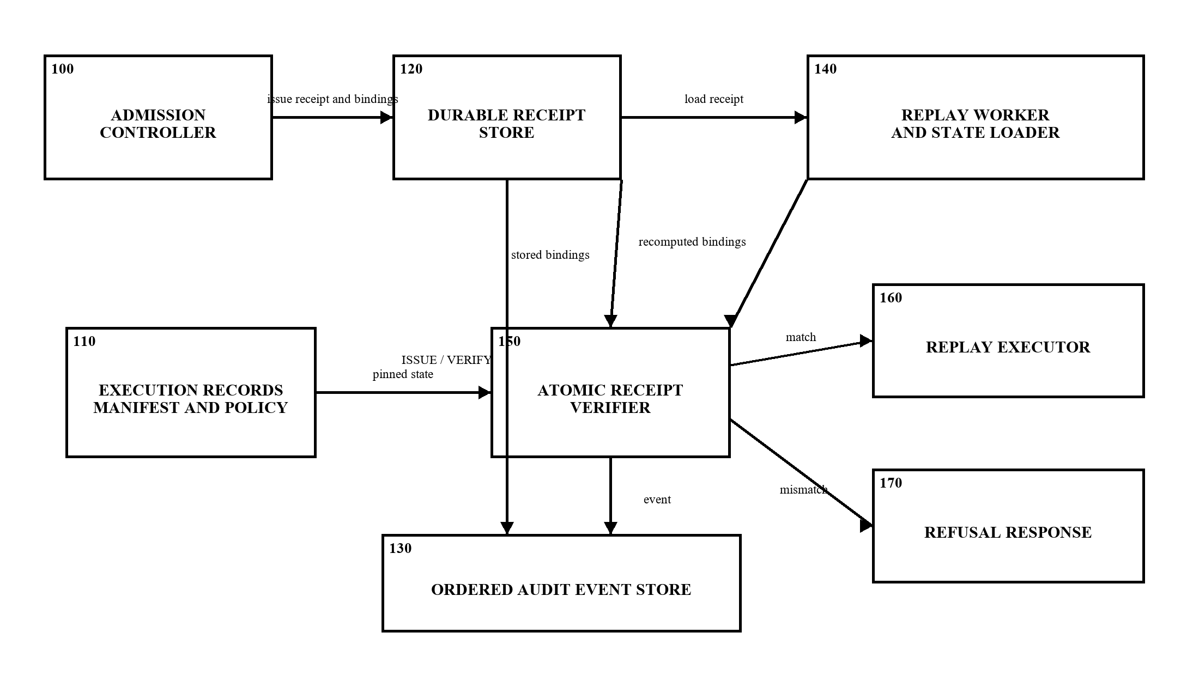
Figure 3. System architecture for state-bound admission control. Solid arrows represent logical transfer of receipt data, recomputed bindings, state records, verification outcome or audit events. The drawing is a functional system arrangement. It does not require each numbered block to be a separate physical server, and it does not represent an external policy attestation service.
On a successful atomic claim, verifier 150 permits creation of replay executor 160. On a missing, stale, conflicting or otherwise mismatched binding, verifier 150 provides refusal response 170 before executor construction. The persistent audit event store 130 receives lifecycle events associated with issuance and verification. In the reference embodiment, stores 120 and 130 are relational tables in the same SQLite database; a production embodiment may place them in a transactional database provided a receipt claim remains atomic.

7.6 Worker-side verification process
Figure 4 gives the ordered process implemented at the worker boundary. The sequence begins with an already prepared recovery proposal 201 and a canonically persisted receipt 202. The worker independently reloads pinned records at 203 and derives the trace, intervention, manifest, policy and capsule identifiers at 204. Step 205 is a decision operation performed in the receipt-store transaction. It checks receipt existence, ISSUED status, expiry, each required binding and, when supplied, the evidence-class ceiling.
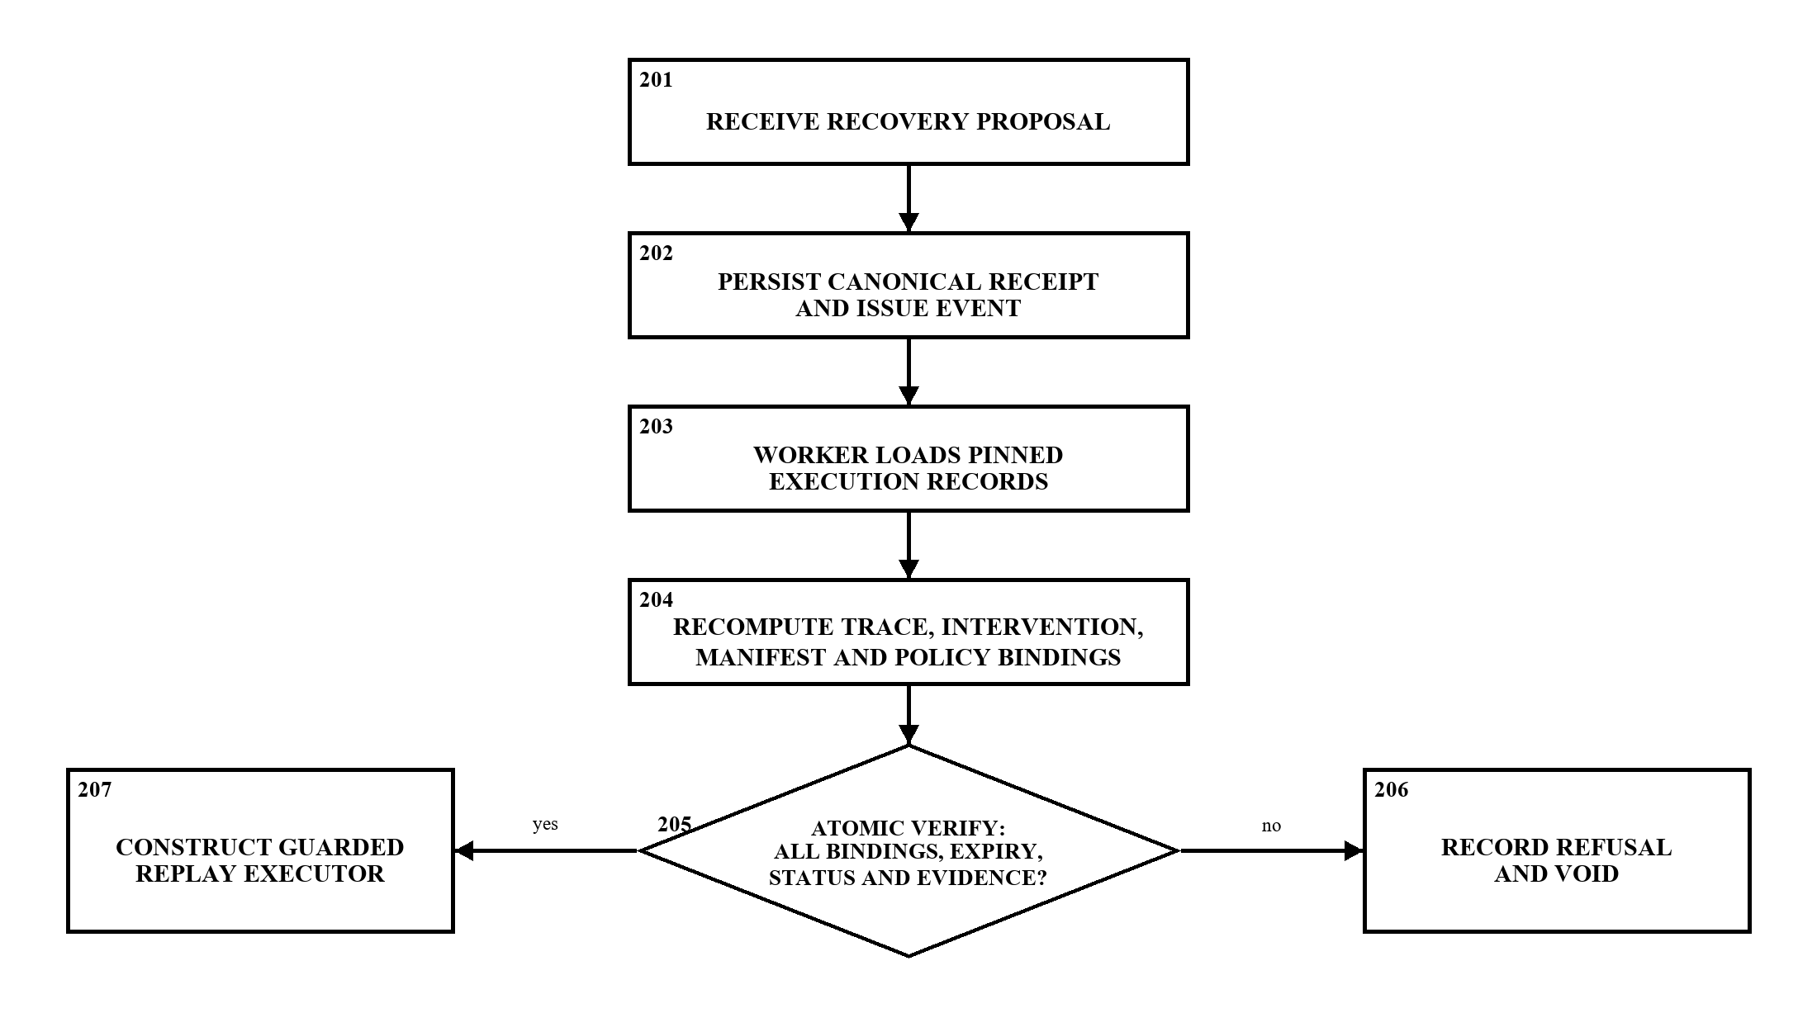
Figure 4. Worker-side verification and dispatch process. The affirmative branch from decision 205 leads to guarded executor construction 207 only after a successful receipt claim. The negative branch writes a refusal reason and terminal state at 206. The shown branch is intentionally before execution: a worker receiving a refusal does not create the replay executor from the rejected proposal.
The mechanism preserves a specific causal order: persisted admission data is compared with state reloaded by the worker; the receipt is atomically claimed; and only then is the replay executor constructed. This is distinct from merely logging a controller decision or performing validation after a replay action has begun. The worker-side comparison can detect divergence in the values supplied to it, but it does not prove that an external system remains unchanged after the comparison has completed.

7.7 Receipt lifecycle and audit linkage
Figure 5 identifies an example receipt lifecycle. Receipt state 301 is created as ISSUED together with an ISSUE event. A successful verification claim moves the receipt to VERIFIED state 302. A later consume operation transitions the record to CONSUMED state 303. Mismatch, expiry, incomplete input and policy or trace divergence reach VOIDED state 304, while explicit release may reach RELEASED state 305. The receipt service appends the corresponding audit event into ordered audit store 306 for the permitted transitions.
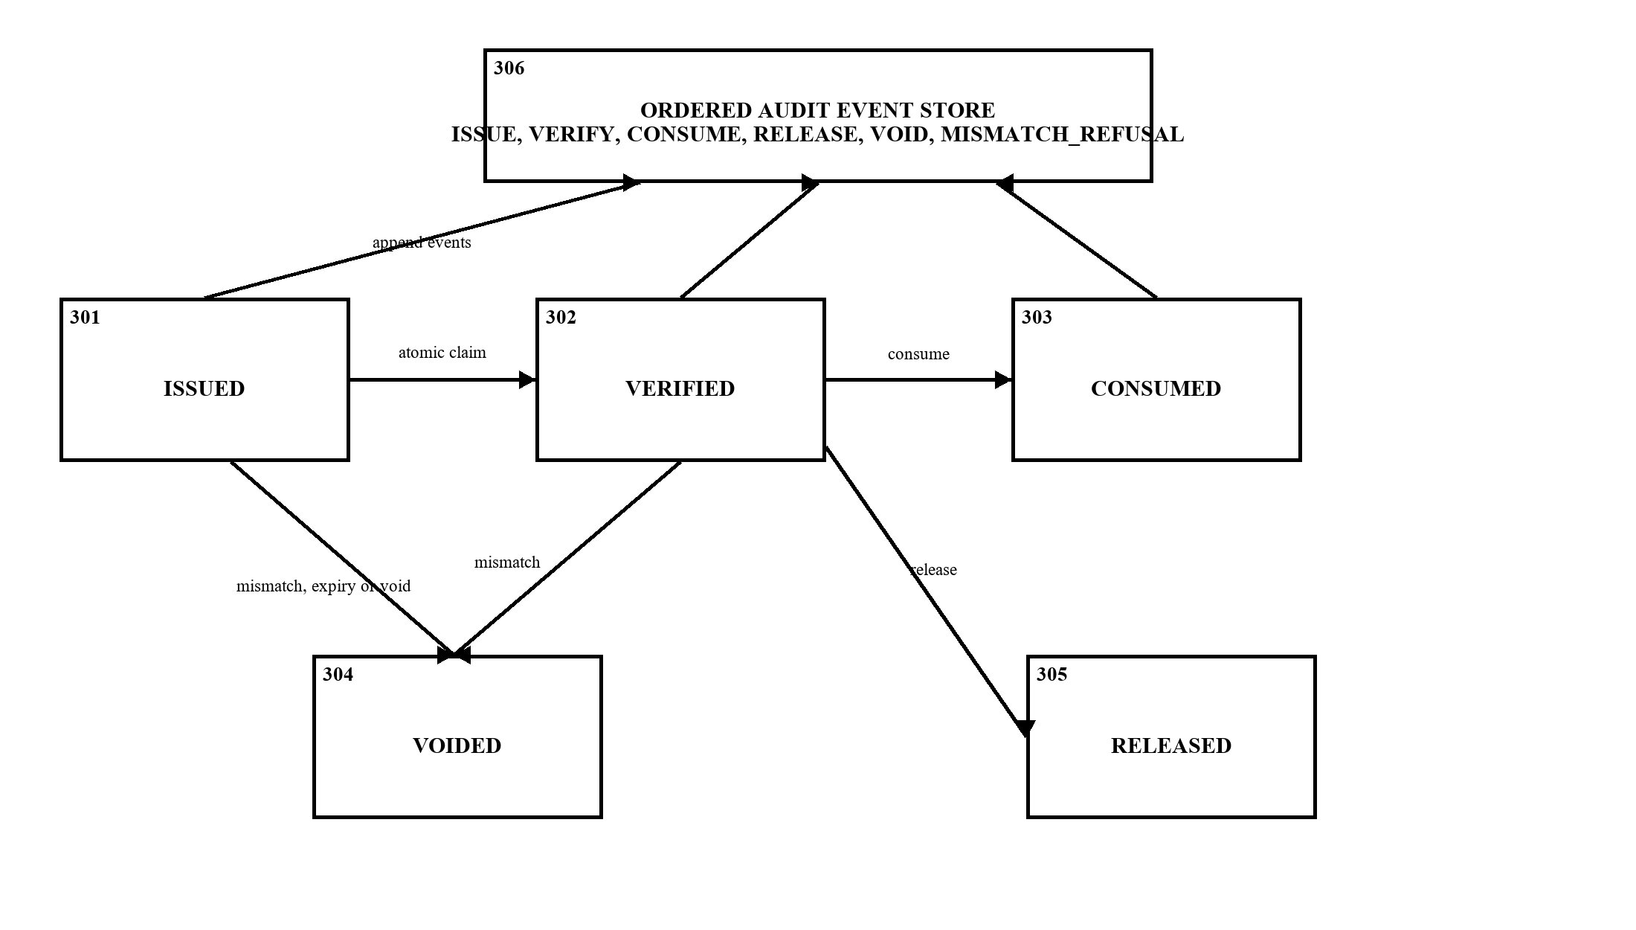
Figure 5. Receipt-state and audit-event relationship. The illustration identifies the lifecycle states relevant to the disclosed control point. It does not imply that every terminal transition is currently authorized by a cryptographic worker lease, nor does it assert immutable external storage of audit events.

7.8 Worker verification implementation
execute_replay_job hashes the loaded trace root identifier, span count and serialized spans, and recomputes the intervention identity. It obtains the manifest digest and policy reference from the stored manifest, source and target versions from the intervention record, and the capsule reference from the job payload. The worker also requires a fully pinned replay manifest before attempting the receipt claim. The receipt checks therefore describe consistency with those records, rather than a live attestation of every external index, provider or deployed policy.
The remediation interface execute_with_admission verifies before calling execute, where capsule preparation and action application occur. Its binding dictionary is supplied on RecoveryProposal. The recovery engine can still invoke legacy execution when no receipt is supplied, and this wrapper does not currently pass an evidence class to the store. Universal remediation enforcement, independent reconstruction of proposal bindings and mandatory evidence classification remain integration work.

7.9 Failure examples
For a trace change, a receipt contains trace digest T1. The worker loads changed spans and obtains T2. The durable verifier detects the unequal trace_root_hash, records MISMATCH_REFUSAL and VOID, and returns failure before replay construction. An omitted trace_root_hash also fails, even if the supplied tenant and manifest values agree.
For duplicate delivery, two workers address the same ISSUED receipt. The first valid transaction changes it to VERIFIED. The later transaction reads VERIFIED and refuses. This gives one successful receipt claim under the tested shared-file conditions. It does not establish exactly-once external side effects if execution crashes after applying an action.
For evidence promotion, a replay admitted with a REAL_CONTROLLED_EXPERIMENT ceiling is checked with PRODUCTION authority. The verifier refuses the larger rank. This case is exercised through the store interface; callers that omit evidence_class do not perform the ceiling comparison.
For policy drift, the receipt retains the policy_hash admitted for the operation. If a worker presents a different policy reference, verification refuses the request before dispatch. The same comparison applies to the replay manifest and capsule references. These checks establish agreement with the values presented to the receipt store; they do not prove that an external policy service or execution environment remained unchanged after the check.

7.10 Resource and deployment limits
A local test reserves USD 1.50 from a USD 2.00 context using predicted cost 1.00, uncertainty 0.20 and rollback reserve 0.30. Object-level release returns the local reservation; object-level commit reconciles measured cost. Durable store.consume and store.release change persisted lifecycle status but do not reconcile that separate context. The reference store consequently cannot enforce a shared multi-host spending ceiling or reclaim another process's budget after loss.
A production extension would need a shared transactional budget account, authenticated ownership or fencing tokens, recovery of expired claims, immutable state snapshots or conditional mutation at action time, and external metering. Expiry is checked when a receipt is claimed; it does not terminate an already running job. A remaining change-after-check window also requires execution-time state protection. These extensions describe implementation work, not completed results.
The reference embodiment is most suitable for a recovery service in which the worker can access the receipt database and the execution records needed to calculate the bindings. A larger deployment can replace SQLite with a durable transactional store, provided the claim operation preserves the single-writer semantics for one receipt binding. Any such replacement must preserve the refusal rule for incomplete inputs, the atomic change from ISSUED to VERIFIED, and the ordered recording of lifecycle events.

8. Experimental validation results:
The following results are recorded from the 09 September 2026 verification session. Source baseline: commit 8097ac3. The tests support the stated reference behavior; counts from overlapping suites must not be added together.
Check | Recorded outcome | Evidence scope
Full Python suite | 610 passed; 22 skipped; 7 warnings | Local regression result; skipped service/platform tests remain outside this run.
Expanded admission and replay checks | 37 passed; 1 skipped | Receipt, worker, manifest and API-related tests.
Final receipt-focused checks | 17 passed | tests/unit/test_admission_store.py and test_admission_receipt.py.
Concurrent claim | Exactly 1 successful claim from 6 attempts | Six processes accessing the same SQLite database.
Concurrent consume | Exactly 1 CONSUME event | Six consume attempts after claim; terminal calls are idempotent.
Refusal and audit mutation | Expected refusals; event mutation detected | Changed version/policy/trace, expiry, evidence promotion, incomplete binding and changed event reason.
Receipt and controlled-replay tests | 22 passed | Receipt lifecycle, deterministic retrieval, evidence hashes, scheduler labels and paired statistics.

Controlled retrieval study
Two schema 2.0.0 SciFact artifacts each evaluate 30 queries from a corpus of 5,183 documents. Four faults were attempted: relevant-document removal, reduced retrieval cutoff, malformed query and stale IDF weights. The included query/fault counts are 75 for seed 42 and 72 for seed 7. Only clean-retrievable queries with a measurable regression enter this evaluation.
Seed | Uniform prior | Fixed order | Random | Oracle prior
42 | 2.680 | 2.680 | 2.453 | 1.000
7 | 2.681 | 2.681 | 2.583 | 1.000

The table gives the mean number of replay attempts. Every strategy recovered the selected cases. Uniform-prior BCRB matched fixed ordering, while the oracle was given the correct repair. These results do not show that BCRB outperforms the comparison strategies without that advance information. Faults affecting the same query are grouped in the analysis, and the two seeds are not treated as independent populations.

Fresh multi-dataset reproducibility execution
Seven additional controlled-replay runs were executed on 09 September 2026 using four materialized BEIR datasets: SciFact, ArguAna, NFCorpus and FiQA. The SciFact, ArguAna and NFCorpus runs use 20 or 30 clean-retrievable queries per seed. FiQA uses one bounded 10-query run because its local corpus is substantially larger. Every run evaluates the same four controlled fault families. All artifacts are correctly marked dirty-source provenance because the workspace contains uncommitted changes, and internal hash and protocol verification passed for all seven files.
Dataset | Seed | Queries | Pairs | Uniform | Fixed | Random | Oracle | Wrong
SciFact | 42 | 30 | 75 | 2.6800 | 2.6800 | 2.4533 | 1.0000 | 2.8533
SciFact | 7 | 30 | 72 | 2.6806 | 2.6806 | 2.5833 | 1.0000 | 2.8472
ArguAna | 42 | 20 | 69 | 2.2899 | 2.2899 | 2.7391 | 1.0000 | 2.5797
ArguAna | 7 | 20 | 69 | 2.3043 | 2.3043 | 2.5072 | 1.0000 | 2.5942
NFCorpus | 42 | 20 | 65 | 2.3231 | 2.3231 | 2.4615 | 1.0000 | 2.5846
NFCorpus | 7 | 20 | 57 | 2.4211 | 2.4211 | 2.2456 | 1.0000 | 2.7018
FiQA | 42 | 10 | 33 | 2.3939 | 2.3939 | 2.1818 | 1.0000 | 2.6061

All 440 included query/fault pairs recovered for every strategy. Values are mean replay attempts across query/fault pairs. The oracle uses the injected correct intervention, while the wrong-prior strategy deliberately receives an incorrect intervention label. Uniform BCRB matched fixed ordering in every fresh run because their candidate orders are the same in this configuration. Random ordering was better on some samples and worse on others. The results therefore do not support a general efficiency claim for either uniform BCRB or random ordering.
The four datasets vary in content and corpus size, but the evaluation remains a controlled BM25 replay harness with selected cases that have both clean-baseline retrieval and measurable fault regression. It is useful for checking that the control and evidence path behaves consistently across datasets. It does not measure a live model, end-user quality, production safety or a patentability advantage. The FiQA result is a smaller exploratory cohort and should not be weighted as heavily as the two-seed datasets.

Technical effects and traceable evidence
Demonstrated effects are refusal under the tested mismatches, one successful durable claim, one consume event and detection of a changed audit record. A production unsafe-dispatch rate, refusal latency distribution and resource-overrun bound have not been measured. They would require counted executor starts, monotonic timing and reconciled actual usage.
The validation is designed around boundary conditions that can cause unsafe dispatch: a changed trace, changed version, changed policy reference, expired receipt, missing required binding, duplicate claim attempt, promotion beyond the evidence ceiling and modified audit event. The results show that the reference store either refuses the attempt or identifies the audit inconsistency in these exercised cases. They should be read as implementation evidence for the receipt-control mechanism, not as a benchmark of a deployed recovery platform.
Evidence files: results/patent_review/scifact_seed42.json, scifact_seed7.json, scifact_rerun_seed42.json, scifact_rerun_seed7.json, arguana_rerun_seed42.json, arguana_rerun_seed7.json, nfcorpus_rerun_seed42.json, nfcorpus_rerun_seed7.json, fiqa_rerun_seed42.json and multidataset_rerun_summary.json. Verification script: scripts/verify_controlled_evidence.py. Receipt implementation: packages/replay/src/admission_store.py and admission_receipt.py. These artifacts describe controlled retrieval experiments and implementation tests, not production canaries.

9. What aspect(s) of the invention need(s) protection?
The proposed subject matter is a computer-system control arrangement in which the worker's ability to dispatch a recovery operation depends on a complete comparison with a durable, single-use receipt. The following candidate language defines the technical relationship for claim drafting; its scope must be tested against the references in Section 3.

Candidate system formulation
A technical system for controlling replay of an autonomous recovery operation, comprising a processor, a memory, a durable receipt database and a worker interface, wherein:
- an admission component stores a receipt identifying a tenant, replay-manifest reference, trace digest, intervention digest, source and target versions, policy reference, capsule reference, expiry, evidence ceiling and declared resource terms;
- a worker loads execution records associated with the operation, derives a trace digest and intervention digest from those records, and provides each required identity binding to a receipt verifier before constructing a replay executor;
- the verifier, within a database write transaction, refuses an incomplete or mismatched binding set, an expired receipt, a receipt whose status is other than ISSUED, or a supplied evidence class exceeding the receipt ceiling;
- on successful verification, the verifier changes the receipt to VERIFIED and records a verification event so that a later claim against the same receipt is refused; and
- a transition component records a permitted terminal receipt state and corresponding event, and an audit verifier checks event sequence, predecessor linkage and recomputed event hashes.

Candidate method formulation
A method performed by cooperating computing processes comprising persisting the admission receipt; loading execution records at the worker; deriving and supplying the required bindings; comparing those bindings, expiry, status and supplied evidence authority within a receipt transaction; claiming the receipt only when the comparison succeeds; dispatching the replay following that claim; and retaining a terminal transition and verifiable event sequence.
The claim drafting focus should remain on the causal relationship between state comparison and dispatch permission. A receipt, hash, database transaction or audit record by itself is unlikely to express the distinguishing technical arrangement. The disclosure should instead describe how the worker reconstructs or obtains the required state, how a mismatch prevents replay construction, and how a successful verification makes a later competing claim fail.

Dependent subject matter and technical effect
Dependent features may specify the required eight-field set, separate digest domains for the receipt, intervention and audit events, refusal on an omitted field, retention of an existing claim after duplicate verification, and the rule preventing duplicate terminal events. The objective effect is control of replay dispatch and duplicate work under recorded-state drift.
A durable multi-host budget, an execution ownership lease and automatic reclamation after worker loss should not be included as implemented features. Generic hashes, graph attention, confidence bounds or budgeted bandits are not asserted as new. For Indian examination, the specification should explain the actual computer-system problem and enforcement mechanism; calling an algorithm a system does not establish eligibility.

10. What is Technology readiness level of your invention? (Tick the appropriate TRL)
Research |  |  | Development |  |  | Deployment
TRL 1 | TRL 2 | TRL 3 | TRL 4 | TRL 5 | TRL 6 | TRL 7 | TRL 8 | TRL 9
Basic Principles observed | Technology concept formulated | Experimental proof of concept | Technology validated in a lab | Technology validated in a relevant environment (industrially relevant in case of key enabling technologies) | Technology demonstrated in a relevant environment (industrially relevant in case of key enabling technologies) | System prototype demonstration in an operational environment | System complete and qualified | Actual system proven in an operational environment (competitive manufacturing in case of key enabling technologies, or in space )
 |  |  | ✓

Basis for the selection
TRL 4 is the supported self-assessment for the receipt-control mechanism. Laboratory tests cover durable local storage, refusal behavior, audit verification and concurrent claims. Existing CI tests for the surrounding application do not establish that the full mechanism works across independent production hosts. Shared budget accounting, protection against external-state changes, worker ownership checks and recovery after worker loss still require implementation and testing.

Institutional review and filing particulars
Inventor and applicant identities, individual contributions, ownership or assignment obligations, any earlier application and the first public-disclosure date require confirmation before filing. The institutional logo and form identifiers reproduce the supplied IDF-B template; they do not indicate institutional approval or patent grant.
Indian examination reference: Guidelines for Examination of Computer Related Inventions 2025, Section 4.5.4.1
The technical description should be assessed as a whole, including the computer-system problem, technical means and resulting effect. This completed IDF-B disclosure is for institutional and patent-professional review; it does not constitute a filed specification or a determination of novelty.
----------------------END OF THE DOCUMENT-----------------------------

