 Invention Disclosure Format (IDF)-B | Document No. | 02-IPR-R003
 | Issue No/Date | 2/01.02.2024
 | Amd. No/Date | 0/00.00.0000
Status: Confidential engineering disclosure prepared for technology-transfer and patent-counsel review. It is designed to improve drafting quality but does not guarantee novelty, inventive step, freedom to operate, or patent grant.
- Title of the invention
SYSTEM AND METHOD FOR RESOURCE-BOUNDED COUNTERFACTUAL REPLAY, EVIDENCE-GATED CAUSAL RECOVERY, AND CRYPTOGRAPHICALLY BOUND EXECUTION IN MULTI-TENANT AGENTIC COMPUTING PIPELINES
- Field / Area of invention
The invention relates to fault diagnosis, controlled execution, recovery orchestration, and evidence integrity in distributed artificial-intelligence and agentic computing pipelines. More particularly, it concerns a control-plane architecture that converts tenant-scoped execution traces into replayable causal state, admits counterfactual experiments under resource reservations, executes them across a killable isolation boundary with incremental memory and output enforcement, rejects inadmissible divergence or insufficient evidence, and cryptographically binds an authorized recovery decision to the exact tested state and evidence provenance.
- Prior patents and publications from literature
Category | Reference | Relevant disclosure | Preliminary distinction / drafting implication | Date
Patent | US 7,949,739 B2 - Method and apparatus for determining causality mapping of distributed systems | Automatically generates causality mappings between causing and detectable events and uses the model for root-cause analysis. | Anticipates causal maps generally. The proposed contribution must not rest on graph construction alone; it is the ordered recovery protocol that couples replay admission, bounded execution, evidence sufficiency, tenant authorization and signed recovery eligibility. | Priority 2004
Patent | WO 2020/177854 A1 - Automated root-cause analysis for distributed systems using tracing data | Uses tracing spans, anomaly scores and distributed-system structure to identify probable root causes. | Strongly limits broad trace-based RCA claims. It does not appear, from this preliminary review, to bind controlled counterfactual replay outcome, incremental resource enforcement and recovery authorization into one fail-closed certificate path. | Published 2020
Patent | US 2022/0172067 A1; US 11,947,439 B2 - Learning from distributed traces for anomaly detection and root cause analysis | Learns microservice anomaly and RCA models from distributed trace data and evaluates component contributions to reconstruction loss. | Graph/ML diagnosis is crowded prior art. Claims should avoid dependence on a particular GAT and instead require replay-derived evidence plus the resource and authorization architecture. | Priority 2020
Research | Krishna et al., CADET: Debugging and Fixing Misconfigurations using Counterfactual Reasoning, arXiv:2010.06061 | Builds a causal model of configurable systems and uses counterfactual reasoning to identify causes and prescribe repairs. | Counterfactual diagnosis and repair are known. Candidate distinction: reproducible replay envelope, pre-allocation reservation/reconciliation, killable incremental limits, evidence stopping, and cryptographic recovery binding. | 2020
Patent | US 9,705,905 B2 - Sandboxed execution of plug-ins | Executes plug-ins in worker processes, monitors memory/CPU usage and terminates workers when limits are exceeded. | Process isolation and monitoring are known. Drafting must require the specific use of incremental serialization before parent materialization, measured reconciliation against a prior reservation, and coupling to the causal evidence gate. | Granted 2017
Research | Torres-Arias et al., in-toto: Providing farm-to-table guarantees for bits and bytes, USENIX Security 2019 | Collects cryptographically verifiable software-supply-chain metadata to provide end-to-end integrity guarantees. | Signed provenance is known. Proposed recovery certificates instead bind runtime replay evidence class, tenant authorization, intervention, resource measurement, policy approval, canary outcome and executor identity to the decision to recover. | 2019
Patent - high relevance | CN 121681201 A - Automated root-cause localization and replayable repair of data anomalies | Builds a heterogeneous topology, generates counterfactual interventions using a do-operator, simulates persistence probability, localizes a root and triggers replay repair. | Potentially close and must be assessed by counsel. Any viable claim should be narrowed to the concrete control-plane combination and technical enforcement details that are not established by this preliminary abstract-level review. | Priority 2025; published 2026
Search status: This is a preliminary engineering landscape, not a novelty, patentability, or freedom-to-operate opinion. A professional claim-by-claim search in India and major jurisdictions remains mandatory.
- Summary and background of the invention (Address the gap / Novelty)
Summary
The disclosed architecture, referred to in this engineering record as DriftGuard-X, provides a closed-loop protocol for diagnosing and recovering failures in stochastic, stateful, multi-component AI pipelines. The protocol captures execution spans in a tenant-scoped trace fabric; constructs a causal reliability graph; packages the original request, component and policy versions, corpus and index identity, exogenous controls, dependency lock and executor identity into an immutable replay state manifest; ranks candidate interventions; reserves resources before allocation; and executes only admitted candidates in a killable process or container boundary. The child boundary incrementally serializes output into bounded frames while a parent monitor enforces resident-memory and wall-time limits, so an unbounded result is rejected before being materialized in the control process. Measured usage is reconciled against the reservation. A replay contributes evidence only if its divergence remains within a replay-equivalence envelope. Recovery is prohibited until an evidentiary stopping rule is confirmed, a minimum causal recovery cut preserves declared invariants, the authenticated access context is unexpired and tenant-bound, and policy approval succeeds. The final recovery eligibility certificate binds the trace root, manifest, intervention, measured resources, replay outcome, evidence kind, policy, approvals, canary result and executor digest to a canonical hash and Ed25519 signature recorded in a tamper-evident ledger.
Technical problem
Agentic and retrieval-augmented pipelines combine non-deterministic model calls, mutable memory, external tools, retrievers, versioned policies and independently deployed services. Conventional monitoring may identify correlation or rank suspicious components, but it does not establish that a proposed change caused recovery under controlled state. Conversely, a replay may itself be unsafe or technically invalid if it reproduces incomplete state, mutates out-of-envelope variables, exhausts host resources, crosses tenant boundaries, or emits an approval record not tied to the tested artifact. The technical problem is therefore not merely selecting a repair; it is maintaining process, state, resource, identity and evidence integrity from the original execution through to the authorized recovery operation.
Gap in existing approaches
- Trace-based RCA systems generally stop at anomaly attribution and do not require a recovery candidate to pass bounded, controlled replay.
- Counterfactual debugging systems may prescribe repairs without binding execution-state completeness, tenant identity, resource reservation and signed recovery eligibility into one protocol.
- Sandbox systems limit CPU or memory but do not ordinarily make incremental pre-materialization output enforcement part of causal evidence admissibility and recovery authorization.
- Attestation and provenance systems protect build or supply-chain integrity but do not ordinarily encode whether recovery evidence was synthetic, controlled replay, or production canary evidence.
- Autonomous recovery systems may use confidence scores that can bypass replay; the proposed state machine fails closed unless at least one replay-derived result passes divergence validation and evidentiary stopping.
Candidate novelty locus
Drafting focus: The candidate inventive contribution is not any isolated use of causal graphs, graph neural networks, bandits, containers, resource monitors, digital signatures or ledgers. It is the ordered fail-closed coupling of: (i) immutable replay-state binding; (ii) pre-allocation resource reservation; (iii) killable replay with incremental memory/output enforcement before parent materialization; (iv) divergence and evidence-sufficiency gating; (v) minimum-cut recovery constrained by tenant authorization and tightening policy; and (vi) a signed certificate whose canonical payload includes evidence provenance and measured resources.
India-focused technical contribution
For examination under Section 3(k) of the Indian Patents Act, the disclosure is intentionally framed as an improvement to computer and network operation rather than a business rule or abstract algorithm. The claimed architecture changes how a distributed computing system allocates resources, isolates execution, transfers bounded outputs between processes, protects tenant state, validates controlled state transitions and authorizes machine recovery. The asserted effects are specific and technical: preventing unbounded replay output from entering the parent heap, enabling forced termination at memory/time bounds, preventing cross-tenant recovery, detecting out-of-envelope state mutation, and making the exact runtime evidence used for a recovery decision cryptographically verifiable. Counsel should align any claims with the 2025 Indian CRI Guidelines and the latest case law.
- Objective(s) of invention
- To transform distributed AI-pipeline traces into a tenant-scoped causal reliability graph and immutable replay state manifest containing sufficient state identity for reproducible counterfactual execution.
- To prevent diagnostic work from starting unless a resource context can reserve the estimated replay cost, count, wall time and rollback reserve, and to reconcile the reservation against measured execution.
- To execute counterfactual interventions outside the API/control-process address space in a killable process, container or equivalent boundary.
- To count serialized output incrementally and reject an oversized result before the complete result is materialized or transferred to the parent process.
- To monitor resident memory and elapsed wall time externally and forcibly terminate the replay boundary when a hard limit is exceeded.
- To admit replay evidence only when divergence remains inside a declared equivalence envelope and an evidentiary stopping rule is confirmed.
- To compute a minimum causal recovery cut that disconnects diagnosed failure paths while preserving unaffected-system invariants.
- To derive tenant scope from authenticated identity, apply tightening policy and approvals, and deny recovery on expired, ambiguous or mismatched access context.
- To encode evidence provenance as a signed field so synthetic simulation cannot be represented as controlled replay or production canary evidence.
- To emit a publicly verifiable, tamper-evident recovery eligibility record bound to trace, manifest, intervention, resources, approvals, canary and executor identity.
- Working principle of the invention (in brief)
- Trace capture and state binding - The trace SDK records parentage, component identity, timing, policy outcome and redacted input/output hashes. A replay manifest binds the original request envelope, trace root, component and policy versions, dataset/corpus and index identity, dependency lock, seed, exogenous controls and executable artifact identity.
- Causal graph and candidate formation - The system constructs a directed reliability graph and produces candidate root causes using rule-based, PageRank, graph-attention or other detector embodiments. Candidate interventions are version-pinned and associated with expected information gain, uncertainty, modeled cost and blast radius.
- Pre-allocation admission - A risk-limited planner rejects work when the budget is exhausted or the evidence value is below threshold. An admitted candidate obtains an atomic resource reservation before a worker or sandbox is allocated.
- Killable bounded replay - The intervention executes in a child process or container. OS limits and a parent monitor enforce hard memory and time bounds. Output is JSON-encoded incrementally into framed chunks; the child and parent both count bytes and reject over-limit frames before reconstructing the object.
- Divergence and evidence update - The replay result is compared with the replay-equivalence envelope. Forbidden mutation terminates the loop. Valid evidence updates a causal belief model, after which an evidentiary stopping rule either confirms, continues, or stops without confirmation.
- Minimum recovery cut - A failure-path enumerator and weighted cut optimizer select the smallest acceptable set of interventions that intersects the diagnosed failure-producing paths while preserving declared invariants.
- Authorization and certification - A controlled validation replay, authenticated tenant-bound access context, policy decision and required approvals must all succeed. The canonical certificate is signed and appended to a hash-linked ledger; any failure leads to RECOVERY_REJECTED rather than implicit fallback.
- Transport to another environment - An optional causal transportability gate compares signed environment descriptors and relevant footprint invariants. Cross-tenant transport is denied by default and any approved transfer still requires canary validation in the target environment.
- Description of the invention in detail
7.1 Overall architecture
The system is divided into an observation plane, evidence/control plane, isolated execution plane and recovery authorization plane. These planes communicate through typed, content-addressed contracts rather than shared mutable objects. The observation plane captures execution. The evidence/control plane constructs graphs, manifests and experiment reservations. The isolated execution plane runs a single intervention under pinned state and hard resource limits. The authorization plane converts only validated evidence into a recovery cut and signed eligibility certificate. This separation provides explicit trust boundaries and allows each gate to fail independently without granting recovery authority.
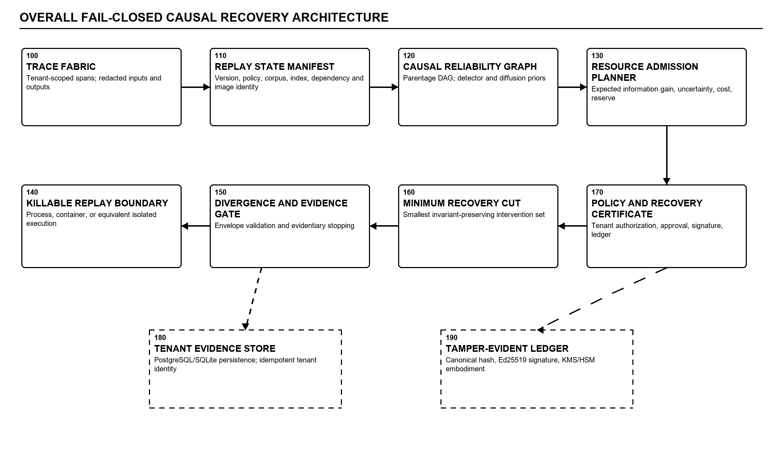
Figure 1. Overall fail-closed causal recovery architecture.
7.2 Trace fabric and causal reliability graph
Each SpanRecord carries a trace identifier, parent span identifier, tenant identifier, pipeline and component identity, version, timing, status, policy result and privacy-preserving payload metadata. In content-restricted modes, raw values are replaced by hashes. Parent-child relationships produce a directed graph whose nodes can encode operational, generation, retrieval, memory, tool and policy features. The graph may be scored by fixed analytical diffusion, learned graph attention, or an ensemble. These scores are priors for experiment selection, not proof of causation. A causal claim remains provisional until a controlled replay changes the targeted component while other declared state is held within the envelope.
7.3 Replay state manifest and equivalence envelope
ReplayStateManifest is an immutable, hashable record that binds state needed to interpret a replay: original run and tenant, component-version map, policy/configuration versions, model/provider metadata, corpus/index and memory snapshot identity, dependency lock, source implementation identity, seed, time/environment controls and container or process artifact identity. A ReplayEquivalenceEnvelope then partitions state into intervened variables, frozen variables, controlled exogenous variables and permitted output differences. Missing required identity, literal placeholders or an unpinned external dependency render the episode inadmissible.
7.4 Risk-limited sequential causal experiment planner
The planner receives candidate interventions, posterior beliefs, expected information gain, uncertainty, blast-radius estimate, measured cost history and remaining ResourceContext. A utility function ranks candidates subject to budget and stopping constraints. Before dispatch, the selected experiment calls reserve(ResourceEstimate). The reservation is an atomic claim on the remaining diagnostic capacity; it is committed with ResourceMeasurement after execution or released on dispatch failure. This prevents oversubscription between concurrent planning and execution and creates an auditable difference between estimated and measured cost. Alternative embodiments may use UCB, Thompson sampling, Pareto ranking, fixed order or exhaustive selection, but all must pass the same admission and evidence gates.
7.5 Killable replay boundary and incremental materialization limit
The replay callable is never invoked in the API process. The parent launches a child process using a multiprocessing context or submits an equivalent OCI-container task. The child applies platform-supported address-space and CPU limits, installs audit controls, disables or stages network, file and subprocess side effects, and executes the version-pinned component. A JSON encoder emits the result as chunks. The child counts encoded bytes before sending frames, and the parent separately checks the aggregate frame length before joining the payload. The parent concurrently samples child RSS and elapsed wall time. An overage causes termination and a non-evidentiary failure outcome. This two-sided incremental bound is materially different from checking the size of an already-materialized object.
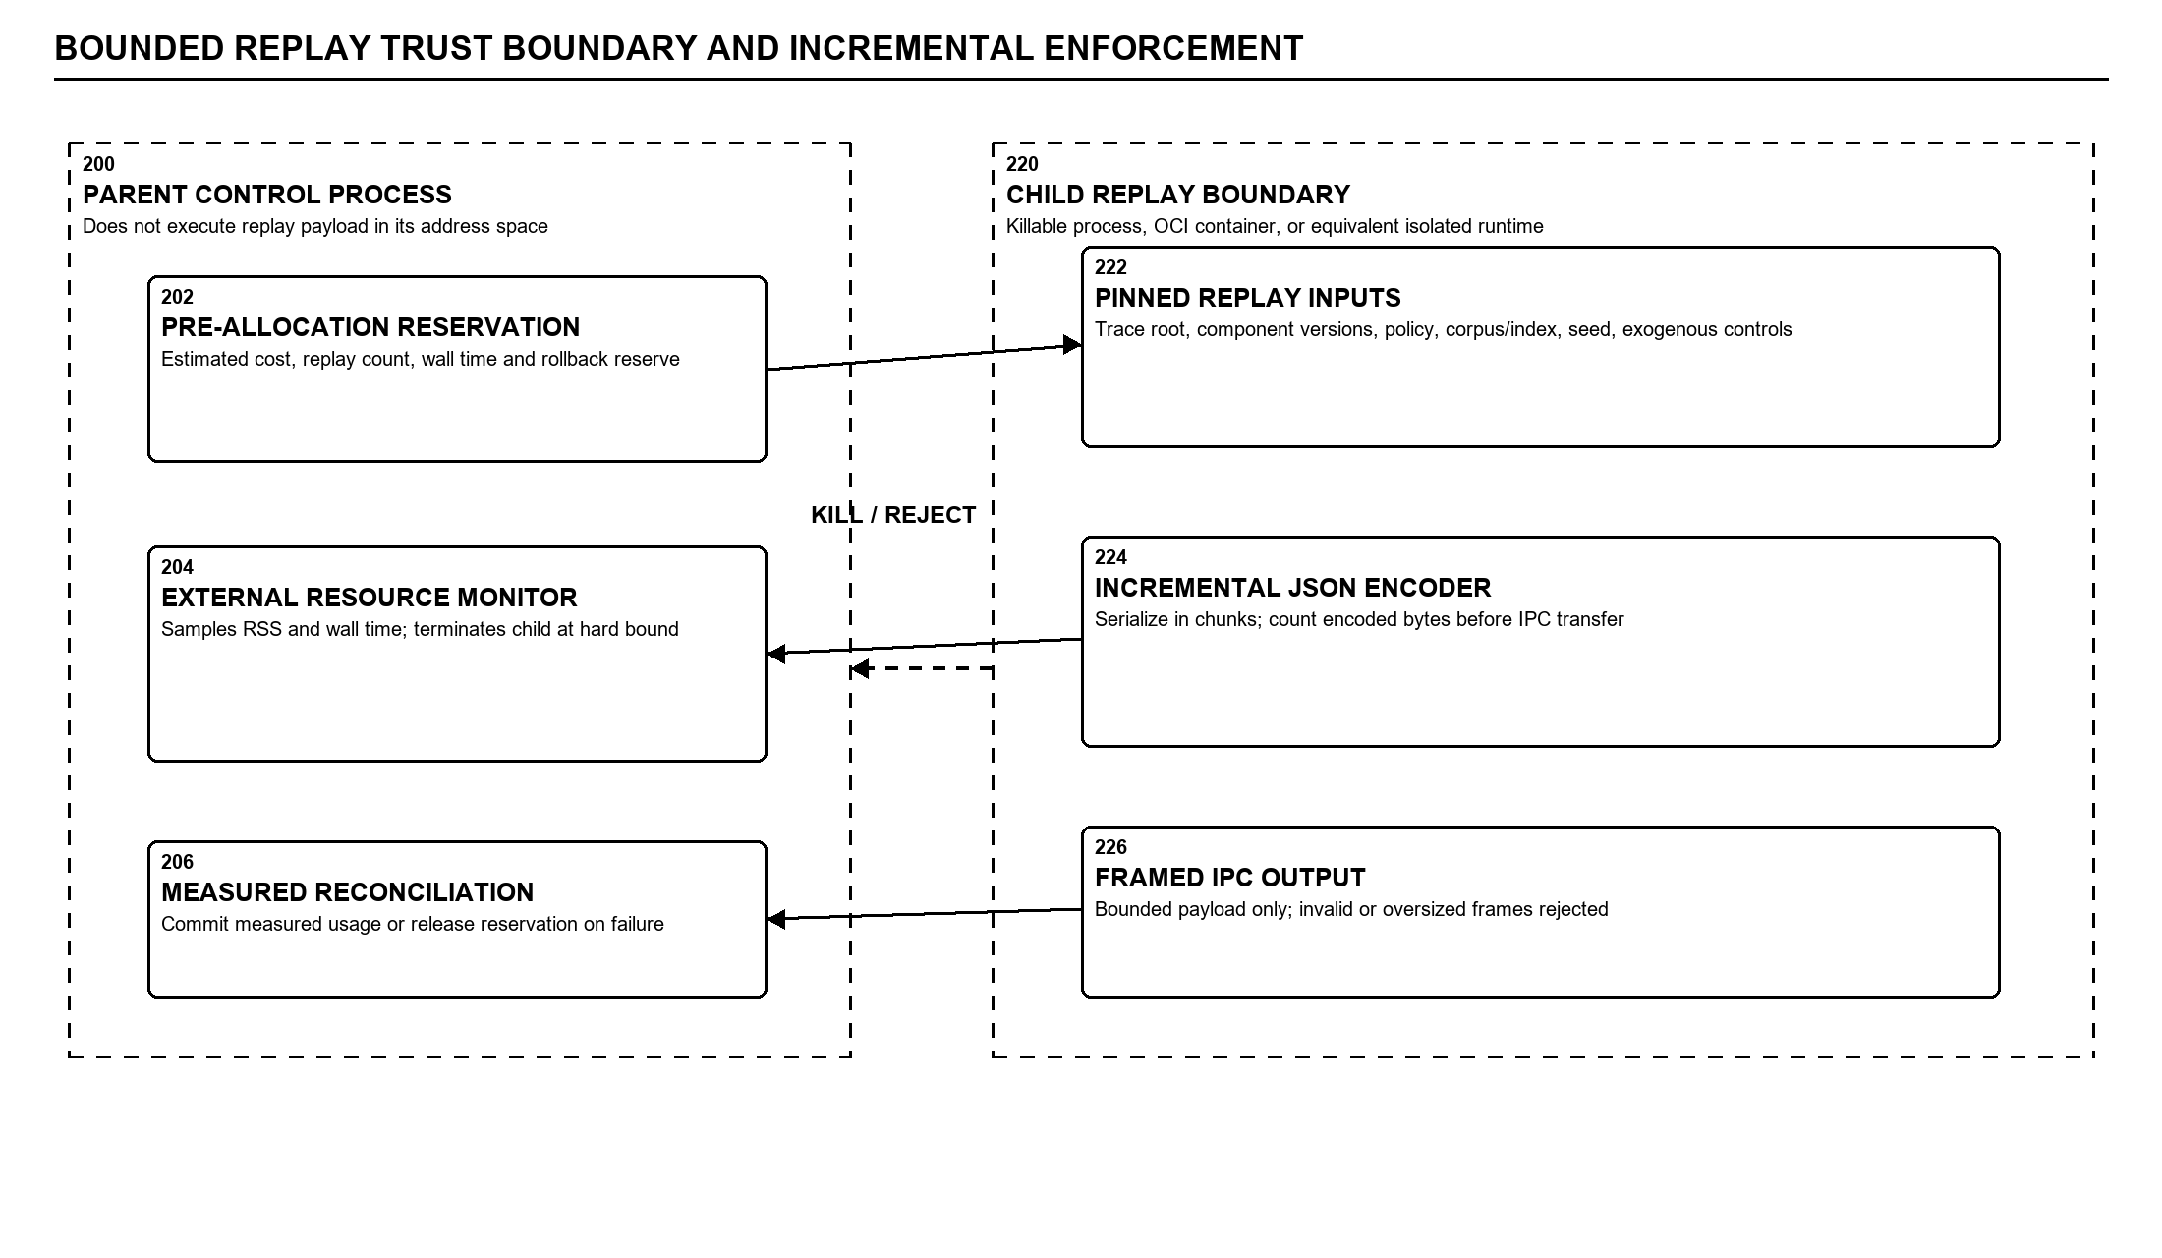
Figure 2. Bounded replay trust boundary and incremental enforcement.
7.6 Exogenous-state control and divergence frontier
The exogenous-state controller injects or normalizes allowed environmental values such as recorded time offsets and deterministic seeds. The divergence validator computes stable hashes of frozen state and compares original versus replay traces. Expected differences are limited to the intervention footprint and declared outputs. A change to frozen memory, unrelated component output, tenant namespace, policy state or prohibited side effect crosses the dynamic causal divergence frontier and immediately invalidates the replay. The invalid result is retained for audit but does not update the causal posterior as valid evidence.
7.7 Evidentiary stopping and fail-closed state machine
The belief model updates root-cause probabilities only from completed, divergence-valid episodes. The stopping policy has distinct outcomes for confirmed evidence, continued experimentation, budget exhaustion, and stopping without confirmation. A high prior probability alone cannot authorize recovery. At least one replay-derived result must pass validation, and the orchestrator must transition through EVIDENCE_SUFFICIENT before recovery validation. Any unsupported statistical bound, expired access context, policy denial, failed canary, invalid signature or execution-limit breach routes to a rejection terminal state.
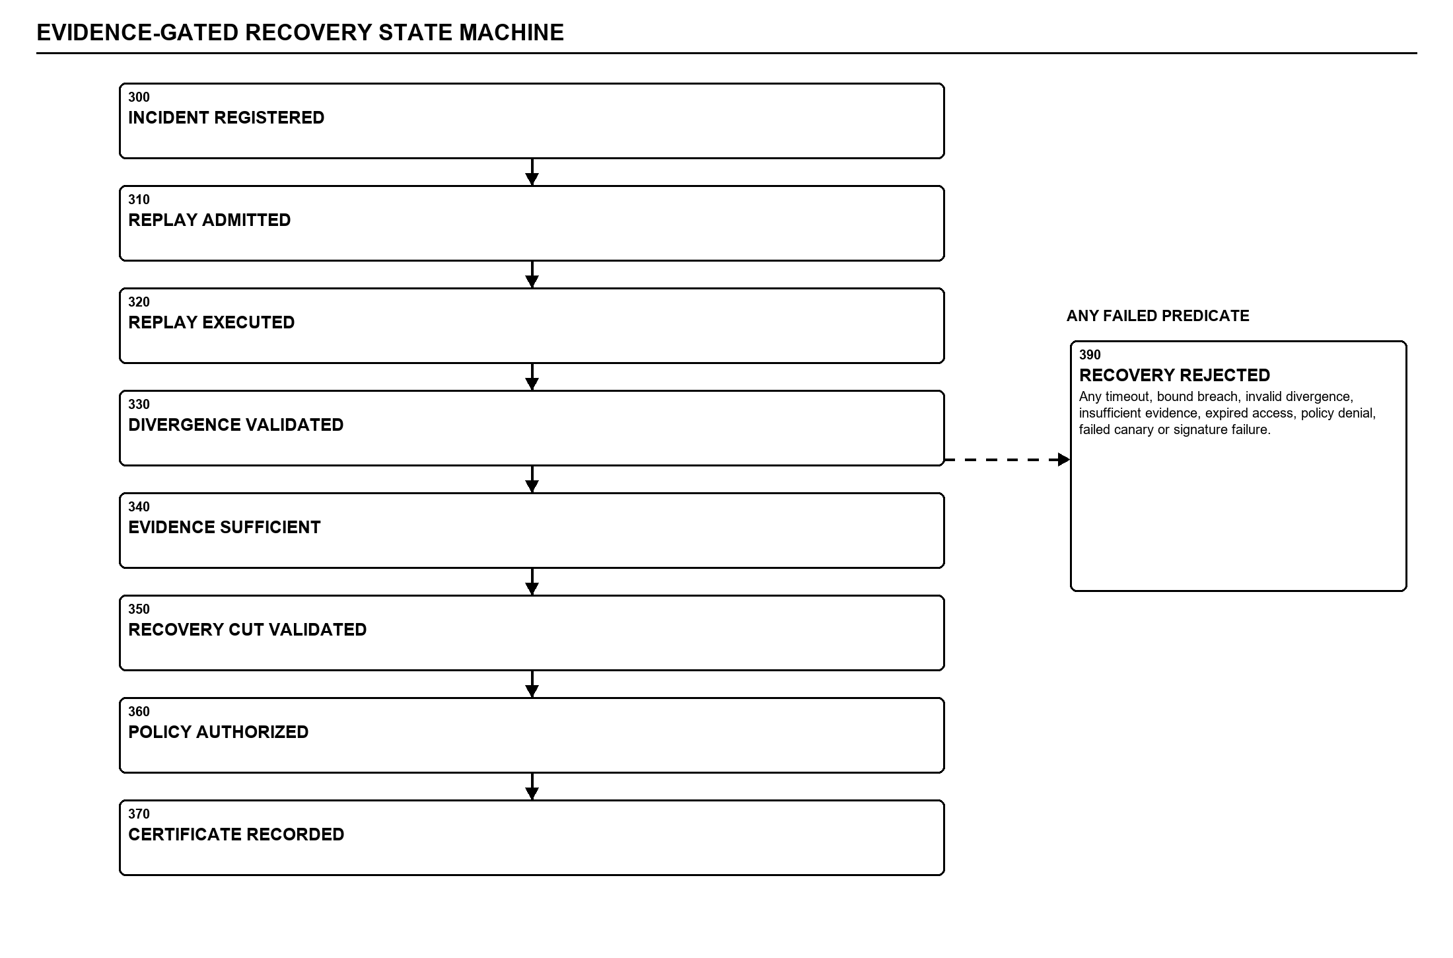
Figure 3. Evidence-gated recovery state machine.
7.8 Minimum causal recovery cut
Once evidence is sufficient, a failure-path enumerator identifies graph paths connecting candidate causes to observed symptoms. A weighted hitting-set or equivalent optimizer computes a CausalRecoveryCut whose intervention nodes intersect the relevant failure paths while minimizing a cost function over mutation count, blast radius, operational risk and policy constraints. The cut is validated against preservation invariants before execution. Cyclic or incomplete graphs may use an approximate solver, but the approximation status is recorded and cannot be promoted to an exact result.
7.9 Tenant-derived authorization and policy gating
Private API routes require authentication. Tenant scope is derived from a signed identity claim or a single unambiguous active membership; an HTTP tenant header, path parameter or query value cannot independently select the tenant. The access context is propagated to recovery validation and must match the trace, intervention, manifest and certificate tenant. The policy engine resolves organization, business-unit, pipeline and agent constraints using tightening-only semantics. High-risk actions may require multiple distinct approvers. Break-glass embodiments require a justification and an immediate post-hoc-review ledger entry.
7.10 Recovery eligibility certificate and evidence ledger
The RecoveryEligibilityCertificate is not a general success badge. Its canonical payload contains identifiers and hashes for the original trace, replay manifest and capsule; intervention and replay outcome; measured resource budget and usage; evidence kind and provenance; tenant and authorization context; resolved policy and approvals; canary result; and executor image or process identity. The payload is serialized with stable field ordering and a domain separator, hashed, signed by an Ed25519 SignerProtocol implementation, and linked to the preceding ledger entry. A development signer is replaceable with KMS/HSM-backed signing without changing certificate semantics. Verification requires only the public key and ledger contents.
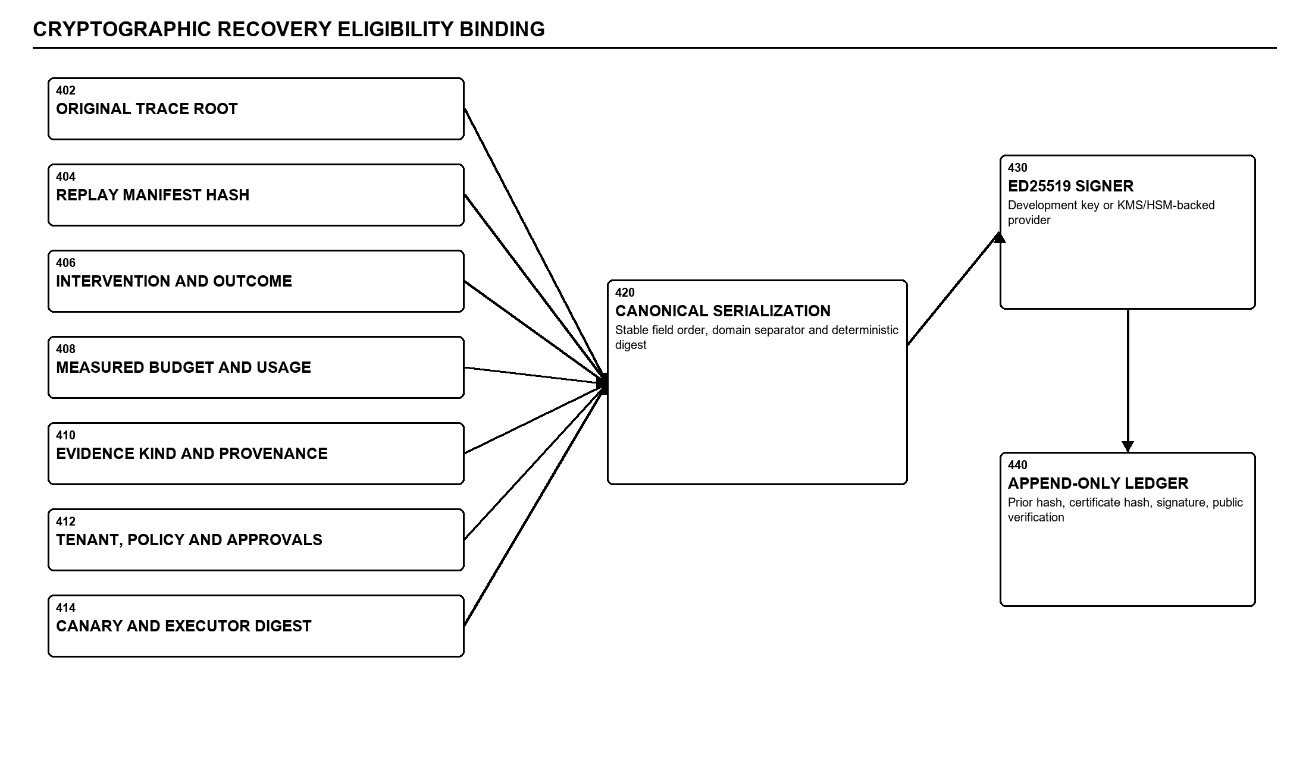
Figure 4. Cryptographic recovery eligibility binding.
7.11 Multi-tenant deployment architecture
A production embodiment uses an OIDC identity provider, Next.js operator console, FastAPI control plane, PostgreSQL persistent state, Redis-backed durable job dispatch, isolated replay workers and KMS/HSM signing. The API derives the tenant, sets a transaction-scoped tenant context, and issues only tenant-bounded work. Workers consume idempotent jobs and do not receive unscoped secrets. Replay containers run as non-root with explicit network and storage policy. Readiness reports unavailable dependencies as failure rather than returning a false-ready status. A testing embodiment may use SQLite and process isolation, provided its evidence kind cannot be represented as production canary evidence.
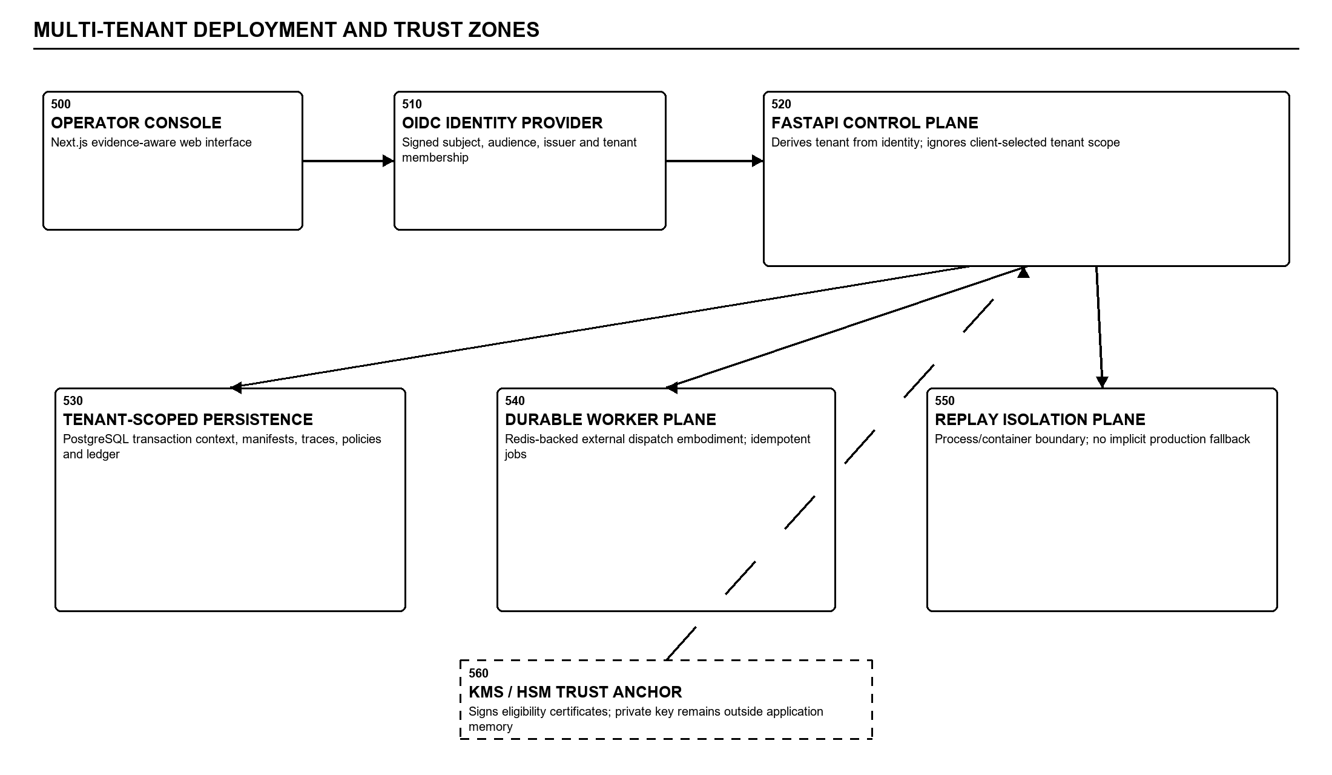
Figure 5. Multi-tenant deployment and trust zones.
7.12 Data contracts and evidence taxonomy
- TraceArtifact - Tenant-scoped collection of spans and the original run state.
- ReplayStateManifest - Content-addressed binding of versions, environment, corpus/index, dependencies and executor identity.
- ReplayEpisode - One controlled intervention, measured outcome, reliability vector, resource use and evidence kind.
- ReplayEquivalenceEnvelope - Frozen, intervened, exogenous and permitted-divergence state definitions.
- CausalRecoveryCut - Selected minimal intervention set and preservation invariants.
- RecoveryEligibilityCertificate - Canonical signed proof that all required recovery gates passed for the exact tested state.
- RecoveryEvidenceKind - Enumerated synthetic_simulation, controlled_replay or production_canary provenance.
7.13 Alternative embodiments
- Isolation may be provided by a spawned process, OCI container, Kubernetes job, micro-virtual machine, trusted execution environment or equivalent killable boundary with the same incremental output contract.
- Candidate ranking may use graph attention, analytical diffusion, causal priors, UCB, Thompson sampling, expected-information-gain maximization, Pareto selection or exhaustive baselines, while preserving admission and evidence rules.
- The recovery cut may use exact weighted hitting set, integer programming, min-cut on a transformed graph, or an approximation whose status is explicitly recorded.
- The ledger may use a hash chain, Merkle DAG or transparency log, provided the signed record binds identical semantic fields and is independently verifiable.
- Signing may use local Ed25519 for laboratory validation or a remote KMS/HSM provider for production; key custody is not required to reside in the application process.
- Transportability may be disabled, same-tenant only, or gated by environment fingerprints, dependency footprints and mandatory target canary validation.

7.14 Control-protocol invariants and irreversible state transitions
In one embodiment, the control plane exposes recovery as an explicit state machine instead of a sequence of loosely coupled service calls. Each transition consumes a typed input, verifies a defined predicate, emits an immutable transition record and advances only to a state whose privileges are no broader than the evidence permits. A retry reuses the operation identity and cannot skip a failed gate; cancellation, timeout or malformed state closes the current attempt.
This ordering is a technical control, not merely workflow documentation. It prevents a high-confidence diagnosis, synthetic result, operator preference or partially completed replay from being treated as recovery authority. The transition record also separates the logical operation identity from individual execution attempts so transport retries do not duplicate the recovery decision.
- Admission invariant - No worker is allocated until tenant identity, manifest completeness and resource reservation are accepted for the same operation.
- Evidence invariant - Only bounded replay that remains inside the equivalence envelope can update replay-derived causal evidence.
- Authorization invariant - Policy is evaluated after the cut is known and therefore binds the actual proposed mutations.
- Certification invariant - The signed record contains the hashes of the precise inputs and decisions enabling its terminal transition.
- Execution invariant - The executor verifies certificate, tenant, target, expiry, supersession and exact cut before mutation.
- Fail-closed invariant - Unknown states, missing fields and incompatible records resolve to rejection rather than best-effort recovery.
Technical effect: the architecture prevents privilege escalation across diagnostic, evidentiary, authorization and execution states while preserving a machine-verifiable history of why each state was reached.
Implementation disclosure: the transition store may be a relational event table, append-only log or consensus-backed state service, provided a conditional write compares the expected predecessor state and operation identity. Each transition record should carry attempt identity, actor or service identity, monotonic sequence, schema version, predicate results, input digests, timestamp source and rejection reason. Concurrency tests should submit conflicting transitions and confirm that at most one expected-state comparison succeeds; restart tests should rebuild the same terminal decision from recorded transitions without consulting volatile worker memory.

7.15 Replay-capsule construction, identity binding and deterministic admission
A replay capsule is a portable execution description assembled before isolation begins. It includes the replay-manifest digest, intervention, declared inputs, frozen-state references, executor identity, serialization contract, reservation token and equivalence envelope. Large artifacts are identified by content address rather than copied into the control message, permitting independent verification without expanding the trusted API-process memory boundary.
The worker validates every required digest before invoking target code and returns a bounded admission failure when an artifact is missing, altered, ambiguous or outside the supported schema range. The capsule therefore acts as an execution identity: two replays are equivalent only when the identity-bearing fields and declared intervention relation satisfy the same admission policy.
- Canonical identity - The digest covers normalized field names, ordered collections, schema version, domain separator and referenced hashes.
- Version closure - Application, dependency, policy, corpus/index, executor and observable provider identities are bound together.
- State partition - Required state must be classified as intervened, frozen, controlled-exogenous or permitted output difference.
- Secret handling - Secrets are resolved inside the tenant-scoped worker and represented by approved reference and version, not plaintext.
- Idempotent admission - Duplicate capsule delivery returns the recorded admission or terminal result without a second reservation.
- Schema migration - Compatibility requires a deterministic migration whose original and migrated digests are both recorded.
Technical effect: replay identity becomes reproducible and independently checkable, reducing state ambiguity and preventing an unpinned or differently configured execution from being admitted as evidence for the original incident.
Implementation disclosure: capsule assembly may occur in the API control plane or a dedicated manifest service, but capsule validation belongs inside the execution boundary as well as at dispatch. Content-addressed artifacts can be fetched into a read-only staging area, verified, mounted or mapped for the child, and discarded after measurement reconciliation. A manifest-completeness policy identifies required fields per component class. Black-box providers are represented by the strongest observable version and configuration evidence available, with the unresolved portion explicitly marked rather than fabricated as deterministic state.

7.16 Supervisor algorithm for two-sided incremental resource enforcement
The replay supervisor separates computation from result materialization. The child incrementally encodes the logical result into bounded frames and checks a cumulative byte counter before placing each frame on the inter-process channel. The parent independently checks received lengths, sequence, elapsed time, child liveness and resident memory, and it does not concatenate frames into the final result until a valid terminal frame arrives.
This two-sided protocol prevents a result from existing in full in both processes merely because a post-hoc size check will reject it later. The resource reservation is reconciled with measured peak memory, elapsed time and encoded bytes, and both the estimate and measurement become evidence fields rather than disposable scheduler telemetry.
- Pre-allocation - The parent atomically reserves the estimated envelope before spawn or dispatch and passes a scoped token.
- Child byte gate - The frame that would cross the cumulative limit is withheld and replaced by a bounded failure record.
- Parent byte gate - Frame order, declared size, cumulative size and terminal checksum are verified before reconstruction.
- External kill path - Wall-time, RSS, CPU, heartbeat or policy failure terminates the child and closes the result channel.
- Reconciliation - Actual usage is committed against the reservation and retained in the signed eligibility evidence.
- Failure semantics - Malformed framing, partial output and forced termination remain auditable but non-evidentiary.
Technical effect: memory and output limits are enforced before parent-process materialization, while an independently measured execution envelope can be tied to the exact replay outcome and certificate.
Implementation disclosure: frames may contain an operation identifier, sequence number, payload length, cumulative length, frame type and rolling digest. The terminal frame declares the final digest and outcome class. The parent retains frames in bounded temporary storage or a streaming parser but does not construct the application object until validation completes. Platform-specific enforcement can combine operating-system resource limits, cgroups, job objects or container quotas with the external supervisor. The certificate records which enforcement mechanisms were active so a weaker laboratory boundary cannot be confused with a production container profile.

7.17 Tenant-derived trust boundaries and tightening-only policy composition
The architecture treats tenancy as an identity-derived security property rather than caller-supplied routing metadata. The API authenticates the principal, resolves one unambiguous active membership and creates an AccessContext containing tenant, principal, roles, authentication strength, request identity and expiry. Every private service receives that context or a narrower capability; tenant values in a path, header, body or query are comparison values only.
Policy resolution follows tightening-only composition across organization, business unit, pipeline, component and action scopes. A descendant rule cannot relax a parent prohibition, approvals bind the manifest and cut digests, and transport to another environment creates a new target-bound authorization decision rather than inheriting source authority.
- Data boundary - Transaction or repository access applies tenant scope before object lookup, including nested resources.
- Work boundary - Queued jobs carry an integrity-protected tenant capability and operation identity checked by the worker.
- Policy lattice - Rules compose by intersection or an equivalent operator that can only retain or reduce permission.
- Approval binding - Approver identity, separation of duty, expiry, manifest and proposed-cut digests are evaluated together.
- Transport boundary - Cross-tenant transfer is denied by default and target canary evidence is independently required.
- Audit boundary - Denied and ambiguous access is recorded without disclosing another tenant's object existence or content.
Technical effect: a client-controlled identifier cannot broaden tenant scope, and the same derived security context is cryptographically and transactionally propagated through replay, policy, certificate and recovery execution.
Implementation disclosure: AccessContext creation is centralized and private routes are registered with an authentication dependency by default, with an explicit allow-list for public health or metadata endpoints. Service repositories accept tenant identity as a required derived argument rather than an optional filter. Database transactions may set row-level-security context; object and artifact keys include tenant namespace; cache keys include tenant and authorization revision. Negative tests enumerate every route and nested object lookup, exercise mismatched path values and ambiguous memberships, and verify indistinguishable not-found or denied behavior where disclosure itself is sensitive.

7.18 Causal-path semantics, recovery-cut construction and preservation checks
The causal reliability graph distinguishes an observed association score from a replay-supported causal edge. Nodes identify versioned pipeline components or relevant state, and edges represent candidate influence relationships with provenance. A replay strengthens, weakens or invalidates an edge only when its intervention and observed change satisfy the equivalence envelope; approximate or unresolved structure remains annotated.
The recovery planner operates on the evidence-qualified subgraph. It enumerates or approximates paths from supported causes to protected symptoms and selects a cut whose interventions intersect the relevant paths while minimizing a weighted combination of mutation count, operational risk, reversibility, policy cost and residual coverage. The combined cut is then replay-validated because individually useful interventions need not remain safe or sufficient when composed.
- Failure-path set - Cycles, truncation, unresolved edges and omitted paths are retained as explicit solver metadata.
- Weighted objective - Blast radius and reversibility supplement node count so the smallest set is not assumed safest.
- Preservation invariants - Tenant boundaries, safety policy, unrelated components and immutable lineage cannot be changed.
- Combined validation - The complete proposed cut is replayed under the same bounded and divergence-qualified controls.
- Approximation disclosure - Method, bound or lack of bound, uncovered paths and reason for approximation are recorded.
- Rollback identity - The cut specifies reversible mutation identity, postconditions and rollback checks for the executor.
Technical effect: recovery scope is derived from evidence-qualified failure paths and preservation constraints, reducing unrelated mutation while preventing an approximate graph or solver result from being represented as exact.
Implementation disclosure: each graph node and edge carries provenance identifying whether it arose from trace structure, analytical scoring, learned inference or divergence-valid replay. The path enumerator operates against a frozen graph revision. Solver output contains selected nodes, objective components, covered and uncovered paths, preservation checks, approximation status and the combined-replay identity. If the graph changes before execution, the cut digest no longer matches and eligibility verification fails. This makes recovery authorization sensitive to causal-graph revision instead of treating a once-generated recommendation as timeless.

7.19 Certificate canonicalization, verification and ledger continuity
The recovery eligibility certificate converts a successful control-plane decision into a portable authorization artifact. Canonicalization occurs only after all gates complete and uses a schema version, domain separator, deterministic field ordering, normalized primitive encoding and explicit representation of absent values. Larger inputs are represented by cryptographic hashes; presentation strings and unordered maps are never authoritative signed content.
A verifier checks schema support, payload digest, signature, key status, tenant and target match, expiry, supersession, evidence level and ledger continuity before acceptance. The ledger links records by preceding-entry hash or equivalent transparency proof so deletion, reordering, substitution and forked histories are detectable without trusting the operator console.
- Semantic binding - Trace, manifest, capsule, cut, evidence provenance, measured resources, policy, canary and executor are bound.
- Key separation - The signer interface supports laboratory keys and production KMS/HSM custody without changing semantics.
- Verifier order - Malformed schema or signature stops verification before any recovery-side effect is considered.
- Ledger linkage - The certificate and later revocation or supersession records remain in an append-only verifiable history.
- Provenance distinction - Synthetic simulation, controlled replay and production canary cannot be relabeled by the UI.
- Active-state resolution - Acceptance uses current chain state, key status and supersession rather than signature validity alone.
Technical effect: the exact recovery basis can be verified independently, and a valid signature cannot mask stale authority, a broken ledger, weaker evidence provenance or a mismatch between validated and requested execution.
Implementation disclosure: canonical payload bytes can be produced by deterministic JSON, CBOR or another defined encoding, but the schema must prescribe ordering, numeric representation, string normalization, time format and domain separation. The key identifier and algorithm are included without embedding private material. Ledger verification walks from a trusted checkpoint or genesis record through each predecessor hash and verifies revocation or supersession events. Test vectors should publish canonical bytes, digest and signature for cross-language verification and should include reordered maps, omitted nulls and altered evidence-kind values as negative cases.

7.20 Distributed deployment, idempotency and failure containment
A distributed embodiment separates browser console, authenticated API, transactional persistence, durable dispatcher, replay workers, artifact storage and signing service. The control plane commits its state transition and an outbox record in one transaction; publication occurs after commit, and a worker claims a unique operation-attempt tuple before execution. Duplicate delivery therefore does not create a second logical replay or recovery action.
Worker leases and heartbeats bound orphaned work. A lost worker produces a non-evidentiary attempt, while reservation reconciliation occurs before a new attempt is admitted. Readiness reflects required dependency availability, so an unavailable store, dispatcher or signing service cannot be hidden behind a successful readiness status and an unsafe local fallback.
- API failure - Retry with the same idempotency key discovers the committed operation or creates it exactly once.
- Dispatcher failure - Unpublished outbox records remain recoverable and duplicate publication is harmless.
- Worker failure - Lease loss closes the attempt, reconciles resources and blocks its output from evidence promotion.
- Store failure - Missing manifest, artifact or ledger state fails the operation rather than using unverified local data.
- Signer failure - Validated recovery remains uncertified; production does not substitute an application-held test key.
- Executor failure - Precondition, mutation receipt, postcondition and rollback outcome distinguish partial application.
Technical effect: transaction and message failures cannot silently duplicate recovery work or promote an orphaned execution, while critical dependency loss remains visible to orchestration and operators.
Implementation disclosure: the outbox, job claim, reservation and transition records share the logical operation identity while attempts have separate identities. A worker claim uses an atomic compare-and-set or lease, and completion is accepted only from the current claimant. Expired work cannot later overwrite a newer terminal attempt. Readiness is distinct from liveness: liveness indicates that the process loop responds, while readiness fails when required persistence, dispatcher, artifact or signing dependencies cannot support the declared deployment profile. Recovery execution uses the same idempotency discipline and stores an immutable mutation receipt.

7.21 Claim-support embodiments and architecture validation protocol
The architecture may be embodied on one host, as a containerized service set or as a cluster deployment, provided the trust boundaries and fail-closed ordering remain intact. The candidate inventive focus is not the isolated use of causal graphs, resource limits, tenancy or signatures; it is the machine-enforced coupling among immutable replay identity, pre-allocation admission, killable incremental replay, divergence-qualified evidence, minimum-cut validation, tenant-derived authorization and a signed provenance-preserving certificate.
Claim drafting should preserve these interfaces and causal relationships while using dependent claims for particular process, container, key-custody, solver and transport embodiments. Validation should exercise both success and forced-failure paths and must keep synthetic, controlled-replay and production-canary evidence separated in raw data, certificates and reports.
- Process embodiment - A spawned child, framed IPC and external monitor implement the materialization boundary without containers.
- Container embodiment - OCI identity, cgroups, network policy and filesystem isolation strengthen the same capsule contract.
- Edge embodiment - A constrained site may return signed measurements while central policy and ledger validation remain mandatory.
- Boundary test - An oversized encoded result must be rejected before the parent joins or parses the complete payload.
- Divergence test - Mutation of frozen memory, policy or unrelated output must prevent an eligible transition.
- Distributed test - Duplicate work, ambiguous tenant, stale approval, signer outage and ledger discontinuity must fail closed.
- Evidence report - Runs use fixed seeds and immutable manifests and report each evidence kind with its own limitations.
Technical effect: multiple deployment embodiments retain one verifiable security and evidence contract, enabling claims to focus on architecture-level enforcement while experimental results remain reproducible and accurately scoped.
Implementation disclosure: a validation package should include the dependency lock, source revision, executor identity, immutable experiment manifest, replay capsules, raw episode records, resource measurements, certificates and report generator version. Required negative tests cover pre-allocation denial, child and parent output limits, RSS and timeout termination, frozen-state divergence, insufficient evidence, approximate-cut disclosure, tenant mismatch, approval expiry, certificate tampering, ledger discontinuity and duplicate delivery. Benchmark reports must stratify evidence provenance and should not infer production effectiveness, planner superiority or safety from synthetic simulation alone.

- Technical effects, validation and limitations
Evidence-bounded technical effects
Architecture mechanism | Implemented support | Verified technical effect | Boundary / limitation
Killable replay and incremental limits | packages/replay/src/engine.py; packages/replay/src/sandbox.py | Child execution can be terminated; RSS, wall time and encoded output are bounded before full parent-process materialization in covered tests. | Process-bound tests passed; Docker isolation was not executed locally because the Docker daemon was unavailable.
Admission reservation and reconciliation | packages/contracts/src/interfaces.py; packages/replay/src/causal_experiment_planner.py; packages/recovery/src/orchestrator.py | A candidate replay reserves estimated budget before dispatch and commits measured usage or releases the reservation on failure. | Current benchmark does not show a cost or replay-count advantage over exhaustive/fixed order in the uniform synthetic harness.
Divergence and evidence sufficiency gate | packages/replay/src/divergence_validator.py; packages/replay/src/stopping_rule.py; packages/recovery/src/orchestrator.py | Recovery cannot proceed unless controlled replay evidence passes divergence validation and the stopping outcome confirms evidence sufficiency. | Causal validity depends on completeness of pinned state and exogenous controls; external providers may still drift.
Evidence-kind binding | packages/contracts/src/evidence.py; packages/ledger/src/schema.py; packages/ledger/src/export.py | Synthetic simulation, controlled replay and production canary evidence remain distinct in records and certificates. | Current benchmark evidence is synthetic_simulation, not production evidence.
Derived tenant authorization | apps/api/src/dependencies.py; tests/security/test_route_tenant_enforcement.py | The server derives tenant scope from signed identity or unambiguous membership; client-selected tenant identifiers cannot choose scope. | Production OIDC, role synchronization and external penetration validation remain deployment gates.
Cryptographic eligibility and ledger | packages/contracts/src/models.py; packages/ledger/src/crypto.py; packages/ledger/src/chain.py | Canonical recovery fields are hash-bound and Ed25519-signed; append-only linkage detects tampering in covered tests. | KMS/HSM-backed signing remains an integration boundary; development tests use non-production keys.
The complete local Python suite reported 430 passed tests and 20 conditional skips; strict MyPy, release-critical formatting, web production build, browser smoke, dependency audits, migration validation, Compose modeling and Kubernetes YAML validation passed for the release candidate. These results show implementation and regression coverage, not patentability, production certification, or universal safety. The seeded benchmark uses synthetic_simulation evidence. It does not support a planner cost, replay-count, blast-radius or superiority claim; exhaustive and fixed-order baselines were cheaper in that harness.
Claims boundary: Do not claim guaranteed causality, optimal recovery, zero false positives, production isolation, real-world cost reduction, universal tenant safety, or superiority over exhaustive search on the present evidence. The strongest present claim direction is architectural enforcement and evidence integrity.
Known implementation and deployment gaps
- Docker image builds and container isolation tests require a Docker-capable runner and were not executed on the local workstation.
- Production OIDC, role synchronization, KMS/HSM keys, TLS ingress, network policies, backup restoration and observability require deployment validation.
- The production provider/retrieval path and durable external dispatcher intentionally fail closed or remain unwired rather than fabricating successful work.
- Black-box model providers cannot guarantee bit-for-bit historical reproducibility; the manifest records identity and controls but cannot freeze an external provider's undisclosed internals.
- Real controlled replay and production-canary evidence, independent security testing and preregistered effectiveness evaluation remain outstanding.
Selected sources used for this engineering disclosure
Indian Patent Office, Guidelines for Examination of Computer Related Inventions (CRIs), 2025
Patents Act, 1970, Section 3(k)
US 7,949,739 B2
WO 2020/177854 A1
US 11,947,439 B2
US 9,705,905 B2
CN 121681201 A
CADET, arXiv:2010.06061
in-toto, USENIX Security 2019
- What aspect(s) of the invention need(s) protection?
Subject to prior-art and inventorship review, protection should focus on the following combinations and interfaces. Broad claims to trace-based RCA, causal graphs, sandboxing, bandits or signed ledgers in isolation are likely vulnerable and are not recommended.
- Ordered fail-closed recovery protocol - The sequence requiring immutable state binding, pre-allocation reservation, bounded controlled replay, divergence validation, evidentiary stopping, minimum recovery cut, tenant authorization and signed eligibility before any recovery execution.
- Two-sided incremental replay-output boundary - Child-side incremental serialization and byte counting plus parent-side framed-IPC aggregation checks, coupled with a killable boundary and external RSS/wall-time monitor, such that an over-limit result is never fully materialized in the control process.
- Reservation-to-measurement evidence binding - Atomic reservation before replay allocation, commit or release semantics, measured reconciliation, and inclusion of both budget and actual usage in the recovery eligibility record.
- Divergence-qualified evidence state machine - A state transition rule that prevents a high-confidence prior or synthetic result from authorizing recovery unless replay-derived evidence has remained within the declared equivalence envelope and reached an evidentiary confirmation outcome.
- Evidence-provenance recovery certificate - A canonical signed certificate in which synthetic simulation, controlled replay and production canary are distinct, cryptographically bound fields along with trace, manifest, intervention, tenant, resources, policy, approvals, canary and executor identity.
- Tenant-bound causal recovery authorization - Derivation of tenant scope from authenticated identity and propagation of that scope through trace, manifest, replay, cut, policy and certificate validation, with ambiguous membership and cross-tenant transport denied by default.
- Minimum-cut recovery under preservation invariants - Selection and validation of a minimal intervention set over failure paths, followed by controlled replay and policy authorization before the cut is eligible for execution.
- Causal transportability gate - Use of signed environment descriptors and causal-footprint invariants to determine whether a previously certified recovery may be tested in another environment, while requiring target canary evidence and default-denying cross-tenant transfer.
Suggested independent claim nucleus for counsel
System claim nucleus: A distributed computing control system comprising a trace/manifest builder, an atomic resource-admission controller, a killable counterfactual replay boundary configured to enforce memory and incrementally serialized output before parent materialization, a divergence/evidentiary state machine, a minimum recovery-cut validator, a tenant-derived policy gate, and a cryptographic certificate generator whose signed canonical payload contains the replay evidence kind and measured resource usage.
Counsel should consider coordinated system, method and apparatus claims, plus dependent claims directed to process/container embodiments, framed IPC, manifest completeness, reservation reconciliation, evidence kinds, tenant derivation, transportability, KMS/HSM signing and ledger verification. In India, avoid a bare computer-readable-medium claim strategy unless counsel confirms current practice; emphasize the technical system architecture and effects beyond ordinary computing.

Inventorship and disclosure record - completion required before filing
Record | Required entry / current note
Inventor name(s) | [TO BE COMPLETED BY APPLICANT]
Specific conception contributed by each inventor | [TO BE COMPLETED WITH DATES AND SUPPORTING COMMITS/NOTES]
Earliest conception date | [TO BE VERIFIED]
First working reduction to practice | [TO BE VERIFIED AGAINST TEST/COMMIT HISTORY]
Employment, university, funding or assignment obligations | [TO BE DISCLOSED TO COUNSEL/TTO]
First disclosure outside a confidential relationship | Public GitHub exposure exists; exact first-public timestamp and repository history require immediate verification.
License/confidentiality conflict | Repository is publicly visible under MIT terms while README states CONFIDENTIAL; counsel must assess effect and correct governance records.
India foreign-filing compliance | If any inventor is resident in India, counsel should review Patents Act Section 39 before foreign filing.

 Invention Disclosure Format (IDF)-B | Document No. | 02-IPR-R003
 | Issue No/Date | 2/01.02.2024
 | Amd. No/Date | 0/00.00.0000
- What is Technology Readiness Level of your invention? (Tick the appropriate TRL)
Research | Research | Research | Development | Development | Development | Deployment | Deployment | Deployment
TRL 1 | TRL 2 | TRL 3 | TRL 4 | TRL 5 | TRL 6 | TRL 7 | TRL 8 | TRL 9
Basic principles observed | Technology concept formulated | Experimental proof of concept | Technology validated in a laboratory | Technology validated in a relevant environment | Technology demonstrated in a relevant environment | System prototype demonstrated operationally | System complete and qualified | Actual system proven operationally
 |  |  | ✓
The invention is assessed at TRL 4 - technology validated in a laboratory environment. The architecture is implemented as an internal research prototype with 430 passing local tests and release-candidate build gates. Process-bound replay killability, incremental memory/output enforcement, tenant route invariants, evidence taxonomy and ledger integrity are covered by tests. The system has not completed production OIDC/KMS integration, Docker isolation validation on this workstation, independent penetration/load testing, or real production-canary evaluation; it should not be represented as TRL 5 or production-ready.
---------------------- END OF THE DOCUMENT ----------------------

