DAA Lab 1
Comparative Study of Algorithm Efficiency and Performance Analysis

Q1: Experimental Analysis:
Perform experimental analysis using different input sizes and input conditions (sorted, reverse-sorted, and random data). Record execution time and memory usage.

CODE:
import time
import tracemalloc
import random

def bubble_sort(arr):
n = len(arr)
for i in range(n):
for j in range(0, n - i - 1):
if arr[j] > arr[j + 1]:
arr[j], arr[j + 1] = arr[j + 1], arr[j]

def insertion_sort(arr):
for i in range(1, len(arr)):
key = arr[i]
j = i - 1
while j >= 0 and arr[j] > key:
arr[j + 1] = arr[j]
j -= 1
arr[j + 1] = key

def merge_sort(arr):
if len(arr) > 1:
mid = len(arr) // 2
left = arr[:mid]
right = arr[mid:]
merge_sort(left)
merge_sort(right)
i = 0
j = 0
k = 0
while i < len(left) and j < len(right):
if left[i] < right[j]:
arr[k] = left[i]
i += 1
else:
arr[k] = right[j]
j += 1
k += 1
while i < len(left):
arr[k] = left[i]
i += 1
k += 1
while j < len(right):
arr[k] = right[j]
j += 1
k += 1

def quick_sort(arr, low=0, high=None):
if high is None:
high = len(arr) - 1
if low < high:
# pick a random pivot instead of always the last element
# this avoids the worst case (very slow, deep recursion) on sorted/reverse-sorted data
random_index = random.randint(low, high)
arr[random_index], arr[high] = arr[high], arr[random_index]

pivot = arr[high]
i = low - 1
for j in range(low, high):
if arr[j] <= pivot:
i += 1
arr[i], arr[j] = arr[j], arr[i]
arr[i + 1], arr[high] = arr[high], arr[i + 1]
pi = i + 1
quick_sort(arr, low, pi - 1)
quick_sort(arr, pi + 1, high)

input_sizes = [100, 500, 1000, 2000, 4000]

print("Input Size | Condition | Algorithm | Time | Peak Memory")
print("-" * 70)

for n in input_sizes:
sorted_data = list(range(n))
reverse_data = list(range(n, 0, -1))
random_data = []
for i in range(n):
random_data.append(random.randint(1, 10000))

data_sets = [
("Sorted", sorted_data),
("Reverse Sorted", reverse_data),
("Random", random_data)
]

for condition, data in data_sets:
arr = data.copy()
tracemalloc.start()
start = time.perf_counter()
bubble_sort(arr)
end = time.perf_counter()
current, peak = tracemalloc.get_traced_memory()
tracemalloc.stop()
print(n, "|", condition, "| Bubble Sort", "|", round(end - start, 6), "|", peak)

arr = data.copy()
tracemalloc.start()
start = time.perf_counter()
insertion_sort(arr)
end = time.perf_counter()
current, peak = tracemalloc.get_traced_memory()
tracemalloc.stop()
print(n, "|", condition, "| Insertion Sort", "|", round(end - start, 6), "|", peak)

arr = data.copy()
tracemalloc.start()
start = time.perf_counter()
merge_sort(arr)
end = time.perf_counter()
current, peak = tracemalloc.get_traced_memory()
tracemalloc.stop()
print(n, "|", condition, "| Merge Sort", "|", round(end - start, 6), "|", peak)

arr = data.copy()
tracemalloc.start()
start = time.perf_counter()
quick_sort(arr)
end = time.perf_counter()
current, peak = tracemalloc.get_traced_memory()
tracemalloc.stop()
print(n, "|", condition, "| Quick Sort", "|", round(end - start, 6), "|", peak)

CODE OUTPUT:
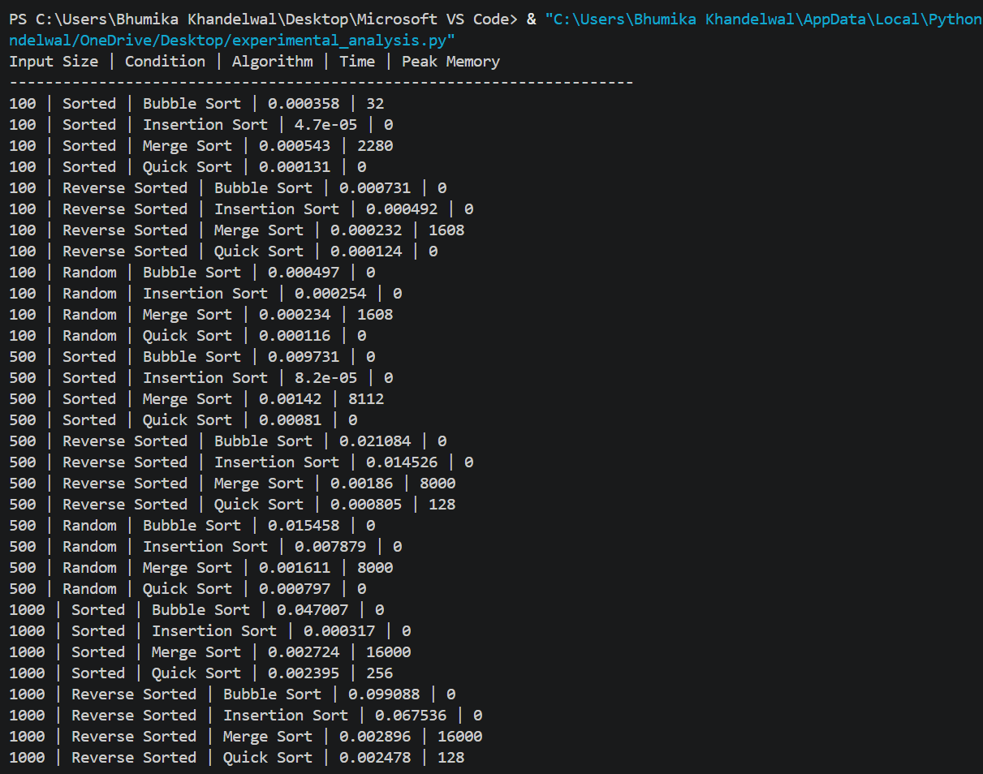

Q2: Complexity Comparison Table:
Prepare a complexity comparison table showing best-case, average-case, worst-case, and space complexities for all implemented algorithms.

TABLE:
Algorithm | Best Case | Average Case | Worst Case | Space Complexity
Bubble Sort | O(n) | O(n²) | O(n²) | O(1)
Merge Sort | O(n log n) | O(n log n) | O(n log n) | O(n)
Insertion Sort | O(n) | O(n²) | O(n²) | O(1)
Quick Sort | O(n log n) | O(n log n) | O(n²) | O(log n)
Fibonacci (Recursive) | O(2ⁿ) | O(2ⁿ) | O(2ⁿ) | O(n)
Fibonacci (Iterative) | O(n) | O(n) | O(n) | O(1)
Fibonacci (DP) | O(n) | O(n) | O(n) | O(n)

Q3: Graph Visualization:
Generate graphs and visualizations comparing execution time and memory consumption of sorting and Fibonacci algorithms. Include appropriate observations.

CODE:
import time
import tracemalloc
import random
import matplotlib.pyplot as plt

def bubble_sort(arr):
n = len(arr)
for i in range(n):
for j in range(0, n - i - 1):
if arr[j] > arr[j + 1]:
arr[j], arr[j + 1] = arr[j + 1], arr[j]

def insertion_sort(arr):
for i in range(1, len(arr)):
key = arr[i]
j = i - 1
while j >= 0 and arr[j] > key:
arr[j + 1] = arr[j]
j -= 1
arr[j + 1] = key

def merge_sort(arr):
if len(arr) > 1:
mid = len(arr) // 2
left = arr[:mid]
right = arr[mid:]
merge_sort(left)
merge_sort(right)
i = 0
j = 0
k = 0
while i < len(left) and j < len(right):
if left[i] < right[j]:
arr[k] = left[i]
i += 1
else:
arr[k] = right[j]
j += 1
k += 1
while i < len(left):
arr[k] = left[i]
i += 1
k += 1
while j < len(right):
arr[k] = right[j]
j += 1
k += 1

def quick_sort(arr, low=0, high=None):
if high is None:
high = len(arr) - 1
if low < high:
pivot = arr[high]
i = low - 1
for j in range(low, high):
if arr[j] <= pivot:
i += 1
arr[i], arr[j] = arr[j], arr[i]
arr[i + 1], arr[high] = arr[high], arr[i + 1]
pi = i + 1
quick_sort(arr, low, pi - 1)
quick_sort(arr, pi + 1, high)

def fibonacci_recursive(n):
if n <= 1:
return n
return fibonacci_recursive(n - 1) + fibonacci_recursive(n - 2)

def fibonacci_iterative(n):
a, b = 0, 1
for _ in range(n):
a, b = b, a + b
return a

def fibonacci_dp(n, memo=None):
if memo is None:
memo = {}
if n <= 1:
return n
if n in memo:
return memo[n]
memo[n] = fibonacci_dp(n - 1, memo) + fibonacci_dp(n - 2, memo)
return memo[n]

input_sizes = [5, 10, 15, 20, 25]

bubble_times, insertion_times, merge_times, quick_times = [], [], [], []
fib_rec_times, fib_iter_times, fib_dp_times = [], [], []

bubble_memory, insertion_memory, merge_memory, quick_memory = [], [], [], []
fib_rec_memory, fib_iter_memory, fib_dp_memory = [], [], []

for n in input_sizes:
data = []
for i in range(n):
data.append(random.randint(1, 1000))

arr = data.copy()
tracemalloc.start()
start = time.perf_counter()
bubble_sort(arr)
end = time.perf_counter()
current, peak = tracemalloc.get_traced_memory()
tracemalloc.stop()
bubble_times.append(end - start)
bubble_memory.append(peak)

arr = data.copy()
tracemalloc.start()
start = time.perf_counter()
insertion_sort(arr)
end = time.perf_counter()
current, peak = tracemalloc.get_traced_memory()
tracemalloc.stop()
insertion_times.append(end - start)
insertion_memory.append(peak)

arr = data.copy()
tracemalloc.start()
start = time.perf_counter()
merge_sort(arr)
end = time.perf_counter()
current, peak = tracemalloc.get_traced_memory()
tracemalloc.stop()
merge_times.append(end - start)
merge_memory.append(peak)

arr = data.copy()
tracemalloc.start()
start = time.perf_counter()
quick_sort(arr)
end = time.perf_counter()
current, peak = tracemalloc.get_traced_memory()
tracemalloc.stop()
quick_times.append(end - start)
quick_memory.append(peak)

tracemalloc.start()
start = time.perf_counter()
fibonacci_recursive(n)
end = time.perf_counter()
current, peak = tracemalloc.get_traced_memory()
tracemalloc.stop()
fib_rec_times.append(end - start)
fib_rec_memory.append(peak)

tracemalloc.start()
start = time.perf_counter()
fibonacci_iterative(n)
end = time.perf_counter()
current, peak = tracemalloc.get_traced_memory()
tracemalloc.stop()
fib_iter_times.append(end - start)
fib_iter_memory.append(peak)

tracemalloc.start()
start = time.perf_counter()
fibonacci_dp(n)
end = time.perf_counter()
current, peak = tracemalloc.get_traced_memory()
tracemalloc.stop()
fib_dp_times.append(end - start)
fib_dp_memory.append(peak)

# Graph 1: Execution Time Comparison
plt.plot(input_sizes, bubble_times, label="Bubble Sort")
plt.plot(input_sizes, insertion_times, label="Insertion Sort")
plt.plot(input_sizes, merge_times, label="Merge Sort")
plt.plot(input_sizes, quick_times, label="Quick Sort")
plt.plot(input_sizes, fib_rec_times, label="Fibonacci (Recursive)")
plt.plot(input_sizes, fib_iter_times, label="Fibonacci (Iterative)")
plt.plot(input_sizes, fib_dp_times, label="Fibonacci (DP)")
plt.xlabel("Input Size")
plt.ylabel("Execution Time (seconds)")
plt.title("Execution Time Comparison")
plt.legend()
plt.show()

# Graph 2: Memory Consumption Comparison
plt.plot(input_sizes, bubble_memory, label="Bubble Sort")
plt.plot(input_sizes, insertion_memory, label="Insertion Sort")
plt.plot(input_sizes, merge_memory, label="Merge Sort")
plt.plot(input_sizes, quick_memory, label="Quick Sort")
plt.plot(input_sizes, fib_rec_memory, label="Fibonacci (Recursive)")
plt.plot(input_sizes, fib_iter_memory, label="Fibonacci (Iterative)")
plt.plot(input_sizes, fib_dp_memory, label="Fibonacci (DP)")
plt.xlabel("Input Size")
plt.ylabel("Peak Memory (bytes)")
plt.title("Memory Consumption Comparison")
plt.legend()
plt.show()

CODE OUTPUT (Execution Time Comparison):

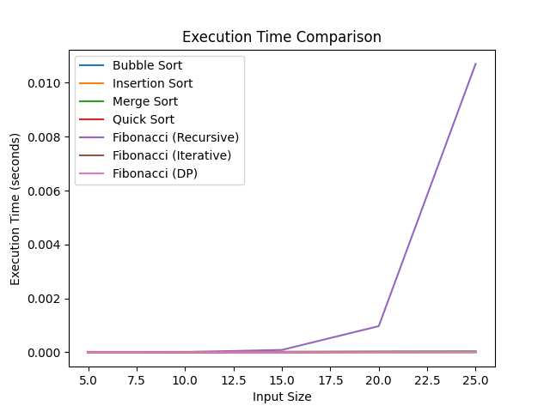

CODE OUTPUT (Memory Consumption Comparison):

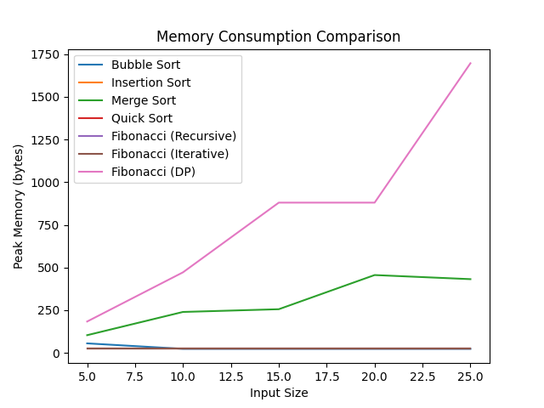
OBSERVATIONS:
- The execution time of Bubble Sort increases rapidly as the input size increases.
- Insertion Sort shows a similar pattern to Bubble Sort, with execution time increasing as input size grows.
- Merge Sort and Quick Sort take less execution time than Bubble Sort and Insertion Sort for larger input sizes.
- Fibonacci (Recursive) shows a rapid increase in execution time as the input size increases, much faster than any sorting algorithm.
- Fibonacci (Iterative) and Fibonacci (DP) remain fast and show very little increase in execution time as input size increases.
- Merge Sort consumes more memory than Bubble Sort, Insertion Sort, and Quick Sort because it uses additional temporary arrays.
- The memory consumption of Bubble Sort, Insertion Sort, and Quick Sort remains comparatively low in the given experiment.
- The memory consumption of Fibonacci (DP) increases as input size increases, since it stores previously calculated values.

