Lab 1: Comparative Study of Algorithm Efficiency and Performance Analysis
Task 3: Graphs and Visualizations
Execution time and memory consumption with observations
Name: Vansh Roll No.: 2401201123 Section: A

1. Sorting: Execution Time
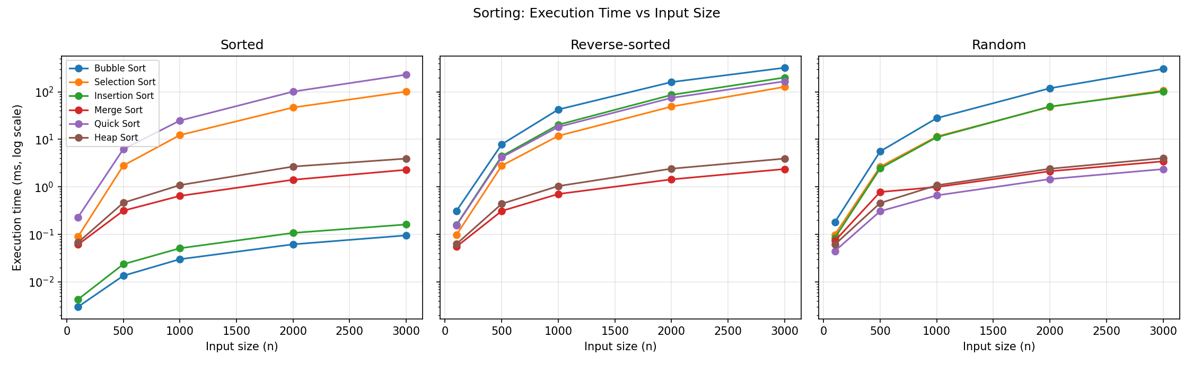
Figure 1: Sorting execution time vs input size for sorted, reverse-sorted and random data (log scale on y-axis).
Observations
- On sorted data, Bubble and Insertion Sort are the fastest (they run in linear time), while Quick Sort is the slowest because of the last-element pivot.
- On reverse-sorted data, Bubble, Insertion, Selection and Quick Sort all grow quadratically, hundreds of times slower than Merge and Heap Sort at n = 3000.
- On random data, Quick Sort is the fastest, closely followed by Merge Sort; Heap Sort is slightly slower due to more comparisons and poorer cache behaviour.
- Selection Sort’s time barely changes with the input order, confirming its Θ(n²) behaviour in all cases.

2. Sorting: Memory Consumption
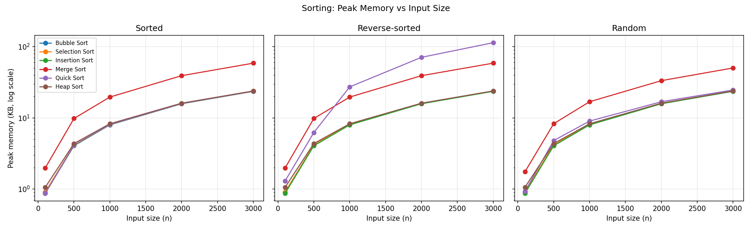
Figure 2: Peak memory vs input size for sorting algorithms (log scale on y-axis).
Observations
- Bubble, Selection, Insertion and Heap Sort show nearly identical memory (about 24 KB at n = 3000); this is just the copy of the input array, so they add no extra auxiliary space.
- Merge Sort uses about 2× more memory (50–59 KB) because of the temporary sub-arrays created at every level of recursion.
- Quick Sort memory is low on random data (about 25 KB) but rises to about 114 KB on reverse-sorted input, as the explicit stack grows to O(n) entries in the worst case.

3. Sorting: Comparison at n = 3000
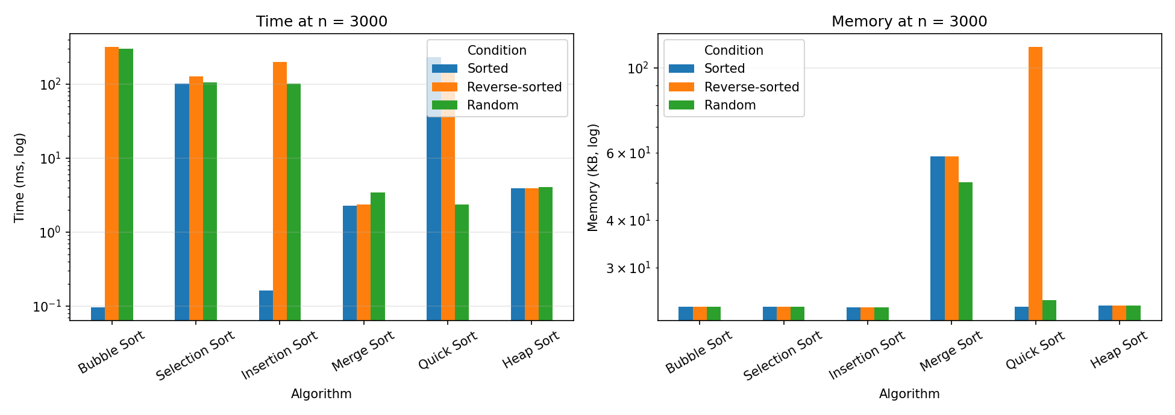
Figure 3: Time (left) and memory (right) for all sorting algorithms at n = 3000.
Observations
- No single algorithm wins in every case. Merge Sort and Heap Sort give predictable performance; Quick Sort is best on random data but needs a better pivot (random or median-of-three) for sorted data.
- Insertion Sort is a good choice for small or nearly sorted data; Merge Sort when stability matters and memory is available; Heap Sort when memory is tight and worst-case guarantees are needed.

4. Fibonacci: Time and Memory
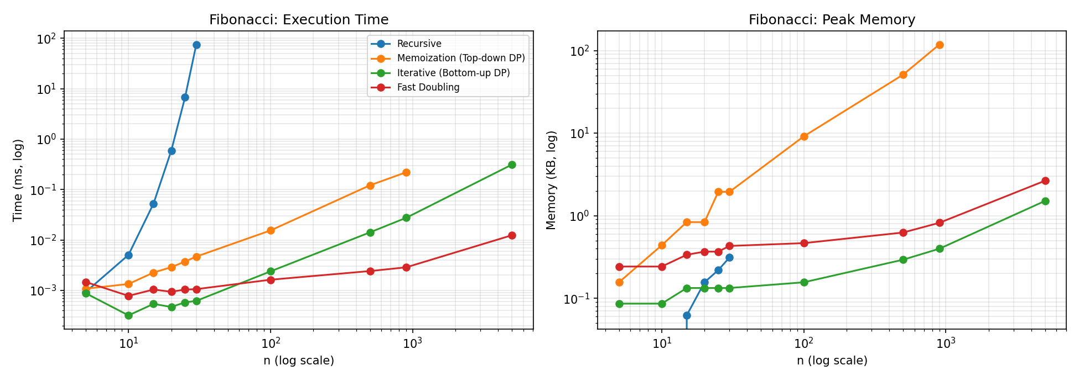
Figure 4: Fibonacci execution time (left) and peak memory (right), both axes logarithmic.
Observations
- Recursive Fibonacci time grows exponentially: about 0.6 ms at n = 20, 6.7 ms at n = 25 and 75 ms at n = 30. It could not practically be run for larger n.
- Memoization, iterative and fast doubling take microseconds. Iterative is the fastest and the most memory-efficient for moderate n (O(1) space).
- Memoization needs the most memory for large n (about 118 KB at n = 900) because it stores every sub-result in a dictionary and uses recursion depth O(n).
- Fast doubling grows slowest as n increases (about 0.012 ms at n = 5000, against about 0.31 ms for iterative), showing its O(log n) behaviour. At very small n its function-call overhead makes it slightly slower than the plain loop.

5. Conclusion
The experiments agree with the theoretical complexities: quadratic sorts degrade quickly with n, O(n log n) sorts stay fast, Quick Sort depends strongly on input order and pivot choice, and the exponential recursive Fibonacci is replaced effectively by dynamic programming or fast doubling.

