What I Learned Building TaskFlow
Internship project notes — the decisions I made, the things I learned, and the bugs that taught me the most

What TaskFlow Does
TaskFlow reads a customer support email, works out what it's about, looks up the answer in a knowledge base, and either sends a reply on its own or hands it to a person. It's a proof of concept: one laptop, one knowledge domain (billing), synthetic data throughout, and no real customers anywhere near it.
The AI writing an email is the boring part. Any model does that. The part worth building was the machinery that decides whether the email is allowed to go out at all.

Technical Decisions

Deterministic Workflow vs Autonomous Agentic Setup
This was the first real architectural decision, and I think the most defensible one. The obvious way to build an "AI support agent" in 2026 is to give a model some tools and let it decide what to do: read the email, call a search tool, maybe call a refund tool, decide when it's finished. That's an agent loop, and the model is in charge of control flow.
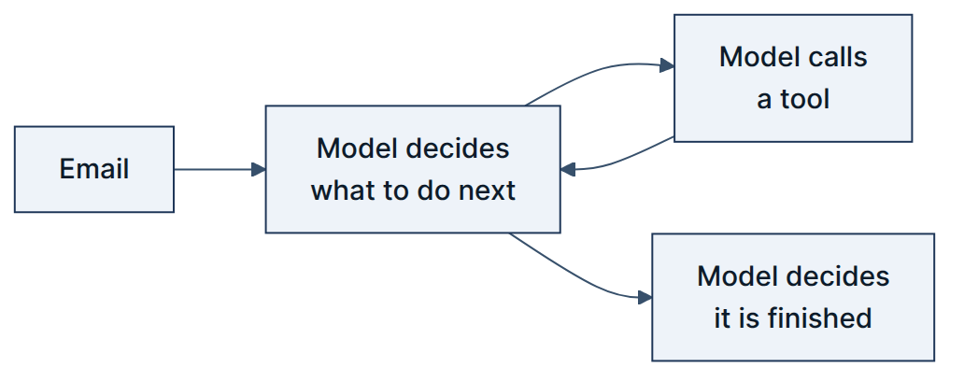
An agent loop: the model decides what happens next, including when to stop.
I went the other way. TaskFlow is a fixed sequence of steps written in ordinary Python:
TaskFlow: the code decides what happens next. The model gets two narrow, well-defined jobs.
The model is called exactly twice — once to classify the email, once to draft a reply from retrieved text. It has no tools, it can't take actions, and it has no say in what happens to its own output. Everything after drafting — validation, policy checks, the safety gates, the score, the routing decision — is deterministic code that runs the same way every time.

Why I chose this architecture
- I can explain it. The orchestrator is a straightforward function that can be read top-to-bottom in a few minutes. Each stage has a clear responsibility, making failures easier to locate and debug.
- Safety is enforced by code. Critical rules are deterministic. For example, “a refund over the ceiling never auto-sends” is enforced before the decision, rather than relying on the model to consistently follow an instruction.
- It is testable. Deterministic routing and safety logic can be covered with unit tests that assert specific inputs produce specific outcomes.
- Prompt injection has a smaller blast radius. Untrusted content cannot directly control tools or business actions. The model can influence generated text, but critical routing and authorization remain outside its control.
- API costs are predictable. LLM calls are limited to tasks that require language understanding. Deterministic operations handle the rest, keeping inference costs bounded and easier to estimate.
- Failures are contained. Each stage has a defined responsibility and output, so a failure can be isolated, retried, or routed to a fallback instead of triggering an unpredictable chain of agent actions.
- It is observable and auditable. Each decision can be logged as a distinct step, creating a clear trail of what happened and why—particularly important when human review or business-critical actions are involved.
The underlying principle: Use the LLM where judgment over language adds value; use deterministic code where correctness, safety, cost, and control matter.

The honest trade-off: an agent loop handles situations nobody planned for, and this design doesn't. Anything outside the ten steps I wrote simply doesn't happen. For a support inbox where the risky cases are known in advance — refunds, legal threats, angry customers — I think that's the right trade. For an open-ended research task it would be the wrong one.

Safety as a Gate, Not a Score Weight
My first design scored a draft on several weighted signals and sent it if the total cleared a threshold. Policy compliance was one of those weights, at 0.15.
That's broken, and the arithmetic shows why: a draft that violated a policy but scored well on citations, grounding, and tone came out at 0.85 against an 0.80 threshold. It would have been sent. A safety rule had been outvoted by a writing-quality rule, which is not a thing that should ever be possible.
So I split the decision into two layers that run in a fixed order:
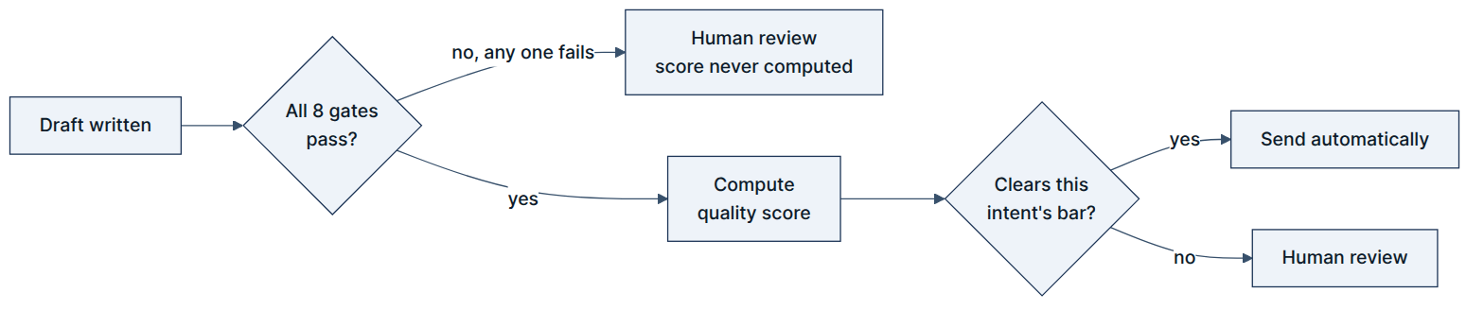
Eight gates run first and can end the decision on their own. The score is only consulted if every gate has already passed.
A score is a compromise between competing signals — that's what a weighted average is for. A safety rule isn't a compromise. Putting the two in the same number was the actual mistake, and separating them is the single change I'd defend hardest if someone challenged the design.

Configuration Over Code
Refund limits, score weights, per-topic thresholds, model names, and policy rules all live in YAML files rather than in Python. This started as tidiness and turned out to matter: during a demo I could change a threshold and re-run to show the routing decision flip, without touching code. It also means a limit like "$500" is a business number someone can change, not a magic constant buried in a function.

Technical Things I Picked Up

Retrieval (RAG) is Several Techniques, Not One
Asking a model a question and hoping it knows the answer produces confident, fluent, wrong answers. So the system searches a knowledge base first and asks the model to answer using only what came back, citing the document each fact came from.
What surprised me is that retrieval itself isn't one thing. This system runs two searches at once — one on meaning (embeddings), one on keywords — merges the results, then re-ranks them with a second, slower model that reads the question and passage together. The keyword search exists because embeddings are bad at exact strings like invoice IDs and error codes. The re-ranker exists because the merged ordering alone wasn't accurate enough. I measured Recall@5 at about 93% over 351 test queries, which sounds good until you remember I wrote the test queries and the documents they're searching.

Working With LLMs in a System, Not a Chat Window
Calling an API and printing the answer is maybe 10% of the work. The rest is everything around it: what happens when the provider is down (fall back to another, then to a local model), what happens when the model returns malformed output, how you track what each request costs, and how you make sure it never sees data it shouldn't. Personal data gets stripped before the text reaches any provider, not after.
I also learned to distrust the model's own confidence. The drafting model returns a confidence number with every draft. The system records it and never routes on it — the model marking its own homework isn't evidence.

Layered Architecture Earns Its Keep (I Was Sceptical)
The project keeps business logic strictly separate from anything that touches an outside service — the database, the AI providers, Gmail. At first this felt like ceremony for a project this size.
It stopped feeling that way twice. First, when I could swap a real AI call for a fake one in tests without touching any logic. Second, when I added a new PII library and an automated boundary check — not a human reviewer — caught me importing it into a layer where third-party libraries aren't allowed. The rule was enforced by the build, so I couldn't quietly break my own architecture at 11pm.

There Are Two Kinds of Tests and They Have Different Jobs
Fast tests use fakes, touch no network or models, and run in seconds — those run constantly while coding. Slower tests load real models and a real database and are worth trusting but not worth running every thirty seconds. Keeping them separate, and being honest about which is which, mattered more than I expected. The suite ended up at 191 tests, and the useful rule I settled on was that tests assert routing decisions and reason codes, never the model's prose — generated text isn't stable, decisions are.

Real Integrations Are Messier Than the Tutorials
Switching Gmail from polling every 30 seconds to real push notifications meant a Google Cloud project, a Pub/Sub topic, an OAuth consent flow, and one IAM permission that's very easy to miss (Gmail's own service account needs publish rights on your topic, and without it the whole thing fails quietly). It did not work first time. When it finally did, I sent a real email and watched it get picked up and routed in under a second, which was disproportionately satisfying.

Problems, Bugs, and What They Taught Me
These were the issues I discovered through testing the system end-to-end. Each exposed a gap that was difficult to identify from code inspection alone.

1. A Safety Rule Was Checking Against Stale Reference Data
A policy rule was designed to detect incorrect prices in AI-generated responses. It compared quoted prices against values stored in configuration. However, the configuration was outdated: it listed the Pro plan at $12, while the knowledge base—the actual source of truth—listed it at $24.
This created a serious failure mode: a correct response could be flagged, while an incorrect response using the stale price could pass.
The configuration also contained a fixed Enterprise price, despite the knowledge base stating that Enterprise pricing is contract-based and should not be presented as a standard price.
Fix: Aligned validation with the authoritative knowledge source and removed contradictory reference values.
Lesson: Safety checks are only as reliable as the data they validate against. Reference data must have a clearly defined source of truth and be kept consistent with it.

2. The PII Detector Flagged the Product's Own Name
I upgraded the PII detection from pattern matching to a model-based detector capable of identifying names, emails, and phone numbers. During testing, legitimate responses were incorrectly blocked because the detector classified the product name, “AcmeFlow Workspace,” as a person's name.
A scan of the knowledge base showed that the product name appeared frequently across multiple documents, meaning this false positive could have blocked a large proportion of otherwise valid responses.
Fix: Added known product and domain-specific terms to an explicit allowlist for the detector.
Lesson: A more sophisticated model does not automatically produce better results. AI components must be evaluated against the system's actual domain data, not only generic examples.

3. A PII Upgrade Reduced Credit-Card Detection
The same PII upgrade introduced another problem. The new library's built-in credit-card detector assigned card numbers a confidence score below my configured threshold. Because the threshold had been raised to reduce false positives from name detection, valid credit-card numbers were no longer being caught reliably.
This meant the upgraded system was weaker at a safety capability that the previous implementation handled correctly.
Fix: Kept project-specific detection patterns for credit cards, SSNs, and API keys and assigned them appropriate high-confidence handling instead of relying entirely on the library defaults.
Lesson: When replacing a working component, regression-test the capabilities it already provided—not just the new functionality being introduced.

4. Two Processes Attempted to Use the Same Database
The embedded vector store uses a file-based locking mechanism. Both the API and the email polling process attempted to open the same database independently. Running them together caused the second process to fail because the database was already locked.
Fix: Changed the architecture so that the poller sends messages to the API rather than running the processing pipeline itself. The API became the single owner of the vector store.
This also simplified the poller and established a cleaner pattern for the push-based listener introduced later.
Lesson: Embedded databases still have concurrency constraints. Architecture must account for ownership and access patterns, not just whether a database technically supports multiple processes.

What Was Genuinely Hard

Choosing thresholds
There is no universally correct confidence threshold. A threshold that is too high causes excessive escalation; one that is too low risks incorrect automation.
Rather than choosing a value arbitrarily, I evaluated the trade-off across different thresholds and selected one based on observed behaviour.

Knowing when there is not enough data
The calibration tool is designed to learn score weights from reviewed outcomes. With only eight available samples, it correctly refused to recommend new weights.
Initially, returning “not enough data” felt like a limitation. In practice, it is a useful safety property: a calibration system should know when its evidence is insufficient to make a reliable recommendation.

Being honest about evaluation
The classifier evaluation currently covers only the offline fallback path and is based on 14 samples. Reporting “100% accuracy” without highlighting the sample size would create a misleading impression of reliability.
The more accurate conclusion is that the observed results are promising but insufficient to establish production-level performance.

What I Would Do Next
- Expand the evaluation dataset: Collect more human-reviewed decisions so the calibration system can learn meaningful score weights.
- Expand the knowledge base: Extend beyond billing to determine which parts of the architecture generalise and which policy rules require domain-specific changes.
- Improve AI evaluation: Develop more systematic evaluation for generation quality instead of relying primarily on subjective assessment.
- Add regression testing: Build a reusable test suite around previously discovered failure cases so future model, library, and configuration changes do not reintroduce them.

Closing Thought
I initially expected most of the learning to come from prompts, embeddings, and models. Those were important, but the deeper lesson was about engineering around AI: deciding what the model should be responsible for and where deterministic software should take control.
The goal was not simply to make the system sound intelligent. It was to build a system that knows when it should stop, when it should ask for help, and when it should not act at all.

