Product Specification Document (PSD)

TaskFlow AI Support Agent
Document Version | 2.0
Date | 2026-08-24
Author | Vansh Rautela
Supersedes | PSD v1.0 (2026-08-24)
Companion | BRD.md — business requirements
Every section below carries a Traces to line naming the FR/NFR IDs it implements.
Status: v1 implemented — core pipeline complete, delivery/SLA hardening in progress
Last verified: 2026-08-24 via the commands below
Build health: lint ✗ (24 ruff findings) · types ✗ (9 mypy errors in 5 files)
· import-boundaries ✓ (1 contract kept, 0 broken) · tests ✓ (68/68 passing)
Verified by: `uv run pytest -q` (68 passed in 38.32s)
`uv run lint-imports` (102 files, 222 dependencies analysed)
`uv run ruff check .` · `uv run mypy src/` · `uv run alembic heads` (d300852af25a)
Runtime: Python 3.12.13
Test layers: unit (64 / 12 files), pipeline (2), integration (2) — all green. tests/e2e/ exists and is empty; end-to-end scenario tests are in progress. Lint and type findings are confined to adapters/channels/, api/app.py, dashboard/app.py, the migration scripts, and one line in domain/models.py. The services/confidence/ package — the safety core — is clean under both tools.

1. Product Overview

1.1 Product vision
TaskFlow turns an inbound customer message into either a policy-compliant, citation-backed reply sent automatically, or an escalation to a human with a single explicit reason. The product is the decision, not the prose: any reasonably modern LLM can write the reply, and almost none can tell you, months later, precisely why sending it was allowed.
The system is built so that the answer to "why did this send?" is always a short, reconstructable chain — these chunks were retrieved with these scores, this draft cited them, these three validators returned these results, these seven gates passed, these five weighted signals produced this score against this threshold, using this model at this cost.

1.2 What it does, in order
Ingest → redact PII → classify intent → retrieve context → draft with citations → validate (×3, concurrent, fail-closed) → evaluate policy rules → evaluate 7 gates → compute the weighted score → decide → enqueue to outbox or create a review item and alert → finalise the trace.
There are no hidden event buses and no orchestration framework. The whole path is one readable async function of about 220 lines (ADR-005).

1.3 What it is not
It is not multi-tenant in operation (one tenant, taskflow-demo), not containerised, not multilingual, and not load-tested. Those are recorded deferrals with stated triggers, not oversights — see BRD §5.3.

2. Architecture
Traces to: NFR-4.1, NFR-4.2, NFR-4.3, NFR-5.1

2.1 Layers
TaskFlow is a hexagonal (ports-and-adapters) application. The layering is not a diagram in a document — it is a contract checked by CI.
┌───────────────────────────────────────────────────────────────────────┐
│ External systems │
│ OpenRouter · Anthropic · Ollama · Qdrant · SQLite · Gmail · Telegram │
├───────────────────────────────────────────────────────────────────────┤
│ Adapters — the only layer allowed to know a vendor exists │
│ adapters/llm/ · adapters/vector/ · adapters/db/ · adapters/channels/ │
├───────────────────────────────────────────────────────────────────────┤
│ Ports — Protocol definitions, no implementations │
│ LLMProvider · LLMRouter · VectorStore · *Repository · ChannelConnector│
├───────────────────────────────────────────────────────────────────────┤
│ Services — pure logic, no I/O beyond an injected port │
│ classify · retrieve · draft · validate · confidence · policy · │
│ review · alert · preprocess · cost │
├───────────────────────────────────────────────────────────────────────┤
│ Domain — Pydantic models, enums, errors. Zero I/O, zero dependencies │
└───────────────────────────────────────────────────────────────────────┘
pipeline/orchestrator.py sits above services and is the one place allowed to wire adapters to services, via an explicit Deps container.

2.2 The enforced boundary
pyproject.toml declares a single forbidden-import contract:
[[tool.importlinter.contracts]]
name = "domain and services never touch adapters or SDKs"
type = "forbidden"
source_modules = ["taskflow.domain", "taskflow.services"]
forbidden_modules = [
"taskflow.adapters", "taskflow.api", "taskflow.worker", "taskflow.dashboard",
"anthropic", "ollama", "qdrant_client", "googleapiclient", "sqlalchemy", "streamlit",
]
uv run lint-imports analyses 102 files and 222 dependencies and currently reports 1 contract kept, 0 broken. This is what makes "SQLite → PostgreSQL is a config change" a checked statement rather than a claim: no service can name a SQLAlchemy type, so no service can depend on SQLite semantics.
Known boundary gap. src/taskflow/ports/vector_store.py imports DocumentChunk from taskflow.services.retrieve.chunking, i.e. ports depends on services. The contract as written does not forbid it. Moving DocumentChunk into domain/ would close the gap.

2.3 Runtime processes
Four independent processes; none requires a container.
Process | Entry point | Port | Responsibility
API server | uv run uvicorn taskflow.api.app:app --port 8000 | :8000 | Message ingestion, trace queries, review actions, metrics
Operator console | uv run streamlit run dashboard/app.py | :8501 | Human review, trace explorer, KPI panel
Outbox worker | uv run python scripts/start_worker.py | — | Claims queued replies and delivers over SMTP
Gmail poller | uv run python scripts/start_gmail_poller.py | — | Polls IMAP for unseen mail and runs the pipeline
External processes: Ollama on localhost:11434 (only for the local fallback). Qdrant and SQLite are embedded, in-process — there is no database server and no vector server (ADR-006, ADR-007).

3. Pipeline Orchestrator
Traces to: FR-1.1, FR-8.4, FR-9.1, FR-10.1, FR-12.1 File: src/taskflow/pipeline/orchestrator.py (218 lines)

3.1 Stage map

3.2 Stage contract
Stage | Input | Output | Module | Failure behaviour
P0 | InboundMessage | Redacted copy + new Trace | services/preprocess/service.py | Pure regex; cannot fail
P1 | Redacted body | (Intent, confidence, LLMCall | None) | services/classify/service.py | Any exception → deterministic keyword classifier
P2 | Redacted body + tenant_id | RetrievalResult | services/retrieve/service.py | Empty chunk list → sufficient=False; gates and score absorb it
P3 | Message + intent + retrieval | (DraftOutput, LLMCall | None) | services/draft/service.py | Any exception → safe template draft
P4 | Draft + retrieval | list[ValidatorResult] (3) + list[PolicyViolation] | services/validate/runner.py, services/policy/service.py | Crash or timeout → errored=True, blocking=True
P5 | Intent, confidence, validators, violations, injection flag | list[GateResult] (7) | services/confidence/gates.py | Deterministic; cannot fail
P6 | Gates + 5 signals + weights + threshold | ConfidenceBreakdown → RoutingDecision | services/confidence/scorer.py | Any gate failure wins over any score
P7 | Decision | Outbox row or review row + alert | ports/repositories.py implementations | Alert dispatch is exception-wrapped and never affects routing
P8 | Final state | Persisted trace | SQLiteTraceRepository.update + .finish | Runs regardless of the decision
Every stage is wrapped by _time_stage, which records elapsed milliseconds as a TraceEventRow. (Event payloads are currently written as {} — the timing is real, the per-stage payload detail is a stated to-do in the source.)

3.3 Dependency injection
@dataclass
class Deps:
trace_repo: TraceRepository # Protocol
llm_router: ProviderRouter
vector_store: VectorStore | None = None
review_repo: ReviewRepository | None = None
outbox_repo: OutboxRepository | None = None

async def run_pipeline(msg: InboundMessage, deps: Deps) -> RoutingDecision: ...
Because every field but the router is a Protocol, the entire pipeline runs in tests against in-memory SQLite and fake providers with no network and no disk service — which is exactly what tests/pipeline/test_orchestrator.py does.

3.4 Known behaviour to be aware of
- The threshold passed to compute() is thresholds_config()["thresholds"]["general"] (0.70) for every intent. The seven other per-intent thresholds in config/thresholds.yaml are not yet selected on. See BRD R-3.
- The SLA deadline on a new review item is now + timedelta(hours=4), not derived from sla_minutes. See BRD R-4.
- generate_draft is called with msg, and the drafting prompt interpolates msg.body_text — the unredacted body. Classification correctly uses the redacted text. See BRD R-1.
- tone_alignment is passed as a constant 1.0; there is no tone scorer yet, so that 0.10 weight is currently a fixed contribution.

4. System Components

4.1 Preprocessing / PII redaction
Traces to: FR-2.1 – FR-2.5, NFR-3.1 File: src/taskflow/services/preprocess/service.py
def preprocess_message_text(text: str) -> str
Class | Pattern | Replacement
Card numbers | \b(?:\d[ -]*?){13,16}\b | [REDACTED_CREDIT_CARD]
US SSN | \b\d{3}-\d{2}-\d{4}\b | [REDACTED_SSN]
Secrets / bearer tokens | \b(?:sk|pk)_[a-zA-Z0-9_\-]{16,}\b or Bearer\s+[a-zA-Z0-9._\-]{20,} | [REDACTED_API_KEY]
Dependencies: none (stdlib re only). Failure modes: none — deterministic and total. Deliberate limitation: regex, not NER, so names, addresses, and phone numbers are not redacted. That is a stated v1 simplification.

4.2 Intent classification
Traces to: FR-3.1 – FR-3.6 File: src/taskflow/services/classify/service.py
async def classify_intent(
text: str, router: LLMRouter | None = None
) -> tuple[Intent, float, LLMCall | None]
It is not a trained model. It is LLM structured output with a deterministic keyword fallback. src/taskflow/ml/ is an empty package; scikit-learn and joblib are declared in pyproject.toml but unused.
Intent taxonomy — 8 values from domain/enums.py:
Intent | Meaning | Auto-send eligible | Configured threshold
billing | Charges, invoices, payment methods, double billing | ✅ | 0.80
technical | API errors, 5xx, bugs, outages | ✅ | 0.70
account | Password resets, 2FA, login | ✅ | 0.70
feature_request | New functionality, enhancements | ✅ | 0.75
refund | Money back, reimbursement, proration | ✅ | 0.90
general | Office hours, general inquiries | ✅ | 0.70
complaint | Angry escalation, service-quality grievance | ❌ preempt | 1.01 (unreachable)
unknown | Ambiguous, unclassifiable, gibberish | ❌ preempt | 1.01 (unreachable)
PREEMPT_INTENTS = frozenset({COMPLAINT, UNKNOWN}) is what Gate G4 reads. The 1.01 thresholds are belt-and-braces: even without G4, the score can never reach them.
Only the general threshold (0.70) is applied by the pipeline today — see §3.4. The table above is the configured intent, not current behaviour.
Flow:
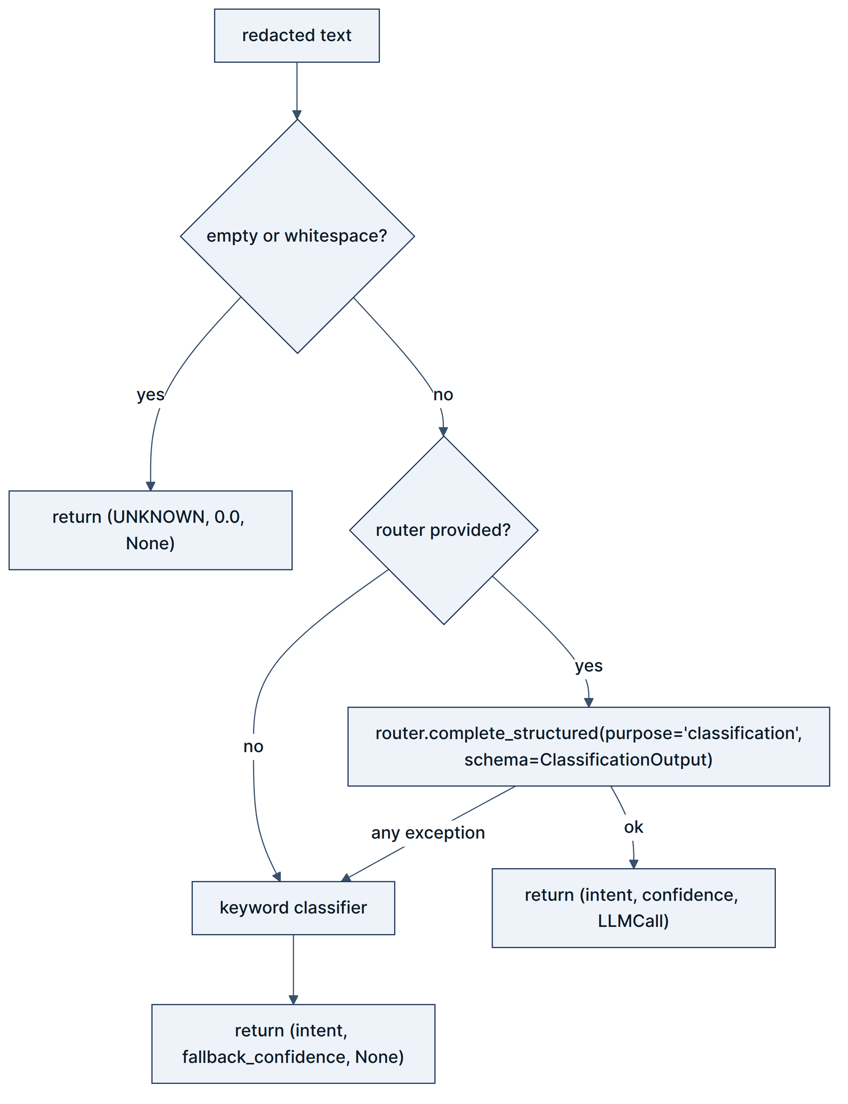
Keyword fallback (confidences from thresholds.yaml::fallback_confidences):
Trigger keywords | Intent | Confidence
refund, money back, reimbursement | refund | 0.95
bill, invoice, charge, charged | billing | 0.90
api, error, 500, 504, bug, crash, webhook, timing out, sso, saml, okta, soc2, nda | technical | 0.85
cancel, close account, erase my data | refund | 0.90
login, password, 2fa, account | account | 0.88
terrible, worst, complain, complaint, ruined | complaint | 0.98
(no match) | unknown | 0.40
Note that unknown at 0.40 sits below the 0.55 abstain threshold, so an unmatched message fails Gate G5 and Gate G4 — two independent reasons never to auto-send it.
Failure modes: the except Exception around the router is broad by design (it must also absorb the KeyError described in §7.3). The cost is that a genuine bug in the classification path is indistinguishable from a provider outage in the trace.

4.3 Knowledge retrieval
Traces to: FR-4.1 – FR-4.8 Files: services/retrieve/{service,query_builder,sufficiency,injection,chunking}.py, adapters/vector/qdrant_store.py
async def retrieve_context(
query: str, tenant_id: str, vector_store: VectorStore | None = None
) -> RetrievalResult
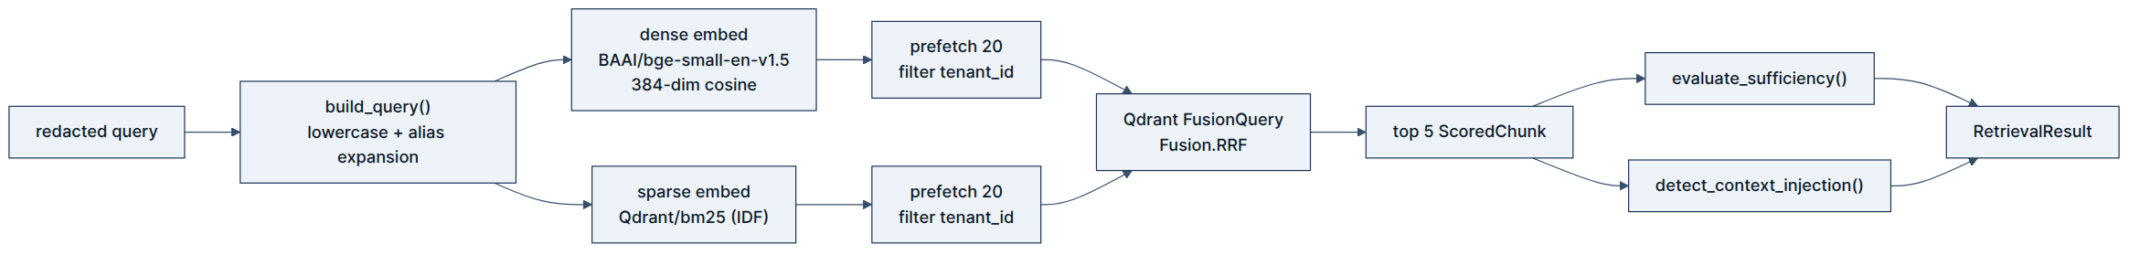
Embedding models — both run in-process via FastEmbed; no embedding API call is ever made:
Model | Type | Dimensions | Role
BAAI/bge-small-en-v1.5 | dense, cosine | 384 | Semantic match
Qdrant/bm25 | sparse, IDF modifier | variable | Lexical / keyword match
Query expansion (config/settings.yaml::retrieval.alias_expansions) — when an alias appears as a whole word, its expansion is appended in parentheses:
Alias | Expansion
2fa | two-factor authentication
sso | single sign-on
api key | api token credential
invoice | billing statement invoice
Sufficiency (config/thresholds.yaml::retrieval) returns (sufficient, gap_reason, top_score, support_count):
Parameter | Value | Meaning
min_top_score | 0.35 | The best chunk must clear this
min_support_score | 0.20 | What counts as a supporting chunk
min_support_count | 2 | How many supporting chunks are required
prefetch_k | 20 | Candidates per branch before fusion
rerank_k | 5 | Chunks handed to drafting
Gap reasons are explicit strings — no_chunks_retrieved, top_score_too_low (0.281 < 0.350), insufficient_support_count (1 < 2) — and land on the trace.
Implementation note. retrieve_context calls vector_store.search(..., limit=5) and qdrant_store.search hardcodes limit=20 on each prefetch branch. The values match rerank_k and prefetch_k, but they are literals in code rather than reads from config. There is no reranker: ScoredChunk.rerank_score exists and is always None, so final_score falls through to rrf_score.
Injection detection (services/retrieve/injection.py) — five case-insensitive patterns scanned across every retrieved chunk. A single hit sets RetrievalResult.suspicious_context=True, which Gate G7 reads:
ignore (all )?(previous|prior) (instructions|rules|prompts)
system prompt:
you are now an?
override (safety|guardrails|filters|policies)
[system_instruction]
Chunking (services/retrieve/chunking.py) — heading-aware markdown splitting at ## and deeper, target 450 tokens (~338 words) with 60-token (~45-word) overlap, forced split if a section runs long. Chunk IDs are {doc_id}:{ordinal} where doc_id = sha256(f"{relpath}\n{title}")[:16], which makes re-ingestion idempotent.
Failure modes: an unreachable vector store raises RetrievalUnavailable; an empty result yields sufficient=False, which zeroes the 0.20 retrieval-relevance signal and usually escalates on score.

4.4 Response drafting
Traces to: FR-5.1 – FR-5.7 File: src/taskflow/services/draft/service.py
async def generate_draft(
msg: InboundMessage, intent: Intent,
retrieval: RetrievalResult, router: LLMRouter,
) -> tuple[DraftOutput, LLMCall | None]
Retrieved chunks are formatted into the prompt as labelled blocks:
[Chunk ID: {chunk_id} | Title: {title} | Section: {section}]
{text}
The system prompt requires the model to answer exclusively from those blocks, to cite inline as [chunk_id], to pick a tone from the five allowed strings, and never to invent dates or terms.
The DraftOutput contract (domain/models.py) — validated, never trusted:
Field | Type | Constraint
response_text | str | 1–4000 chars; accepts aliases response, reply, body
citations | list[Citation] | Bare strings are coerced to Citation objects
tone | str | ^(formal|friendly|apologetic|neutral|technical)$
complexity | str | ^(simple|moderate|complex)$
draft_confidence | float | 0.0–1.0, default 0.85 — logged only, never routed on
model_config is extra="ignore" so a chatty model's surplus keys do not fail the parse.
Citation enforcement — a model validator runs at parse time:
@model_validator(mode="after")
def _citation_markers_present(self) -> Self:
if self.citations:
missing = [c.chunk_id for c in self.citations
if f"[{c.chunk_id}]" not in self.response_text]
if missing:
valid = [c for c in self.citations if f"[{c.chunk_id}]" in self.response_text]
object.__setattr__(self, "citations", valid)
return self
It strips citations that are not referenced inline rather than raising. The rationale is that a local model that lists a citation without using it should be corrected, not have its whole response discarded. The strictness is recovered downstream: the citations validator independently checks every remaining structured citation and every inline [id] marker against the actually-retrieved chunk IDs, and Gate G3 vetoes on failure.
Template fallback — when the router raises for any reason:
Thank you for reaching out regarding your {intent} request. [{first_chunk_id}]
Our support team has logged this request.
with tone="friendly", complexity="simple", and draft_confidence = fallback_confidences.draft (0.50). Because it carries essentially no grounded content, its grounding ratio collapses and it escalates on score.

4.5 Validation
Traces to: FR-6.1 – FR-6.6, NFR-2.4 Files: services/validate/{runner,pii_leak,citations,grounding}.py
async def run_validators(
draft: DraftOutput, retrieval: RetrievalResult | None, timeout_s: float = 15.0
) -> Sequence[ValidatorResult]
Three validators, run concurrently under asyncio.gather:
# | Name | File | What it computes | Blocking | Gate
1 | pii_leak | pii_leak.py | Scans the outbound draft for the same three secret classes as inbound redaction | yes on failure | G2
2 | citations | citations.py | Union of structured citation IDs and inline [id] markers must all resolve to retrieved chunk IDs; score = resolved fraction | yes on failure | G3
3 | grounding | grounding.py | Word-overlap ratio against the concatenated context; compared to min_grounding_ratio (0.80) | no | none — feeds the score only
What grounding actually computes:
context = " ".join(chunk.text.lower() for chunk in retrieval.chunks)
meaningful = {w for w in draft.response_text.lower().split() if len(w) > 3}
grounded = {w for w in meaningful if w in context}
ratio = round(len(grounded) / len(meaningful), 2)
This is a word-overlap proxy, not entailment. It has honest limitations: substring matching means "bill" matches inside "billing"; word order and negation are invisible; a draft that copies context verbatim scores 1.0 regardless of whether it answers the question. It is cheap, deterministic, explainable, and adds no LLM call — the trade recorded in ADR-003, revised here because the ADR describes an LLM entailment check that was not built. A cross-encoder or NLI entailment upgrade is the natural v2 move.
Note also that grounding is non-blocking and has no gate. A poorly grounded draft is punished through the 0.25 weight, not vetoed — a deliberate choice, since a low overlap ratio is evidence, not proof.
The fail-closed doctrine (runner.py::safe_run):
try:
return await asyncio.wait_for(coro, timeout=timeout_s)
except TimeoutError:
return ValidatorResult(validator_name=name, passed=False, score=0.0,
reason="Validator timed out", blocking=True, errored=True)
except Exception as e:
return ValidatorResult(validator_name=name, passed=False, score=0.0,
reason=f"Validator crashed: {e}", blocking=True, errored=True)
errored=True is what Gate G6 reads. A validator that breaks is treated as a validator that failed — never as a validator that was skipped.

4.6 Policy engine
Traces to: FR-13.1 – FR-13.5 Files: services/policy/service.py, config/policies.yaml
def evaluate_policies(
msg: InboundMessage, draft: DraftOutput | None, intent: Intent
) -> list[PolicyViolation]
Ten rules, entirely data-driven — adding a rule is a YAML edit, never a code change (ADR-004). Each rule declares an id, a severity, an optional applies_to (inbound | outbound, default outbound), an optional applies_when.intent filter, and a detect block.
Four detection types are implemented:
Type | Semantics
amount_over | Extract dollar amounts by regex; violate if any exceeds threshold
regex_any | Violate on the first pattern that matches the target text
regex_absent | Violate when none of the patterns match — used for required language
price_mismatch | If a plan name appears in the draft, any quoted dollar figure that differs from the known price violates
Critical rules — these block auto-send via Gate G1:
Rule ID | Applies to | Detection | Rationale
refund_ceiling | outbound | amount_over, threshold 500 | Support has no authority to approve above the ceiling
no_feature_dates | outbound | regex_any — "will be available in/by", "next quarter we will ship" | Never commit a ship date for an unreleased feature
no_credential_request | outbound | regex_any — "send/share/provide/confirm your password / 2FA / OTP / API key" | Support must never ask for a secret
legal_threat_escalation | inbound | regex_any — lawyer, attorney, legal action, sue, lawsuit, small claims, GDPR complaint | A legal threat is always a human's problem
gdpr_deletion_routing | inbound | regex_any — "delete/erase/remove (all) my/our data/account/personal data" | Deletion requests belong to the privacy team
no_discount_invention | outbound | regex_any — "NN% off/discount", "free month/year/upgrade" | Only discounts defined in the KB may be offered
no_security_details | outbound | regex_any — "our/the database/infrastructure runs/uses", "internal endpoint/service/hostname" | No internal architecture disclosure
Warning rules — recorded on the trace, never blocking:
Rule ID | Applies when | Detection
pricing_accuracy | outbound | price_mismatch against {pro: 12, enterprise: 29}
no_competitor_disparagement | outbound | regex_any — "worse/inferior/broken than"
escalation_language_required | intent ∈ {complaint, refund} | regex_absent — the draft must contain "I'm sorry", "I apologise", or "understand your frustration"
Warnings currently have no numeric effect. The v1 draft stated they reduce the tone score; tone_alignment is passed as a constant 1.0, so they do not. Wiring warnings into a real tone signal is the intended fix.
Failure modes: a rule with an invalid regex raises at evaluation time and would propagate out of the pipeline — there is no per-rule exception isolation. Adding one is a small, worthwhile hardening.

4.7 The two-layer confidence architecture
Traces to: FR-7.1 – FR-7.9, FR-8.1 – FR-8.5, BO-1, BO-2 Files: services/confidence/gates.py, services/confidence/scorer.py · ADR-001
This is the centrepiece of the product.

4.7.1 Why two layers
The rejected design put policy_compliance at weight 0.15 inside a weighted average with a 0.80 auto-send bar. A draft with a critical policy violation scoring 0.0 on that term and 1.0 everywhere else reaches 0.85 and auto-sends. The PII validator had no term at all, so it could fail and change nothing. That is not a safety system; it is a safety-flavoured average.
The fix is categorical rather than numerical: safety is a veto, not a weight. Gates are evaluated first and are conjunctive. The score is computed only to choose among drafts that already passed every gate.

4.7.2 Layer 1 — seven conjunctive veto gates
def evaluate_gates(
intent: Intent, intent_confidence: float, abstain_threshold: float,
validators: list[ValidatorResult], violations: list[PolicyViolation],
citations_resolve: bool, suspicious_context: bool,
) -> list[GateResult]
Note the signature: evaluate_gates is a pure function. No I/O, no config lookup, no clock. Everything it needs is passed in, which is why the six gate tests run in milliseconds with no fixtures.
Gate | GateId value | Passes when | Trips on
G1 | G1_policy_critical | no violation has severity == CRITICAL | $600 refund promise, ship-date commitment, credential request, legal threat, GDPR deletion, invented discount, infrastructure disclosure
G2 | G2_pii_leak | the pii_leak validator passed | card number, SSN, or secret key in the outbound draft
G3 | G3_citations_resolve | citations_resolve is True | a [chunk_id] marker or structured citation that resolves to nothing retrieved
G4 | G4_intent_allows_auto | intent not in PREEMPT_INTENTS | intent is complaint or unknown
G5 | G5_classifier_confident | intent_confidence >= abstain_threshold (0.55) | the classifier is not sure enough to act autonomously
G6 | G6_validators_healthy | no validator has errored=True | a validator crashed or exceeded 15 s
G7 | G7_no_suspicious_context | suspicious_context is False | instruction-like text inside a retrieved chunk
All seven are evaluated every time — the function does not short-circuit — so the trace records the state of every gate, not just the first failure. decide() then reports the first failed gate as the reason code, which is why every escalation has exactly one cause.
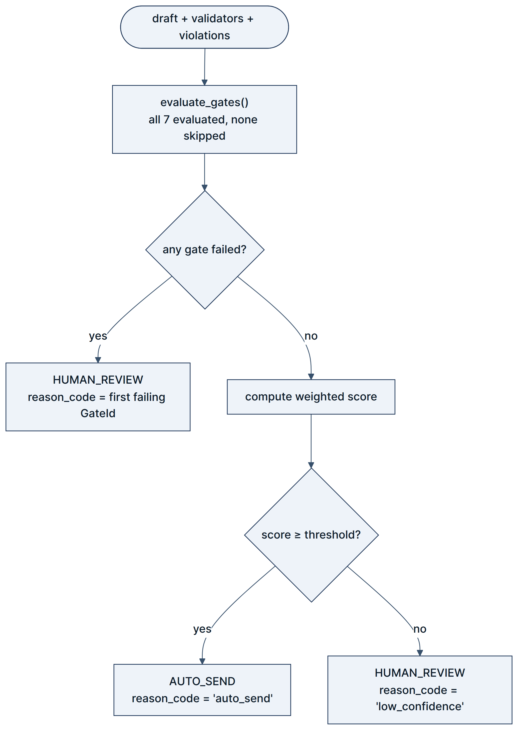

4.7.3 Layer 2 — the weighted quality score
def compute(gates, signals, weights, threshold, draft_confidence) -> ConfidenceBreakdown
def decide(breakdown) -> RoutingDecision
Signal | Weight | How the orchestrator computes it
citation_coverage | 0.35 | 1.0 if the citations validator passed, else 0.0
grounding_entailment | 0.25 | The grounding validator's word-overlap ratio (continuous)
retrieval_relevance | 0.20 | 1.0 if RetrievalResult.sufficient, else 0.0
intent_confidence | 0.10 | The classifier's confidence (continuous)
tone_alignment | 0.10 | Constant 1.0 — no tone scorer exists yet
 | 1.00 | Sum verified: 0.35 + 0.25 + 0.20 + 0.10 + 0.10 = 1.00 ✓
score = Σ signalᵢ × weightᵢ, then:
if breakdown.failed_gates: → HUMAN_REVIEW, reason_code = first failed gate ID
elif breakdown.score >= threshold: → AUTO_SEND, reason_code = "auto_send"
else: → HUMAN_REVIEW, reason_code = "low_confidence"
compute() deliberately calculates the score even when gates have failed, so the trace answers "how good was this draft, independently of why we refused to send it?" — which is exactly what makes test_critical_policy_violation_never_auto_sends legible: the score is above 0.95 and the message is escalated.
draft_confidence — the model's own opinion of its work — is carried into ConfidenceBreakdown.draft_confidence_logged and read by nothing in decide(). A model's self-assessment is evidence for a human, never an input to an autonomous decision.
Calibration note. Three of the five signals are currently binary or constant (citation_coverage, retrieval_relevance, tone_alignment). A draft that passes citations, retrieves sufficiently, and has any tone therefore starts at a floor of 0.35 + 0.20 + 0.10 = 0.65, only 0.05 below the 0.70 threshold actually in use. This makes the effective bar softer than the configuration implies, and is a second reason to land the per-intent threshold fix (BRD R-3) alongside a continuous tone signal.

4.8 LLM provider system
Traces to: NFR-2.1, NFR-2.2, NFR-2.6, FR-12.2 Files: adapters/llm/{router,openrouter,claude,ollama}.py, config/providers.yaml
class ProviderRouter(LLMRouter):
async def complete_structured[T: BaseModel](
self, *, purpose: str, system: str, user: str, schema: type[T]
) -> tuple[T, LLMCall]
Configured providers (config/providers.yaml — the only place model IDs are allowed to appear, enforced by scripts/check_no_hardcoded_models.py and a pre-commit hook):
Provider | Auth env var | Models by purpose | Timeout | Pricing per 1K tokens
openrouter | OPENROUTER_API_KEY | classification, draft, grounding, datagen → openai/gpt-4o-mini | 30 s | in $0.00015 / out $0.0006
claude | ANTHROPIC_API_KEY | draft, grounding → claude-haiku-4-5; datagen → claude-sonnet-4-5 | 30 s | in $0.0 / out $0.0 — placeholder
ollama | OLLAMA_BASE_URL | draft, grounding, datagen → qwen3:8b | 120 s | free (local)
Claude pricing is unset. config/providers.yaml carries {in_per_1k: 0.0, out_per_1k: 0.0} with a comment to fill it from the pricing page. Every Claude call therefore records cost_usd = 0.0, so the ledger understates spend whenever failover reaches Claude. Verify current prices at https://claude.com/pricing#api before quoting a figure.
Operating modes (priority in providers.yaml, selected by TASKFLOW_LLM_MODE):
Mode | Chain | Use
cloud_first | openrouter → claude → ollama | Normal operation
local_only | ollama | Zero-network operation; demo insurance
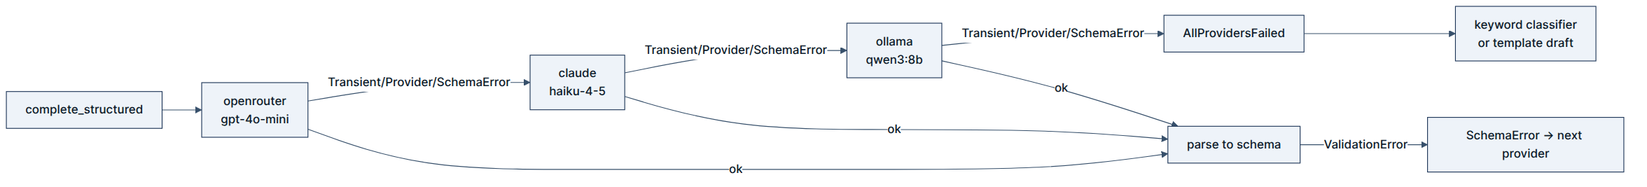
Structured output per provider:
- OpenRouter — the JSON schema is appended to the system prompt and response_format: {"type": "json_object"} is set; the raw text is then parsed against the Pydantic model.
- Claude — native messages.parse(output_format=schema) with constrained decoding; stop_reason of refusal or max_tokens is raised as SchemaError so the router moves on.
- Ollama — the JSON schema is passed as format=, which the runtime compiles to a GBNF grammar; if that fails, it degrades to format="json", so the local fallback keeps a structural guarantee.
Every adapter translates its vendor exception into a domain error (TransientError, ProviderError, SchemaError). This is what lets services/ handle failure without ever importing anthropic or ollama.
Cost accounting — services/cost/service.py::calculate_cost reads pricing from providers.yaml and computes (prompt/1000)·in_rate + (completion/1000)·out_rate, rounded to 6 decimals, recorded per call on the LLMCall model.
Known gap (BRD R-8): classification cannot fail over. Only openrouter defines a classification model. When the router reaches Claude for that purpose, model_for("claude", "classification") raises KeyError, which is not in the router's except (TransientError, ProviderError, SchemaError) clause, so it escapes complete_structured entirely. classify_intent's broad except Exception catches it and falls back to keywords. Net effect: the classification chain is OpenRouter, or keywords — the drafting chain is the only genuinely 3-deep one.
Budgets — providers.yaml declares max_llm_calls_per_message: 3, daily_spend_usd: 2.00, alert_at_pct: 80. No code reads this block. The natural ceiling is 2 calls per message (one classification, one draft) because grounding is deterministic. Enforcement is a v2 item.

4.9 Human review console
Traces to: FR-9.1 – FR-9.6 Files: services/review/service.py, dashboard/app.py
async def list_pending_reviews(repo) -> list[ReviewItem]
async def get_review_detail(repo, review_id) -> ReviewItem | None
async def approve_review(review_repo, outbox_repo, review_id, ...) -> bool
async def edit_and_approve_review(review_repo, outbox_repo, review_id,
edited_text, ...) -> bool
async def reject_review(review_repo, review_id, ...) -> bool
async def escalate_review(review_repo, review_id, ...) -> bool
State machine:
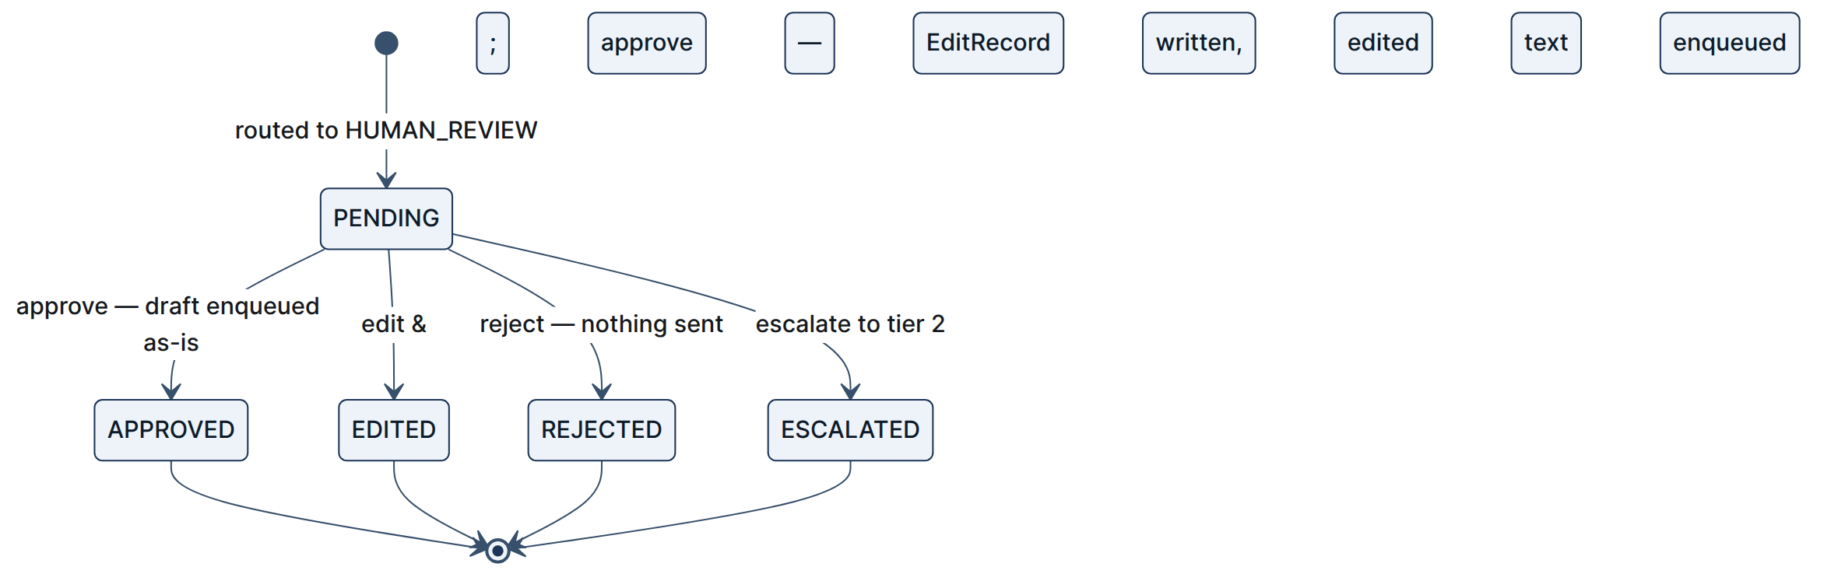
Every transition goes through one optimistic-locking UPDATE:
UPDATE reviews SET state = :to WHERE review_id = :id AND state = :expected
-- rowcount == 1 → this actor won; 0 → someone else got there first
Two operators clicking Approve on the same item at the same moment produce exactly one send. tests/unit/test_review_worker.py::test_optimistic_lock_collision is the proof.
Operator console — three Streamlit tabs (dashboard/app.py):
Tab | Contents
📝 Human Review Console | The pending queue; per item, the inbound customer query, the routing and safety analysis (action, reason, reason code, score vs threshold), the citations and KB chunks, an editable draft, an operator-notes field, and Approve / Edit&Approve / Reject / Escalate
🔍 Traces & Observability | Trace table and a detail inspector for a chosen trace_id
📊 System Health & Metrics | Total messages, auto-send rate, human-review rate, total LLM cost, intent breakdown
Recipient addressing: ReviewItem.sender_email and ReviewItem.inbound_body were added by migrations 019f6dc5d4f0 and d300852af25a so the operator sees the original message and the approved reply reaches the right person. The fallback address when sender_email is null is support-fallback@taskflow.dev.
Failure modes: approve_review returns False when the item is missing or no longer PENDING; the API turns that into 400. Note that the transition commits before the outbox enqueue, so a crash between the two leaves an APPROVED item with no queued reply — an at-most-once seam that a single transaction spanning both would close.

4.10 Outbound delivery
Traces to: FR-10.1 – FR-10.5, NFR-2.3 Files: worker/outbox_worker.py, adapters/db/repositories.py::SQLiteOutboxRepository
async def process_outbox_batch(outbox_repo: OutboxRepository, limit: int = 10) -> int
async def run_worker_loop(outbox_repo, poll_interval_s: float = 1.0,
run_once: bool = False) -> int
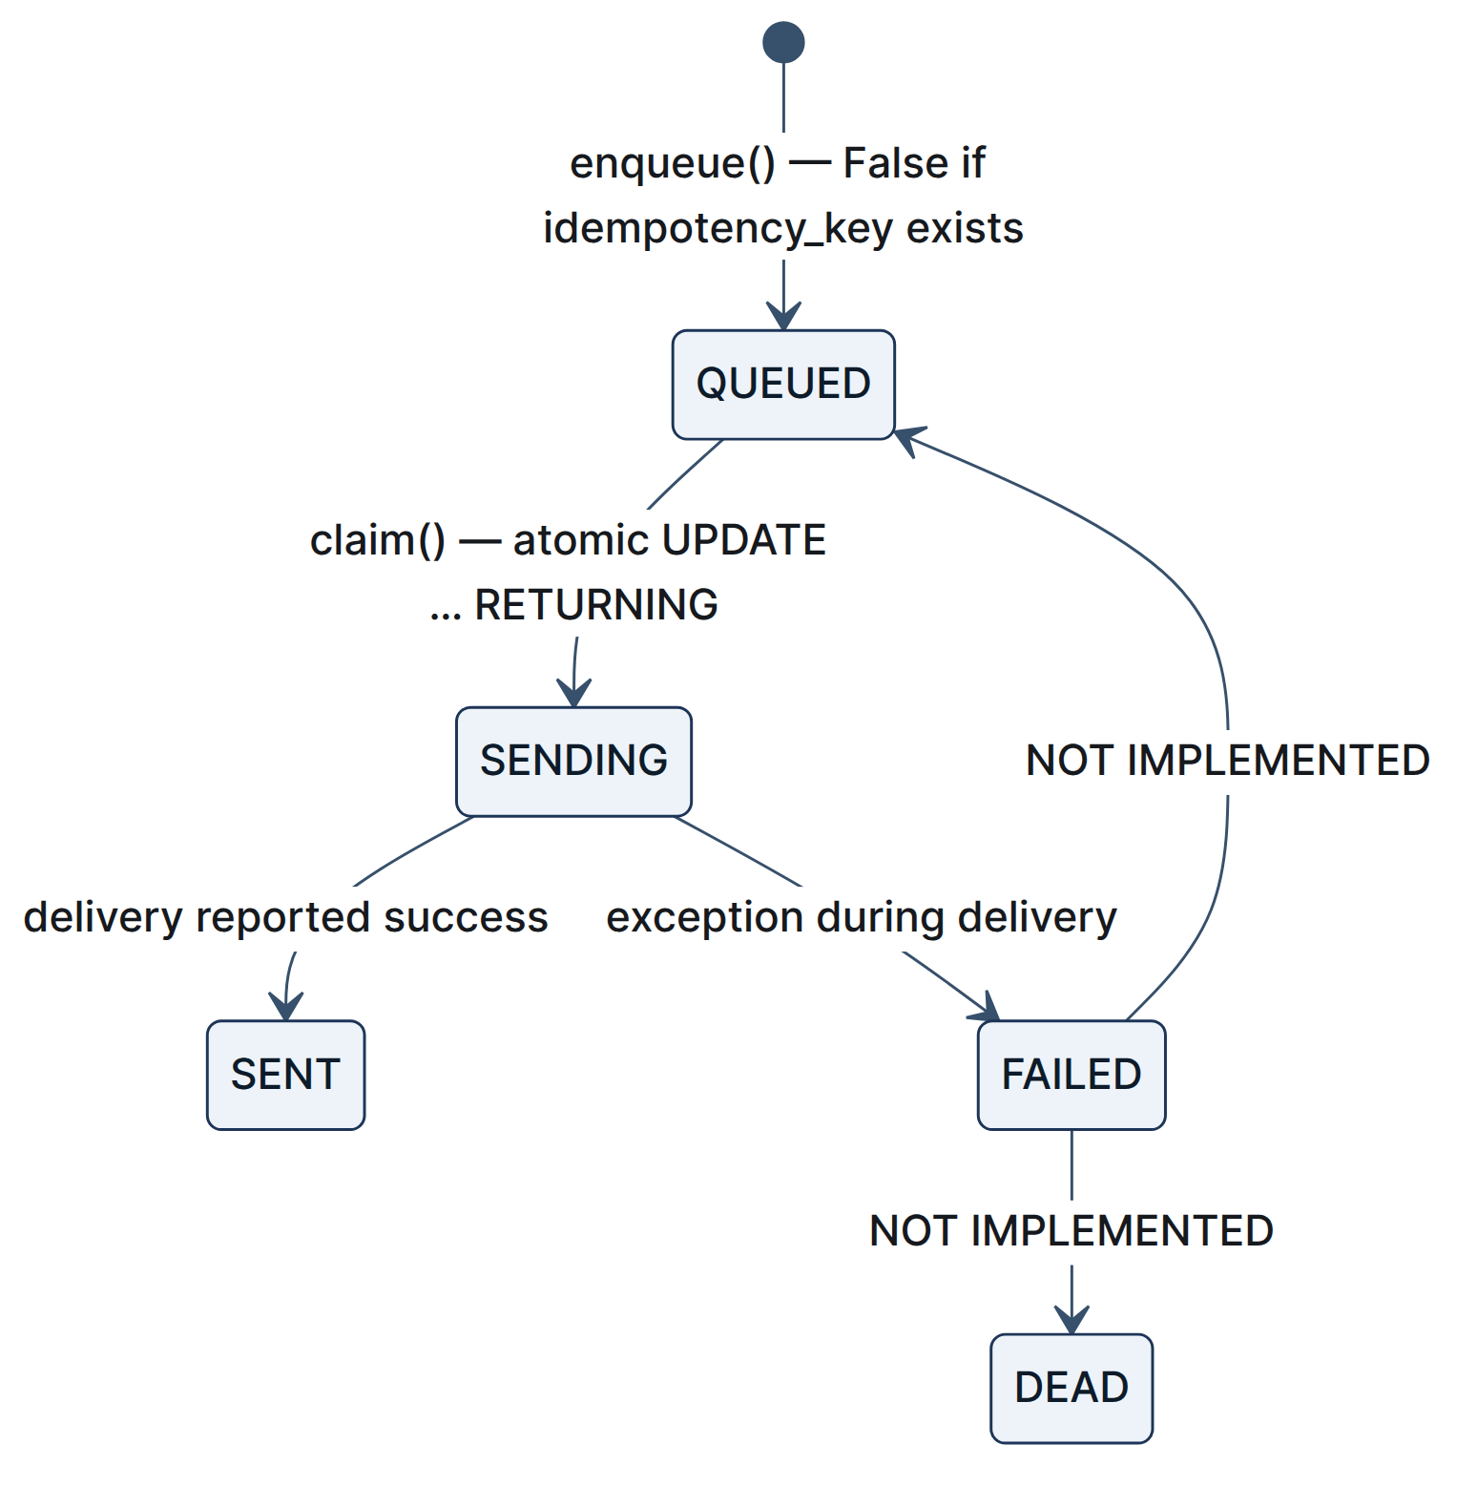
Claim is a single atomic statement, so two workers cannot claim the same row:
UPDATE outbox SET state = 'sending'
WHERE outbound_id IN (SELECT outbound_id FROM outbox WHERE state = 'queued' LIMIT :n)
AND state = 'queued'
RETURNING *
Idempotency keys — two forms are in use:
Origin | Key format
Pipeline auto-send | OutboundMessage.make_idempotency_key(conversation_id, body) → {conversation_id}:{sha256(body)[:16]}
Operator approve / edit | outbound:{review_id}:approved / outbound:{review_id}:edited
Both are backed by UNIQUE(idempotency_key) in the schema, so enqueue() returning False is the first line of send-once defence and the constraint is the second.
Known gap (BRD R-5). deliver_message() attempts SMTP when the recipient contains @, but its final statement is an unconditional return True. A failed send is therefore marked SENT. There is also no lease column, no retry_count increment, and no DEAD transition, despite claim_lease_minutes: 5 and max_attempts: 3 in config/settings.yaml. Delivery is currently at-most-once with optimistic reporting, not the at-least-once-with-retry the config describes.

4.11 Alerting
Traces to: FR-11.1 – FR-11.5, BO-7 File: services/alert/service.py
async def send_email_alert(subject, body, recipient=None) -> bool
async def send_telegram_alert(text, parse_mode="HTML") -> bool
async def send_custom_webhook_alert(payload: dict) -> bool
async def dispatch_alert(item: ReviewItem) -> dict[str, bool]
Channel | Transport | Configuration | Payload
Email | Gmail SMTP, smtp.gmail.com:587, STARTTLS | GMAIL_USER, GMAIL_APP_PASSWORD, OPS_EMAIL | Full plain-text brief: review ID, trace ID, tenant, customer address, the query, action/reason/reason-code, score vs threshold, the draft, citations
Telegram | Bot API sendMessage | TELEGRAM_BOT_TOKEN, TELEGRAM_CHAT_ID | HTML-formatted brief with the same fields, every interpolated value passed through html.escape
Webhook | HTTP POST, 10 s timeout | ALERT_WEBHOOK_URL | The complete ReviewItem as JSON
Independent failure is the design point. Each sender returns a plain bool, catches its own exceptions, and returns False when its credentials are absent — an unconfigured channel is a silent no-op, not an error. dispatch_alert calls all three in sequence and returns a per-channel result map. The orchestrator additionally wraps the whole dispatch in try/except, so no alerting failure can change a routing decision.
The three channels above are the supported set. The repository also contains one additional webhook sender in this module that is not part of the product, and a TEAMS_WEBHOOK_URL setting plus alerts.channel: teams in config/settings.yaml for which no Teams transport exists at all. Neither is documented as a supported channel here; both should be removed. See §7.1.
Cost of the current design: alerts are dispatched sequentially and inline with the request, so three slow channels add their timeouts (up to ~10 s each for Telegram and the webhook) to the pipeline's tail latency. Moving to asyncio.gather would be a one-line improvement.

4.12 Observability
Traces to: FR-12.1 – FR-12.5, BO-2 Files: domain/models.py::Trace, adapters/db/repositories.py::SQLiteTraceRepository
The Trace is the product's audit artefact. One per message, capturing:
trace_id · conversation_id · message_id · tenant_id · source_channel · started_at / finished_at · intent + intent_confidence + classifier_version · the whole RetrievalResult (chunks, scores, sufficiency, gap reason, injection flag) · the whole DraftOutput · every ValidatorResult · the whole ConfidenceBreakdown (all seven gates, all five signals, the weights, the score, the threshold) · the RoutingDecision · every LLMCall · delivery_result · errors
Trace.total_cost_usd sums the call ledger. Complex sub-objects are stored as JSON columns on traces, so a trace round-trips through _row_to_trace back into fully typed Pydantic models — which is why GET /traces/{id} can hand a reviewer the complete decision.

5. REST API Specification
Traces to: FR-1.1, FR-9.2, FR-12.4, FR-12.5 File: src/taskflow/api/app.py · Base URL: http://localhost:8000
Method | Path | Request | Success response | Errors
GET | / | — | Service banner: name, status, and an endpoint index | —
GET | /healthz | — | {"status": "ok", "service": "taskflow-api"} | —
GET | /favicon.ico | — | 204 No Content (excluded from the OpenAPI schema) | —
POST | /messages | InboundMessageRequest | {message_id, action, reason, reason_code, score} | —
GET | /traces?limit=50 | query limit ∈ [1, 200] | list[Trace] (JSON mode) | —
GET | /traces/{trace_id} | — | Trace | 404 not found
GET | /reviews | — | list[ReviewItem], pending only, SLA order | —
POST | /reviews/{review_id}/approve | OperatorRequest | {"status": "approved", "review_id": …} | 400 not found or not pending
POST | /reviews/{review_id}/edit | EditReviewRequest | {"status": "edited_and_approved", "review_id": …} | 400 as above
POST | /reviews/{review_id}/reject | OperatorRequest | {"status": "rejected", "review_id": …} | 400 as above
GET | /metrics | — | metrics object (below) | —
There is no POST /reviews/{id}/escalate endpoint, although escalate_review() exists in the service layer and the Streamlit console uses it directly.

5.1 Request schemas
class InboundMessageRequest(BaseModel):
message_id: str
tenant_id: str = "taskflow-demo"
channel: Channel = Channel.CONSOLE # email | webchat | console
sender: str
subject: str | None = None
body_text: str

class OperatorRequest(BaseModel):
operator: str = "operator_admin"
reason: str | None = None

class EditReviewRequest(BaseModel):
edited_text: str
operator: str = "operator_admin"
reason: str = "human edit"

5.2 Example — ingest
POST /messages
Content-Type: application/json

{
"message_id": "msg-001",
"tenant_id": "taskflow-demo",
"channel": "email",
"sender": "customer@example.com",
"subject": "Refund request",
"body_text": "I need a refund for unused seat licenses"
}
{
"message_id": "msg-001",
"action": "human_review",
"reason": "Critical policy violation detected",
"reason_code": "G1_policy_critical",
"score": 0.913
}
action is a RouteAction value; reason_code is either a GateId value, auto_send, or low_confidence.

5.3 Metrics response
{
"total_traces": 42,
"actions_breakdown": {"auto_send": 24, "human_review": 18},
"auto_send_rate_pct": 57.14,
"human_review_rate_pct": 42.86,
"total_cost_usd": 0.014712
}
Computed over the 200 most recent traces, not all time.

5.4 Lifecycle and known API-layer notes
lifespan() builds the engine, runs Base.metadata.create_all, constructs the three repositories, instantiates ProviderRouter() and QdrantVectorStore(), and stores the Deps container in a module-level dict. On shutdown it disposes the engine.
- The API constructs dedupe_key as f"{tenant_id}:{message_id}", which differs from InboundMessage.make_dedupe_key()'s {channel}:{provider_message_id}. Since no dedupe check runs in the pipeline, neither form is currently enforced.
- create_all at startup coexists with Alembic migrations. For a fresh database either is sufficient; the migrations are the authority for schema evolution.
- There is no authentication on any endpoint. TASKFLOW_API_TOKEN exists in settings and is unused. Acceptable for a single-machine demo, and a v2 prerequisite for anything else.

6. Data Model Specification
Traces to: FR-1.1, FR-5.1, FR-9.3, FR-10.2, FR-12.1, NFR-5.4

6.1 Domain models
All inherit Base(BaseModel) with model_config = ConfigDict(frozen=True, extra="forbid") — immutable, and unknown fields are a parse error. DraftOutput is the single exception (extra="ignore"), because an LLM will add keys.
InboundMessage
Field | Type | Notes
message_id | str | Our UUID
dedupe_key | str | {channel}:{provider_message_id} via make_dedupe_key()
tenant_id | str | Isolation key present on every table
channel | Channel | email | webchat | console
sender | str | Customer address or identifier
subject | str | None
body_text | str | Normalised original
body_redacted | str | PII-redacted; intended as the only text an LLM sees
thread_ref | str | None | Gmail threadId; also seeds conversation_id
provider_message_id | str | External ID
provider_thread_headers | dict[str, str] | In-Reply-To, References
received_at | datetime | UTC
raw_ref | str | None | Archived original
Chunk / ScoredChunk / RetrievalResult
Chunk: chunk_id ({doc_id}:{ordinal}), doc_id, title, section, text, doc_type, product_tier, intents, version, source_path, tenant_id. ScoredChunk adds dense_score, sparse_score, rrf_score, rerank_score, and a final_score property preferring rerank_score when present (it never is today). RetrievalResult: query_used, chunks, sufficient, gap_reason, suspicious_context, latency_ms, top_score, support_count.
DraftOutput / Citation — see §4.4. ValidatorResult — validator_name, passed, score, reason, evidence, blocking, latency_ms, errored. PolicyViolation — rule_id, severity, description, matched_text. GateResult — gate_id, passed, reason.
ConfidenceBreakdown — the seven GateResults, the five signal values, the weights dict, score, threshold, and draft_confidence_logged, plus two derived properties: failed_gates and gates_passed.
RoutingDecision — action, reason, reason_code, confidence, decided_at.
ReviewItem — review_id, trace_id, conversation_id, tenant_id, state, draft, decision, created_at, sla_deadline, escalated_at, sender_email, inbound_body.
EditRecord — review_id, original_draft, edited_draft, editor, edited_at, reason, char_diff.
OutboundMessage — outbound_id, conversation_id, tenant_id, channel, recipient, subject, body_text, reply_headers, state, idempotency_key, retry_count, plus make_idempotency_key().
LLMCall — purpose, provider, model, prompt_tokens, completion_tokens, cost_usd, latency_ms, attempts, repaired, failed_over.
Trace / TraceEvent — see §4.12.

6.2 Enumerations (domain/enums.py)
Enum | Values
Channel | email, webchat, console
Intent | billing, technical, account, feature_request, refund, complaint, general, unknown — 8
RouteAction | auto_send, human_review, template_sent, rejected_spam, dropped_duplicate*
GateId | G1_policy_critical … G7_no_suspicious_context — 7
ReviewState | pending, approved, edited, rejected, escalated
OutboxState | queued, sending, sent, failed, dead*
Severity | critical, warning
* defined but never emitted by current code — see BRD §5.3.

6.3 Persistence schema
src/taskflow/adapters/db/orm.py — nine tables, every one carrying tenant_id.
Table | Primary business key | Notable columns | Constraints
inbox | dedupe_key | message, channel, sender, both body forms, thread headers, raw_ref | UNIQUE(dedupe_key)
traces | trace_id | intent, confidence, classifier_version, and JSON columns for retrieval / draft / validators / confidence / decision / llm_calls / errors | UNIQUE(trace_id)
trace_events | — | trace_id, stage, payload, elapsed_ms, at | index(trace_id)
reviews | review_id | state, draft_json, decision_json, sla_deadline, escalated_at, sender_email, inbound_body | UNIQUE(review_id)
edit_records | — | original / edited draft, editor, reason, char_diff | index(review_id)
outbox | outbound_id | recipient, subject, body, reply_headers, state, retry_count, last_error | UNIQUE(idempotency_key) (uq_outbox_idempotency_key)
llm_calls | — | provider, model, tokens, cost, latency, attempts, failed_over | index(trace_id)
audit | — | actor, action, entity type/id, payload | index(entity_id)
alerts | — | alert type, entity, message, channel, sent, error | index(tenant_id)
The two UNIQUE constraints marked in bold are the safety-critical ones and are directly tested (test_inbox_try_claim_unique, test_outbox_no_double_send).
llm_calls, audit, and alerts are defined and migrated but not yet written to — LLM calls are currently persisted inside traces.llm_calls_json.
Engine configuration (adapters/db/engine.py) — on every pooled connection: PRAGMA journal_mode=WAL, PRAGMA busy_timeout=5000, PRAGMA foreign_keys=ON. verify_engine() asserts WAL took effect.
Migrations — Alembic, 3 revisions, head d300852af25a:
Revision | Change
0001_initial | All nine tables
019f6dc5d4f0 | reviews.sender_email
d300852af25a | reviews.inbound_body

7. Configuration Reference
Traces to: NFR-4.2, ADR-004

7.1 Environment variables (.env)
Loaded by pydantic-settings in src/taskflow/config/settings.py with extra="ignore".
Variable | Default | Purpose
TASKFLOW_ENV | local | Environment label
TASKFLOW_TENANT_ID | taskflow-demo | Default tenant
TASKFLOW_API_TOKEN | change-me | Declared; not enforced by any endpoint
DATABASE_URL | sqlite+aiosqlite:///./data/taskflow.db | Async DB URL
QDRANT_PATH | ./data/qdrant | Embedded Qdrant storage
QDRANT_COLLECTION | taskflow_kb | Collection name
TASKFLOW_LLM_MODE | cloud_first | cloud_first | local_only
OPENROUTER_API_KEY | — | Primary provider auth
ANTHROPIC_API_KEY | — | Secondary provider auth
OLLAMA_BASE_URL | http://localhost:11434 | Local provider
GMAIL_CREDENTIALS_PATH | secrets/credentials.json | OAuth credentials (unused by the IMAP path)
GMAIL_TOKEN_PATH | secrets/token.json | OAuth token (unused by the IMAP path)
GMAIL_LABEL | INBOX | Mailbox to poll
GMAIL_POLL_SECONDS | 15 | IMAP poll interval for the inbound daemon
GMAIL_USER | — | SMTP/IMAP account
GMAIL_APP_PASSWORD | — | Gmail app password
OPS_EMAIL | — | Alert recipient; falls back to GMAIL_USER
TELEGRAM_BOT_TOKEN | — | Telegram alerts
TELEGRAM_CHAT_ID | — | Telegram destination
ALERT_WEBHOOK_URL | — | Generic webhook alerts
Settings declares two further alert-webhook variables beyond the table above. Neither is a documented product channel — one has no transport implementation at all, and the other is excluded by product decision — and both should be removed from Settings.
Security note: the git-tracked .env.example currently contains a live-looking Gmail app password. Rotate it and scrub the file (BRD R-9).

7.2 YAML configuration
File | Governs | Key sections
config/providers.yaml | LLM providers | mode, priority, providers.*.{models,capabilities,timeout_s,pricing}, budgets
config/thresholds.yaml | The decision maths | weights, thresholds, gates, fallback_confidences, citation_validation_threshold, retrieval, sla_minutes, validator_timeout_s
config/policies.yaml | The 10 policy rules | rules[].{id,severity,description,applies_to,applies_when,detect,message}
config/settings.yaml | Application behaviour | tenant_id, retrieval, worker, pollers, spam, fastpath, alerts
config/prompts/ | Prompt assets | drafting.md, grounding.md, quality_rubric.md, datagen_*.md, templates.yaml
All loaders are @lru_cached, so a config change requires a process restart — with one demo-relevant exception: a scenario re-run in a fresh process picks up an edited threshold immediately, which is the ten-second live demonstration ADR-004 was written for.
Configured-but-unused settings, listed so nobody mistakes config for behaviour: providers.yaml::budgets (entire block); settings.yaml::spam, ::fastpath, ::pollers, ::alerts, ::worker.claim_lease_minutes, ::worker.max_attempts; thresholds.yaml::sla_minutes and all per-intent entries under thresholds except general.

8. Technology Stack
Traces to: NFR-5.1 · Source of truth: pyproject.toml

8.1 Runtime dependencies
Category | Package | Constraint | Role
Language | Python | >=3.12,<3.13 | StrEnum, PEP 695 generics. Verified on 3.12.13
Package manager | uv | — | Environment and lockfile (uv.lock)
Web | fastapi | >=0.115 | REST API
Web | uvicorn[standard] | >=0.32 | ASGI server
Web | jinja2 | >=3.1 | Templating (declared; not exercised)
Web | python-multipart | >=0.0.12 | Form parsing (declared; not exercised)
Models | pydantic | >=2.9 | Domain models, LLM output contracts
Config | pydantic-settings | >=2.6 | .env loading
Config | pyyaml | >=6.0 | YAML config loading
Persistence | sqlalchemy[asyncio] | >=2.0.36 | Async ORM
Persistence | aiosqlite | >=0.20 | Async SQLite driver
Persistence | alembic | >=1.14 | Migrations
Retrieval | qdrant-client[fastembed] | >=1.12 | Embedded vector store + local embeddings
Retrieval | sentence-transformers | >=3.3 | Declared; retrieval uses FastEmbed
ML | scikit-learn | >=1.5 | Declared for the deferred trained classifier; unused
ML | numpy | >=2.0 | Numeric support
ML | joblib | >=1.4 | Declared for model persistence; unused
LLM | anthropic | >=0.40 | Claude provider
LLM | ollama | >=0.4 | Local provider
Channels | google-api-python-client | >=2.150 | Declared; the poller uses stdlib imaplib
Channels | google-auth-oauthlib | >=1.2 | Declared; unused by the IMAP path
Ops | httpx | >=0.28 | OpenRouter, Telegram, webhooks
Ops | tenacity | >=9.0 | Declared; retries are hand-rolled in the router
Ops | structlog | >=24.4 | Structured logging
UI | streamlit | >=1.40 | Operator console
Six declared dependencies are currently unexercised (jinja2, python-multipart, sentence-transformers, scikit-learn, joblib, google-*, tenacity). They are listed rather than quietly omitted: an unused dependency is a real maintenance cost, and pruning them is a legitimate cleanup task.

8.2 Development dependencies
Package | Constraint | Role
pytest | >=8.3 | Test runner (asyncio_mode = "auto")
pytest-asyncio | >=0.24 | Async test support
pytest-cov | >=6.0 | Coverage
ruff | >=0.8 | Lint + format; line length 100; rules E,F,I,UP,B,SIM,ASYNC,RUF
mypy | >=1.13 | Types; disallow_untyped_defs on domain, services, ports
types-PyYAML | — | Stubs
import-linter | >=2.1 | The architectural boundary contract
pre-commit | >=4.0 | Git hooks
matplotlib | >=3.9 | Evaluation plots
Pre-commit hooks: ruff (--fix), ruff-format, detect-private-key, check-added-large-files (2 MB), check-yaml, end-of-file-fixer, and the local no-hardcoded-models hook.

9. Test Architecture
Traces to: NFR-4.4

9.1 The pyramid, as it actually stands
Layer | Location | Files | Tests | Dependencies
Unit | tests/unit/ | 12 | 64 | Fakes, in-memory SQLite, no network
Pipeline | tests/pipeline/ | 1 | 2 | Full orchestrator against fakes + in-memory SQLite
Integration | tests/integration/ | 1 | 2 | Real embedded Qdrant and on-disk SQLite
End-to-end | tests/e2e/ | 0 | 0 | — empty; in progress
 |  | 14 | 68 | 38.32 s wall time

9.2 Tests per file (verified counts)
File | Component under test | Tests
tests/unit/test_repositories.py | Engine pragmas, schema, inbox, outbox, review, trace repositories | 13
tests/unit/test_drafting.py | Draft generation and all three validators | 8
tests/unit/test_gates.py | The seven safety gates and the routing decision | 6
tests/unit/test_retrieval.py | Alias expansion, sufficiency, injection, retrieval service | 6
tests/unit/test_api.py | REST endpoints | 5
tests/unit/test_policy.py | Policy rule evaluation | 5
tests/unit/test_review_worker.py | Review service and outbox worker | 5
tests/unit/test_alert.py | Multi-channel alert dispatch | 4
tests/unit/test_classifier.py | LLM and fallback classification | 4
tests/unit/test_providers.py | Cost calculation and router failover | 4
tests/unit/test_imports.py | Package import health, no hardcoded models | 2
tests/unit/test_openrouter.py | OpenRouter adapter guards | 2
tests/pipeline/test_orchestrator.py | Auto-send and complaint-escalation paths | 2
tests/integration/test_pipeline_e2e.py | Full pipeline over real Qdrant + SQLite | 2

9.3 Fixtures
tests/conftest.py provides fake_llm, fake_store, and weights. tests/fixtures/fakes.py provides:
Fixture | Behaviour
FakeLLMProvider | Satisfies the LLMRouter shape; returns canned structured responses per purpose, records every call, and can be constructed to raise on demand
FakeVectorStore | Returns a fixed chunk list with fixed scores, so retrieval quality never varies inside a unit test
Pytest markers declared in pyproject.toml: integration, live (real paid API calls), e2e, slow.

9.4 The load-bearing test
tests/unit/test_gates.py::test_critical_policy_violation_never_auto_sends sets every quality signal to 1.0, asserts breakdown.score > 0.95, and then asserts the decision is HUMAN_REVIEW with reason_code == "G1_policy_critical". Its docstring says it plainly: "the score really is high — that is the point." It is the regression guard for ADR-001 and must never be weakened.

9.5 Honest gaps
- tests/e2e/ is empty. The five demo scenarios in docs/12_DEMO_SCRIPT.md are the natural content.
- No test asserts local_only behaviour end to end.
- No test drives a poisoned chunk through the pipeline to prove G7 blocks a real send; the detector is tested in isolation.
- No test asserts that redacted text (rather than raw text) reaches the drafting prompt — which is precisely why BRD R-1 went unnoticed.

10. Operational Runbooks
Traces to: NFR-5.1, NFR-5.4
All commands are run from Code/TaskFlow/taskflow/. Paths are repository-relative.

10.1 First-time setup and start
# 1. dependencies
uv sync

# 2. environment
cp .env.example .env # then edit: API keys, GMAIL_USER, GMAIL_APP_PASSWORD, Telegram
# NOTE: scrub the placeholder credential in .env.example first

# 3. schema
uv run alembic upgrade head # → d300852af25a

# 4. knowledge base → embedded Qdrant (42 documents → 178 chunks)
uv run python scripts/ingest_kb.py

# 5. optional: local model for offline operation
ollama pull qwen3:8b

# 6. API server
uv run uvicorn taskflow.api.app:app --port 8000 --reload

# 7. operator console (separate terminal)
uv run streamlit run dashboard/app.py

# 8. outbox delivery worker (separate terminal)
uv run python scripts/start_worker.py

# 9. optional: live Gmail inbound polling
uv run python scripts/start_gmail_poller.py
The Makefile has drifted from the tree and several targets will not run as written: api points at taskflow.api.main:app (correct module is taskflow.api.app:app), dash points at src/taskflow/dashboard/app.py (the app is at dashboard/app.py), and kb, preflight, train, eval, and demo-reset reference scripts/generate_kb.py, scripts/preflight.py, taskflow.ml.train_classifier, taskflow.ml.evaluate, and data/snapshots/demo_seed.db, none of which exist. Use the commands above.

10.2 Scripts that exist and work
Script | Purpose | Command
ingest_kb.py | Chunk and embed the knowledge base into Qdrant | uv run python scripts/ingest_kb.py
run_scenario.py | Run one message string through the whole pipeline and print the decision | uv run python scripts/run_scenario.py --text "I need a refund"
verify_system.py | Live health demo — three scripted queries end to end, plus alert dispatch | uv run python scripts/verify_system.py
test_live_sender.py | Real SMTP + Telegram delivery check | uv run python scripts/test_live_sender.py
eval_classifier.py | Intent classification accuracy over the labelled splits | uv run python scripts/eval_classifier.py
eval_retrieval.py | Retrieval quality metrics | uv run python scripts/eval_retrieval.py
eval_drafting.py | Draft quality evaluation | uv run python scripts/eval_drafting.py
generate_datasets.py | Regenerate synthetic evaluation datasets | uv run python scripts/generate_datasets.py
check_leakage.py | Detect overlap between train/val/test splits | uv run python scripts/check_leakage.py
check_no_hardcoded_models.py | Fail if a model ID appears in src/ | uv run python scripts/check_no_hardcoded_models.py
start_worker.py | Outbox delivery daemon | uv run python scripts/start_worker.py
start_gmail_poller.py | Gmail IMAP inbound daemon | uv run python scripts/start_gmail_poller.py
verify_system.py and test_live_sender.py make real network calls and send real email; they were deliberately not executed while verifying this document.

10.3 Quality gates
uv run pytest -q # 68 passed in 38.32s
uv run pytest tests/unit/ -q # fast layer only
uv run pytest -m integration -q # real Qdrant + SQLite
uv run pytest --cov=taskflow # with coverage

uv run ruff check . # 24 findings today (21 auto-fixable via --fix)
uv run mypy src/ # 9 errors in 5 files today
uv run lint-imports # 1 contract kept, 0 broken ← must stay green
uv run lint-imports is the one that must never go red: it is the mechanical guarantee behind every portability claim in this document.

10.4 Tuning without a deploy
- Edit config/thresholds.yaml (weights, thresholds, gates.abstain_threshold, gates.min_grounding_ratio, or the retrieval parameters).
- Re-run uv run python scripts/run_scenario.py --text "…".
- The routing decision changes with no code edit and no schema change.
The same applies to config/policies.yaml — adding a rule is adding a YAML block.

11. Error-Handling Hierarchy
Traces to: NFR-2.1, NFR-2.4 · File: src/taskflow/domain/errors.py
TaskFlowError base for every deliberate error
├── ConfigError missing/invalid config — startup only, never at request time
├── TransientError worth retrying: timeouts, 5xx, connection resets
│ ├── ProviderError an LLM provider failed → trigger failover
│ │ └── SchemaError output does not satisfy the schema → try the next provider
│ └── RetrievalUnavailable vector store unreachable → downstream signals absorb it
├── AllProvidersFailed every provider exhausted → keyword/template fallback → human review
├── ConflictError optimistic lock lost — someone actioned this review first
└── DuplicateMessage dedupe key already seen — a signal, not a failure
The hierarchy exists so that services/ can branch on failure meaning without importing a vendor SDK: every adapter translates anthropic.APITimeoutError, ollama.ResponseError, httpx.ConnectError, and HTTP 429/502/503/504 into these types at the boundary.
SchemaError subclassing ProviderError is deliberate — a model that cannot produce valid JSON is a provider failure, and the correct response is the same one: move to the next provider.

12. Deployment Architecture
Traces to: NFR-5.1

12.1 Current topology — one machine, no containers
┌──────────────────────────────────────────────────────────────┐
│ Single machine │
│ │
│ ┌────────────────────┐ ┌──────────────────────────┐ │
│ │ FastAPI / uvicorn │ │ Streamlit console │ │
│ │ :8000 │ │ :8501 │ │
│ └─────────┬──────────┘ └───────────┬──────────────┘ │
│ │ │ │
│ ┌─────────┴────────────────────────────────┴─────────────┐ │
│ │ SQLite WAL — data/taskflow.db (9 tables) │ │
│ └────────────────────────────────────────────────────────┘ │
│ ┌────────────────────────────────────────────────────────┐ │
│ │ Embedded Qdrant — data/qdrant/ (178 chunks) │ │
│ └────────────────────────────────────────────────────────┘ │
│ ┌───────────────────────┐ ┌───────────────────────────┐ │
│ │ Outbox worker │ │ Gmail IMAP poller │ │
│ │ scripts/start_worker │ │ scripts/start_gmail_poller│ │
│ └───────────────────────┘ └───────────────────────────┘ │
│ ┌────────────────────────────────────────────────────────┐ │
│ │ Ollama — localhost:11434 (optional, local fallback) │ │
│ └────────────────────────────────────────────────────────┘ │
└──────────────────────────────────────────────────────────────┘
│ │ │
▼ ▼ ▼
OpenRouter Gmail SMTP/IMAP Telegram / Webhook
Anthropic
Requirements: Python 3.12.x, roughly 8 GB RAM if the local model is used, ~2 GB disk. No Docker, no Kubernetes, no database server, no vector server, no message broker.

12.2 Path to production — a roadmap, not a gap list
Each step is deliberately small because the architecture was built to make it small.
Step | Change | Why it is small
Postgres instead of SQLite | Change DATABASE_URL; run Alembic | No service imports SQLAlchemy — guaranteed by the CI boundary contract
Qdrant server instead of embedded | One-line client construction in QdrantVectorStore | The query code is identical in both modes (ADR-007)
Redis Streams instead of the SQLite queue | Implement the EventBus port | The port exists; delivery semantics are unchanged at this scale (ADR-006)
Horizontal API scaling | Run more uvicorn workers | The API is stateless; all state is in the database
Multiple delivery workers | Add the lease column the config already anticipates | claim() is already a single atomic UPDATE … RETURNING
Multi-tenancy | Per-tenant keys, corpora, and queues | Every table and every retrieval query already carries tenant_id
Authentication | Enforce TASKFLOW_API_TOKEN as a FastAPI dependency | The setting already exists
Containerisation | Dockerfile + compose | No hidden host dependency beyond Ollama

13. Future Roadmap (post-v1)
Ordered by value per unit of effort. The first four are defect repairs from BRD §15 and should land before any new capability.
# | Item | Priority | Effort | Notes
1 | Pass body_redacted to the drafting prompt | P0 | Trivial | BRD R-1. Add a test asserting no raw secret reaches the prompt
2 | Select the auto-send threshold by intent | P0 | Trivial | BRD R-3. Unlocks the whole per-intent design already in config
3 | Fix delivery reporting; add retry, lease, and DEAD | P0 | Small | BRD R-5. Turns at-most-once into at-least-once
4 | Generate the classifier prompt's intent list from the enum | P0 | Trivial | BRD R-2. Removes a silent quality regression
5 | Repair or delete the non-importing Telegram channel connector | P0 | Trivial | BRD R-7
6 | Wire pipeline-level deduplication using the tested try_claim | P1 | Small | Required the moment the poller runs continuously
7 | Read sla_minutes; add a periodic due() sweeper with breach alerts | P1 | Small | Makes the SLA real rather than decorative
8 | Enforce the budgets block: per-message call ceiling, daily spend cap, 80% alert | P1 | Small | Also fill in real Claude pricing (BRD R-10)
9 | A continuous tone signal to replace the constant 1.0 | P1 | Small | Also gives warning-severity policy hits a numeric effect
10 | End-to-end scenario tests in tests/e2e/ | P1 | Medium | The five demo scenarios are the obvious content
11 | Clear the 24 ruff findings and 9 mypy errors | P1 | Small | 21 of 24 are auto-fixable
12 | Entailment-based grounding (cross-encoder or NLI) | P2 | Medium | Replaces the word-overlap proxy; ADR-003 anticipated this
13 | Cross-encoder reranking between RRF and drafting | P2 | Medium | rerank_k and rerank_score already exist
14 | Trained intent classifier from the labelled splits | P2 | Medium | scikit-learn, joblib, and the datasets are already in place
15 | Spam filter and FAQ fast path | P2 | Small | Config blocks and RouteAction values already exist
16 | Move DocumentChunk into domain/ and tighten the import contract to cover ports | P2 | Trivial | Closes the ports→services edge in §2.2
17 | Thread-context awareness for multi-turn conversations | P2 | Medium | ThreadContext model already defined
18 | Web chat channel | P3 | Medium | Channel.WEBCHAT exists; needs an endpoint and a page
19 | Multi-tenant isolation beyond tenant_id columns | P3 | Large | Per-tenant keys, corpora, queues
20 | A/B evaluation harness across model versions | P3 | Medium | Golden and tiered datasets already exist

Companion document: BRD.md — business requirements, acceptance criteria, the traceability matrix, and the known-defects register. Architectural rationale is in 02_ARCHITECTURE_DECISIONS.md; the component diagram is in ARCHITECTURE.md.

