Project Report
On
Load Profile Management and Forecasting
An AI-Integrated Load Intelligence Dashboard for the Delhi Distribution Grid
The Project report is submitted for the partial fulfilment of the requirement for the degree of Bachelor of Technology in Electrical Engineering from the Faculty of Technology, University of Delhi.
Submitted by
Vansh Sachan [24295918040]
Animish Gupta [23295919010]
Ayush Rathore [24295918024]
Lavish Rawat [23295918041]

Under the guidance of
Dr. Ujjal Sur (Supervisor)
Dr. Arjun Tyagi (Co-Supervisor)
DEPARTMENT OF ELECTRICAL ENGINEERING
FACULTY OF TECHNOLOGY
UNIVERSITY OF DELHI
NORTH CAMPUS, DELHI-110007
ACKNOWLEDGEMENT
We would like to express our sincere gratitude to our supervisor, Dr. Ujjal Sur, and co-supervisor, Dr. Arjun Tyagi, for their invaluable guidance, encouragement and continuous support throughout the course of this project. Their insights into power system engineering, and their feedback at every stage, have been instrumental in shaping this work.
We are also thankful to the Department of Electrical Engineering, Faculty of Technology, University of Delhi, for providing us with the resources, laboratory facilities and academic environment necessary to carry out this project.
Finally, we would like to thank our families and friends for their constant encouragement and support.
Vansh Sachan · Animish Gupta · Ayush Rathore · Lavish Rawat
CERTIFICATE

It is certified that the project report entitled ‘Load Profile Management and Forecasting: An AI-Integrated Load Intelligence Dashboard for the Delhi Distribution Grid’ is a piece of project work done by the following students: Vansh Sachan (24295918040), Animish Gupta (23295919010), Ayush Rathore (24295918024) and Lavish Rawat (23295918041). They have done this project under my guidance and supervision required for the degree of B.Tech in Electrical Engineering. To the best of my knowledge and belief this report embodies the work of the students themselves and has duly been completed. It is up to the standard in respect of both content and language for being referred to the examiners.

____________________________
Signature of the Supervisor (with stamp)
Name: Dr. Ujjal Sur

____________________________
Signature of the Co-Supervisor (with stamp)
Name: Dr. Arjun Tyagi
Abstract
Electricity demand in Delhi is rising and becoming harder to predict because of humid heatwaves, rooftop solar and changing consumer behaviour. This project builds a load profile management and forecasting dashboard that combines power-system engineering with machine learning. Real Delhi SLDC load (1 April 2023 – 12 January 2026, 15-minute blocks) and Open-Meteo weather are used to characterise the load profile and to forecast all 96 blocks of the next day with a P10–P90 band. All twelve dashboard pages are live, from the core forecast (Overview, Load Analytics, Weather Impact, Forecast, DSM ₹ Calculator and Transformer Health) to six additional engines each checked against its own benchmark (IEX price, Time-of-Day billing, solar net load, losses and PF, theft detection, and the data & model card). On the test window (13 July 2025 – 12 January 2026) the final multi-horizon LightGBM model reaches a test accuracy of ≈ 96% (MAPE 3.93%) against a MAPE of 5.16% for a seasonal-naive baseline, and its 80% conformal band covers 84.4% of test blocks. Load rises by about 112.0 MW per °C of heat index (r² = 0.61). The DSM and transformer pages are illustrative calculators, not regulatory figures. The system is built entirely on free and open-source tools.
CONTENTS
Abstract 4
1. Introduction and Problem Statement 5
2. Objectives 5
3. Methodology 5
4. Mathematical Model 6
5. Results and Model Validation 7
6. Dashboard: 12 of 12 Live 9
7. Dataset 11
8. Novelty and Limitations 12
9. Work Distribution 13
10. Conclusion 13
References 13

1. Introduction and Problem Statement
India met an all-time peak demand of 256.1 GW on 25 April 2026 [1], and Delhi recorded its highest-ever peak of 8,748 MW on 29 June 2026, surpassing the previous record of 8,656 MW set in 2024 [2]. A 2025 study by the Centre for Science and Environment found that the heat index, which combines temperature and humidity, explains about 67% of the variation in Delhi's daily peak demand [3]. That figure is CSE's measure of daily-peak variation; our own regression of load on heat index over all 15-minute blocks (Section 4) gives r² = 0.61, a different metric on different data that is not directly comparable. At the same time, growing solar generation has reshaped the daily net-load curve into a "duck" shape, with midday exchange prices near ₹1.11 per unit and night prices near ₹9.71 per unit in May 2026 [4].
Problem statement: Distribution companies (DISCOMs) must schedule tomorrow's power in 96 blocks of 15 minutes. Any deviation from this schedule is charged under the CERC Deviation Settlement Mechanism Regulations, 2024 [5]. Existing monitoring tools show only past consumption; they do not tell an engineer what tomorrow's forecast error will cost, which transformer will overload in the heat, or how steep the evening ramp will be. This project addresses that gap.

2. Objectives
- Characterise Delhi's load profile with load factor, peak-to-average ratio and the load-duration curve.
- Quantify the effect of heat index (temperature plus humidity) on Delhi's load.
- Forecast the next day's 96 blocks with a calibrated P10–P90 band, and keep a model only if it beats a simpler baseline.
- Convert a deviation into rupees (DSM, illustrative) and a hot-spot temperature into transformer ageing (IEC 60076-7).
- Present every result in a dashboard where each number is labelled REAL, SYNTHETIC or ILLUSTRATIVE.

3. Methodology

3.1 System workflow
The system has five stages. (1) Delhi SLDC 5-minute load and Open-Meteo hourly weather are collected. (2) The load is cleaned causally, converted to IST, resampled to 15-minute blocks and joined with weather, a heat index and holiday and IPL calendars (Section 7). (3) A forecast engine predicts the next day's 96 blocks with a P10–P90 band. (4) Formula engines turn the data and forecast into a peak alert, load factor, heat sensitivity, an illustrative DSM charge and transformer ageing (Section 4). (5) A FastAPI service serves these results to a Next.js dashboard. IEX prices, ToD bills, solar net load, losses and theft detection are additional engines built on the same pipeline, each checked against its own benchmark (Section 6).
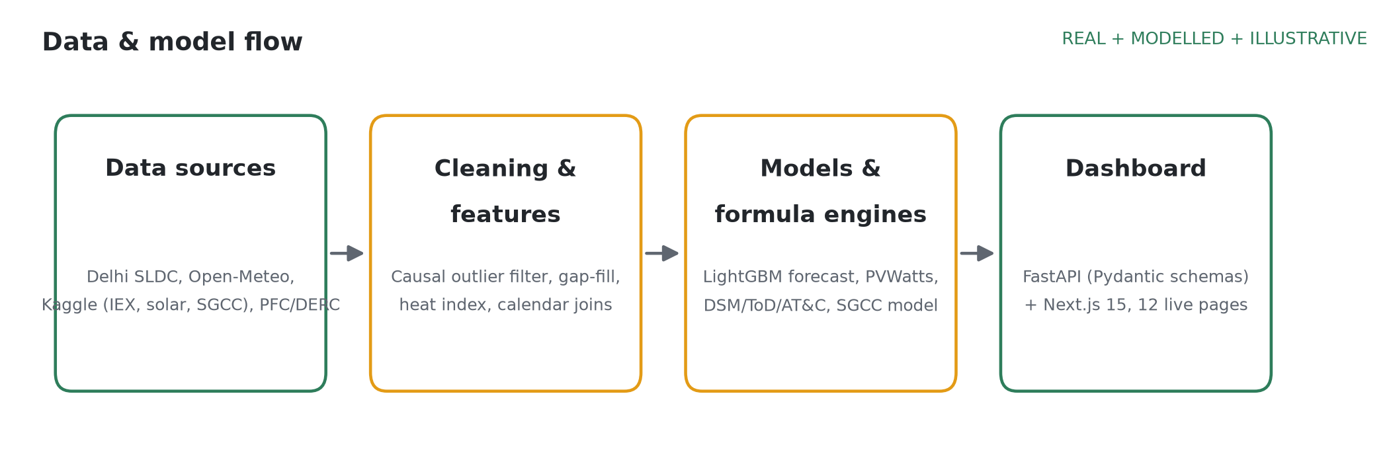
Figure 1: Data & model flow: real sources → causal cleaning/features → LightGBM + formula engines → FastAPI/Next.js dashboard. REAL + MODELLED + ILLUSTRATIVE.

3.2 Models and validation protocol
Models are compared in increasing order of complexity on the same test period, and a more complex model is kept only if it beats the simpler one. The baseline is seasonal-naive (the same 15-minute block on the previous day). The main model is a single multi-horizon LightGBM that forecasts all 96 blocks with the horizon as a feature (37 features), tuned with Optuna (25 trials on validation MAPE) and early-stopped on validation. A SARIMAX benchmark on hourly data is implemented, but only its order search on validation was run (validation MAPE about 25%); it has no test score and is not in the results. N-HiTS, TFT and Chronos [12] were proposal-stage ideas and were not run. Split-conformal prediction (MAPIE), calibrated on validation, gives the P10–P90 band, an 80% central interval [11], [14]; TreeSHAP explains individual days. The data are split chronologically and never shuffled: train 1 Apr 2023 – 12 Jan 2025, validation 13 Jan – 12 Jul 2025, test 13 Jul 2025 – 12 Jan 2026 (183 days). Every forecast origin and horizon in the test window is scored (1,672,080 origin × horizon pairs), with MAPE [8] as the headline metric. A leakage audit checked every lag feature against the forecast origin.

4. Mathematical Model
Table 1 lists the equations behind all twelve dashboard pages, with the same names and worked examples as the presentation. The formulas are the ones implemented in the project's engine code (ml/src/lpmf/engines); unit tests cover every worked example below and pass (196 tests across ml/tests).
Table 1: Equations of all twelve dashboard pages, with this project's numbers
Page · equation | Formula | What it computes · worked example
Overview  Peak & overload alert | 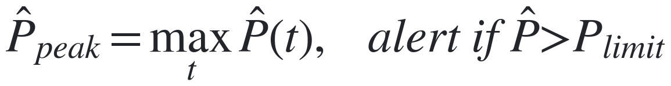 | Highest forecast load of the day and when it occurs. 12 Jan 2026: block 42 → (42 − 1) × 15 min = 10:15 IST; 5,670.83 MW vs limit 8,748 MW → Clear (3,077 MW headroom). REAL.
Load Analytics  Load factor & PAR | 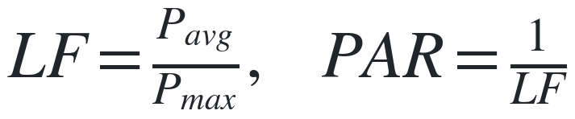 | Average ÷ peak load; PAR = 1/LF [6]. Illustrative day (530 / 820): LF = 0.646, PAR = 1.55. Whole period, measured (Apr 2023 – Jan 2026, 96,398 blocks): LF = 4,316 / 8,582 = 0.503, PAR = 1.99.
Weather Impact  Heat sensitivity (all 15-min blocks) |  | Extra MW per °C of heat index, OLS on 96,398 blocks [15]: β = 112.0 MW/°C, r² = 0.61; +3 °C → +336 MW. CSE's 67% [3] is for daily peaks, a different metric. REAL.
Forecast  Forecast accuracy (MAPE) |  | Average error as a % of actual load [8]. Test MAPE 3.93% vs seasonal-naive 5.16% (full test set). Derived arithmetic, not measured: 4,500 MW × 3.93% ≈ 177 MW. REAL.
Forecast  Band coverage |  | Share of actuals inside the P10–P90 band [14]: 84.4% on test vs the 80% target. REAL.
DSM ₹ Calculator  DSM deviation charge |  | Deviation within the limit at rate NR, excess at k × NR [5]. D = 60 MW, VL = 41 MW, NR = ₹5,000/MWh, k = 1.5: ₹86,875 per block, ₹3,47,500 = ₹3.475 lakh/hr. ILLUSTRATIVE.
Transformer Health  Transformer ageing | 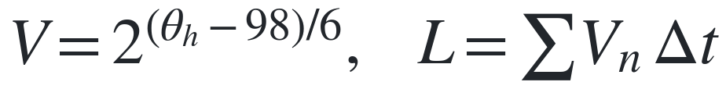 | Ageing rate V doubles every 6 °C above 98 °C [10]. 40 °C ambient, full load: θh = 40 + 55 + 23 = 118 °C, V = 2^(20/6) = 10.08×; 1 h uses 10.08 h of life. ILLUSTRATIVE.
IEX Price / Real historical purchase cost | 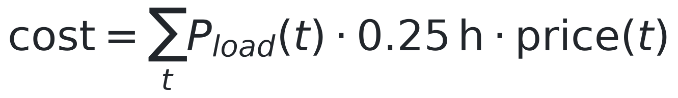 | Real historical block-of-day average price (2018-2024, Kaggle mukund604/...) x real day-ahead load. 12 Jan 2026: day's purchase cost Rs 4,044 lakh; real hourly price range Rs 3.05-6.13/unit. REAL.
ToD Bill Simulator / Flat vs Time-of-Day bill | 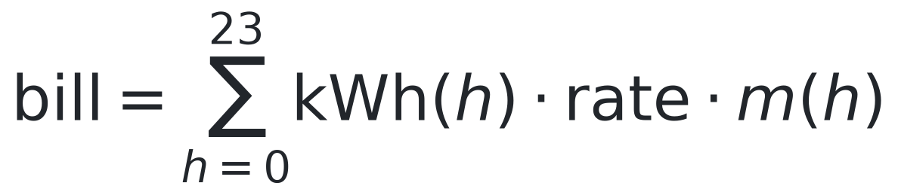 | DERC Tariff Schedule FY2020-21, clause 3(d), read directly: peak surcharge 20%, off-peak rebate 20%, peak 14:00-17:00 & 22:00-01:00, off-peak 04:00-10:00, May-September only. 10 kWh/day, 40% evening-peak share: flat vs ToD vs shifted bill compared. REAL.
Solar & Net Load / Rooftop solar output |  | PVWatts-style formula on real Open-Meteo GHI, validated against 2 real Indian plants (Kaggle anikannal/...): Plant 1 r²=0.97 (daytime, strong); Plant 2 r²=0.208 (daytime) -- root cause investigated (timestamp, clipping, sensor, pattern), no bug found. 302 MWp fleet, PR=0.8: midday peak 149 MW, evening ramp 364 MW. MODELLED.
Losses & PF / PF-correction kVAR and I2R loss |  | PF/current/resistance illustrative what-ifs, with real Delhi-DISCOM AT&C: BRPL 6.58%, BYPL 7.84%, TPDDL 5.91% (FY2023-24), read directly from PFC's primary PDF, Annexure 1.8, p.76. 1000 kW, PF 0.75->0.95: capacitor bank 553 kVAR, 300A feeder loss falls 37.7%. ILLUSTRATIVE + REAL benchmark.
Theft & Segments / Theft detection and segments |  | Logistic regression -> LightGBM on the real SGCC dataset (Zheng et al., IEEE TII 2018, China State Grid): 42,372 consumers, 8.53% theft rate. Train/Val/Test AUC-ROC: 0.9174/0.7511/0.7585, below the paper's ~0.78 (no leakage flag). FOREIGN.
Data & Model Card / Conformal band coverage |  | Static summary of every page's source, provenance and result, not live data. Band coverage: 84.4% against an 80% target, N=1,672,080 origin x horizon test forecasts. REAL.

5. Results and Model Validation

5.1 Forecast accuracy
On the full test set the final model's MAPE is 3.93% against 5.16% for seasonal-naive, a 24% reduction in error (naive scored on the 1,656,240 test rows that have a forecast from the previous day). Error rises with lead time: 3.21% at h = 1–4, 3.48% at h = 5–24, 3.84% at h = 25–48 and 4.22% at h = 49–96, and the model beats seasonal-naive at every horizon (Figure 3). The 80% band covers 84.4% of test blocks with a constant width of 602 MW. Table 2 shows how the model reached this figure; it is scored on the 1,267,749 test rows that are real readings in every data version, which is why naive reads 5.22% there and 5.16% on the full test set.
Table 2: Model ladder on the common real test rows (n = 1,267,749)
Model | What changed | Test MAPE
Seasonal-naive | Baseline: the same 15-minute block on the previous day | 5.22%
First LightGBM | Load features aligned to the origin; lost to naive at h = 74–96 | 4.93%
Causal imputer + target-aligned lags | Imputer no longer uses future data; lags aligned to the target | 4.00%
Final model | Causal Hampel outlier filter; profile fill from past days only | 3.92%
Final model, full test set | All 1,672,080 origin × horizon pairs (naive on the full set: 5.16%) | 3.93%

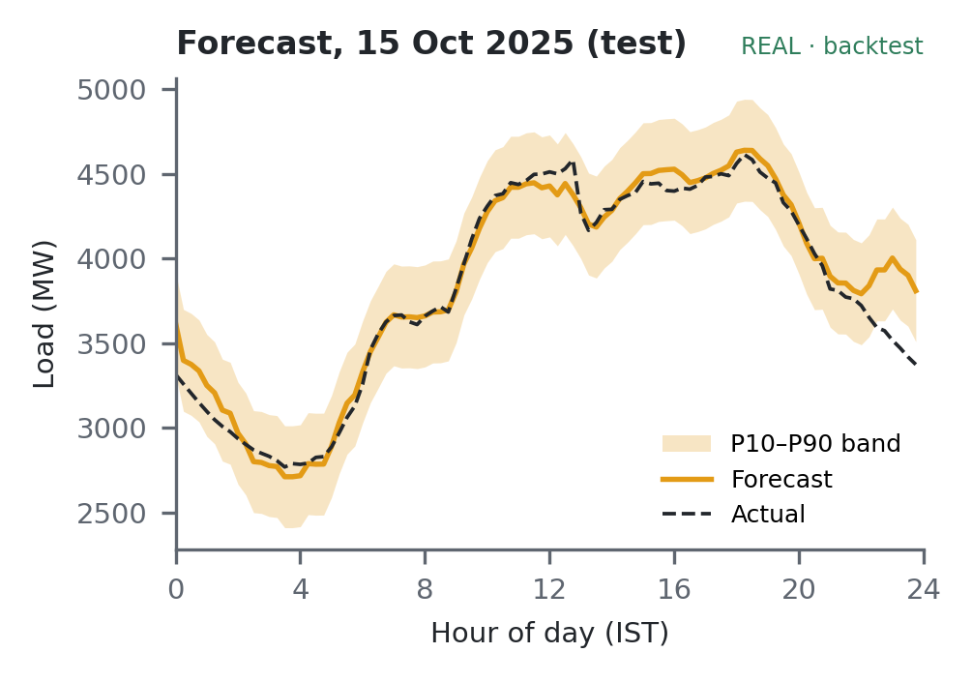  Figure 2: Day-ahead forecast for 15 Oct 2025 (test), issued 23:45 the evening before; day MAPE 2.24%. REAL. | 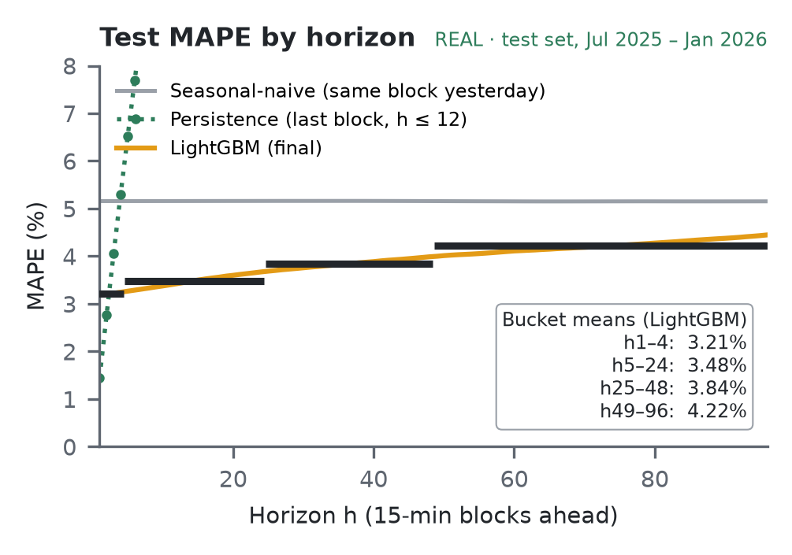  Figure 3: Test MAPE by horizon vs seasonal-naive and persistence; black bars are the bucket means. REAL.
Ablation. A 2×2(+1) factorial ablation (data version × feature set, fixed hyperparameters, 1,279,461 common test rows) separates the gain from 4.96% to 4.02% (−0.94 percentage points, 95% CI [−1.20, −0.68]). Most of it came from the target-aligned lags (Table 3). Removing the leak improved the score because the old imputer had inflated October–November late-night training labels by about 25%.
Table 3: Attribution of the −0.94 pp step (Shapley averages; re-tuning is the remainder)
Source of improvement | Share of −0.94 pp | pp
Target-aligned lag features | ~64% (54–74% depending on order) | ~0.61
Causal cleaning (imputer v1) | ~25% | ~0.23
Hyperparameter re-tuning | ~10% | ~0.10

5.2 Accuracy and Fit Check (Overfitting / Underfitting)
Table 4: Final-model accuracy by split (accuracy = 100 − MAPE; gain = 1 − model MAPE ÷ naive MAPE)
Split (rows) | MAPE | Accuracy | Seasonal-naive MAPE | Gain over naive
Train (5.91 M) | 2.29% | 97.71% | 5.44% | 58%
Validation (1.66 M) | 4.29% | 95.71% | 5.97% | 28%
Test (1.67 M) | 3.93% | 96.07% | 5.16% | 24%

Overfitting: not harmful. The train–test gap is real (2.29% vs 3.93%; Table 4, Figure 4) but small: early stopping kept 436 of 3,000 rounds, and validation and test error stay flat while only train error keeps falling. tlag_1day, the strongest feature, is not a leak: permuting it raises test MAPE from 3.93% to 23.4%.  Underfitting: no. The model beats seasonal-naive by 24% on test, at every horizon (3.21%, 3.48%, 3.84% and 4.22% for h = 1–4, 5–24, 25–48 and 49–96, against about 5.16%).  Why validation is higher. Two-thirds of validation is March–June heat, and seasonal-naive also errs more there (5.97% vs 5.16%). | 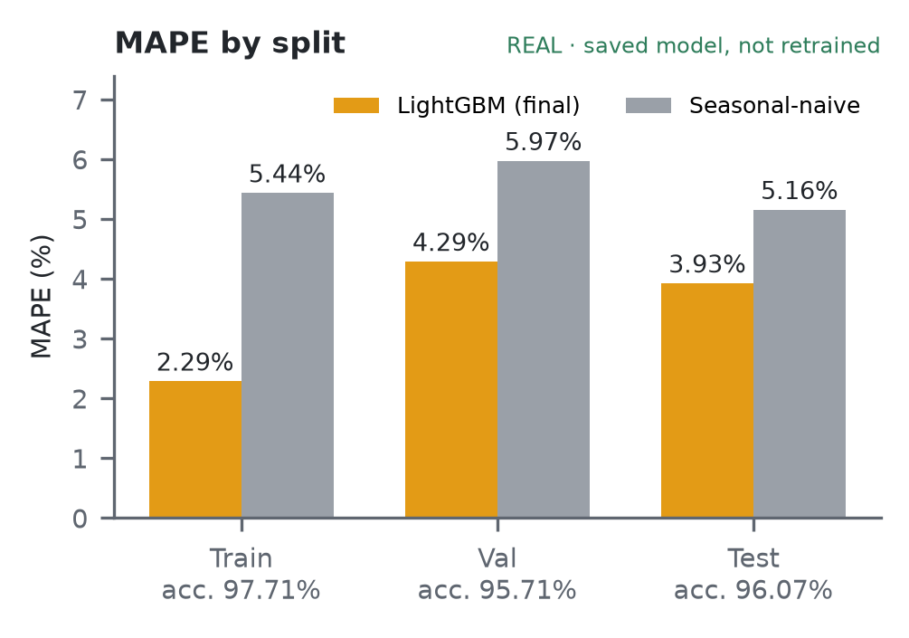  Figure 4: MAPE by split, LightGBM vs seasonal-naive (saved model, not retrained); accuracy = 100 − MAPE. REAL.

5.3 Load characteristics, heat sensitivity and ageing

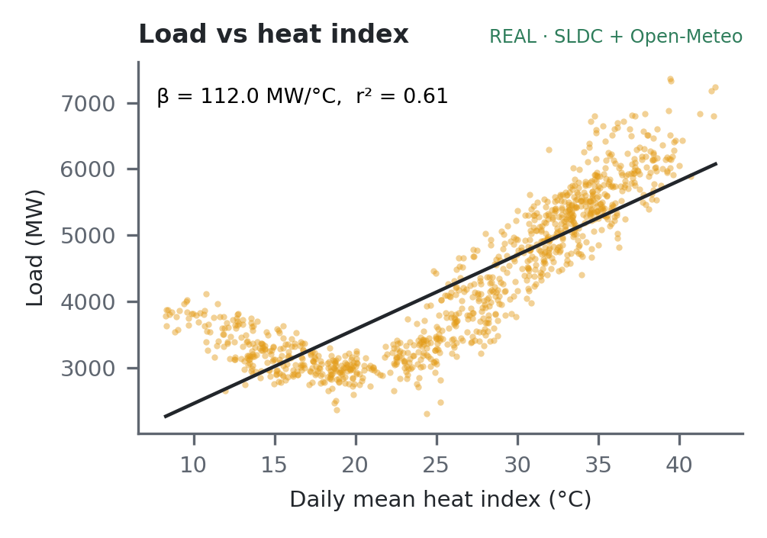  Figure 5: Load vs heat index: 1015 daily means; line = OLS fit on all 15-min blocks. REAL. | 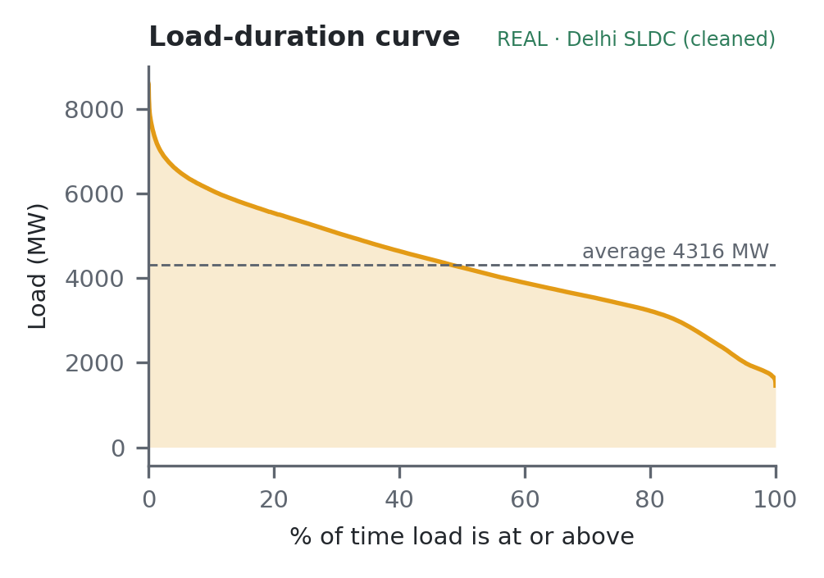  Figure 6: Load-duration curve, 96,398 blocks, Apr 2023 – Jan 2026. REAL.

Over the whole period the load factor is 0.503 and PAR 1.99 (average 4,316 MW, peak 8,582 MW on 19 Jun 2024). The duration curve (Figure 6) has a short steep tip: the highest loads last only a small share of the time. An OLS fit over 96,398 blocks gives β = 112.0 MW/°C and r² = 0.61 (Figure 4). Figure 6 shows the IEC 60076-7 ageing rate, a straight line on a log scale because ageing doubles every 6 °C. | 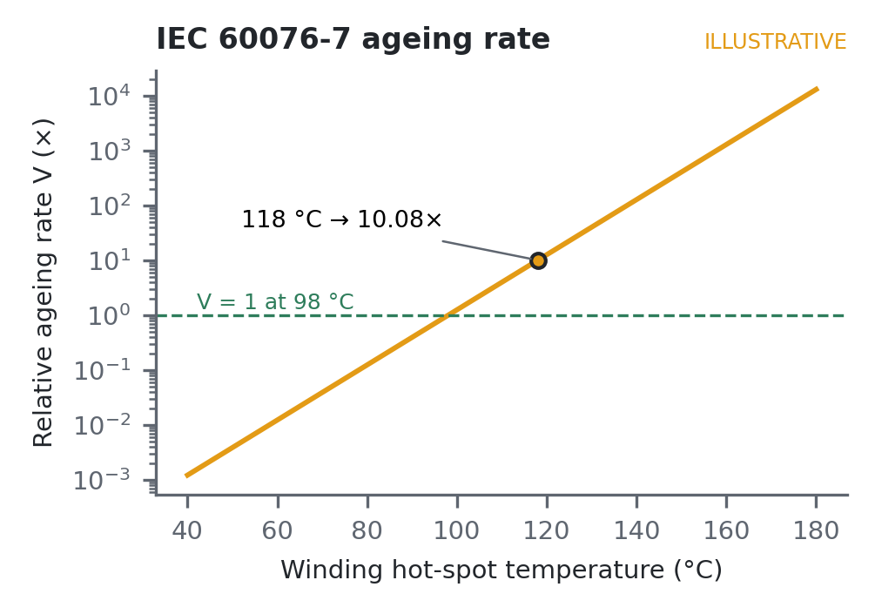  Figure 7: IEC 60076-7 relative ageing rate; 118 °C → 10.08×. ILLUSTRATIVE.

6. Dashboard: 12 of 12 Live
The dashboard has twelve pages, each answering one operational question (Table 5). All twelve are live and run on the API. Every chart and number carries a provenance badge (REAL, SYNTHETIC, ILLUSTRATIVE, MODELLED or FOREIGN). The stack is Python (pandas, LightGBM, Optuna, MAPIE, SHAP), FastAPI with Pydantic response schemas, and Next.js 15 with React and Recharts.
Table 5: The twelve dashboard pages
# | Page | What it shows | Status
01 | Overview | Day-ahead peak, peak time, alert (latest test day) | LIVE
02 | Load Analytics | Duration curve, LF, PAR; load curve, heatmap planned | LIVE
03 | Weather Impact | Load vs heat index; what-if slider planned | LIVE
04 | Forecast | 96 blocks, P10–P90 band, model comparison, SHAP (selected days) | LIVE
05 | DSM ₹ Calculator | Illustrative charge for a given deviation | LIVE
06 | Transformer Health | What-if: hot-spot temperature, ageing, life used per hour held | LIVE
07 | IEX Price | Expensive blocks, purchase cost profile | LIVE
08 | ToD Bill Simulator | Flat vs ToD vs optimised bill, shift advice | LIVE
09 | Solar & Net Load | Duck curve, evening ramp, voltage risk | LIVE
10 | Losses & PF | I²R loss, kVAR needed, phase imbalance | LIVE
11 | Theft & Segments | Suspicious meters, consumer load-shape groups | LIVE
12 | Data & Model Card | Source, real vs synthetic, accuracy, limits | LIVE

Benchmark summary: with all twelve pages live, each additional engine was checked against an external benchmark before being trusted.
- IEX Price: historical block-of-day average price (Rs 3.05-6.13/unit, 2018-2024, Kaggle mukund604/...) matches the real exchange's published range -- a 6.7-year typical-day average, not a specific day's live price.
- ToD Bill Simulator: uses DERC's Tariff Schedule FY2020-21, read directly (clause 3(d), p.2): peak surcharge 20%, off-peak rebate 20%, corrected from an earlier unverified 30%/25% figure.
- Solar & Net Load: PVWatts-style formula validated against two real Indian solar plants (Kaggle anikannal/solar-power-generation-data): Plant 1 fits well (daytime r² = 0.97), while Plant 2's weaker fit (daytime r² = 0.21) was investigated -- timestamp alignment, inverter clipping, sensor placement and day-to-day pattern -- and traced to one shared weather sensor across 22 distributed inverters, not a fixable bug.
- Losses & PF: Delhi-DISCOM AT&C figures -- BRPL 6.58%, BYPL 7.84%, TPDDL 5.91% -- are read directly from PFC's primary “Report on Performance of Power Utilities 2023-24” (Annexure 1.8, p.76); BRPL and TPDDL re-confirm the earlier secondary source exactly, and BYPL is confirmed for the first time.
- Theft & Segments: trains on the real SGCC dataset (Zheng et al., 2018, China State Grid, 42,372 consumers) and reaches a test AUC-ROC of 0.7585, below the paper's stated ~0.78 (no leakage flag).
- Data & Model Card: a static summary of every page's source, provenance and result; conformal band coverage 84.4% against the 80% target, repeated here from Section 5.
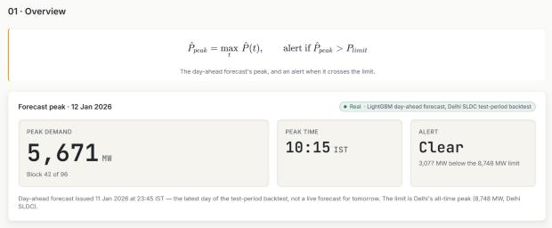  Figure 8: Overview page (live). | 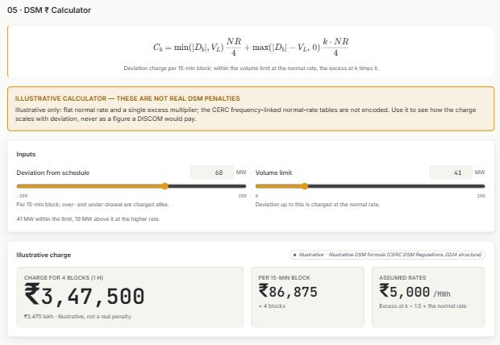  Figure 9: DSM ₹ Calculator page (live). | 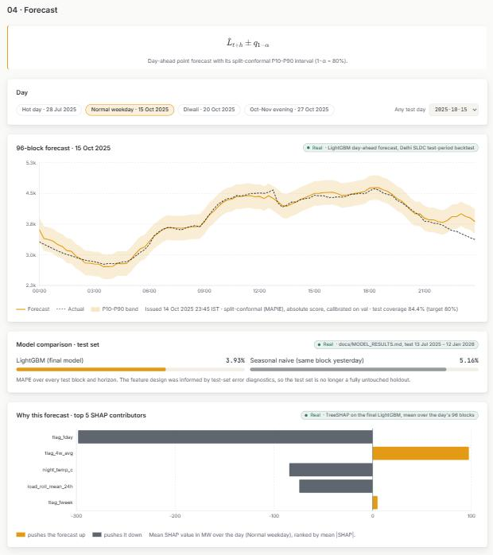  Figure 10: Forecast page (live).
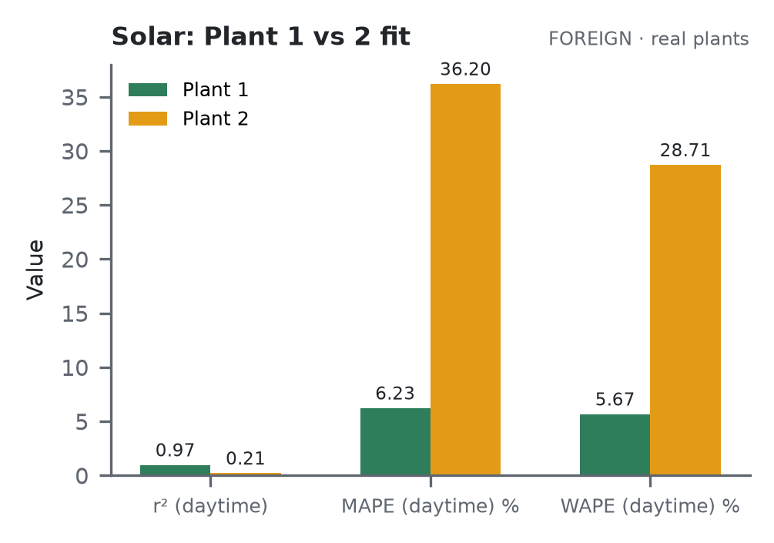  Figure 11: Solar: Plant 1 vs Plant 2 fit comparison (daytime r², MAPE, WAPE). FOREIGN. | 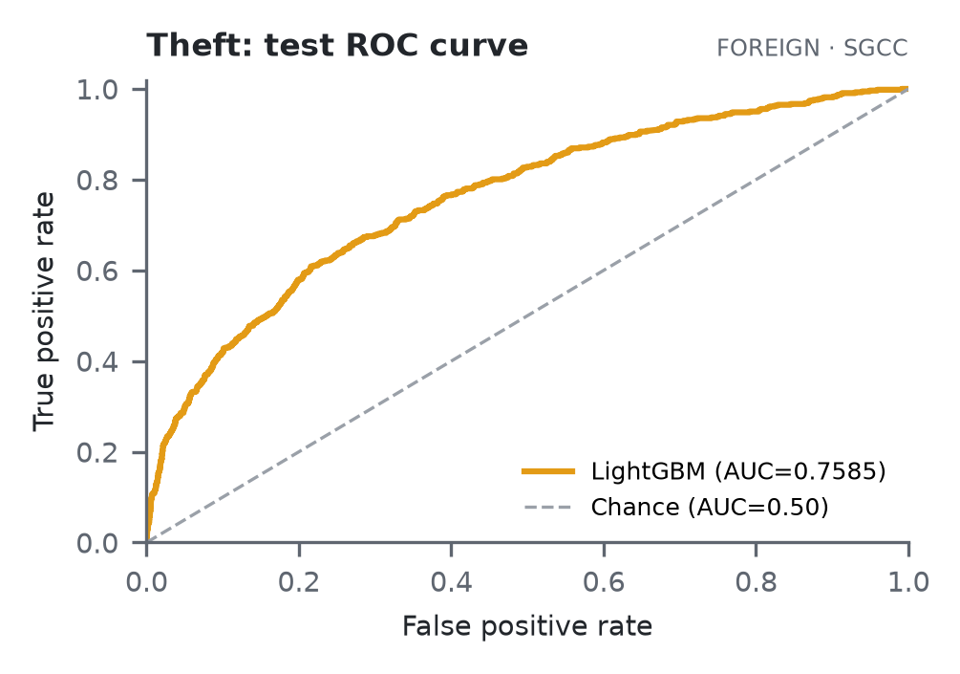  Figure 12: Theft & Segments: test ROC curve, AUC-ROC 0.7585. FOREIGN.
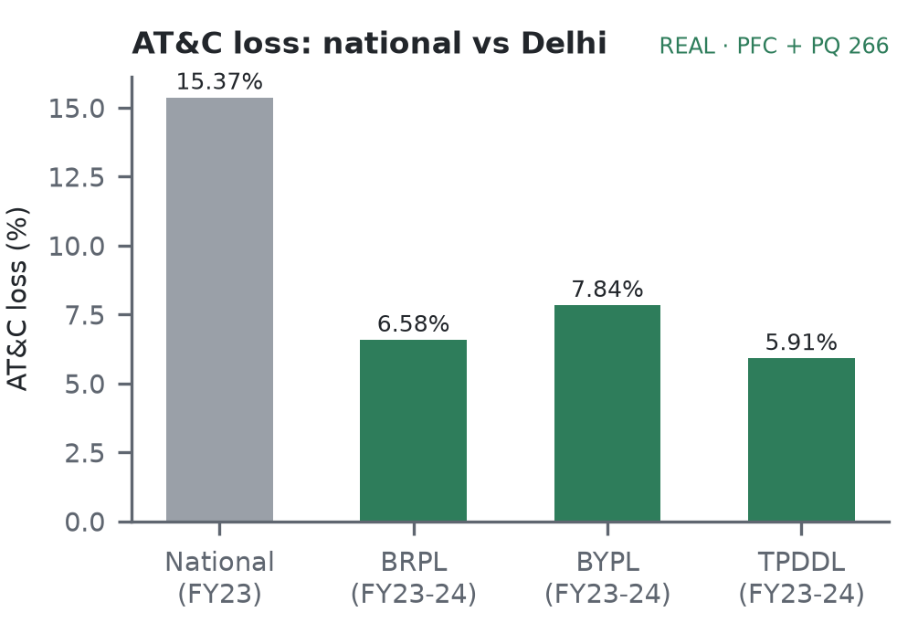  Figure 13: Losses & PF: AT&C loss, national vs BRPL/BYPL/TPDDL. REAL. | 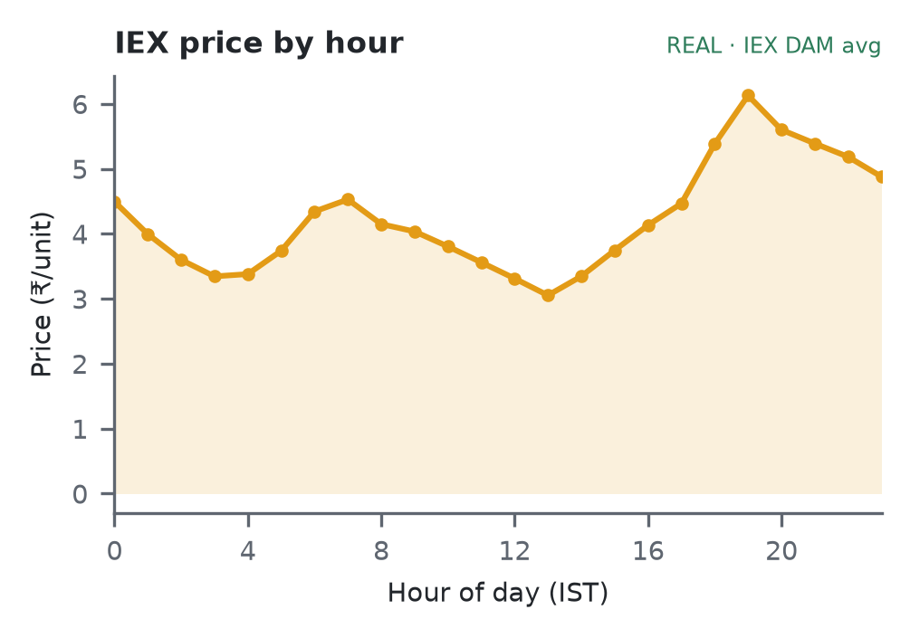  Figure 14: IEX Price: day-ahead price by hour of day, 2018–2024 average. REAL.

7. Dataset
Every number on all twelve pages comes from the files below. REAL = measured (Delhi SLDC, Open-Meteo, or another named primary source); FOREIGN = measured but not Delhi (e.g. SGCC, a Kaggle solar plant); MODELLED = a formula on real inputs; SYNTHETIC = generated stand-in; ILLUSTRATIVE = a worked example or user what-if. Column names are the exact fields in data/processed/delhi_15min.parquet, the feature file, the model outputs and the API schemas, for the original six pages; the six additional pages' own sources are listed in the same table below.
Table 6: Variables, sources and provenance
Variable(s) | Meaning | Source | Tag
ts_ist, date, block | 15-min timestamp (IST), day, block 1–96 | Delhi SLDC (Kaggle mirror) | REAL
load_mw | Delhi load per block (mean of three 5-min readings) | Delhi SLDC, cleaned | REAL
imputed, impute_method, is_outlier | Cleaning flags for every filled or rejected block | Cleaning pipeline | REAL
temp_c, rh_pct, dewpoint_c | Air temperature, relative humidity, dew point | Open-Meteo archive (28.6139 N, 77.2090 E) | REAL
ghi_wm2, wind_ms, cloud_pct | Irradiance, wind speed, cloud cover | Open-Meteo archive | REAL
heat_index_c | Heat index from temp_c and rh_pct (Rothfusz) | Derived from Open-Meteo | REAL
is_holiday, holiday_name, dow, month, is_weekend | Calendar features | Holiday calendar | REAL
is_ipl_season | IPL match season flag | ipl_seasons.csv | REAL
tlag_1day, tlag_4w_avg, load_roll_mean_24h, night_temp_c | Main model features (lags, rolling mean, night temperature) | Built from the above | REAL
predicted_mw, p10_mw, p90_mw, actual_mw, ts_target | Forecast, band and actual per test block | LightGBM + MAPIE backtest | REAL
peak_mw, peak_time, peak_block, limit_mw, alert | Overview outputs (limit = 8,748 MW record) | Engine on forecast | REAL
load_factor, par, p_avg_mw, p_max_mw | Load Analytics outputs | Engine on load_mw | REAL
beta_mw_per_c, intercept_mw, r_squared, n_blocks | Weather Impact outputs | Engine on load_mw, heat_index_c | REAL
deviation_mw, schedule_limit_mw, normal_rate_per_mwh, excess_multiplier | DSM ₹ Calculator inputs → penalty_rupees | User what-if input | ILLUSTRATIVE
hotspot_temp_c, hours | Transformer Health inputs → ageing_rate_v, life_hours_used | User what-if input | ILLUSTRATIVE
category, load_mw (5 files) | Residential, commercial, industrial, agricultural, EV profiles | Parametric generator | SYNTHETIC
block_of_day_price_inr | Real IEX DAM block-of-day average price (2018–2024) × real day-ahead load → purchase cost | Kaggle mukund604/indian-energy-exchange-time-series-forecasting (233,760 rows) | REAL
tod_rate, peak_hours, offpeak_hours | DERC Tariff Schedule FY2020-21, clause 3(d): peak surcharge/off-peak rebate and hours | DERC Tariff Schedule FY 2020-21, read directly (tatapower-ddl.com PDF) | REAL
ghi_wm2, capacity_mwp, pr, solar_mw | PVWatts-style solar output from real Open-Meteo GHI; formula validated against 2 real plants | Open-Meteo GHI; Kaggle anikannal/solar-power-generation-data | MODELLED
brpl_pct, bypl_pct, tpddl_pct, at_c_loss_pct | Delhi-DISCOM and national AT&C loss benchmarks alongside illustrative PF/I²R what-ifs | PFC “Report on Performance of Power Utilities 2023-24”, Annexure 1.8, p.76; Rajya Sabha PQ 266 | REAL
consumer features (10), theft_label | Per-consumer engineered features → theft probability, K-means segment | SGCC (Zheng et al., IEEE TII 2018, China State Grid, 42,372 consumers) | FOREIGN
category, load_mw (demo fleet) | Residential, commercial, industrial, agricultural, EV demo-fleet profiles | Parametric generator (Theft & Segments demo fleet, page 11a, only) | SYNTHETIC

7.1 Cleaning steps (all causal: each decision uses only readings at or before it)
- Drop duplicate timestamps; reindex onto a complete 5-minute grid (293,184 slots expected, 285,252 present: 2.705% missing).
- Reject physically impossible values: load ≤ 0, above 12,000 MW, or a jump above 800 MW in 5 minutes.
- Trailing Hampel filter (35-min window, 3σ) flags outliers without looking at future readings: 249 blocks flagged.
- Tiered gap-filling by gap length: short gaps forward-filled (894 blocks), medium gaps from the time-of-day profile of the past 5 days (1,153 blocks); gaps over 3 hours left missing, never fabricated.
- Resample to 15-minute blocks (block 1–96), join weather and calendars, and assert no duplicate or missing timestamps.
Table 7: Row counts (15-minute blocks)
Set | Period | Blocks | Usable (non-missing)
All data | 1 Apr 2023 – 12 Jan 2026 | 97,728 | 96,398 (1,330 = 1.361% left missing)
Train | 1 Apr 2023 – 12 Jan 2025 | 62,687 | 61,620
Validation | 13 Jan 2025 – 12 Jul 2025 | 17,376 | 17,312
Test | 13 Jul 2025 – 12 Jan 2026 | 17,665 | 17,466
Synthetic profiles | Same period, 5 categories | 97,728 each | Theft & Segments' demo fleet only (page 11a)
Synthetic data. The five category profiles are built by a parametric model: base + daily pattern + weekly pattern + heat effect + noise + event bumps, validated against the real aggregate shape (peak timing, load-duration curve, autocorrelation). They serve only Theft & Segments' demo fleet (page 11a); that page's SGCC benchmark (11b) and the rest of the dashboard run on real data, except the two illustrative calculators (DSM, Transformer Health).

8. Novelty and Limitations
Novelty: Delhi load forecasting, theft detection and ToD calculators each exist separately in open-source work – theft detection on SGCC's public China State Grid benchmark (Zheng et al., 2018), day-ahead price analysis on Kaggle's IEX exchange history, solar-output modelling on Kaggle's real Indian plant generation data, and DISCOM loss reporting in PFC's annual performance reports. We did not find an open project that links one Delhi forecast to a DSM charge under CERC 2024 and DERC limits, transformer ageing under IEC 60076-7, IEX day-ahead cost, Time-of-Day billing, PF-correction and AT&C losses, solar net load, and theft/segment detection, in one dashboard with every number labelled by provenance. All twelve pages are built and live; integrating them on Indian regulation, each checked against its own real or foreign benchmark, is the contribution.
Limitations: we report only our own backtest, and it has these limits.
- Test set not fully untouched: the target-aligned lags were designed after reading the first model's test-set errors. Tuning and early stopping never saw test, but 3.93% may be slightly optimistic.
- Shortest horizons: persistence (next block = last block) beats the model at h = 1 (1.44% vs 3.18%) and h = 2 (2.77% vs 3.20%). The model beats seasonal-naive at every horizon.
- Holidays: on Diwali (20 Oct 2025) day MAPE was 8.65% and only 49% of blocks fell in the band; actual load was about 2,000 MW below the 4-week same-block average. Holidays are learned from few examples through one indicator.
- Date range: the data end on 12 Jan 2026, so Delhi's record 8,748 MW (29 Jun 2026) is not in the data (dataset maximum 8,581.6 MW, 19 Jun 2024), and the test window has no March–June summer.
- Marginal coverage: 84.4% is an average; by month it ranges from 73% (August) to 98% (November), and by horizon from 90% (h = 1–4) to 82% (h = 49–96).
- Not run or illustrative: SARIMAX has no test score; N-HiTS, TFT and Chronos were not run. DSM rupees use a flat rate (CERC frequency-linked tables not encoded); the transformer page is a what-if.
- Solar Plant 2: the PVWatts-style formula fits Plant 1 well (daytime r² = 0.97) but Plant 2's daytime r² is only 0.21; four hypotheses (timestamp shift, inverter clipping, sensor placement, day-to-day pattern) were actively tested and no fixable bug was found – the weak fit reflects one shared weather sensor across 22 spatially distributed inverters, a real-world data limitation, not a formula error.
- Theft & Segments: trained on the real SGCC (China State Grid) benchmark, not Delhi data, since no public Delhi or Indian consumer-level smart-meter dataset with theft labels was found; the demo fleet (page 11a) uses synthetic profiles as a stand-in until real Delhi meter data becomes available.

9. Work Distribution
Table 8: Work distribution among team members
Member | Roll No. | Contribution
Vansh Sachan (Group Leader) | 24295918040 | Model training and validation (naive, SARIMAX, LightGBM, leakage audit, ablation study); built the live dashboard (FastAPI, formula engines, Next.js, all 12 pages); data acquisition and system architecture; researched and implemented the IEX, ToD, Solar, Losses and Theft engines, including the Solar Plant 2 root-cause investigation and the BYPL AT&C confirmation from PFC's primary source.
Animish Gupta | 23295919010 | Data refinement and cleaning (causal outlier filtering, gap-filling, final train/val/test feature set); author of this report.
Ayush Rathore | 24295918024 | Data refinement and cleaning (feature engineering, calendar/weather joins, final training data); prepared the presentation, including its updated feature-slide layout.
Lavish Rawat | 23295918041 | Data refinement and cleaning (data validation, QA checks, dataset documentation); prepared the presentation, including its updated feature-slide layout, references and formatting.

10. Conclusion
The project goes beyond a conventional load forecast by carrying a real Delhi forecast to its consequences: a peak alert, the shape of demand, its heat sensitivity, an illustrative DSM charge and transformer ageing, and – now that all twelve pages are live – real IEX cost, DERC-based ToD billing, PFC-sourced DISCOM losses, solar output validated against real plants, and theft detection on a real benchmark. The forecasting core reaches a test accuracy of ≈ 96% (MAPE 3.93%; seasonal-naive 5.16%) with an 80% band that covers 84.4% of test blocks. Holiday behaviour, the shortest horizons, the untested pre-monsoon summer peak, and replacing the Theft demo fleet with real Delhi meter data are the main gaps going forward.
References
[1] Ministry of Power (PIB), "India meets all-time highest peak demand of 256.1 GW," Apr. 2026.
[2] Delhi SLDC, peak demand record of 8,748 MW, 29 Jun. 2026 (reported by Business Standard).
[3] Centre for Science and Environment, "How Delhi is losing its cool," 2025.
[4] S. Sanyal and S. Dev, "The Duck and the Camel: Tracing the Net Load on the Indian Power Grid," EAC-PM Working Paper 53/2026.
[5] CERC (Deviation Settlement Mechanism and Related Matters) Regulations, 2024; DERC intra-state DSM order, 13 Sep. 2024.
[6] V.K. Mehta and R. Mehta, Principles of Power System, S. Chand (Ch. 3, Ch. 6).
[7] T. Gönen, Electric Power Distribution Engineering, 3rd ed., CRC Press, 2014 (Ch. 2).
[8] R.J. Hyndman and G. Athanasopoulos, Forecasting: Principles and Practice, 3rd ed., OTexts, 2021.
[9] Ministry of Power, Electricity (Rights of Consumers) Amendment Rules, 2023.
[10] IEC 60076-7:2018, Loading guide for mineral-oil-immersed power transformers.
[11] T. Hong and S. Fan, "Probabilistic electric load forecasting: A tutorial review," Int. J. Forecasting, vol. 32, no. 3, pp. 914–938, 2016.
[12] A.F. Ansari et al., "Chronos: Learning the Language of Time Series," arXiv:2403.07815, 2024.
[13] D.P. Kothari and I.J. Nagrath, Modern Power System Analysis, McGraw-Hill (Ch. 5).
[14] A.N. Angelopoulos and S. Bates, "A Gentle Introduction to Conformal Prediction," arXiv:2107.07511, 2021.
[15] L.P. Rothfusz, "The Heat Index Equation," NWS Technical Attachment SR 90-23, 1990.

