WEEK 3 TASK REPORT

Advanced Data Analysis and Visualization in Logistics

Project: Logistics Data Analysis and Predictive Optimization
Dataset: Hypothetical Logistics Dataset (500 shipment records)
Tools: Python, Pandas, NumPy, Matplotlib

1. Objective
The objective of Week 3 is to perform exploratory data analysis (EDA) on a hypothetical logistics dataset and communicate operational findings through clear visualizations. The analysis focuses on delivery time, shipment volume, distance, transportation cost, transport mode, region, product category, and delay risk. The results are intended to demonstrate how data-driven analysis can reveal efficiency issues, cost drivers, and potential bottlenecks.

2. Dataset Structure
A reproducible hypothetical dataset of 500 shipment records was generated using Python. Each record represents a shipment. The numerical variables were simulated with realistic ranges and relationships, while categorical variables represent transport modes, regions, and product categories.
Variable | Type | Purpose
Shipment_ID | Integer | Unique shipment identifier
Region | Categorical | Geographic operating region
Transport_Mode | Categorical | Road, Rail, Air or Sea
Product_Category | Categorical | Shipment product group
Shipment_Volume_kg | Numeric | Shipment size/volume
Distance_km | Numeric | Transportation distance
Delivery_Time_Days | Numeric | Delivery performance metric
Transportation_Cost_INR | Numeric | Estimated transport cost
Delay_Risk | Numeric | Estimated probability/risk of delay

3. Exploratory Data Analysis
The dataset contains 500 rows and 9 variables. No missing values or duplicate records were introduced in the simulated dataset. Descriptive statistics were calculated for the main numerical variables. Mean, median, standard deviation, minimum and maximum values were used to understand central tendency and dispersion.
Shipment_Volume_kg: mean = 524.37, median = 525.60, standard deviation = 180.34, range = 80.00 to 1025.70.
Distance_km: mean = 643.15, median = 581.30, standard deviation = 380.67, range = 50.00 to 1800.00.
Delivery_Time_Days: mean = 4.30, median = 4.27, standard deviation = 1.82, range = 0.50 to 10.74.
Transportation_Cost_INR: mean = 812.65, median = 764.01, standard deviation = 316.01, range = 116.87 to 1907.27.
Delay_Risk: mean = 0.18, median = 0.17, standard deviation = 0.12, range = 0.01 to 0.52.

4. Visualization and Interpretation

Delivery-Time Distribution
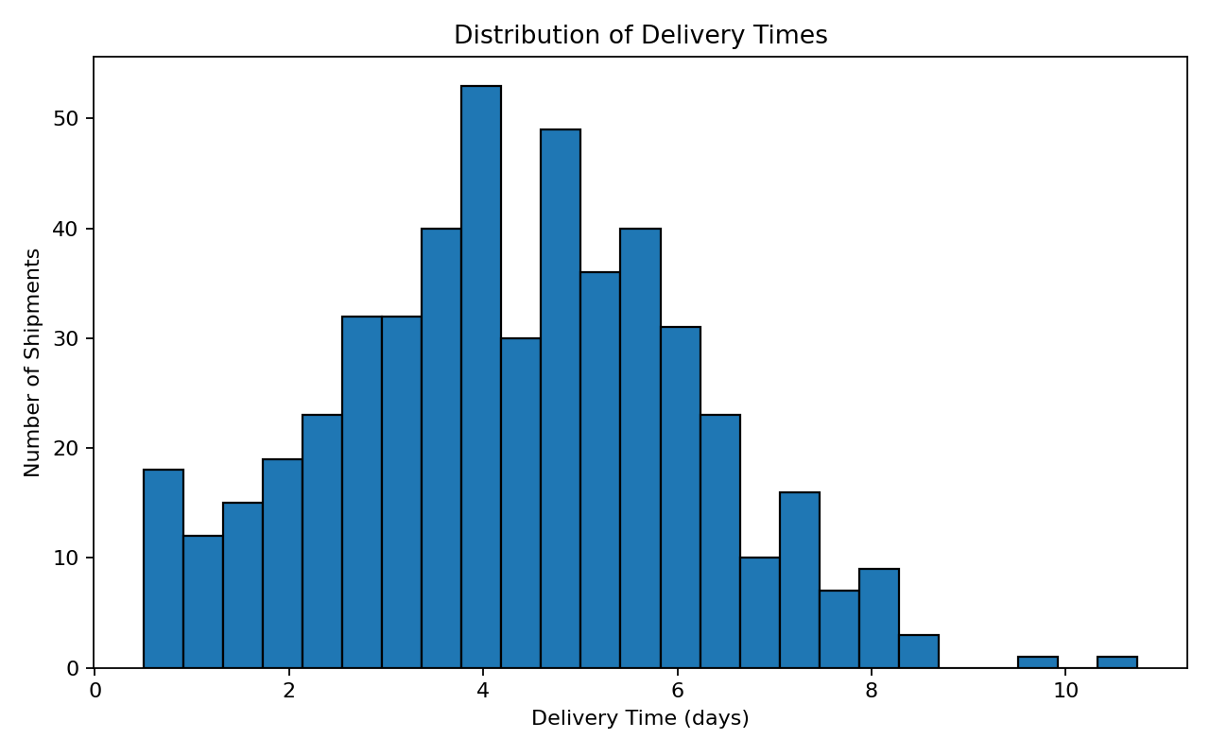
The histogram shows the spread of delivery times. Most shipments are concentrated in a central range, while longer delivery times form the operational tail. The tail is important because a smaller number of slow shipments can create customer-service problems and require exception management.

Distance vs Transportation Cost
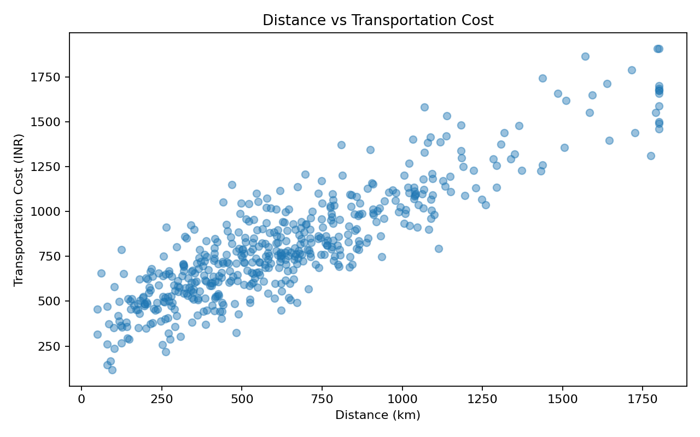
The scatter plot shows a clear positive relationship between distance and transportation cost. Longer routes generally require more transport resources, making distance an important cost driver. The spread around the trend indicates that transport mode, shipment volume and operational variability also influence cost.

Average Delivery Time by Transport Mode
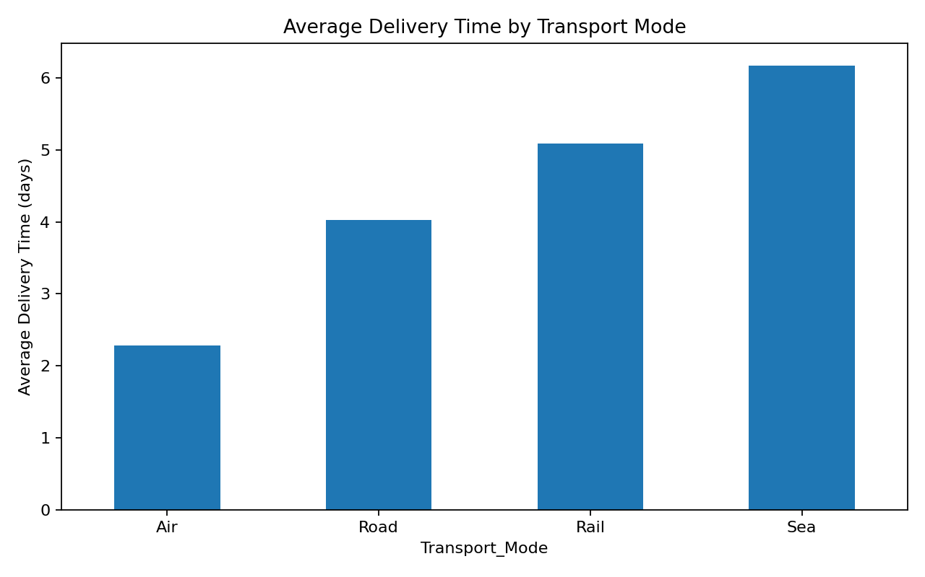
The bar chart compares delivery performance across transport modes. Air transport is expected to be faster but more expensive, while sea and rail can provide lower-cost alternatives with longer transit times. Road transport provides a useful middle ground for many shipments.

Shipment Volume vs Delivery Time
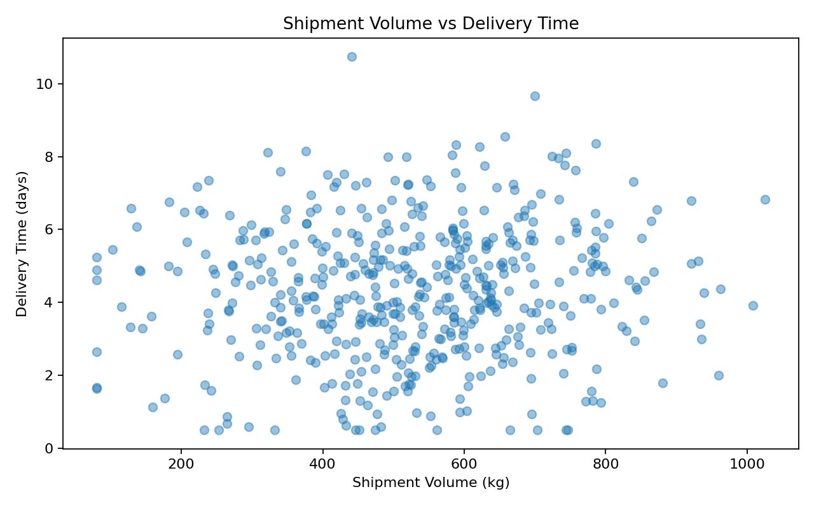
The scatter plot indicates that larger shipment volumes can be associated with longer delivery times. This may occur because high-volume shipments require additional handling, capacity planning and coordination.

Correlation Matrix
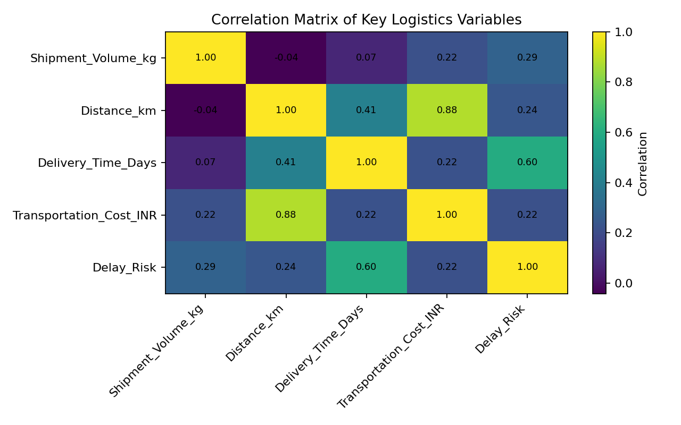
The correlation matrix summarizes linear relationships among the key numerical variables. Distance and transportation cost show a strong positive relationship. Delivery time is also influenced by distance and volume, while delay risk tends to increase with slower operational performance.

5. Group-Level Analysis
Transport-mode comparison:
Mode | Avg Delivery (days) | Avg Cost (INR) | Avg Volume (kg) | Avg Delay Risk
Air | 2.28 | 1048 | 514.1 | 0.128
Road | 4.03 | 813 | 525.6 | 0.160
Rail | 5.09 | 737 | 536.9 | 0.217
Sea | 6.18 | 687 | 514.2 | 0.258
The group-level table supports operational comparison rather than relying only on overall averages. A logistics manager can use these comparisons to select a transport mode according to the service level and cost requirements of a shipment.

6. Key Analytical Insights
- Transportation distance is a major cost driver; long routes should be reviewed for route consolidation and carrier-rate optimization.
- Transport mode creates a speed-versus-cost trade-off. Faster modes may reduce delivery time but increase cost, so mode selection should depend on shipment priority.
- High-volume shipments require stronger capacity planning because larger loads can increase handling and transit time.
- The slowest delivery observations represent potential bottlenecks and should be investigated using route, carrier, region and shipment-volume information.
- Correlation analysis is useful for identifying relationships, but correlation does not prove causation. Operational decisions should be validated with domain knowledge and further modeling.

7. Visualization Justification
Histograms are useful for understanding distributions and identifying unusually slow or fast shipments. Scatter plots are appropriate for studying relationships between continuous variables such as distance, cost, volume and delivery time. Bar charts make categorical comparisons, such as transport-mode performance, easy to interpret. A correlation matrix provides a compact overview of relationships among multiple numerical variables. Together, these visualizations convert raw logistics records into information that can support operational decisions.

8. Python Methodology
The analysis was implemented using NumPy for reproducible simulation, Pandas for data manipulation and aggregation, and Matplotlib for visualization. A fixed random seed was used so the hypothetical dataset and analytical results can be reproduced. The complete Python script is provided separately in the project repository.
# Example EDA
print(df.shape)
print(df.describe())
# Group comparison
mode_summary = df.groupby("Transport_Mode").agg(
Avg_Delivery_Days=("Delivery_Time_Days", "mean"),
Avg_Cost_INR=("Transportation_Cost_INR", "mean")
)
# Correlation
corr = df[["Distance_km", "Delivery_Time_Days",
"Transportation_Cost_INR", "Shipment_Volume_kg"]].corr()
print(corr)

9. Recommendations
- Use transport-mode performance dashboards to balance delivery speed and cost.
- Review long-distance routes for consolidation, better routing and carrier negotiation.
- Flag high-volume shipments early so capacity and handling resources can be planned.
- Investigate shipments in the slowest delivery-time segment as potential bottlenecks.
- Use the Week 3 EDA outputs as inputs for Week 4 predictive modeling and optimization.

10. Conclusion
This analysis demonstrates how exploratory data analysis and visualization can be used to understand logistics performance. The hypothetical dataset reveals practical relationships among distance, shipment volume, delivery time and transportation cost. The visualizations make these patterns easier to communicate and provide a foundation for predictive modeling. In Week 4, the project can extend this work by predicting delivery performance and evaluating optimization strategies.

11. References / Tools
Python documentation and standard library practices for NumPy, Pandas and Matplotlib.
DataCo Smart Supply Chain dataset was used as the public project reference dataset in Weeks 1–2; Week 3 uses a separate hypothetical dataset as required by the task.

