WEEK 4 TASK REPORT

Predictive Modeling and Optimization in Logistics

Project: Logistics Data Analysis and Predictive Optimization
Target: Delivery Time (days)
Tools: Python, Pandas, Scikit-learn

1. Objective
The objective of Week 4 is to develop a predictive model that forecasts a key logistics performance metric and use the results to propose optimization strategies. This report predicts delivery time in days using shipment volume, distance, region, product category and transport mode. Two regression approaches are compared, evaluated using a held-out test set and 5-fold cross-validation, and translated into practical transportation and planning recommendations.

2. Problem Definition and Data Simulation
The Week 3 hypothetical logistics dataset is reused so the four-week internship forms one connected project. The prediction target is Delivery_Time_Days. Features are selected because they are available before delivery and can reasonably support planning decisions. Actual delivery outcome fields are not used as predictors, reducing the risk of target leakage.
Feature | Type | Role
Region | Categorical | Geographic operating context
Transport_Mode | Categorical | Planned transportation method
Product_Category | Categorical | Product/handling characteristics
Shipment_Volume_kg | Numeric | Shipment size
Distance_km | Numeric | Planned route distance
Delivery_Time_Days | Numeric target | Metric to forecast

3. Data Preparation
The data is split into 80% training and 20% testing records using a fixed random state. Categorical variables are one-hot encoded. Numerical variables are standardized for the linear model. These transformations are placed inside a Scikit-learn Pipeline so that the test set is not used to learn preprocessing parameters.

4. Model Selection
Linear Regression was selected as a transparent baseline because it is simple to interpret and provides a useful benchmark. Random Forest Regression was selected as a nonlinear ensemble method because logistics relationships can involve interactions and non-linear effects. Comparing both models helps determine whether the added complexity produces better predictive performance.

5. Model Training and Evaluation
The models were trained on the training set and evaluated on the unseen test set. MAE measures average absolute prediction error in days, RMSE penalizes larger errors more strongly, and R² measures the proportion of target variance explained by the model. Five-fold cross-validation on the training data provides an additional stability check.
Model | MAE | RMSE | R² | 5-Fold CV RMSE
Linear Regression | 1.003 | 1.282 | 0.557 | 1.209
Random Forest | 1.083 | 1.345 | 0.512 | 1.295
The best model under the primary RMSE criterion is Linear Regression. The selected model is used for the illustrative optimization step below. Because the dataset is hypothetical, these metrics demonstrate the modeling workflow rather than representing production performance.

6. Actual vs Predicted Performance
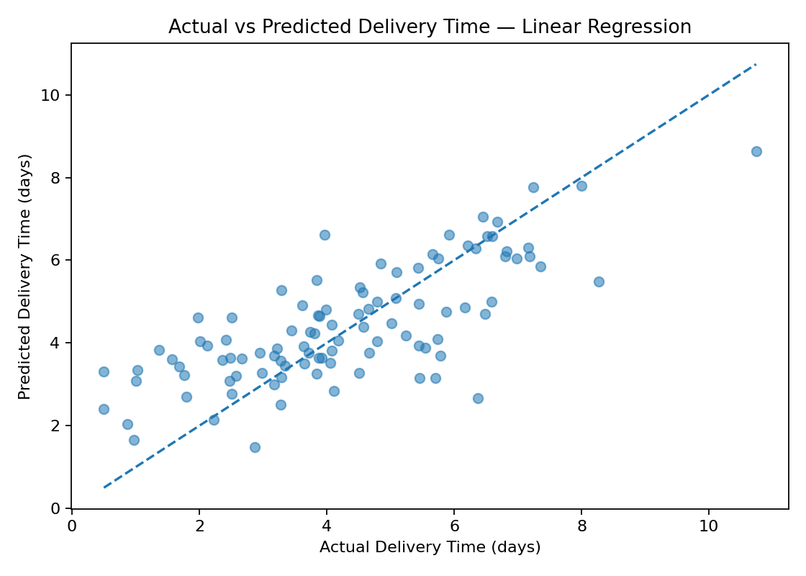
The actual-versus-predicted plot compares observed delivery time with model predictions. Points closer to the diagonal indicate smaller prediction errors. Wider deviations identify shipments that deserve additional investigation or may require features not included in the dataset.

7. Residual Analysis
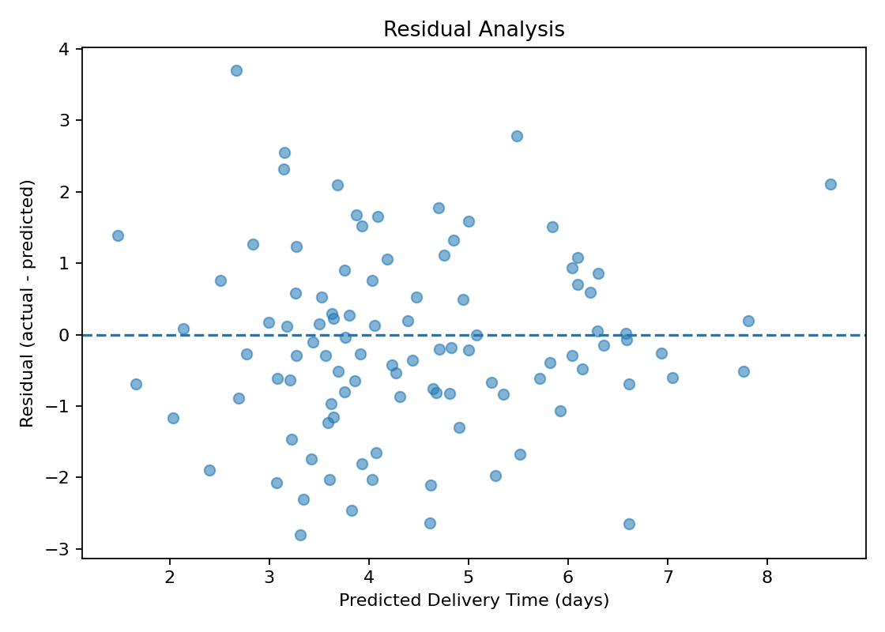
Residual analysis helps identify systematic prediction errors. A well-behaved residual plot should show errors scattered around zero without a strong pattern. Large residuals indicate shipments for which operational conditions may not be fully captured by the current features.

8. Optimization Strategy
A practical optimization approach is to treat the trained model as a decision-support component. For a new shipment, the planner can evaluate the predicted delivery time under Road, Rail, Air and Sea alternatives while keeping the shipment's other characteristics fixed. The mode with the lowest predicted delivery time can be selected when the priority is speed. In a real system, this objective would be extended to include transportation cost, capacity, service-level constraints and carbon impact.
Region | Category | Volume kg | Distance km | Fastest Mode | Predicted Days
West | Apparel | 497.7 | 1066.9 | Air | 3.13
North | Industrial | 348.1 | 603.6 | Air | 1.85
West | Apparel | 597.0 | 778.8 | Air | 2.60
East | Electronics | 385.0 | 621.6 | Air | 2.05
West | Electronics | 319.4 | 413.9 | Air | 1.72
East | Electronics | 684.9 | 749.3 | Air | 2.55
East | Industrial | 334.2 | 572.7 | Air | 1.80
West | Food | 521.5 | 214.2 | Air | 1.38
North | Industrial | 519.7 | 500.6 | Air | 1.76
West | Industrial | 699.2 | 190.3 | Air | 1.43

9. Optimization Recommendations
- Use predicted delivery time to identify shipments likely to miss desired service levels before dispatch.
- Evaluate alternative transport modes for urgent shipments and choose the fastest feasible option when service priority is high.
- For cost-sensitive shipments, extend the optimization objective to minimize cost while maintaining a maximum acceptable delivery time.
- Use route distance and shipment volume as early planning signals for capacity allocation and consolidation.
- Monitor prediction errors and retrain the model as more real operational data becomes available.

10. Python Implementation
The complete Python implementation is provided separately as week4_predictive_modeling.py. The core workflow uses train_test_split, ColumnTransformer, Pipeline, LinearRegression, RandomForestRegressor and standard regression metrics.
# Core evaluation
pred = model.predict(X_test)
mae = mean_absolute_error(y_test, pred)
rmse = mean_squared_error(y_test, pred) ** 0.5
r2 = r2_score(y_test, pred)

11. Limitations
The dataset is hypothetical and therefore cannot establish real-world predictive accuracy. The model also does not include carrier, weather, traffic, warehouse processing time, holidays, or route-level constraints. A production implementation should use historical operational data, time-based validation where appropriate, monitoring for drift, and a constrained optimization model that incorporates cost and capacity.

12. Conclusion
This Week 4 project demonstrates an end-to-end predictive workflow for logistics. Delivery time was selected as the forecasting target, Linear Regression and Random Forest were compared, and performance was evaluated using MAE, RMSE, R² and cross-validation. The selected Linear Regression model was then used to illustrate transport-mode decision support. The approach shows how predictive analytics can move logistics planning from descriptive reporting toward proactive decision-making. Future work can integrate cost, capacity and service-level constraints into a formal multi-objective optimization model.

13. Project Continuity
Week 1 established the strategic logistics analytics roadmap; Week 2 focused on data preparation; Week 3 performed exploratory analysis and visualization; Week 4 completes the workflow with prediction and optimization. This continuity provides a consistent project narrative across the internship.

14. References / Tools
Scikit-learn documentation and standard Python data-science practices for preprocessing, regression, validation and evaluation.
The Week 3 hypothetical logistics dataset created for this internship project is used as the Week 4 modeling input.

