Summer/Industrial Training

Institute of Engineering S Technology





SUMMER TRAINING REPORT

On Fit-Flow
Submitted by

Vaibhav Mishra (2315002374)
Sankalp Sharma (2315001976)
Utkarsh Saraswat (2315002359)
Tarun Khemani (2315002304)
Vansh Sharma (2315002404)

Department of Computer Engineering & Applications
Institute of Engineering & Technology

GLA University Mathura- 281406, INDIA
2025

Contents

Abstract | 5
Certificate | 6
Acknowledgments | 11
1. Introduction(This chapter must describe introduction about your project) | 12
- Motivation and Overview | 12
1.2 Objectives | 12
2. Software Requirement Analysis | 13
2.1 Define the problem | 13
2.2 Define the modules and their functionalities | 13
3. Software Design | 14
3.1 Data Flow Diagrams (DFD) | 14
3.2 UML Diagrams | 14
3.2.1 Class Diagram | 14
3.2.2 Interaction Diagrams | 15
3.2.3 Object Diagrams | 15
3.2.4 Use-Case Diagrams | 16
4. Database Design | 17
4.1 E–R Diagrams | 17
4.2 Database Tables | 17
4.3 Stored Procedures | 18
5. Testing | 19
5.1 Black Box Testing | 19
5.2 White Box Testing | 19
6. Implementation and User Interface 20
6.1 Screenshots of all UI pages 20
7. References/Bibliography 22

8. Appendices 23
8.1 Coding / Code Templates 23
8.2 Class Functionalities 24

Abstract

Fit-Flow is a web-based fitness management platform developed during a 45-day summer training program at W3grads. The platform enables users to track workouts, monitor progress, access structured training modules for multiple sports, and engage with a community-driven learning environment. The system is built using modern technologies such as React, Tailwind CSS, and charting libraries. This report presents the project’s objectives, requirements, design diagrams, implementation workflow, and testing strategies.

Department of computer Engineering and Applications GLA University, Mathura
17 km. Stone NH#2, Mathura-Delhi Road, P.O. – Chaumuha,
Mathura – 281406

Declaration

I hereby declare that the work which is being presented in the Summer Training “Title – Fit-Flow”, in partial fulfillment of the requirements for Summer Training viva voce, is an authentic record of my own work carried under the supervision of “W3grads”.

Signature of Candidate:
Name of Candidate: Vaibhav Mishra Roll. No.: 2315002374
Course: B. Tech CS Year: 3rd
Semester: 5th

Department of computer Engineering and Applications GLA University, Mathura
17 km. Stone NH#2, Mathura-Delhi Road, P.O. – Chaumuha,
Mathura – 281406

Declaration

I hereby declare that the work which is being presented in the Summer Training “Title – Fit-Flow”, in partial fulfillment of the requirements for Summer Training viva voce, is an authentic record of my own work carried under the supervision of “W3grads”.

Signature of Candidate:
Name of Candidate: Sankalp Sharma Roll. No.: 2315001976
Course: B. Tech CS Year: 3rd
Semester: 5th

Department of computer Engineering and Applications GLA University, Mathura
17 km. Stone NH#2, Mathura-Delhi Road, P.O. – Chaumuha,
Mathura – 281406

Declaration

I hereby declare that the work which is being presented in the Summer Training “Title – Fit-Flow”, in partial fulfillment of the requirements for Summer Training viva voce, is an authentic record of my own work carried under the supervision of “W3grads”.

Signature of Candidate:
Name of Candidate: Utkarsh Saraswat Roll. No.: 2315002359
Course: B. Tech CS Year: 3rd
Semester: 5th

Department of computer Engineering and Applications GLA University, Mathura
17 km. Stone NH#2, Mathura-Delhi Road, P.O. – Chaumuha,
Mathura – 281406

Declaration

I hereby declare that the work which is being presented in the Summer Training “Title – Fit-Flow”, in partial fulfillment of the requirements for Summer Training viva voce, is an authentic record of my own work carried under the supervision of “W3grads”.

Signature of Candidate:
Name of Candidate: Tarun Khemani Roll. No.: 2315002304
Course: B. Tech CS Year: 3rd
Semester: 5th

Department of computer Engineering and Applications GLA University, Mathura
17 km. Stone NH#2, Mathura-Delhi Road, P.O. – Chaumuha,
Mathura – 281406

Declaration

I hereby declare that the work which is being presented in the Summer Training “Title – Fit-Flow”, in partial fulfillment of the requirements for Summer Training viva voce, is an authentic record of my own work carried under the supervision of “W3grads”.

Signature of Candidate:
Name of Candidate: Vansh Sharma Roll. No.: 2315002404
Course: B. Tech CS Year: 3rd
Semester: 5th

Acknowledgement

I would like to express my sincere gratitude to all those who supported me throughout the completion of this project, “Sports Activity Management Website Integrated with AI.”

First, I extend my heartfelt thanks to my project guide for their valuable guidance, encouragement, and constructive feedback, which helped me shape this project successfully. I am also thankful to my faculty members for providing the necessary resources and a supportive learning environment.

I would like to acknowledge the contribution of my classmates and friends for their constant support, ideas, and motivation throughout the development process. I am also grateful to my family for their continuous encouragement and belief in my capabilities.

Finally, I appreciate all the online resources, tools, and technologies that assisted me in building this project. Their availability made the research and development process more efficient.

Introduction

Fit-Flow is a modern sports and fitness learning platform that helps users maintain physical discipline through structured modules, progress tracking dashboards, and community interaction features. The platform includes training modules for sports such as cricket, football, volleyball, table tennis, and gym workouts.

Motivation & Overview

The motivation behind building Fit-Flow is the growing need for a unified, tech- driven fitness training platform that teaches correct form and provides progress visualization.

Objectives

- Provide structured, sport-specific training modules.

- Enable progress tracking and visual analytics.

- Support a community forum for interaction and coaching help.

- Implement responsive UI aligned with the modern fitness theme.

- Lay foundation for future AI-based form analysis.

​Software Requirement Analysis

Problem Definition

This section explains the real-world problem Fit-Flow aims to solve—lack of proper guidance in sports training, difficulty in tracking progress, and the absence of a unified digital platform for form analysis, community support, and sport-specific learning.

Modules & Their Functionalities (SRS Format)

This section outlines all modules in Software Requirements Specification (SRS) format, including:
- Login & Authentication Module

- Dashboard & Progress Tracking Module

- Community Module

- Sports Training Modules (Cricket, Football, etc.)

- AI Feedback Module

- Admin/Coach Module

Each module is described in terms of inputs, outputs, processing, preconditions, and postconditions.

​Software Design

This chapter includes the detailed design of the system.

Data Flow Diagrams (DFD)

DFD Level 0, Level 1, and Level 2 diagrams showing the flow of data between user, frontend, backend, and database.
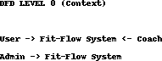

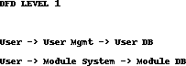



UML Diagrams

This section contains the required Unified Modeling Language diagrams:

Class Diagram

Shows major classes such as User, Module, Session, Progress, Post, Comment, Coach Feedback, etc., with relationships and attributes.
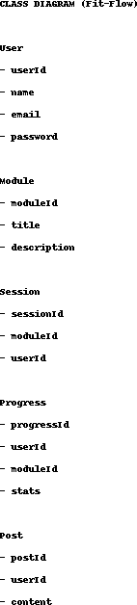

Interaction Diagrams

      - Sequence Diagrams (e.g., Login process, Start Session, Post in Community)

      - Collaboration Diagrams showing object interactions

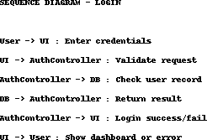

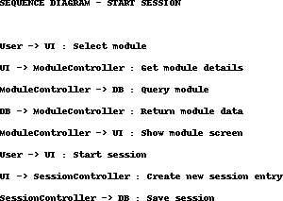

Object Diagrams

Snapshots of objects at runtime (e.g., user with multiple session objects).

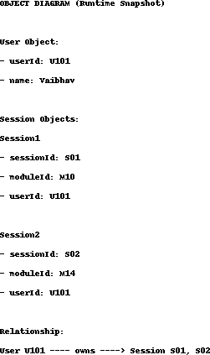

Use-Case Diagrams

Illustrates all system actors—User, Coach, Admin—and their interactions.

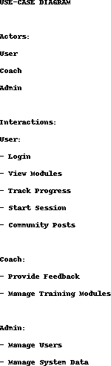

Sports Activity Management System – DFD (PDF) DFD Level 0 (Context Diagram) Admin, Coach, and Player interact with the central system: “Sports Activity Management System”. They send data such as user info, schedules, and performance details, and receive outputs like reports, training plans, and notifications. DFD Level 1 (Detailed Diagram) Processes: 1.0 User Management 2.0 Activity & Schedule Management 3.0 Performance Tracking 4.0 AI Recommendation System Data Stores: D1 User Database D2 – Activity/Schedule Database D3 – Performance Database Flow Summary: • Admin and Coach manage users
→ stored in User DB • Coach manages schedules → stored in Activity DB; Players view schedules • Player performance data → stored in

Performance DB; Coaches view updates • AI module analyzes performance data → gives smart recommendations

​Database Design

This chapter includes all database-related design details.

E–R Diagrams

Entity–Relationship diagram representing User, Module, Session, Post, Comment, and their relationships.
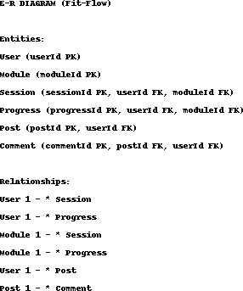

Database Tables

For each table:

- Table Name

- Attributes/Fields

- Data Type

- Description

- Primary & Foreign Keys

Example tables: Users, Modules, Sessions, Posts, Comments, Progress, Feedback, etc.

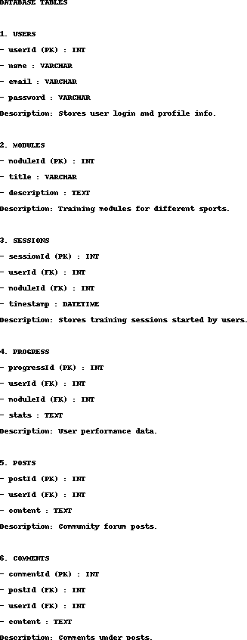

Stored Procedures (Optional for Firebase; Required for SQL Projects)
If SQL database is used:

- Insert/Update/Delete stored procedures

- Query optimization methods

If using Firebase, explain Firestore queries instead.

​Testing

Black Box Testing

Two–three test cases based on inputs and expected outputs (e.g., login validation, form submission, module loading).

White Box Testing

Includes path testing, loop testing, and code structure testing for critical components.

Test Case Format:

- Test Case ID

- Test Objective

- Input

- Expected Output

- Actual Output

- Result (Pass/Fail)

​Implementation and User Interface

This chapter provides:

- Screenshots of all UI pages
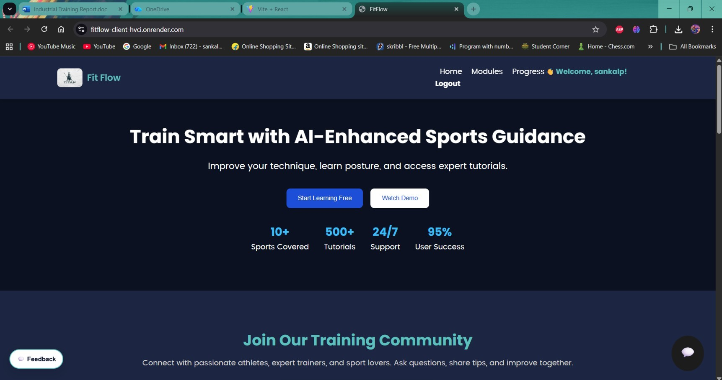

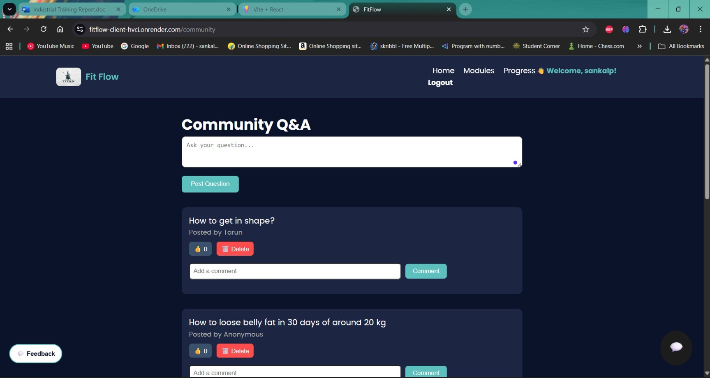

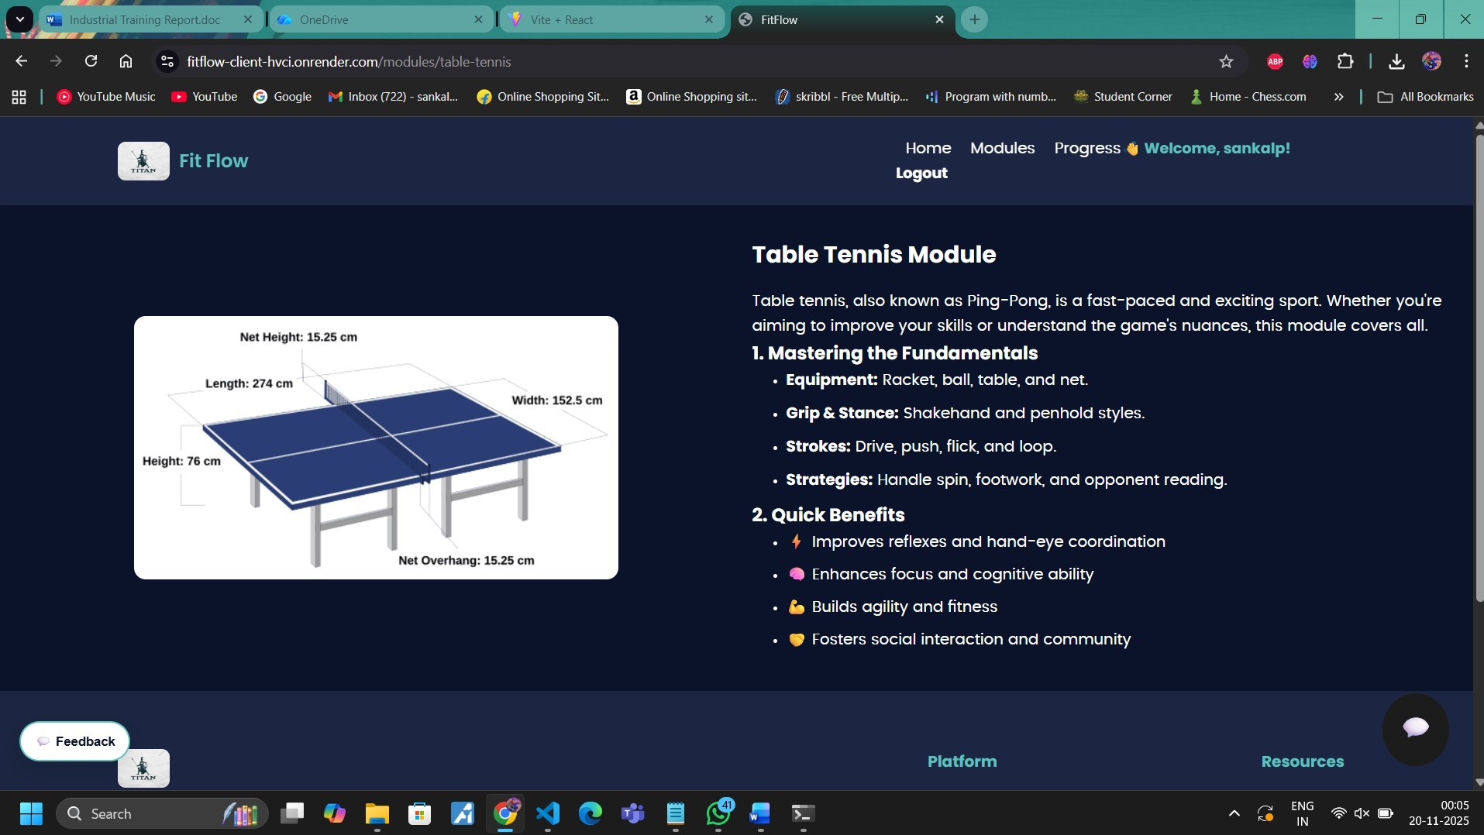

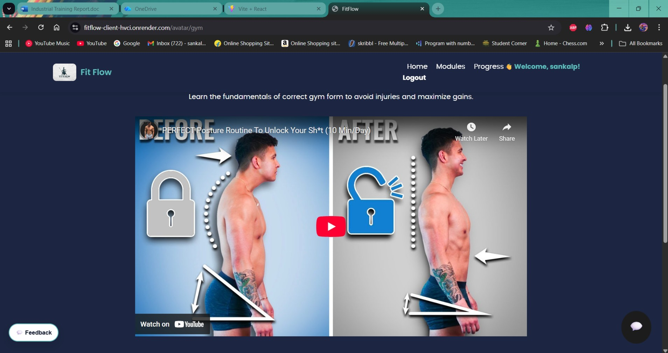

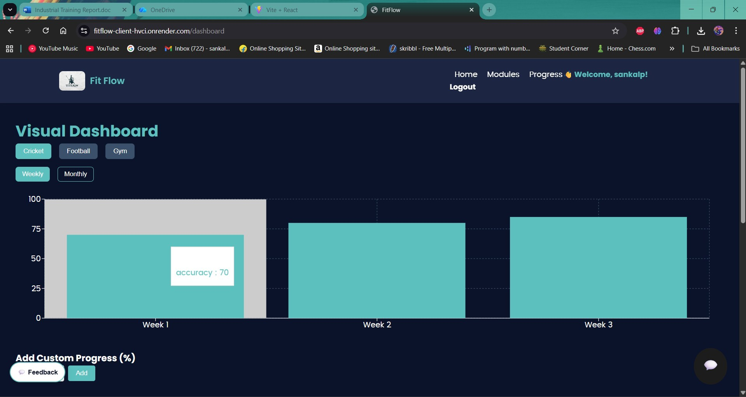

​References

- ReactJS Documentation
- Tailwind CSS Documentation
- Firebase Documentation
- Chart.js / Recharts Documentation

​Appendices

Coding / Code Templates

- Important JavaScript/React components
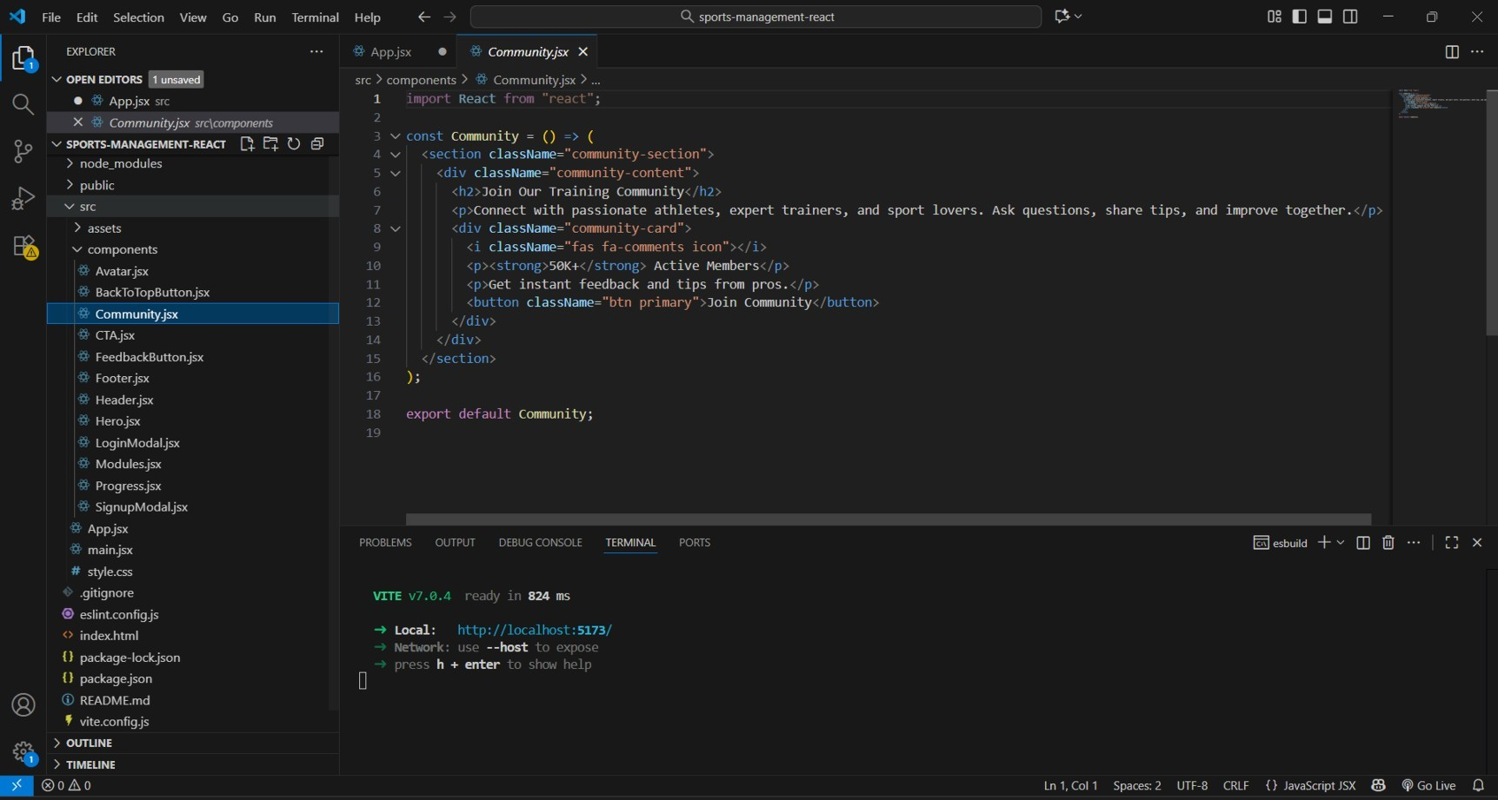

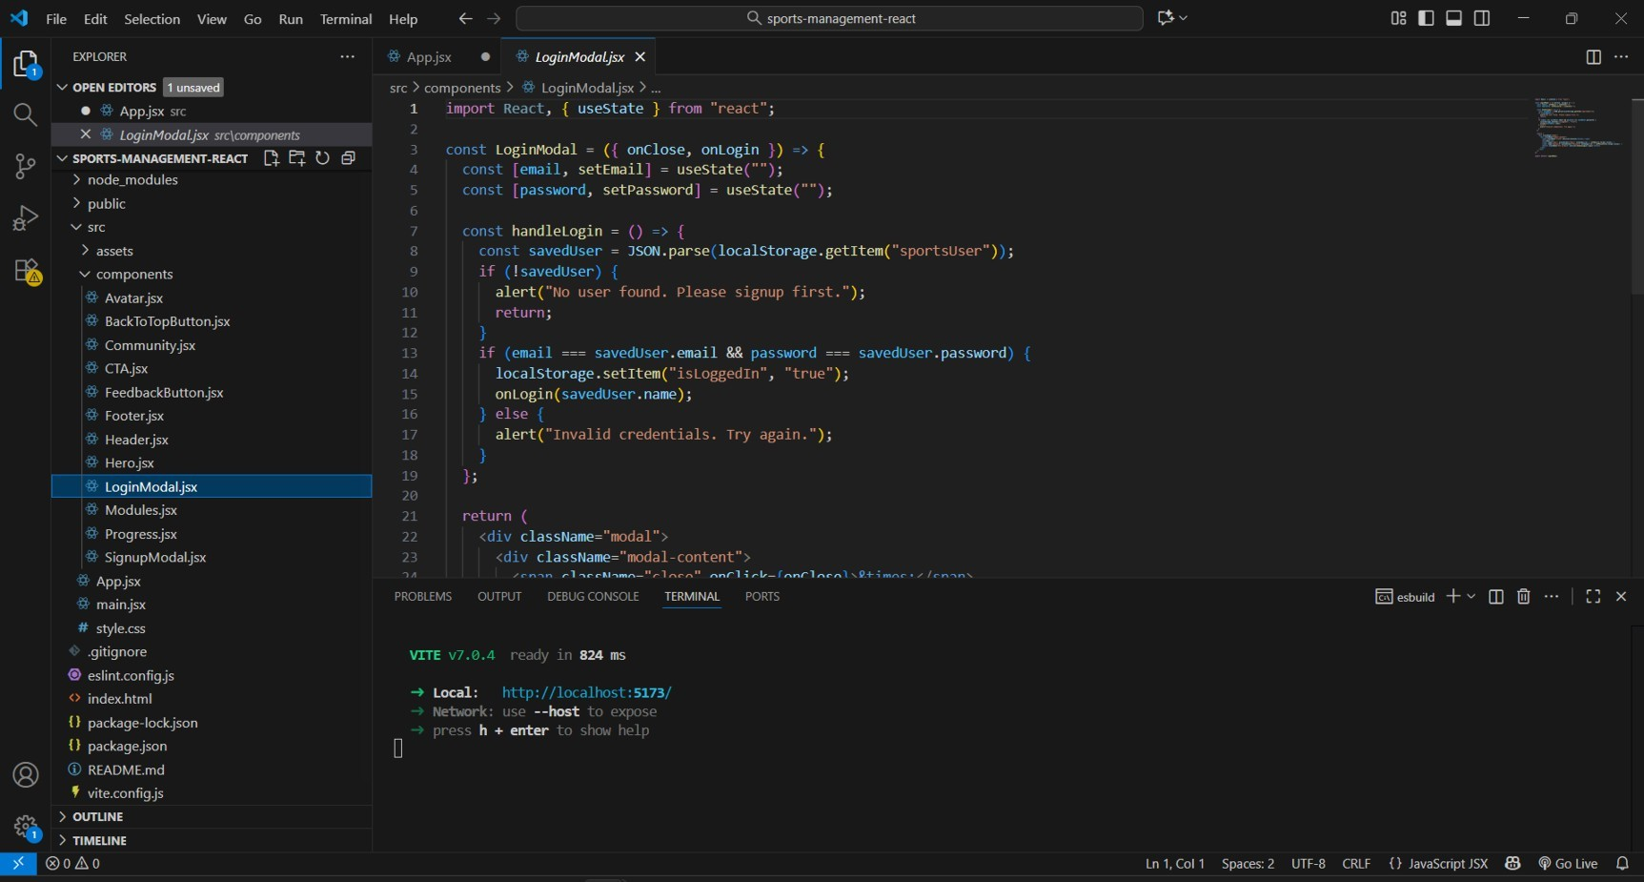

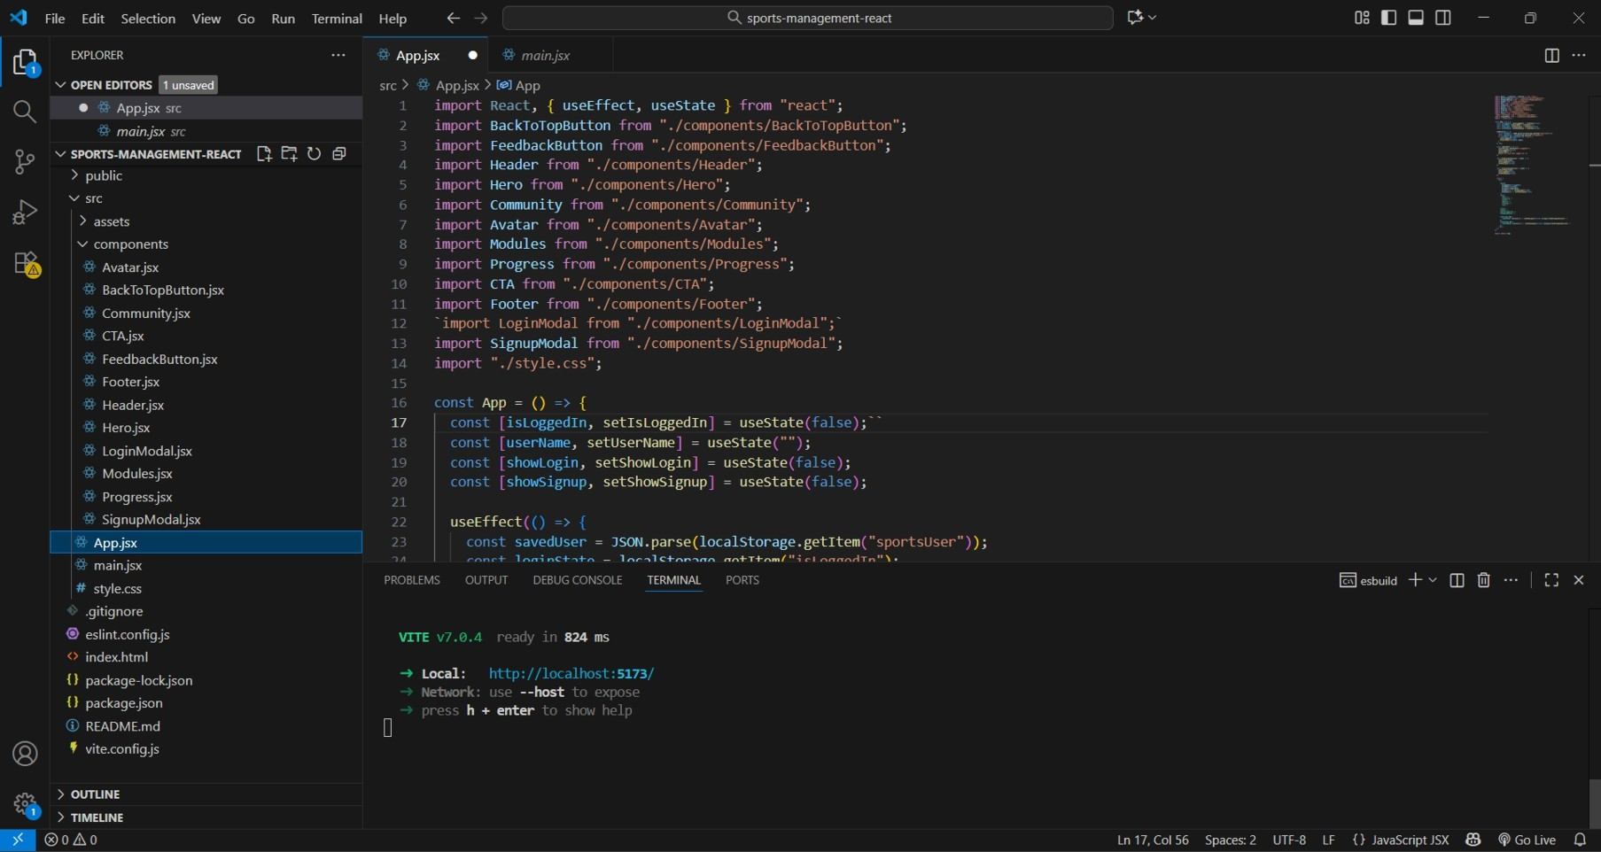

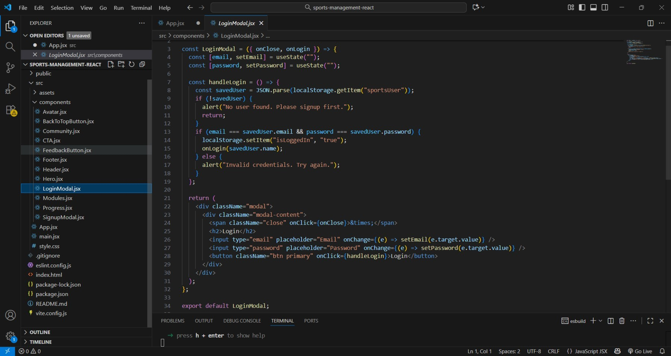

Class Functionalities

For each class/component describe:

- Purpose

- Input parameters

- Output/Return type

- Methods & their functionality

