Module Breakdown (8 Modules)
Frontend Modules (3)
F1. Authentication & User Interface Module

F2. QR Scanner & Attendance Module

F3. Admin Dashboard Module

Backend Modules (5)
B1. Authentication & Authorization Service

B2. QR Code Generation Service

B3. Attendance Processing Service

B4. Attendance Management & Filtering Service

B5. Database & Persistence Layer
Requirements
Functional Requirements
- User/Admin login and authentication
- QR code–based attendance marking
- Prevent duplicate attendance
- Time-bound QR session validation
- Admin can view and filter attendance records
- Send notifications (SMS/Email) after attendance

Non-Functional Requirements
- High availability during peak QR scans
- Low latency response
- Scalability for large number of users
- Secure access and data protection
- Fault tolerance and reliability

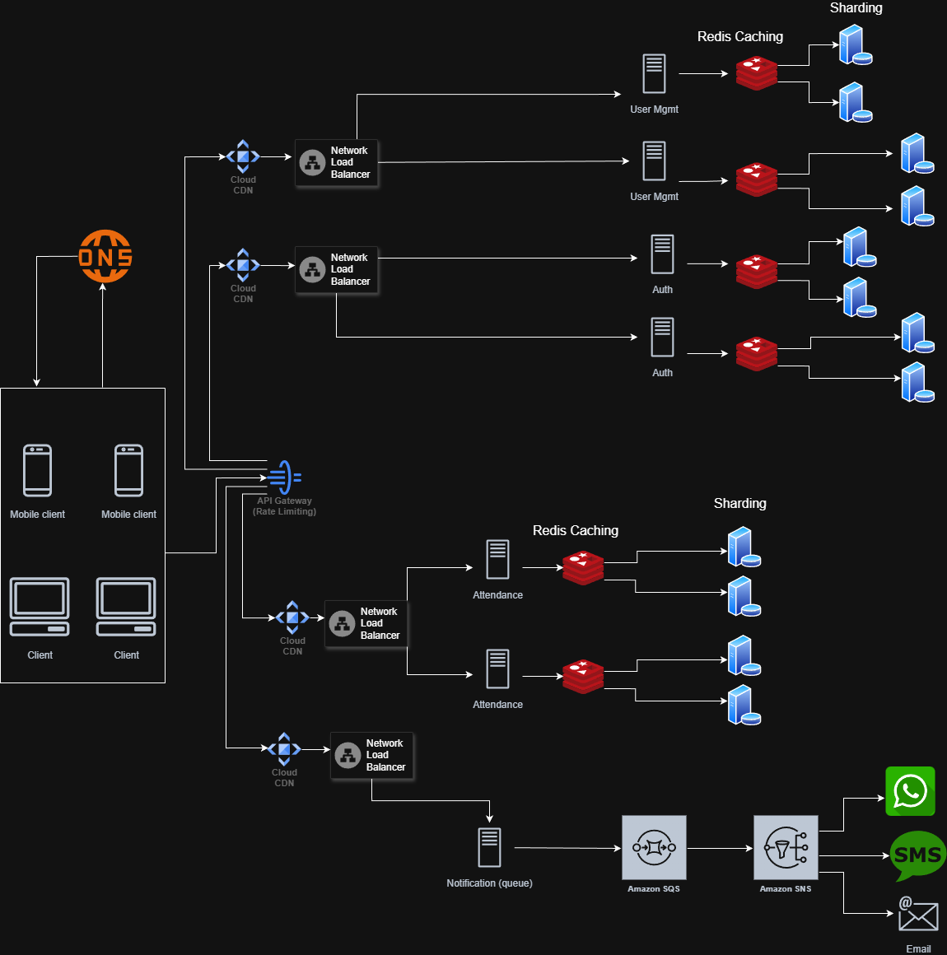

High-Level Design
The system follows a microservices-based cloud architecture.
Clients (web and mobile) access the system via DNS, which routes requests to a CDN for serving static frontend content. API requests are forwarded to a centralized API Gateway, which acts as the single-entry point for backend services and handles authentication, routing, and rate limiting.
Each backend function is implemented as an independent stateless microservice, deployed behind its own network load balancer to enable horizontal scaling and fault isolation. Core microservices include User Management, Authentication, Attendance, and Notification.
To improve performance, Redis caching is used for frequently accessed data. Persistent data is stored in a sharded and replicated database cluster, ensuring scalability and high availability.
Notifications are handled asynchronously using a message queue, allowing non-blocking communication with external notification providers

Low-Level Design
Microservices
- API Gateway
  - Request routing
  - JWT validation
  - Rate limiting
- Authentication Service
  - User login
  - Token generation
  - Role validation
- User Management Service
  - User profile management
  - Role assignment
- Attendance Service
  - QR validation
  - Attendance marking
  - Duplicate prevention
- Notification Service
  - Consume events from queue
  - Send SMS/Email notifications

