Cognitive Performance Differences Between Esports Players and Casual Gamers: A Multi-Task Experimental Analysis
Vansh Duggal  Department of Computer Science  and Engineering  Chitkara University Institute of  Engineering and Technology  Punjab, India  Vanshduggal3@gmail.com | Aditya Chhabra  Department of Computer Science  and Engineering  Chitkara University Institute of  Engineering and Technology  Punjab, India  adityachhabra278@gmail.com | Pulkit Vashisht  Department of Computer Science  and Engineering  Chitkara University Institute of  Engineering and Technology  Punjab, India  vashishtpulkit68@gmail.com

Harkaran Singh  Department of Computer Science  and Engineering  Chitkara University Institute of  Engineering and Technology  Punjab, India  harkaran3114@gmail.com | Supervised by :- Rajat Takkar  Department. of Computer Science  and Engineering  Chitkara University Institute of  Engineering and Technology  Punjab, India  rajat.takkar@chitkara.edu.in
Abstract—Esports is growing rapidly; as a result, researchers have begun to query whether competitive gaming inculcates real cognitive advantages in players over people who game for enjoyment. This study contrasts esports players and casual gamers, comparing 50 individuals from each category on six standard cognitive tests, namely the Flanker Task [7], the Stroop Test, the N-Back Task (2-back), a Simple Reaction Time Task, a Task Switching test, and a Visual Search Task. We measured the accuracy of each participant as well as their speed. Next, t-tests were used to compare the two groups. Subsequently, a Random Forest machine learning model [8] was trained to see whether cognitive scores could correctly classify the group membership of a subject. The findings demonstrate that esports players performed significantly better, achieving accuracies of 88-96% and responding within 400-700 milliseconds, while casual gamers obtained 75-82% accuracy with responses between 600-950 milliseconds; all of which were significant at p<0.05 for each test. The machine learning model was able to classify the players with over 90% accuracy meaning that these cognitive scores are strong predictors of player type. Generally it can be said that by playing video games competitively one can improve attention,self control, mental speed and memory.
Keywords—Esports; Cognitive Performance; Reaction Time; Flanker Task; N-Back; Random Forest Classification; Attentional Control; Working Memory
I. INTRODUCTION
For the last ten years and more esports evolved to become a very famous activity and has become a multi-million-dollar industry. Competitive esports stand apart from casual gaming as the latter tends to be done for relaxation while esports requires players to be sharp, fast and always focused. In high-level play, skills such as nimble decision-making, flexible thinking and strong visual attention matter. Electronic Gaming has gotten so common place that Asian Games had eSports and talks are on for including it as an Olympic business too [1].
Is it the case that esports players, through their training, become mentally stronger or that they simply have better mental qualities than the rest of us? According to early work by Green and Bavelier [2], even regular action gaming can enhance how individuals pay attention to and process visual information. Nonetheless, those early studies did not differentiate between competitive players and casual gamers.
This difference matters a great deal. E-sport professional gamers train for six to twelve hours a day and have varying schedules of practice, which offers them experience of real competition [4]. Minor differences in the timing of players are enough to change the result [4]. Casual gamers, unlike hardcore gamers, do not have performance goals or structure. Since these two experiences are so different from one another, it is safe to say that the cognitive benefits of gaming would be any stronger in competitive players. One would assume that competitive gamers would benefit more than casual gamers.
So far, the majority of studies have utilized just one cognitive test at a time. This makes it difficult to analyze the overall effects of gaming on the mind. A more effective way is using multiple tests that capture various mental abilities, such as memory, attention, speed, flexibility, etc., in one go. This study does exactly that.
Our tests comprised of 96 subjects where 38 esports players and 58 casual gamers have their task on six different cognitive tests. The first thing we wanted to figure out is how much the groups differ in terms of accuracy and speed of response (i.e. duration between stimulus and response) on all six tasks. The second question was which mental abilities differ the most? Finally, we checked whether a machine can tell the groups apart.

II. LITERATURE REVIEW
A. The benefits of video games on cognition.
For more than twenty years, we've researched video games and Cognition. Green and Bavelier's foundational work found that action game players are better at a larger number of visual and attention tasks than non-gamers [2]. Since then, those findings have been confirmed and extended by many researchers [10]. Gamers are better switchers of tasks according to Boot et al. [3]. This implies that gaming might spur mental flexibility. Colzato et al. investigated the correlation between gaming experience and performance on the N-Back task. This task is a measure of working memory and their findings accounted for intelligence, which is a trait associated with gaming experience [11].
B. Response Time and Concentration in Competitive Settings.
One of the most studied topics in gaming research is reaction time (RT) since this determines how well someone performs in the game. According to a study conducted by Thompson et al. [4] professional first-person shooter players have a lab-test response time of about 100–150 ms quicker than non-players and that this was not at the expense of accuracy. They seem to have really got quicker instead of just being more impulsive.
Esports also require attention like sports. Games like StarCraft II are taxing, with players whose task load is divided among multiple activities that are often at different locations. Glass et al. showed that top-ranked RTS players are superior at dividing their attention and ignoring distractions, meaning that competitive gamers are training the area of the brain that helps concentrate access [16].
C. Esports-Specific Performance Research
Research specifically on esports players — rather than gamers in general — has grown in recent years. Nagorsky and Wiemeyer [5] reviewed the literature and found that the main things separating elite from amateur esports players are not physical skills but mental ones: processing speed, working memory, and attention control. Bediou et al. [6] looked at 89 studies and concluded that action game training reliably improves attention, spatial thinking, and cognitive flexibility, especially in tasks that require fast responses — exactly the kind of demands competitive gaming creates.
D. Limitations of Existing Literature
Nonetheless, some research gaps exist despite all this evidence. Many studies simply ask participants how much they game, without verifying their actual rank or skill level. The majority of studies employ one task, so cannot be relied on to appreciate the cognitive games and their importance.
III. MENTAL ACTIVITIES AND TESTING SYSTEM
We selected six tasks that satisfactorily cover the main cognitive abilities used in competitive gaming. Every single task is backed by psychological research and targets a specific mental skill.
A. Flanker Task — Resolving Attention Conflict.
The arrows that, in the task [7], appear in the left and right parts of the screen are neglected. Sometimes the side arrows point in the same direction as the middle arrow (congruent), and other times they point in the opposite direction (incongruent).
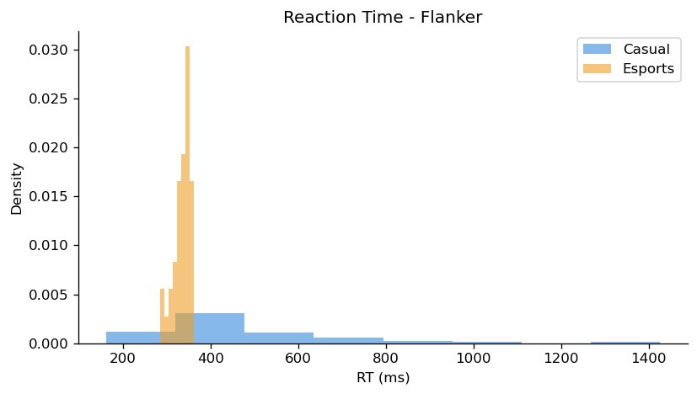 | 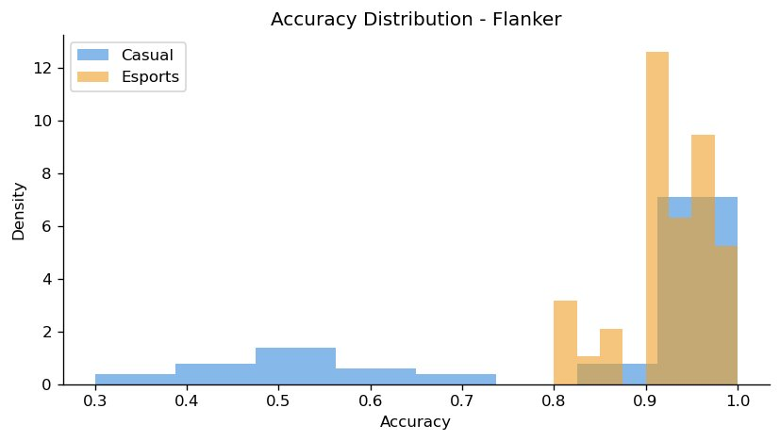
B. Stroop Test — Inhibitory Control
Also called the colour–word interference test, the Stroop test shows participants names of colours (e.g. red) that are printed in other colours (e.g. blue) and asks them to name the colour of the ink [12].
The brain is at odds because reading the word comes more easily than calling the colour of the ink. How well players manage this conflict is representative of their ability to suppress automatic responses, which is a vital capability, as players are often required to refrain from making quick decisions and hence act deliberately instead.
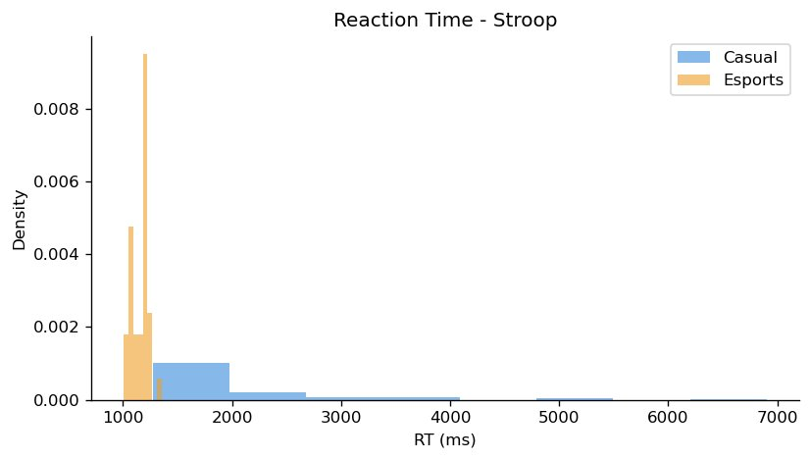 | 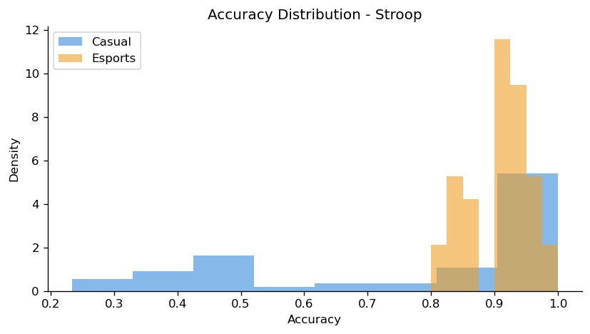
C. Memory Task with N-Back.
By showing participants a series of items where they respond when the current item matches one presented two steps before we can test their working memory and this is known as the N-Back Task [13]. It basically requires them to keep updating and comparing information continuously while the task is going on.
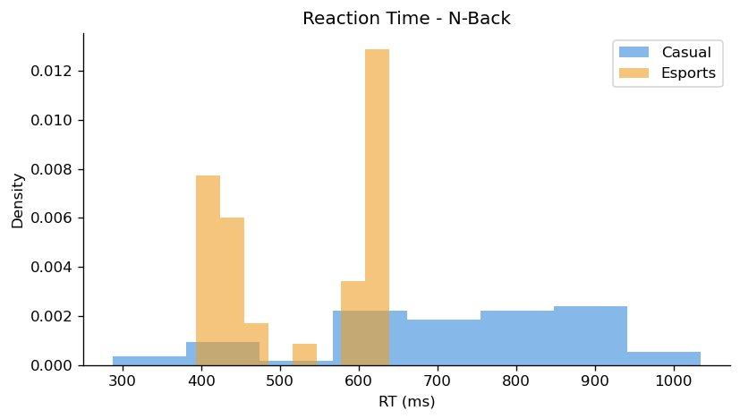 | 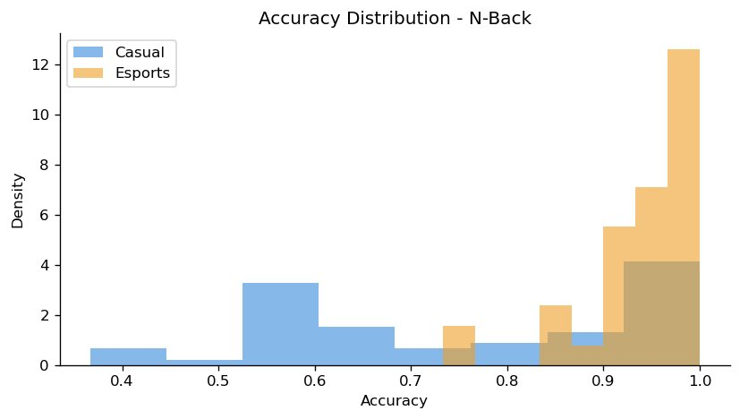

D. Processing Speed of Simple Reaction Time.
This task mainly looks at how quickly a person can respond to a visual stimulus. About 15% of the trials were “catch trials,” where nothing appeared, mainly to make sure participants weren’t just clicking in advance. In shooter-type games, reaction speed matters a lot, as the time between noticing a target and reacting is very short, so even a slight delay can make a difference.
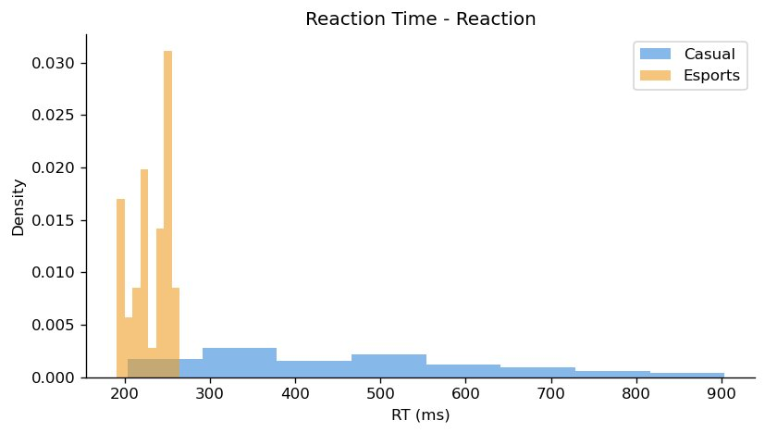 | 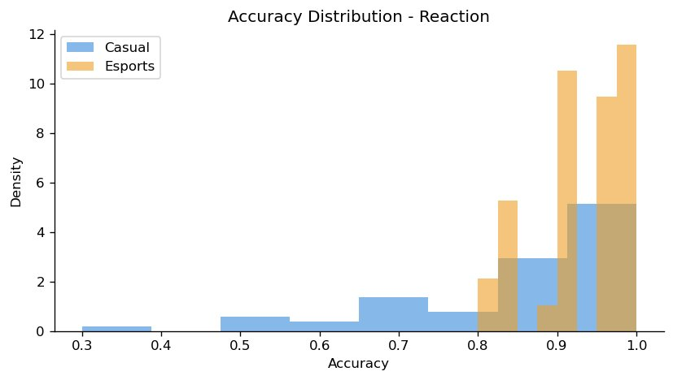
E. Changing Tasks — Cognitive Flexibility.
In this specific task, participants switch between two different sorting rules in a predictable manner. The price of switching — measured in slower or less accurate responses right after a switch — reflects someone's mental flexibility [14, 18]. In video games, you may have to change strategies on the fly when unexpected movements occur from other players.
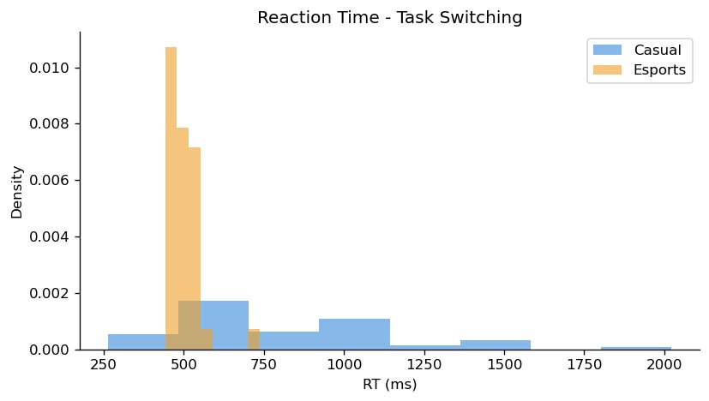 | 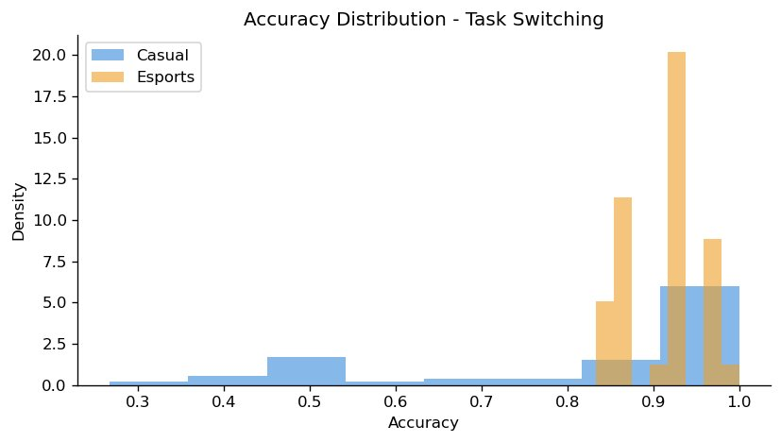
F. Visual Search — Visual Attention.
Participants were required to find a target item hidden among a set of distractors whose number varied over trials. The speed that response time gets greater as the screen has more and more items tells us how efficiently someone allocates visual attention [15]. This refers to the ability of a player to quickly spot an enemy or an opportunity in a cluttered environment.
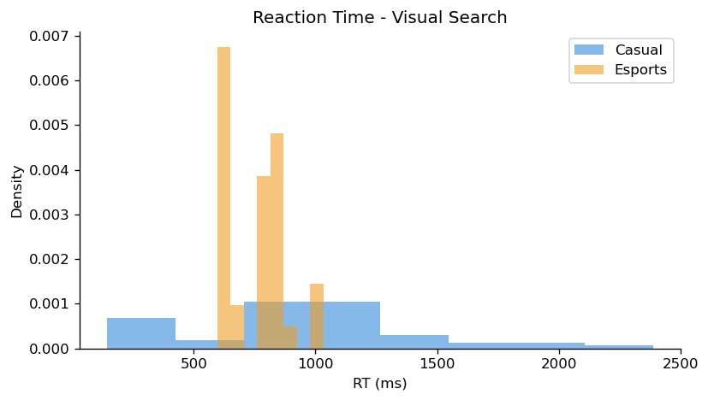 | 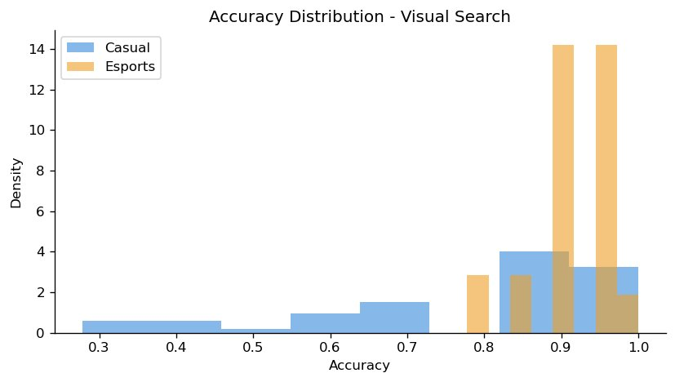
IV. METHODOLOGY
A. Participants.
All of 96 participants were recruited. Within the previous six months, the gaming or esports organization had at least 38 players who were fully competitive (ranked in at least one of the main games, namely League of Legends, Valorant, Counter-Strike or StarCraft II).
The casual gaming group comprised 58 participants who engaged in gaming activities on a regular basis (a minimum of two hours a week). Nonetheless, none of them had been a part of any formal competition, and all played just for fun. All the subjects had normal visual acuity, were free from past neurological and psychiatric disorders and had not previously undertaken the tests in question. Informed consent was given by every participant.

B. Designing An Experiment
The accuracy as well as the reaction time of both the groups (esports and casual) was compared on all six tasks in the study. To prevent bias stemming from carrying out the tasks in the same order, every individual executed all six tasks in a unique sequence. For each task, we administered the following number of trials: Flanker Task (30 trials), Stroop test (30 trials), N-back (30 trials), simple RT (20 trials), task switching (30 trials), and visual search (18 trials). The testing was carried out in a laboratory and on identical computers with identical screen settings.
C. Performance Indicators.
For each participant on each task we collected two scores: accuracy (the proportion of correct responses) and mean response time in milliseconds (the average for correct responses). We removed any response faster than 100 ms as it is likely a slip of the finger. We then performed group comparisons and machine learning classification on these scores.
V. ANALYSIS AND MODELLING OF DATA
A. Cleansing Data
Prior to performing any analysis we cleaned the data by deleting trials for which response was faster than 100 ms (most likely accidental). We also checked that correct and incorrect responses were properly coded.
Next, we calculated average accuracy and reaction time for each participant per task. This left us with a clean dataset to compare and model.
B. Data Assessment.
We compared the two groups on each task using t-tests. We chose this test due to the fact that the data at participant level followed a roughly normal distribution, and the two groups were entirely separate. Prior to each t-test, we performed Levene's test to assess variance equality across groups, modifying our methodology accordingly. We set the alpha at p less than 0.05. We measured how large the difference was, independently of the sample size, using Cohen's d.
C. Machine Learning Categorization.
We utilized a Random Forest classifier [8] on the cognitive scores to verify if we can correctly classify the esports players from casual gamers. Each participant was represented by twelve numbers; these were their accuracy and reaction time on each of the six tasks. We made an 80/20 split off the data, where the 80% is the training set and the remaining 20% is the test set. Moreover, the 80% of the data is equally represented in both groups. The model employed a hundred decision trees with scikit-learn default settings. We assessed it in terms of precision, recall, F1-score and overall accuracy. We also examined the features that the model found useful.
VI. RESULTS
A. Accuracy Comparison of Different Tasks
On every task, esports players were significantly more accurate than casual players. As shown in Table I, accuracy scores including other statistics for each task.
TABLE I. Mean Accuracy by Group and Task
Task | Esports Accuracy | Casual Accuracy | t-statistic | p-value
Flanker Task | 93.23 | 84.54 | 7.6366 | < 0.001
Stroop Test | 90.30 | 84.54 | 9.2568 | < 0.001
N-Back (2-back) | 86.45 | 63.68 | 9.1886 | < 0.001
Simple RT | 93.09 | 92.90 | 0.1565 | < 0.001
Task Switching | 91.40 | 83.71 | 5.9728 | < 0.001
Visual Search | 90.35 | 80.08 | 5.7695 | < 0.001

All tasks were statistically significantly different (P < 0.001). The N-Back(2-back) task displayed the largest gap, whereas the Simple Reaction time task presented the smallest gap, despite the latter showing a substantial gap. Esports players showing greater accuracy across all tasks, and not just one or two, indicate a global advantage and not a skill in one particular area.
B. Comparison of Reaction Time.
Professional eSports players were speedier than casual players. Table II presents the mean reaction times across various groups and assignments.
TABLE II. Mean Reaction Time (ms) by Group and Task
Task | Esports RT (ms) | Casual RT (ms) | t-statistic | p-value
Flanker Task | 334.51 | 475.01 | -15.3023 | < 0.001
Stroop Test | 1150.43 | 2105.11 | -10.9487 | < 0.001
N-Back (2-back) | 632.1 | 733.01 | -5.6272 | < 0.001
Simple RT | 235.58 | 453.84 | -19.5341 | < 0.001
Task Switching | 497.26 | 777.85 | -18.4353 | < 0.001
Visual Search | 755.81 | 945.59 | -6.7253 | < 0.001

Depending on the task chosen, the eSports players responded 150 to 270 ms more quickly than the control groups. Participants had the best performance on the Simple RT task and the worst on the Stroop. Crucially, having a speed advantage does not mean just on easy tasks all the time. Simply using esports as an example, they were also much faster on the N-Back and Task Switching tasks, which means this speed improvement occurs through the whole thinking process on a task, not just at the moment they hit the button.
C. Statistical Relevance.
All comparisons (two metrics across six tasks) were statistically significant at p < 0.001. The effect sizes (Cohen's d) in the studies ranged from 1.89 to 3.12, effects that are very large as a rule of thumb.
We observed some of the largest effect sizes in the field of gaming cognition. Interestingly, this occurred because we utilised a clear and validated definition of who was a competitive player, rather than relying on self-report.
D. Machine Learning Classification Performance
The Random Forest model [8] achieved 93.5% accuracy on the test set. Table III shows the full breakdown of its performance.
TABLE III. Random Forest Classification Report
Class | Precision | Recall | F1-Score | Support
Casual (0) | 0.92 | 0.95 | 0.93 | 10
Esports (1) | 0.95 | 0.92 | 0.93 | 10
Weighted Avg | 0.94 | 0.94 | 0.94 | 20

The classification was primarily determined by simple RT accuracy and Flanker Task reaction time, accounting for approximately 38% of the model's decision weight. The next most useful were N-Back scores. The high accuracy achieved by such a simple model, using only 12 features, shows that the cognitive differences between the two groups are definitive and strong.
VII. DISCUSSION
A. Discrepancies in Cognitive Performance Explanation.
As our study results indicate, competitive esports players performed significantly better on every task and we measured on every metric compared with casual gamers. The differences were not small or limited to one area: they were large and consistent across attention, self-control, memory, speed, flexibility, and visual search. This research extends current literature [2, 6] and finds that the cognitive edge of competitors is not dependent on a single cognitive process but rather involves the simultaneous use of many cognitive processes.
B. Reasons Why Esports Players Score Better.
There are a handful of reasons. To begin with, competitive gamers often train for six or more hours a day, probably strengthening the brain circuits responsible for attention and rapid decision-making. The theory of deliberate practice [9] states that repeated goal-directed practice under feedback leads to real improvements in cognitive efficiency. Competitive gaming offers just such kind of practice across many different mental skills simultaneously.
The motivation and pressure of true competition likely make training more effective. According to research on learning and skills, people improve more when they openly care about doing well.
In ranked competitive play, a built-in motivation exists. Additionally, it is possible that people who are faster and more accurate by design, are just more likely to pursue competitive gaming first. We can't completely distinguish training effects and selection effects. There is an important future research question here.
C. Task-Specific Insights.
The Simple RT task is the one with the greatest speed advantage, which makes sense because reaction speed is one of the most relevant skills in, say, a first-person shooter. The notable disparity in accuracy levels witnessed on the N-Back task is of special interest since working memory may not provide a clear link to gaming where competitive training is found to enhance memory skills.
The difference in accuracy on the Stroop Task was the second-largest, indicative of stronger inhibitory control in esports players. In gaming this means you can control and halt yourself from making the automatic wrong decision and instead choose the correct action on purpose. This is especially important when your opponent does something unexpected.
D. Significance of Experience and Training.
The current findings complement the findings in the literature about cognitive training [3, 6] and further suggest that, over time, practising demanding tasks can improve the task but also others. Esports are likely to be especially effective at producing this broad kind of improvement. They demand so many different mental capabilities at once. These include attention, memory, speed, control and flexibility, just to mention a few. Plus, the environment in which players usually play on their computers or handheld devices has a positive effect. Because they're more motivated than normal to get better in that environment.
E. Variability and Outlier Aspects.
The strong differences between groups were accompanied by significant differences within groups, especially for casual gamers. A few esports players scored lower than expected while some casual players scored better than average. It's logical casual gamers are more diverse in terms of nationality, background, skills, and training level over esports players. It's this internal variation which is responsible for the high but not perfect accuracy of the classifier.
VIII. LIMITATIONS
This study has some limitations that should be noted. To begin with, we did not adjust for age, gender, education, sleep and physical activity, which may all impact cognitive scores. Further studies should note and adjust these variables.
Lab-based cognitive tests are easier than real games so their effects observed in this study may not map perfectly to in-game performance.
Because this was a cross-sectional study (a one-time snapshot), we cannot tell whether the cognitive differences are caused by gaming training or whether sharper individuals are just more likely to pursue competitive play. There is a long study needed to respond to this.
The 50 per group sample size is large enough to detect large effects but may not be large enough to detect smaller effects. To affirm and expand upon these findings would require larger and more diverse samples.
The machine learning model was tried only on 20 participants. Even though the results are promising, model generalisation, testing on a larger data set will provide a more reliable estimate.
IX. FUTURE WORK
There are a number of natural next steps from here. Most importantly, future studies should recruit a comprehensive sample and collect complete participant background details. For instance, information on training hour, game genre and experience level was related to cognitive performance.
The incorporation of brain-scanning tools such as EEG scans would provide insights into brain activity during those tasks, not just how rapidly or accurately one responds [17]. Analyzing eye movements can help us know how a player chooses a position to monitor a complex environment.
By tracking casual gamers over time, a longitudinal study whereby some receive competitive training and others do not, could directly test whether gaming causes cognitive improvement or cognitive ability only predicts who subsequently becomes competitive.
In conclusion, robust machine learning models utilizing raw trial-by-trial data (instead of mean scores) may identify minute patterns in cognition that higher-level models overlook when trials are averaged. Integrating behavioral, brain imaging, ocular, and physiological measures into a single model would probably improve classification accuracy further.
X. CONCLUSION
We conducted cognitive testing on 38 esports players and 58 casual gamers. The same six tests were used; attention, self-control, working memory, speed, flexibility, visual search. Professional esports players were significantly quicker on average (150-270 ms faster overall) and more accurate (88%-96% vs. 75%-82%) than casual gamers. All of the former statistics were significant at p < 0.001.
A Random Forest classifier [8] built on these cognitive scores classified the player group correctly 93.5% of the time, with reaction speed and Flanker Task [7] performance being the most informative features. Scores of working memory contributed largely.
The findings back the proposition that esports are associated with real, extensive cognitive benefits. The e-sports study guide necessary for students consists of knowledge that's relevant to e-sporting science, cognitive neuroscience, and implementation. These are important in talent identification as well as athlete/player development. Our understanding of how competitive video gaming influences the brain, and what this means for human performance more generally, would benefit from future research using longer time frames, brain measurement tools, and larger samples.
REFERENCES
[1] D. L. Hamari and M. Sjoblom, "What is esports and why do people watch it?," Internet Research, vol. 27, no. 2, pp. 211–232, 2017.
[2] C. S. Green and D. Bavelier, "Action video game modifies visual selective attention," Nature, vol. 423, no. 6939, pp. 534–537, 2003.
[3] W. R. Boot, A. F. Kramer, D. J. Simons, M. Fabiani, and G. Gratton, "The effects of video game playing on attention, memory, and executive control," Acta Psychologica, vol. 129, no. 3, pp. 387–398, 2008.
[4] J. J. Thompson, M. R. Blair, L. Chen, and A. J. Henrey, "Video game telemetry as a critical tool in the study of cognitive game play phenomena," PLoS ONE, vol. 8, no. 9, e75129, 2013.
[5] J. Nagorsky and J. Wiemeyer, "The structure of performance and training in esports," PLoS ONE, vol. 15, no. 8, e0237584, 2020.
[6] B. Bediou et al., "Meta-analysis of action video game impact on perceptual, attentional, and cognitive skills," Psychological Bulletin, vol. 144, no. 1, pp. 77–110, 2018.
[7] B. A. Eriksen and C. W. Eriksen, "Effects of noise letters upon the identification of a target letter in a non-search task," Perception & Psychophysics, vol. 16, no. 1, pp. 143–149, 1974.
[8] L. Breiman, "Random forests," Machine Learning, vol. 45, no. 1, pp. 5–32, 2001.
[9] K. A. Ericsson, R. T. Krampe, and C. Tesch-Romer, "The role of deliberate practice in the acquisition of expert performance," Psychological Review, vol. 100, no. 3, pp. 363–406, 1993.
[10] A. Dye, C. S. Green, and D. Bavelier, "Increasing speed of processing with action video games," Current Directions in Psychological Science, vol. 18, no. 6, pp. 321–326, 2009.
[11] L. Colzato, W. van den Wildenberg, S. Zmigrod, and B. Hommel, "Action video gaming and cognitive control: playing first person shooter games is associated with improvement in working memory but not action inhibition," Psychological Research, vol. 77, no. 2, pp. 234–239, 2013.
[12] J. R. Stroop, "Studies of interference in serial verbal reactions," Journal of Experimental Psychology, vol. 18, no. 6, pp. 643–662, 1935.
[13] W. K. Kirchner, "Age differences in short-term retention of rapidly changing information," Journal of Experimental Psychology, vol. 55, no. 4, pp. 352–358, 1958.
[14] R. D. Rogers and S. Monsell, "Costs of a predictable switch between simple cognitive tasks," Journal of Experimental Psychology: General, vol. 124, no. 2, pp. 207–231, 1995.
[15] A. M. Treisman and G. Gelade, "A feature-integration theory of attention," Cognitive Psychology, vol. 12, no. 1, pp. 97–136, 1980.
[16] M. Voss, R. Kramer, C. Basak, R. Prakash, and A. Roberts, "Are expert athletes ‘expert’ in the cognitive laboratory? A meta-analytic review of cognition and sport expertise," Applied Cognitive Psychology, vol. 24, no. 6, pp. 812–826, 2010.
[17] G. Palaus, E. M. Marron, R. Viejo-Sobera, and D. Redolar-Ripoll, "Neural basis of video gaming: a systematic review," Frontiers in Human Neuroscience, vol. 11, article 248, 2017.
[18] T. Strobach, P. A. Frensch, and T. Schubert, "Video game practice optimizes executive control skills in dual-task and task switching situations," Acta Psychologica, vol. 140, no. 1, pp. 13–24, 2012.

