Software Requirements Specification

for

A Digital Farm Management and Biosecurity Monitoring System for Pig and Poultry Farms
Version 1.0 approved
Prepared by Vansh Dhumal & Team
Shri Vaishnav Vidyapeeth Vishwavidyalaya

04 September 2026
Table of Contents
Table of Contents ii
Revision History ii
1. Introduction 1
1.1 Purpose 1
1.2 Document Conventions 1
1.3 Intended Audience and Reading Suggestions 1
1.4 Product Scope 1
1.5 References 1
2. Overall Description 2
2.1 Product Perspective 2
2.2 Product Functions 2
2.3 User Classes and Characteristics 2
2.4 Operating Environment 2
2.5 Design and Implementation Constraints 2
2.6 User Documentation 2
2.7 Assumptions and Dependencies 3
3. External Interface Requirements 3
3.1 User Interfaces 3
3.2 Hardware Interfaces 3
3.3 Software Interfaces 3
3.4 Communications Interfaces 3
4. System Features 4
4.1 System Feature 1 4
4.2 System Feature 2 (and so on) 4
5. Other Nonfunctional Requirements 4
5.1 Performance Requirements 4
5.2 Safety Requirements 5
5.3 Security Requirements 5
5.4 Software Quality Attributes 5
5.5 Business Rules 5
6. Other Requirements 5
Appendix A: Glossary 5
Appendix B: Analysis Models 5
Appendix C: To Be Determined List 6

Revision History
Name | Date | Reason For Changes | Version
 |  |  | 1.0

List of Figures

Figure No. | Figure Title
Figure 1 | FarmDrishti System Context
Figure 2 | FarmDrishti Product Perspective
Figure 3 | Overall System Workflow
Figure 4 | User Role Interaction
Figure 5 | System Architecture
Figure 6 | Use Case Diagram
Figure 7 | Context Level Data Flow Diagram
Figure 8 | DFD Level 0
Figure 9 | DFD Level 1
Figure 10 | Entity Relationship Diagram
Figure 11 | Mobile Application Navigation Flow
Figure 12 | AI/ML Disease Risk Assessment Workflow
Figure 13 | Deployment Architecture

List of Tables

Table No. | Table Title
Table 1 | Revision History
Table 2 | User Classes
Table 3 | Functional Requirements
Table 4 | Non-Functional Requirements
Table 5 | User Role Permissions
Table 6 | Hardware Requirements
Table 7 | Software Requirements
Table 8 | External Software Interfaces
Table 9 | Business Rules
Table 10 | Database Entities

1. Introduction

  - Purpose

The purpose of this Software Requirements Specification (SRS) document is to provide a complete and structured description of the requirements of FarmDrishti, a digital farm management and biosecurity monitoring system designed primarily for pig and poultry farms.
This document defines the functional and non-functional requirements, system interfaces, user roles, system features, operating environment, design constraints, security requirements, performance requirements, business rules, and other requirements necessary for the development and implementation of FarmDrishti.
FarmDrishti is intended to provide a centralized digital platform for managing farm-related activities such as animal health monitoring, disease surveillance, biosecurity management, visitor management, inventory management, weather monitoring, audits, compliance, reporting, training, emergency information, and notifications.
The system will primarily be implemented as a mobile application, supported by a web-based application for management and administrative activities. A centralized backend will provide secure APIs and data management services, while a database will store farm and operational information.

1.2 Document Conventions

The following conventions are used throughout this document.
Requirement Identification
Functional requirements are identified using the following format:
FR-XX
where FR represents Functional Requirement.
Example:
FR-01: The system shall allow registered users to log into the application.
Non-functional requirements are identified using:
NFR-XX
Example:
NFR-01: The system shall protect user data using appropriate authentication and authorization mechanisms.
Business rules are identified using:
BR-XX
Example:
BR-01: Only authorized users shall be permitted to access farm-specific information.
Use cases are identified using:
UC-XX
Example:
UC-01: User Login.
Requirement Language
The term "shall" indicates a mandatory system requirement.
The term "should" indicates a recommended requirement.
The term "may" indicates an optional or future requirement.
Technical Abbreviations

Abbreviation | Meaning
SRS | Software Requirements Specification
API | Application Programming Interface
UI | User Interface
UX | User Experience
REST | Representational State Transfer
JWT | JSON Web Token
DB | Database
ML | Machine Learning
AI | Artificial Intelligence
DFD | Data Flow Diagram
ER | Entity Relationship
UML | Unified Modeling Language
FCM | Firebase Cloud Messaging
HTTPS | Hypertext Transfer Protocol Secure

  - Intended Audience and Reading Suggestions

This document is intended for all individuals involved in the planning, development, implementation, testing, evaluation, and maintenance of FarmDrishti.
The intended audience includes:
- Project Guide and Academic Evaluators
To understand the purpose, scope, requirements, architecture, and expected functionality of the project.
- Project Developers
To use the requirements as a reference while implementing the mobile application, web application, backend services, database, and AI/ML components.
- UI/UX Designers
To understand user roles, system workflows, interfaces, and functional requirements.
- Database and Backend Developers
To design database entities, relationships, APIs, authentication mechanisms, and server-side functionality.
- AI/ML Developers and Researchers
To understand the data requirements and expected functionality of the disease-risk assessment component.
- Software Testers
To derive test cases and validation criteria from the documented functional and non-functional requirements.
- Farm Owners, Managers, Workers, and Veterinarians
To understand the intended functionality and usage of the system.

  - Product Scope

FarmDrishti is a mobile-first digital farm management and biosecurity monitoring platform developed to support pig and poultry farm operations.
The system will provide a centralized environment for recording, monitoring, managing, and analyzing farm-related information. The platform will allow authorized users to manage farm details, monitor animal health, report suspected diseases, perform biosecurity checklists, maintain visitor records, manage inventory, monitor weather conditions, conduct audits, generate reports, access training resources, and receive relevant notifications.
The primary scope of FarmDrishti includes the following functional areas:
- User authentication and authorization
- User profile management
- Farm management
- Farm zone management
- Animal health monitoring
- Disease surveillance
- Biosecurity checklist management
- Visitor management
- Inventory management
- Weather monitoring
- Audit and compliance management
- Reports and analytics
- Training and guidelines
- Emergency information
- Notifications and alerts
- AI/ML-based disease-risk assessment
The mobile application will provide convenient access to farm information and operational functions during day-to-day farm activities. The web application will provide additional functionality for farm management, administrative operations, reporting, analytics, and monitoring.
The system will use a centralized backend to manage application logic and provide REST-based APIs. A relational database will be used for storing structured farm and operational data.
The AI/ML component will be explored for assessing potential disease-risk conditions based on available farm, health, environmental, and biosecurity information. The risk assessment will be used as a decision-support mechanism and shall not be considered a replacement for professional veterinary diagnosis.
Scope Boundary
The initial version of FarmDrishti will focus on software-based farm management and monitoring. Fully automated hardware control, autonomous treatment decisions, automated medicine administration, and hardware-dependent IoT functionality will remain outside the core scope unless appropriate hardware, data sources, and testing facilities are available.

  - References

The following categories of references will be used during the analysis, design, development, and validation of FarmDrishti:
- Software Requirements Specification standards and guidelines.
- Relevant scientific literature concerning biosecurity practices in pig and poultry farms.
- Research literature related to livestock disease surveillance and risk assessment.
- Relevant agricultural and veterinary guidelines.
- Flutter and Dart technical documentation.
- React and TypeScript technical documentation.
- Java and Spring Boot technical documentation.
- PostgreSQL technical documentation.
- Python and Scikit-learn technical documentation.
- FastAPI technical documentation.
- Firebase technical documentation.
- Documentation for selected weather and mapping APIs.
Specific research papers, standards, government guidelines, and technical documentation used during the development of FarmDrishti shall be listed in the final reference section of the project.

2. Overall Description
2.1 Product Perspective

FarmDrishti is designed as a centralized, multi-platform farm management system consisting of a mobile application, web application, backend server, database, external services, and an optional AI/ML service.

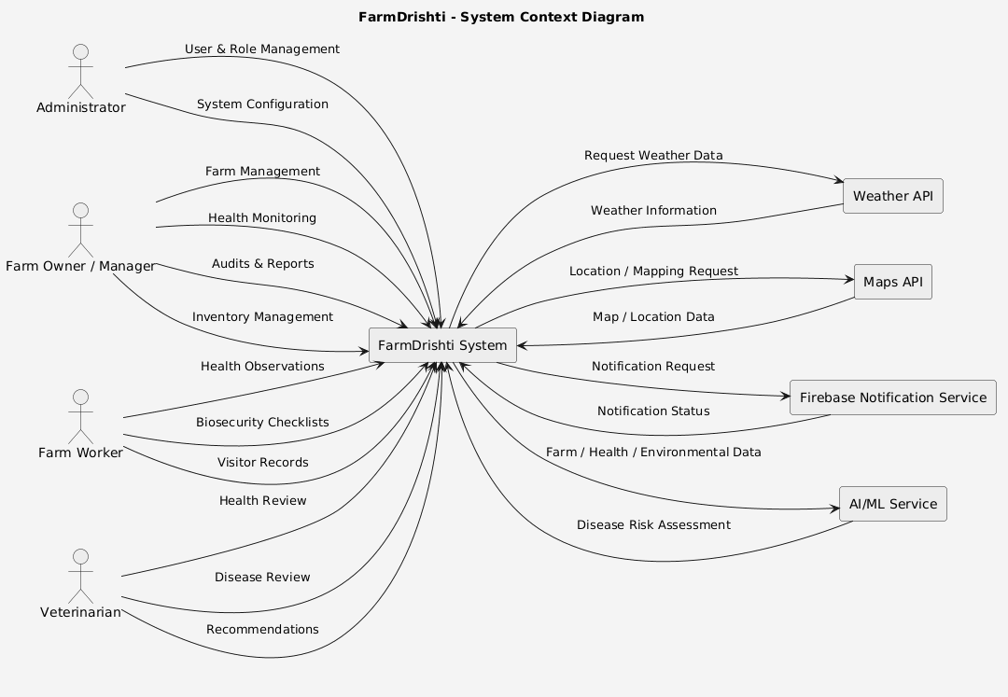
The mobile application will serve as the primary interface for farm owners, managers, workers, and veterinarians. The web application will provide an extended interface for administrative, management, reporting, and analytical operations.The system will follow a client-server architecture.High-Level Product Structure

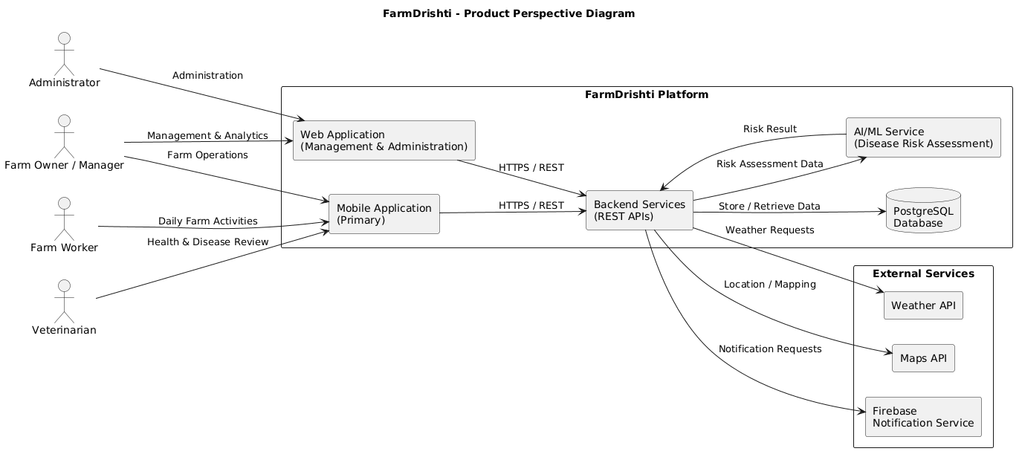
2.2 Product Functions
FarmDrishti shall provide the following major functions:

2.2.1 Authentication and User Management
- User registration
- User login
- Logout
- Password management
- Role-based access
- User profile management

2.2.2 Farm Management
- Farm registration
- Farm information management
- Farm location
- Farm type
- Farm zone management
- Animal population information

2.2.3 Health Monitoring
- Health observations
- Health records
- Mortality records
- Zone-level health monitoring
- Health history
- Health status visualization

2.2.4 Disease Surveillance
- Disease reporting
- Symptom recording
- Disease history
- Suspected disease tracking
- Disease risk assessment
- Disease alerts

2.2.5 Biosecurity Management
- Biosecurity checklists
- Checklist completion
- Compliance scoring
- Corrective actions
- Biosecurity history

2.2.6 Visitor Management
- Visitor registration
- Visit purpose
- Entry and exit records
- Visitor history
- Visitor-related risk information

2.2.7 Inventory Management
- Inventory registration
- Stock quantity management
- Feed tracking
- Medicine tracking
- Vaccine tracking
- Cleaning material tracking
- Expiry monitoring

2.2.8 Weather Monitoring
- Current weather information
- Temperature
- Humidity
- Forecast
- Weather alerts

2.2.9 Audits and Compliance
- Audit creation
- Audit checklist
- Compliance assessment
- Non-compliance recording
- Corrective action tracking
- Audit history

2.2.10 Reports and Analytics
- Health reports
- Disease reports
- Biosecurity reports
- Inventory reports
- Audit reports
- Farm performance summaries

2.2.11 Training and Guidelines
- Biosecurity guidelines
- Hygiene guidelines
- Disease prevention information
- Training materials

2.2.12 Emergency Management
- Emergency contacts
- Veterinary contacts
- Emergency procedures
- Important emergency information

2.2.13 Notifications
- Disease alerts
- Weather alerts
- Inventory expiry alerts
- Audit reminders
- Biosecurity reminders

2.2.14 AI/ML Risk Assessment
- Collection of relevant farm data
- Data preprocessing
- Risk analysis
- Disease-risk classification
- Risk alerts
- Decision-support recommendations

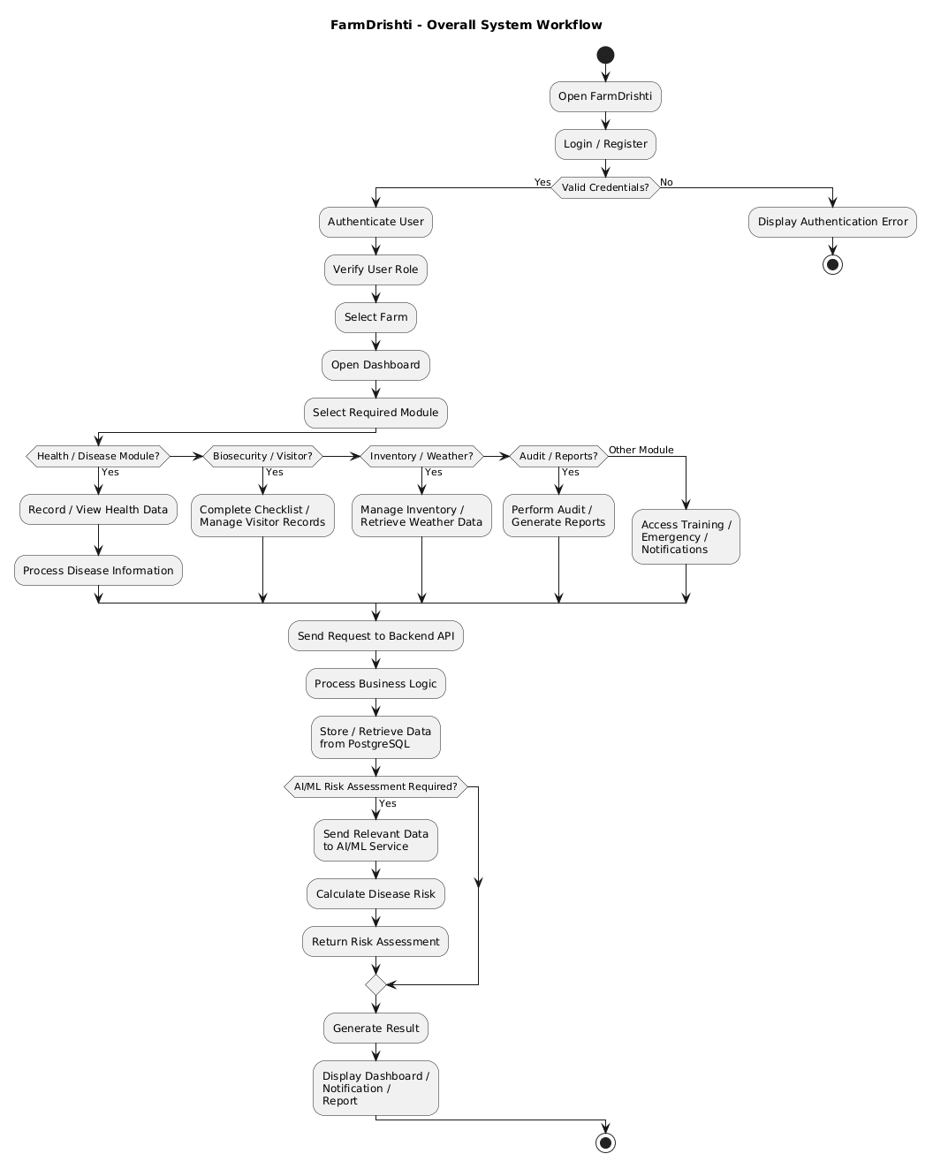

2.3 User Classes and Characteristics

FarmDrishti will support four primary user categories.

User Class | Description | Major Activities
Administrator | Responsible for system-level management | Users, roles, configuration
Farm Owner/Manager | Responsible for farm operations | Farm, health, reports, inventory, audits
Farm Worker | Performs daily operational activities | Health observations, checklists, visitors
Veterinarian | Provides professional health and disease assessment | Health review, disease review, recommendations

Administrator
Administrators will have the highest level of system access. They will manage users, roles, permissions, and system-level configuration.

Farm Owner/Manager
Farm owners or managers will manage farm information and monitor operational activities. They will have access to health monitoring, disease surveillance, biosecurity, inventory, audits, reports, and analytics.

Farm Worker
Workers will perform authorized daily farm activities such as recording health observations, completing checklists, and maintaining visitor records.

Veterinarian
Veterinarians will review relevant health and disease information and provide professional recommendations where applicable.

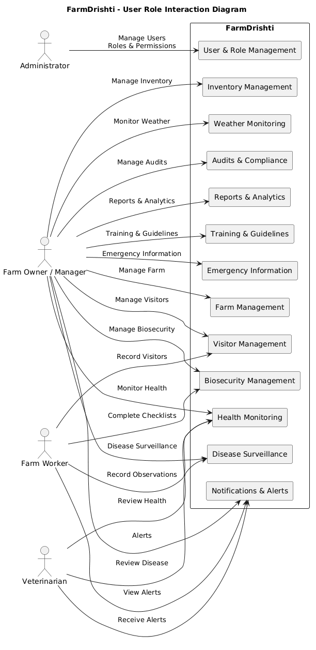
2.4 Operating Environment

FarmDrishti will operate in the following environment:
Mobile Environment
- Android smartphones
- Android 8.0 or later recommended
- Internet connectivity for online services
- GPS where location functionality is required
- Camera where image capture is supported

Web Environment

The web application will support modern web browsers including:
- Google Chrome
- Microsoft Edge
- Mozilla Firefox

Server Environment

- Java 21 or compatible LTS version
- Spring Boot
- PostgreSQL
- Python environment for AI/ML services
- Linux-based or equivalent cloud/server environment

Development Environment

- Windows, Linux, or macOS
- Android Studio
- Visual Studio Code
- IntelliJ IDEA
- PostgreSQL
- Git
- GitHub

2.5 Design and Implementation Constraints

The following constraints shall be considered during the design and implementation of FarmDrishti:

- The application shall primarily target mobile users.
- The system shall require an internet connection for cloud-based synchronization and external API services.
- The quality of AI/ML predictions will depend on the availability and quality of suitable datasets.
- Weather-related functionality will depend on the availability and limitations of the selected weather API.
- System functionality shall be implemented within the available academic project timeline and resources.
- The application shall protect sensitive user and farm information.
- The system shall use role-based authorization to prevent unauthorized access.
- The initial system shall avoid unnecessary dependence on specialized hardware.
- AI/ML predictions shall be treated as decision-support information rather than professional veterinary diagnosis.
- The system architecture should allow future integration with IoT devices and additional external services.

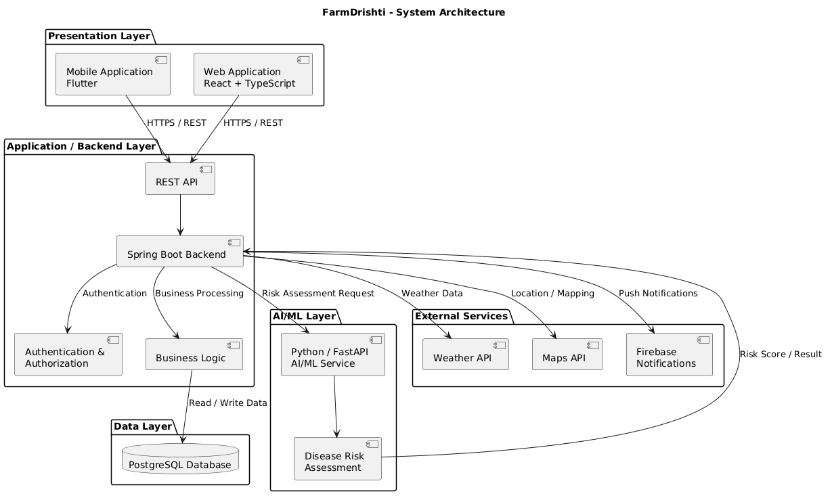

2.5.1 Deployment Architecture
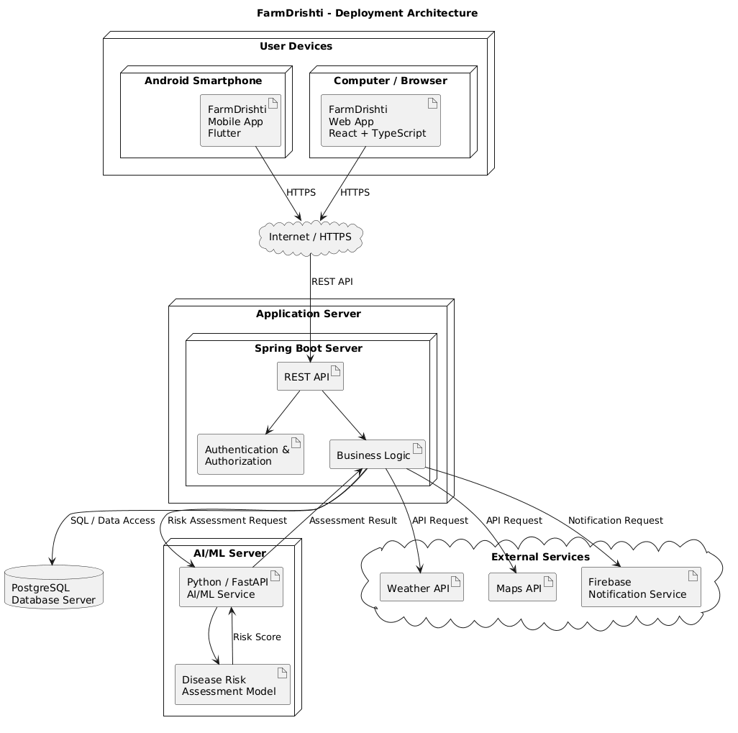
2.6 User Documentation

The following documentation shall be developed for FarmDrishti:
- User Manual
- Installation and Setup Guide
- Administrator Guide
- Farm Manager Guide
- Farm Worker Guide
- Veterinarian Guide
- API Documentation
- Technical Documentation
- Testing Documentation
- Final Project Report

2.7 Assumptions and Dependencies

Assumptions
The following assumptions are made:
- Users will have access to a compatible smartphone or computer.
- Users will provide accurate farm and operational information.
- Farm managers will maintain appropriate records.
- Users will have the required permissions for their assigned activities.
- Internet connectivity will generally be available for online functionality.
- Appropriate datasets will be available for AI/ML development.
- External services such as weather APIs will remain accessible during system operation.

Dependencies
FarmDrishti may depend on:
- Internet connectivity
- PostgreSQL database
- Backend server
- Weather API
- Mapping service
- Firebase notification services
- AI/ML service
- Cloud infrastructure
- Third-party authentication or communication services, where applicable

3. External Interface Requirements

3.1 User Interfaces

The FarmDrishti mobile application will provide a mobile-first interface based on the approved project UI design.
The major interfaces shall include:
- Splash Screen
- Login
- Registration
- Dashboard
- Farm Health
- Zone Details
- Disease Surveillance
- Biosecurity Checklist
- Visitor Management
- Inventory Management
- Weather
- Audits and Compliance
- Reports
- Training Guidelines
- Emergency Contacts
- User Profile
- Notifications
- Settings

General UI Requirements

The interface shall:
- Use consistent navigation.
- Provide readable text and controls.
- Provide clear feedback after user actions.
- Validate user input.
- Display appropriate error messages.
- Use role-based navigation.
- Support responsive layouts.
- Maintain consistency with the approved FarmDrishti design system.

3.2 Hardware Interfaces

FarmDrishti may interact with the following device hardware:

Smartphone Camera

The camera may be used to capture images associated with health or disease observations where supported.

GPS

GPS may be used for:
- Farm location
- Location-based services
- Mapping
- Weather location selection

Network Interface

The mobile and web applications shall use available internet connectivity to communicate with backend services.

Future IoT Interface

Future versions may support sensors for:
- Temperature
- Humidity
- Environmental monitoring
- Animal activity
- Other farm parameters
IoT functionality shall not be considered mandatory for the initial implementation.

3.3 Software Interfaces
Software Interface | Purpose
Flutter | Mobile application development
React | Web application development
Spring Boot | Backend application
PostgreSQL | Database management
Python/FastAPI | AI/ML service
Firebase | Notifications
Weather API | Weather information
Maps API | Location and mapping

3.4 Communications Interfaces

FarmDrishti shall use secure network communication between clients and backend services.
Mobile / Web Application
│
HTTPS
↓
REST API
↓
Spring Boot Server
↓
PostgreSQL
The system shall use:
- HTTPS for secure communication.
- REST APIs for client-server communication.
- JSON for structured API data exchange.
- Authentication tokens for protected resources.

4. System Features

This section will contain the detailed requirements for every FarmDrishti module.
We will not write generic "Feature 1, Feature 2" nonsense. Each feature will have:
- Description
- Actors
- Preconditions
- Inputs
- Processing
- Outputs
- Functional requirements
- Exception conditions
- Related UI
- Related API
- Related database entities

4.1 Authentication and User Management

Description
The authentication and user management module shall provide secure access to FarmDrishti. Users shall be required to authenticate before accessing protected system functionality.

Actors
- Administrator
- Farm Owner/Manager
- Farm Worker
- Veterinarian

Inputs
- Name
- Email/username
- Password
- User role
- Farm information where applicable
Processing
User
↓
Login
↓
Credential Validation
↓
Authentication
↓
Role Verification
↓
JWT Token Generation
↓
Dashboard
Outputs
- Authentication status
- Access token
- User role
- User profile
- Authorized dashboard

Functional Requirements

ID | Requirement
FR-AUTH-01 | The system shall allow users to register an account.
FR-AUTH-02 | The system shall allow registered users to log in.
FR-AUTH-03 | The system shall validate user credentials before authentication.
FR-AUTH-04 | The system shall provide role-based access control.
FR-AUTH-05 | The system shall prevent unauthorized users from accessing protected resources.
FR-AUTH-06 | The system shall allow authenticated users to log out.
FR-AUTH-07 | The system shall allow users to manage authorized profile information.

5. Other Nonfunctional Requirements

5.1 Performance Requirements

- The system should provide responsive interaction during normal usage.
- API requests should be processed within an acceptable response time under normal load.
- Database queries should be optimized for frequently accessed records.
- The application should avoid unnecessary network requests.
- The system should support an increasing number of farms and users without major architectural changes.

5.2 Safety Requirements

- FarmDrishti shall clearly distinguish decision-support information from professional veterinary diagnosis.
- AI/ML risk assessments shall not automatically prescribe treatment.
- Critical alerts shall provide clear information to authorized users.
- Emergency information shall be presented clearly and accessibly.
- Incorrect or incomplete data shall not be presented as confirmed medical diagnosis.

5.3 Security Requirements

- The system shall implement secure authentication.
- Passwords shall not be stored as plain text.
- Protected APIs shall require appropriate authentication.
- Role-based authorization shall be implemented.
- Communication between clients and backend services shall use HTTPS.
- User sessions/tokens shall be managed securely.
- Input validation shall be performed on client and server sides.
- Users shall only access information permitted by their roles.
- Sensitive database information shall be protected from unauthorized access.
- Appropriate logging shall be maintained for important security-related events.

5.4 Software Quality Attributes

FarmDrishti shall aim to provide the following quality attributes:

Usability
The system shall provide an intuitive interface suitable for users with varying levels of technical experience.

Reliability
The system shall maintain consistent records and minimize data loss.

Maintainability
The application shall use modular architecture and organized code.

Scalability
The architecture shall support additional farms, users, records, and future modules.

Portability
The mobile application shall support commonly used Android devices, while the web application shall support modern browsers.

Testability
Major system components shall be designed so that they can be independently tested.

5.5 Business Rules

ID | Business Rule
BR-01 | Only authenticated users shall access protected system features.
BR-02 | Users shall only access functionality permitted by their assigned role.
BR-03 | Each farm shall have a unique farm identifier.
BR-04 | Disease reports shall be associated with a farm and relevant zone where applicable.
BR-05 | Biosecurity compliance shall be calculated from applicable checklist results.
BR-06 | Inventory quantities shall be updated when authorized stock transactions are recorded.
BR-07 | Expiring inventory items shall be identified according to configured expiry rules.
BR-08 | High-risk disease assessments shall generate appropriate alerts for authorized users.
BR-09 | Audit results shall be stored for future review and reporting.
BR-10 | AI/ML risk assessments shall be treated as decision-support information and not as professional diagnosis.

6. Other Requirements

FarmDrishti shall support future expansion of the platform.
Potential future requirements include:
- IoT sensor integration
- Advanced disease prediction
- Image-based analysis
- Additional livestock types
- Multi-language support
- Offline-first operation
- Advanced analytics
- Government or regulatory system integration
- Cloud-based large-scale deployment
- Advanced farm automation

Appendix A: Glossary

Term | Definition
FarmDrishti | Digital farm management and biosecurity monitoring platform
Biosecurity | Measures used to prevent the introduction and spread of disease
Disease Surveillance | Systematic monitoring and recording of disease-related information
Farm Zone | A defined operational or physical area within a farm
Compliance | Degree to which required procedures or standards are followed
Audit | Structured evaluation of farm practices against defined requirements
JWT | JSON Web Token used for authenticated communication
REST API | Web-based interface used for communication between software components
AI | Artificial Intelligence
ML | Machine Learning
Risk Assessment | Evaluation of available information to estimate potential risk
DFD | Data Flow Diagram
ER Diagram | Entity Relationship Diagram
SRS | Software Requirements Specification

Appendix B: Analysis Models

The following models shall be included in the final SRS:

B.1 System Context Diagram

Shows FarmDrishti and its interaction with:
- Administrator
- Farm Manager
- Farm Worker
- Veterinarian
- External APIs
- AI/ML service

B.2 Use Case Diagram

Shows all major actors and their interactions with FarmDrishti.
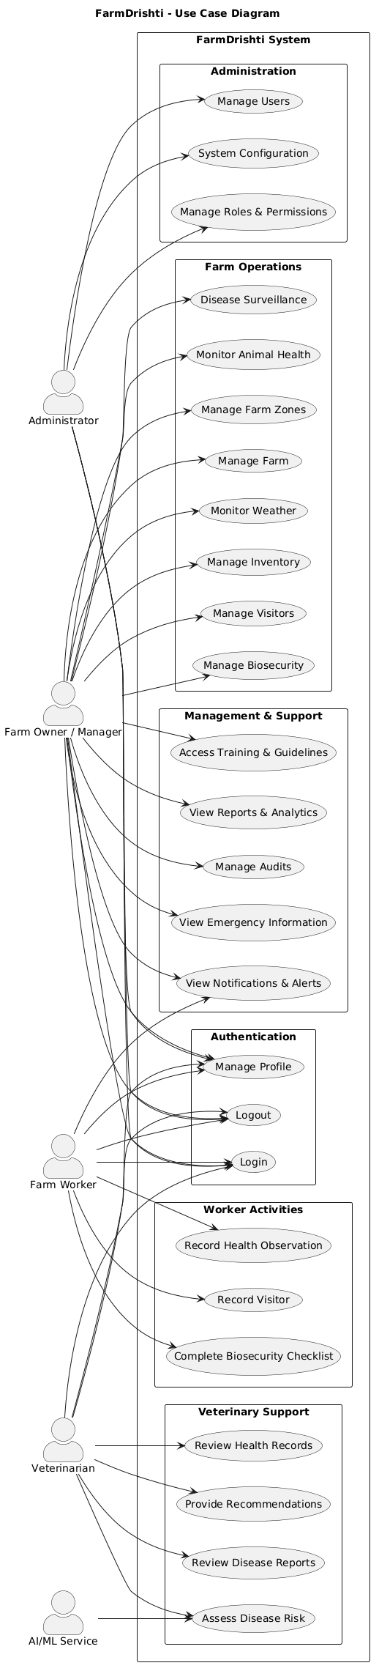
B.3 Overall System Workflow
User
↓
Authentication
↓
Role Verification
↓
Farm Selection
↓
Dashboard
↓
Select Module
↓
Perform Operation
↓
Backend API
↓
Database
↓
Result
↓
Notification / Report / Dashboard

B.4 Data Flow Diagram
DFD diagrams shall represent the flow of information between users, application processes, database entities, and external services.

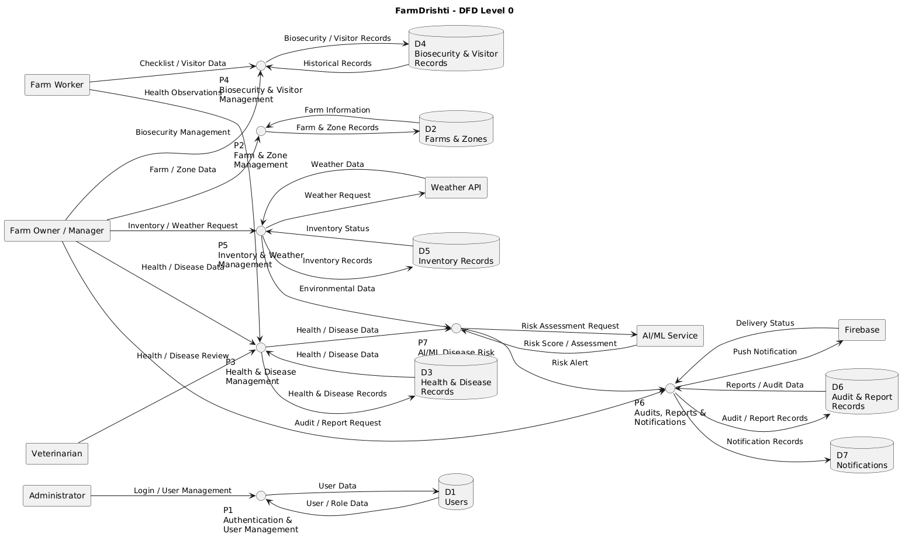
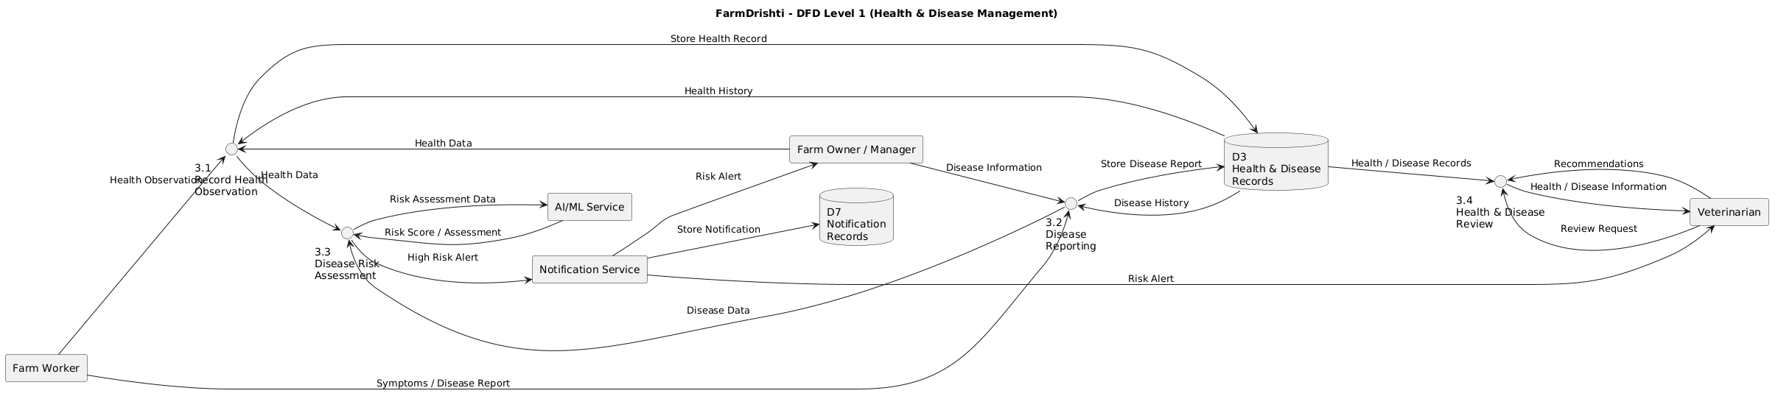

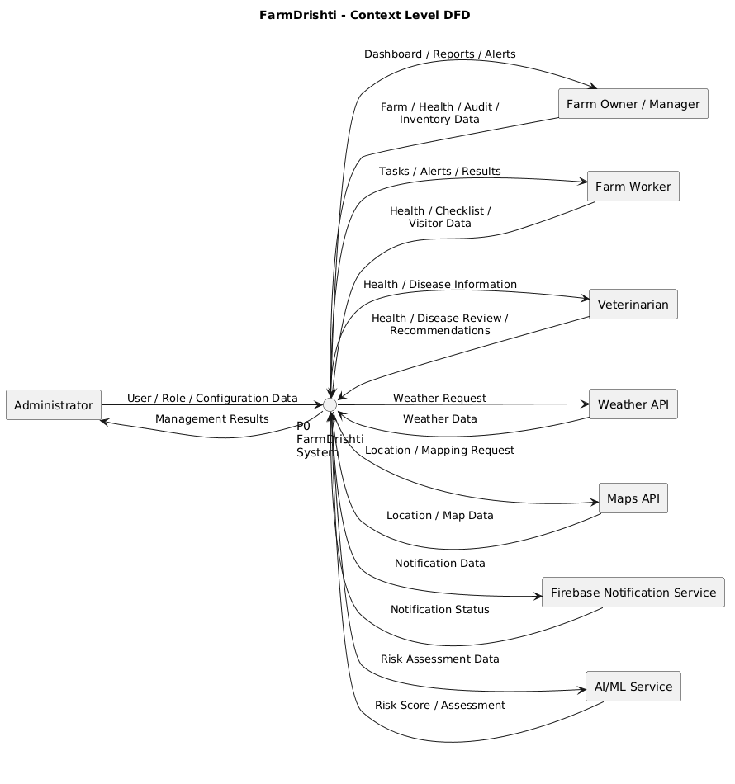

B.5 Entity Relationship Diagram
The ER diagram shall represent the relationships among major database entities including:
- Users
- Farms
- Zones
- Health Records
- Disease Reports
- Biosecurity Checklists
- Visitors
- Inventory
- Audits
- Reports
- Notifications
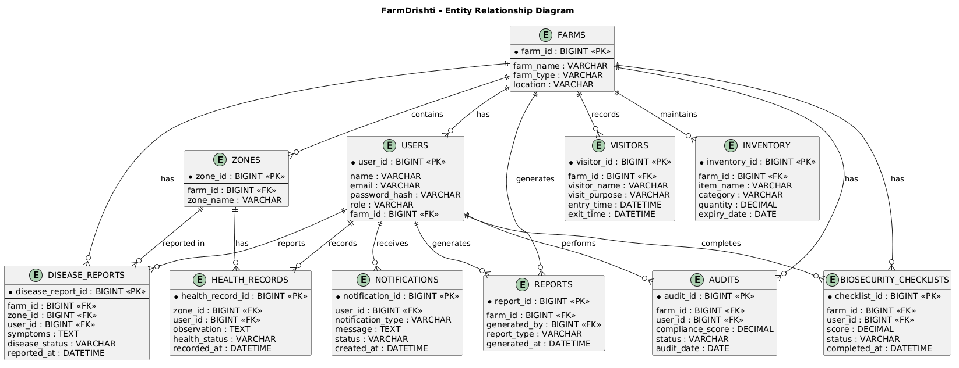

B.6 AI/ML Workflow
Farm Data
↓
Data Collection
↓
Data Validation
↓
Data Preprocessing
↓
Feature Engineering
↓
ML Model
↓
Risk Classification
↓
Risk Score
↓
Alert / Decision Support
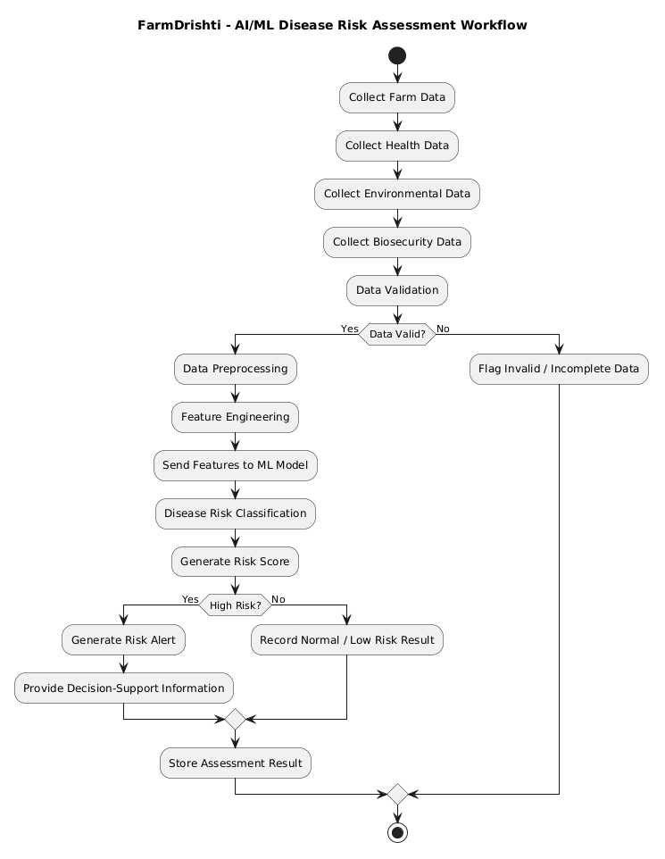

B.7 Mobile Navigation Flow
Splash
↓
Login / Register
↓
Dashboard
├── Health
├── Disease
├── Biosecurity
├── Visitors
├── Inventory
├── Weather
├── Audits
├── Reports
├── Training
├── Emergency
└── Profile

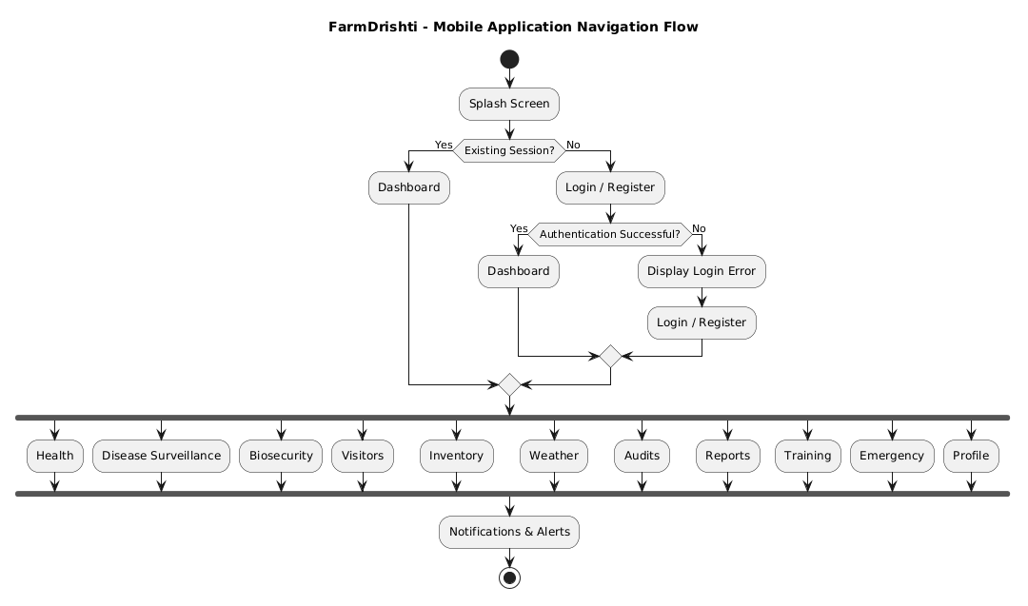

Appendix C: To Be Determined List

ID | Item | Status
TBD-01 | Final AI/ML algorithm | To be determined after dataset analysis
TBD-02 | Final disease-risk dataset | To be determined
TBD-03 | Weather API provider | To be selected
TBD-04 | Maps provider | To be selected
TBD-05 | Cloud deployment provider | To be selected
TBD-06 | Final notification configuration | To be determined
TBD-07 | Optional IoT integration | Future consideration

