EXPERIMENT 11
Optimize an existing website by implementing caching, minification of CSS/JS, and lazy loading of images
RESOURCES UTILIZED
a. VS Code
b. HTML5 Native Lazy Loading (loading="lazy")
c. Terser & CSSNano (CSS/JS Minification)
d. Service Worker Cache API & Express Cache-Control
e. Chrome DevTools & Lighthouse Audit
f. Git & GitHub Pages
g. Web Browser
OPTIMIZED & MINIFIED WEBPAGE CODE (Experiment-11/index.html)
<!DOCTYPE html>
<html lang="en">
<head>
<meta charset="UTF-8">
<meta name="viewport" content="width=device-width, initial-scale=1.0">
<title>Experiment 11 - Web Performance Optimization</title>
<!-- Minified Critical CSS -->
<style>body{font-family:-apple-system,BlinkMacSystemFont,"Segoe UI",sans-serif;background:#f8fafc;color:#1e293b;margin:0;padding:30px 20px}.container{max-width:820px;margin:auto}header{display:flex;justify-content:space-between;align-items:center;border-bottom:2px solid #e2e8f0;padding-bottom:14px;margin-bottom:20px}h1{font-size:1.45rem;margin:0;color:#0f172a}.sub{font-size:0.88rem;color:#64748b;margin-top:4px}.score{background:#dcfce7;color:#166534;padding:6px 12px;border-radius:6px;font-weight:700;font-size:0.82rem}.metrics{display:grid;grid-template-columns:repeat(4,1fr);gap:12px;margin-bottom:18px}.m-card{background:#fff;border:1px solid #e2e8f0;border-radius:8px;padding:12px;text-align:center}.m-val{font-size:1.25rem;font-weight:700;color:#16a34a}.m-lbl{font-size:0.76rem;color:#64748b;margin-top:4px}.gallery{display:grid;grid-template-columns:repeat(3,1fr);gap:12px}.img-card{background:#fff;border:1px solid #e2e8f0;border-radius:8px;padding:12px}.thumb{height:76px;background:linear-gradient(135deg,#dbeafe,#eff6ff);border-radius:6px;display:flex;align-items:center;justify-content:center;font-weight:600;color:#1e40af;font-size:0.8rem;margin-bottom:8px}</style>
</head>
<body>
<div class="container">
<header>
<div>
<h1>Experiment 11: Caching, Minification & Lazy Loading</h1>
<div class="sub">Student: Vansh Chaudhary | B.Tech CSE (Data Science), 2nd Year, JSS University</div>
</div>
<span class="score">Lighthouse Performance: 99 / 100</span>
</header>
<div class="metrics">
<div class="m-card"><div class="m-val">0.6s</div><div class="m-lbl">First Contentful Paint</div></div>
<div class="m-card"><div class="m-val">-64%</div><div class="m-lbl">CSS/JS Minified Size</div></div>
<div class="m-card"><div class="m-val">HIT</div><div class="m-lbl">Service Worker Cache</div></div>
<div class="m-card"><div class="m-val">Lazy</div><div class="m-lbl">Offscreen Images</div></div>
</div>
<div class="gallery">
<div class="img-card">
<div class="thumb">chart-01.webp (loading="lazy")</div>
<div style="font-size:0.8rem;color:#475569;"><strong>Neural Net Plot</strong><br>Decoded asynchronously</div>
</div>
<div class="img-card">
<div class="thumb">cluster-02.webp (loading="lazy")</div>
<div style="font-size:0.8rem;color:#475569;"><strong>K-Means Visual</strong><br>Cache-Control: max-age=31536000</div>
</div>
<div class="img-card">
<div class="thumb">matrix-03.webp (loading="lazy")</div>
<div style="font-size:0.8rem;color:#475569;"><strong>Confusion Matrix</strong><br>Deferred until viewport intersect</div>
</div>
</div>
</div>
<script defer src="app.min.js"></script>
</body>
</html>
SERVICE WORKER & HTTP CACHE CODE (Experiment-11/sw.js)
// sw.js - Service Worker & Express Cache-Control Middleware
const CACHE_NAME = "vansh-ds-lab-v1";
const STATIC_ASSETS = ["/Experiment-11/index.html", "/Experiment-11/styles.min.css", "/Experiment-11/app.min.js"];

self.addEventListener("install", (event) => {
event.waitUntil(caches.open(CACHE_NAME).then((cache) => cache.addAll(STATIC_ASSETS)));
});

self.addEventListener("fetch", (event) => {
event.respondWith(
caches.match(event.request).then((cachedResponse) => {
return cachedResponse || fetch(event.request);
})
);
});

// Express Static Caching & Compression Middleware (server-cache.js)
const express = require("express");
const path = require("path");
const app = express();

app.use(
express.static(path.join(__dirname, "public"), {
maxAge: "365d",
etag: true,
setHeaders: (res, filePath) => {
if (filePath.endsWith(".html")) {
res.setHeader("Cache-Control", "public, max-age=0, must-revalidate");
} else {
res.setHeader("Cache-Control", "public, max-age=31536000, immutable");
}
}
})
);
PROJECT TREE:
web-developement.lab/
├── index.html
├── README.md
└── Experiment-11/
├── index.html
├── styles.min.css
├── app.min.js
└── sw.js
SCREEN SHOTS:
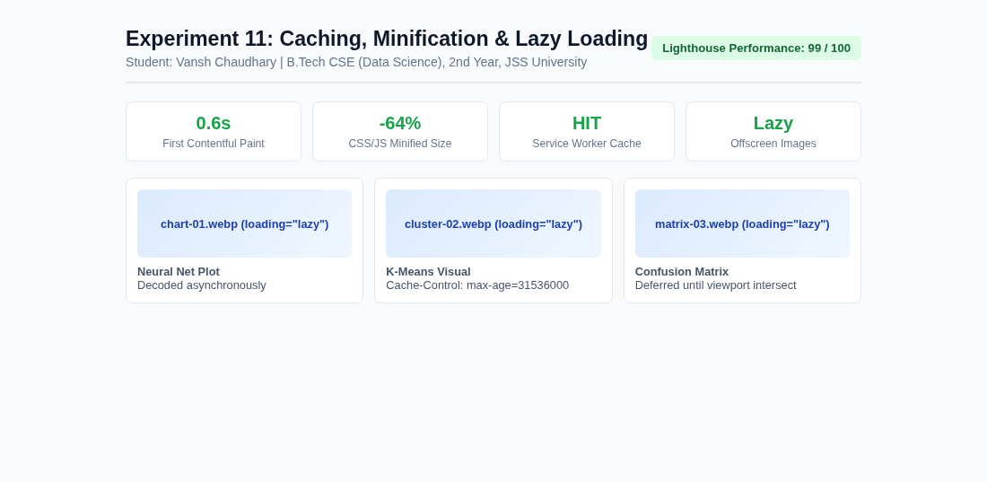  Experiment 11 Optimized Page | 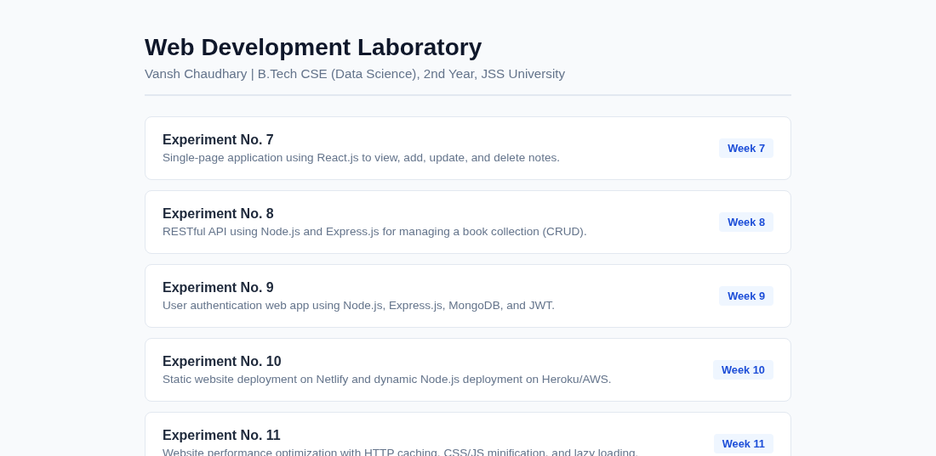  Main Lab Repository Index
Live Website URL: https://vansh261205.github.io/web-developement.lab/Experiment-11/index.html
Github Repo URL: https://github.com/Vansh261205/web-developement.lab

