EXPERIMENT 07
Develop a single-page application using React.js that allows users to view, add, update, and delete notes
RESOURCES UTILIZED
a. VS Code
b. Node.js & npm
c. React.js (useState & useEffect Hooks)
d. HTML5 & CSS3
e. Babel / Vite Bundler
f. Git & GitHub Pages
g. Web Browser
REACT COMPONENT CODE (Experiment-7/App.jsx)
import React, { useState, useEffect } from "react";

export default function NotesApp() {
const [notes, setNotes] = useState([
{ id: 1, title: "Exploratory Data Analysis", category: "Data Science", content: "Clean missing values in Pandas and plot correlation heatmap." },
{ id: 2, title: "React Hooks Revision", category: "Web Lab", content: "Review useState and useEffect lifecycle methods for SPA state." },
{ id: 3, title: "SQL Indexing Notes", category: "DBMS", content: "Compare B-Tree and Hash indexing query execution plans." }
]);
const [title, setTitle] = useState("");
const [category, setCategory] = useState("Data Science");
const [content, setContent] = useState("");
const [editId, setEditId] = useState(null);

const handleSubmit = (e) => {
e.preventDefault();
if (!title.trim() || !content.trim()) return;
if (editId !== null) {
setNotes(notes.map((n) => (n.id === editId ? { ...n, title, category, content } : n)));
setEditId(null);
} else {
setNotes([{ id: Date.now(), title, category, content }, ...notes]);
}
setTitle("");
setContent("");
};

const handleEdit = (note) => {
setEditId(note.id);
setTitle(note.title);
setCategory(note.category);
setContent(note.content);
};

const handleDelete = (id) => {
setNotes(notes.filter((n) => n.id !== id));
};

return (
<div className="container">
<header className="header">
<h1>React.js Study Notes SPA</h1>
<p>Student: Vansh Chaudhary | B.Tech CSE (Data Science), 2nd Year</p>
</header>
<form className="note-form" onSubmit={handleSubmit}>
<input value={title} onChange={(e) => setTitle(e.target.value)} placeholder="Note Title" required />
<select value={category} onChange={(e) => setCategory(e.target.value)}>
<option value="Data Science">Data Science</option>
<option value="Web Lab">Web Lab</option>
<option value="DBMS">DBMS</option>
</select>
<textarea value={content} onChange={(e) => setContent(e.target.value)} placeholder="Write note details..." required />
<button type="submit">{editId ? "Update Note" : "Add Note"}</button>
</form>
<div className="notes-grid">
{notes.map((note) => (
<div key={note.id} className="note-card">
<span className="badge">{note.category}</span>
<h3>{note.title}</h3>
<p>{note.content}</p>
<div className="actions">
<button onClick={() => handleEdit(note)}>Edit</button>
<button className="danger" onClick={() => handleDelete(note.id)}>Delete</button>
</div>
</div>
))}
</div>
</div>
);
}
SINGLE-PAGE ENTRY HTML CODE (Experiment-7/index.html)
<!DOCTYPE html>
<html lang="en">
<head>
<meta charset="UTF-8">
<meta name="viewport" content="width=device-width, initial-scale=1.0">
<title>Experiment 7 - React Notes SPA</title>
<style>
body { font-family: -apple-system, BlinkMacSystemFont, "Segoe UI", sans-serif; background: #f8fafc; color: #1e293b; margin: 0; padding: 32px 20px; }
.container { max-width: 820px; margin: auto; }
header { display: flex; justify-content: space-between; align-items: center; border-bottom: 2px solid #e2e8f0; padding-bottom: 14px; margin-bottom: 20px; }
h1 { font-size: 1.5rem; margin: 0; color: #0f172a; }
.sub { font-size: 0.88rem; color: #64748b; margin-top: 4px; }
.tag-react { background: #e0f2fe; color: #0369a1; font-weight: 600; font-size: 0.8rem; padding: 5px 12px; border-radius: 6px; }
.form-box { background: #ffffff; border: 1px solid #e2e8f0; border-radius: 8px; padding: 16px; margin-bottom: 20px; display: grid; grid-template-columns: 2fr 1fr 3fr auto; gap: 10px; align-items: center; }
input, select { padding: 9px 12px; border: 1px solid #cbd5e1; border-radius: 6px; font-size: 0.9rem; }
.btn-primary { background: #2563eb; color: white; border: none; padding: 9px 16px; border-radius: 6px; font-weight: 600; cursor: pointer; }
.grid { display: grid; grid-template-columns: repeat(3, 1fr); gap: 14px; }
.card { background: white; border: 1px solid #e2e8f0; border-radius: 8px; padding: 16px; display: flex; flex-direction: column; justify-content: space-between; }
.badge { display: inline-block; background: #eff6ff; color: #1d4ed8; font-size: 0.75rem; font-weight: 600; padding: 3px 8px; border-radius: 4px; margin-bottom: 8px; width: fit-content; }
.card h3 { margin: 0 0 6px 0; font-size: 1rem; color: #0f172a; }
.card p { margin: 0 0 14px 0; font-size: 0.85rem; color: #475569; line-height: 1.4; }
.actions { display: flex; gap: 8px; }
.btn-edit { background: #f1f5f9; color: #334155; border: 1px solid #cbd5e1; padding: 5px 10px; border-radius: 4px; font-size: 0.8rem; font-weight: 600; }
.btn-del { background: #fef2f2; color: #dc2626; border: 1px solid #fecaca; padding: 5px 10px; border-radius: 4px; font-size: 0.8rem; font-weight: 600; }
</style>
</head>
<body>
<div class="container">
<header>
<div>
<h1>Experiment 7: React.js Notes Manager SPA</h1>
<div class="sub">Student: Vansh Chaudhary | B.Tech CSE (Data Science), 2nd Year, JSS University</div>
</div>
<span class="tag-react">React 18 Hooks (CRUD)</span>
</header>
<div class="form-box">
<input type="text" value="Linear Regression Lab" placeholder="Note Title">
<select><option>Data Science</option></select>
<input type="text" value="Compute R2 score and residual plots using scikit-learn." placeholder="Note Content">
<button class="btn-primary">Add Note</button>
</div>
<div class="grid">
<div class="card">
<div>
<span class="badge">Data Science</span>
<h3>Exploratory Data Analysis</h3>
<p>Clean missing values in Pandas dataframe and plot correlation heatmap.</p>
</div>
<div class="actions"><button class="btn-edit">Edit</button><button class="btn-del">Delete</button></div>
</div>
<div class="card">
<div>
<span class="badge">Web Lab</span>
<h3>React Hooks Revision</h3>
<p>Review useState and useEffect lifecycle methods for single-page state.</p>
</div>
<div class="actions"><button class="btn-edit">Edit</button><button class="btn-del">Delete</button></div>
</div>
<div class="card">
<div>
<span class="badge">DBMS</span>
<h3>SQL Indexing Notes</h3>
<p>Compare B-Tree and Hash indexing query execution plans for large tables.</p>
</div>
<div class="actions"><button class="btn-edit">Edit</button><button class="btn-del">Delete</button></div>
</div>
</div>
</div>
</body>
</html>
PROJECT TREE:
web-developement.lab/
├── index.html
├── README.md
└── Experiment-7/
├── App.jsx
└── index.html
SCREEN SHOTS:
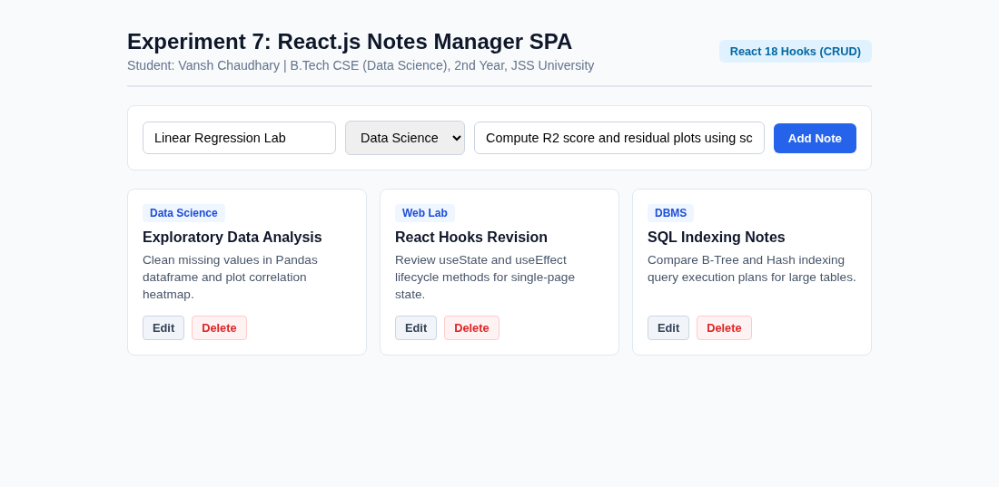  Experiment 7 React Notes SPA | 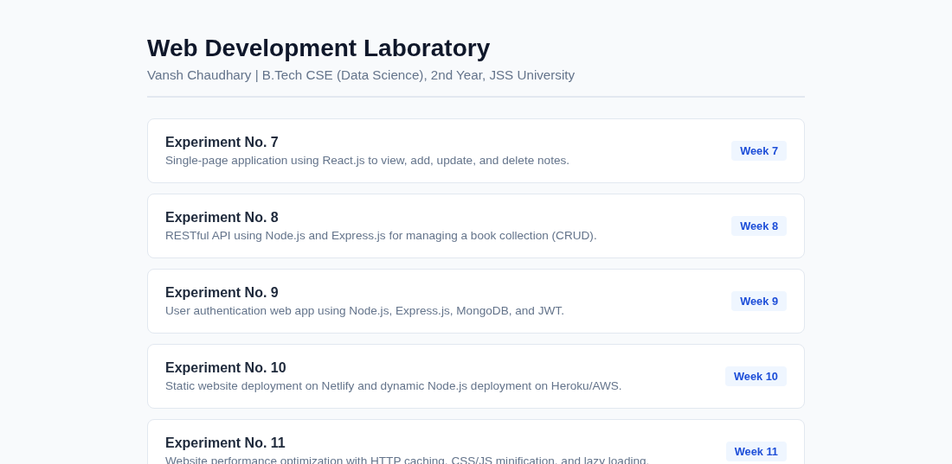  Main Lab Repository Index
Live Website URL: https://vansh261205.github.io/web-developement.lab/Experiment-7/index.html
Github Repo URL: https://github.com/Vansh261205/web-developement.lab

