EXPERIMENT 08
Build a simple RESTful API using Node.js and Express.js for managing a book collection (CRUD operations)
RESOURCES UTILIZED
a. VS Code
b. Node.js Runtime
c. Express.js Framework
d. Postman / REST API Client
e. JavaScript (ES6+)
f. Git & GitHub
g. Web Browser
EXPRESS REST API SERVER CODE (Experiment-8/server.js)
const express = require("express");
const cors = require("cors");
const app = express();
const PORT = process.env.PORT || 4000;

app.use(cors());
app.use(express.json());

let books = [
{ id: 1, title: "Python for Data Analysis", author: "Wes McKinney", isbn: "978-1098104030", category: "Data Science" },
{ id: 2, title: "Hands-On Machine Learning", author: "Aurelien Geron", isbn: "978-1098125974", category: "AI & ML" },
{ id: 3, title: "Eloquent JavaScript", author: "Marijn Haverbeke", isbn: "978-1593279509", category: "Web Dev" }
];

// GET all books
app.get("/api/books", (req, res) => {
res.status(200).json({ success: true, count: books.length, data: books });
});

// GET single book by ID
app.get("/api/books/:id", (req, res) => {
const book = books.find((b) => b.id === parseInt(req.params.id));
if (!book) return res.status(404).json({ success: false, message: "Book not found" });
res.status(200).json({ success: true, data: book });
});

// POST create a new book
app.post("/api/books", (req, res) => {
const { title, author, isbn, category } = req.body;
if (!title || !author) return res.status(400).json({ success: false, message: "Title and author required" });
const newBook = { id: books.length ? books[books.length - 1].id + 1 : 1, title, author, isbn, category };
books.push(newBook);
res.status(201).json({ success: true, message: "Book added", data: newBook });
});

// PUT update existing book
app.put("/api/books/:id", (req, res) => {
const book = books.find((b) => b.id === parseInt(req.params.id));
if (!book) return res.status(404).json({ success: false, message: "Book not found" });
Object.assign(book, req.body);
res.status(200).json({ success: true, message: "Book updated", data: book });
});

// DELETE remove a book
app.delete("/api/books/:id", (req, res) => {
const index = books.findIndex((b) => b.id === parseInt(req.params.id));
if (index === -1) return res.status(404).json({ success: false, message: "Book not found" });
const deleted = books.splice(index, 1);
res.status(200).json({ success: true, message: "Book deleted", data: deleted[0] });
});

app.listen(PORT, () => console.log(`Book CRUD API running on http://localhost:${PORT}`));
API CLIENT DASHBOARD CODE (Experiment-8/index.html)
<!DOCTYPE html>
<html lang="en">
<head>
<meta charset="UTF-8">
<meta name="viewport" content="width=device-width, initial-scale=1.0">
<title>Experiment 8 - Node.js & Express Book API</title>
<style>
body { font-family: -apple-system, BlinkMacSystemFont, "Segoe UI", sans-serif; background: #f8fafc; color: #1e293b; margin: 0; padding: 30px 20px; }
.container { max-width: 840px; margin: auto; }
header { display: flex; justify-content: space-between; align-items: center; border-bottom: 2px solid #e2e8f0; padding-bottom: 14px; margin-bottom: 20px; }
h1 { font-size: 1.45rem; margin: 0; color: #0f172a; }
.sub { font-size: 0.88rem; color: #64748b; margin-top: 4px; }
.badge-api { background: #dcfce7; color: #166534; padding: 5px 12px; border-radius: 6px; font-weight: 600; font-size: 0.8rem; }
.layout { display: grid; grid-template-columns: 1.35fr 1fr; gap: 16px; }
.panel { background: white; border: 1px solid #e2e8f0; border-radius: 8px; padding: 16px; }
.panel h3 { margin: 0 0 12px 0; font-size: 0.95rem; color: #0f172a; }
table { width: 100%; border-collapse: collapse; font-size: 0.82rem; }
th, td { text-align: left; padding: 8px 6px; border-bottom: 1px solid #f1f5f9; }
th { color: #475569; font-weight: 600; background: #f8fafc; }
.method { display: inline-block; padding: 2px 6px; border-radius: 4px; font-weight: 700; font-size: 0.72rem; margin-right: 6px; }
.get { background: #dbeafe; color: #1e40af; }
.post { background: #dcfce7; color: #166534; }
.put { background: #fef3c7; color: #92400e; }
.del { background: #fee2e2; color: #991b1b; }
pre { background: #0f172a; color: #38bdf8; padding: 12px; border-radius: 6px; font-size: 0.76rem; margin: 0; overflow-x: auto; line-height: 1.4; }
</style>
</head>
<body>
<div class="container">
<header>
<div>
<h1>Experiment 8: Node.js & Express RESTful Book API</h1>
<div class="sub">Student: Vansh Chaudhary | B.Tech CSE (Data Science), 2nd Year, JSS University</div>
</div>
<span class="badge-api">200 OK • Express 4.19</span>
</header>
<div class="layout">
<div class="panel">
<h3>Book Collection Records (GET /api/books)</h3>
<table>
<thead><tr><th>ID</th><th>Title</th><th>Author</th><th>Category</th></tr></thead>
<tbody>
<tr><td>#1</td><td>Python for Data Analysis</td><td>Wes McKinney</td><td>Data Science</td></tr>
<tr><td>#2</td><td>Hands-On Machine Learning</td><td>Aurelien Geron</td><td>AI & ML</td></tr>
<tr><td>#3</td><td>Eloquent JavaScript</td><td>Marijn Haverbeke</td><td>Web Dev</td></tr>
<tr><td>#4</td><td>Deep Learning with Python</td><td>Francois Chollet</td><td>Deep Learning</td></tr>
</tbody>
</table>
<div style="margin-top: 14px; font-size: 0.8rem; color: #475569;">
<span class="method get">GET</span><span class="method post">POST</span><span class="method put">PUT</span><span class="method del">DELETE</span> /api/books/:id
</div>
</div>
<div class="panel">
<h3>JSON Response Payload</h3>
<pre>{
"success": true,
"status": 200,
"count": 4,
"data": [
{
"id": 1,
"title": "Python for Data Analysis",
"author": "Wes McKinney",
"isbn": "978-1098104030"
}
]
}</pre>
</div>
</div>
</div>
</body>
</html>
PROJECT TREE:
web-developement.lab/
├── index.html
├── README.md
└── Experiment-8/
├── package.json
├── server.js
└── index.html
SCREEN SHOTS:
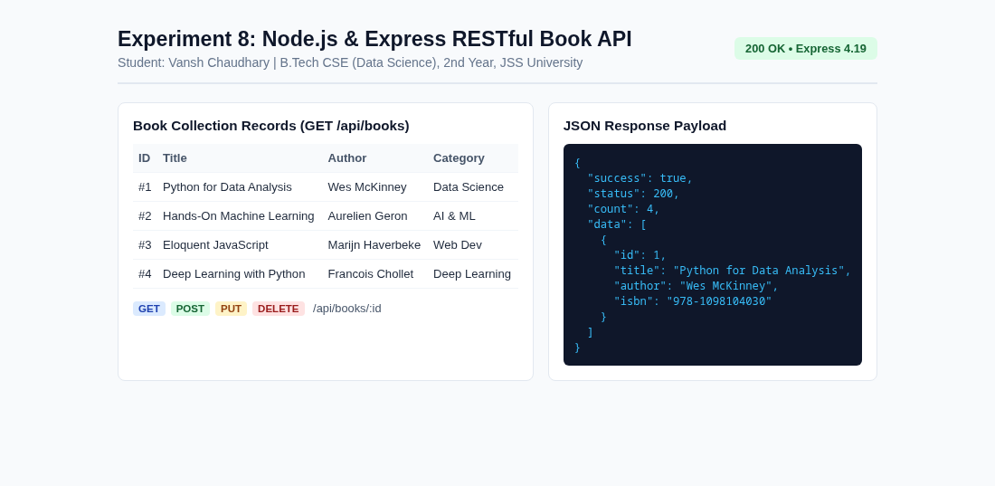  Experiment 8 Book CRUD API | 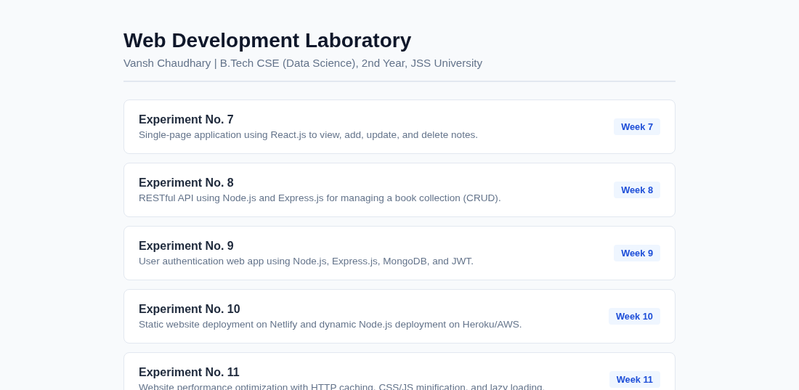  Main Lab Repository Index
Live Website URL: https://vansh261205.github.io/web-developement.lab/Experiment-8/index.html
Github Repo URL: https://github.com/Vansh261205/web-developement.lab

