EXPERIMENT 01
Set up a GitHub repository for a project, create branches, merge changes, and use GitHub Pages for hosting a simple static site
RESOURCES UTILIZED
a. VS Code
b. Git
c. GitHub
d. HTML
e. CSS
f. GitHub Pages
g. Web Browser
HTML FILE CODE (Experiment-1/index.html)
<!DOCTYPE html>
<html lang="en">
<head>
<meta charset="UTF-8">
<meta name="viewport" content="width=device-width, initial-scale=1.0">
<title>Experiment 1 - Static Site</title>
<style>
body { font-family: sans-serif; background: #f8fafc; color: #334155; padding: 60px 20px; text-align: center; }
.box { background: white; max-width: 500px; margin: auto; padding: 30px; border-radius: 8px; border: 1px solid #e2e8f0; }
h1 { color: #0f172a; font-size: 1.5rem; }
.tag { display: inline-block; background: #dcfce7; color: #166534; padding: 4px 10px; border-radius: 4px; font-weight: 600; font-size: 0.85rem; margin-top: 10px; }
</style>
</head>
<body>
<div class="box">
<h1>Experiment 1: GitHub Pages Demo</h1>
<p>This static webpage is hosted live using GitHub Pages as part of the Web Development Lab practicals.</p>
<div class="tag">Hosted Successfully</div>
<hr style="margin: 20px 0; border: none; border-top: 1px solid #e2e8f0;">
<p style="font-size: 0.9rem; color: #64748b;">Student: Vansh Chaudhary | JSS University</p>
</div>
</body>
</html>
MAIN LAB INDEX CODE (index.html)
<!DOCTYPE html>
<html lang="en">
<head>
<meta charset="UTF-8">
<meta name="viewport" content="width=device-width, initial-scale=1.0">
<title>Web Development Lab | Vansh Chaudhary</title>
<style>
body { font-family: -apple-system, BlinkMacSystemFont, "Segoe UI", Roboto, sans-serif; background: #f8fafc; color: #1e293b; margin: 0; padding: 40px 20px; }
.container { max-width: 760px; margin: auto; }
header { border-bottom: 2px solid #e2e8f0; padding-bottom: 16px; margin-bottom: 24px; }
h1 { font-size: 1.75rem; margin: 0 0 6px 0; color: #0f172a; }
.student-info { color: #64748b; font-size: 0.95rem; }
.grid { display: flex; flex-direction: column; gap: 12px; }
.card { background: #ffffff; border: 1px solid #e2e8f0; border-radius: 8px; padding: 18px 20px; display: flex; justify-content: space-between; align-items: center; text-decoration: none; color: inherit; }
.card:hover { border-color: #2563eb; background: #fbfdff; }
.exp-title { font-weight: 600; font-size: 1rem; color: #1e293b; }
.exp-desc { font-size: 0.85rem; color: #64748b; margin-top: 4px; }
.badge { font-size: 0.8rem; background: #eff6ff; color: #1d4ed8; padding: 4px 10px; border-radius: 4px; font-weight: 600; white-space: nowrap; }
</style>
</head>
<body>
<div class="container">
<header>
<h1>Web Development Laboratory</h1>
<div class="student-info">Vansh Chaudhary | B.Tech CSE (Data Science), 2nd Year, JSS University</div>
</header>
<div class="grid">
<a class="card" href="Experiment-1/index.html"><div><div class="exp-title">Experiment No. 1</div><div class="exp-desc">Git repository setup, branching, merging, and static site hosting via GitHub Pages.</div></div><span class="badge">Week 1</span></a>
<a class="card" href="Experiment-2/index.html"><div><div class="exp-title">Experiment No. 2</div><div class="exp-desc">Personal portfolio webpage with responsive navigation, about section, projects, and contact form.</div></div><span class="badge">Week 2</span></a>
<a class="card" href="Experiment-3/todo.html"><div><div class="exp-title">Experiment No. 3</div><div class="exp-desc">Dynamic to-do list application with add, toggle complete, and delete using JavaScript DOM.</div></div><span class="badge">Week 3</span></a>
<a class="card" href="Experiment-4/optimized.html"><div><div class="exp-title">Experiment No. 4</div><div class="exp-desc">Webpage optimization for technical SEO and web accessibility (WCAG compliance).</div></div><span class="badge">Week 4</span></a>
<a class="card" href="Experiment-5/weather.html"><div><div class="exp-title">Experiment No. 5</div><div class="exp-desc">Weather application fetching live meteorological data using JavaScript Fetch API.</div></div><span class="badge">Week 5</span></a>
<a class="card" href="Experiment-6/blog.html"><div><div class="exp-title">Experiment No. 6</div><div class="exp-desc">Responsive multi-column blog layout built with Bootstrap 5 and custom media queries.</div></div><span class="badge">Week 6</span></a>
</div>
</div>
</body>
</html>
PROJECT TREE:
web-developement.lab/
├── index.html
├── README.md
└── Experiment-1/
└── index.html
SCREEN SHOTS:
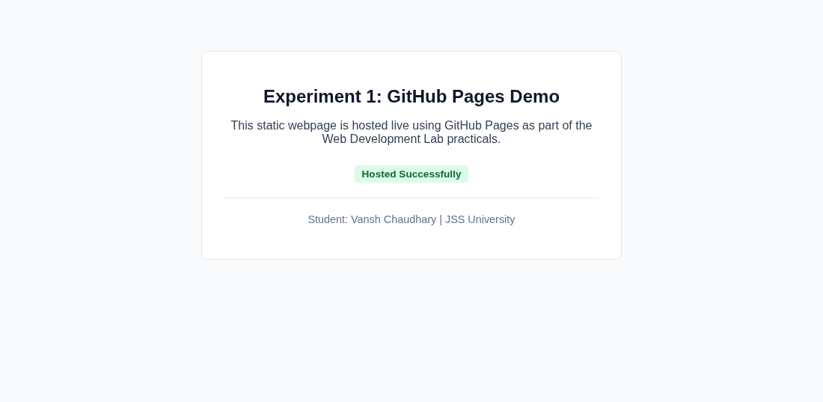  Experiment 1 Static Page | 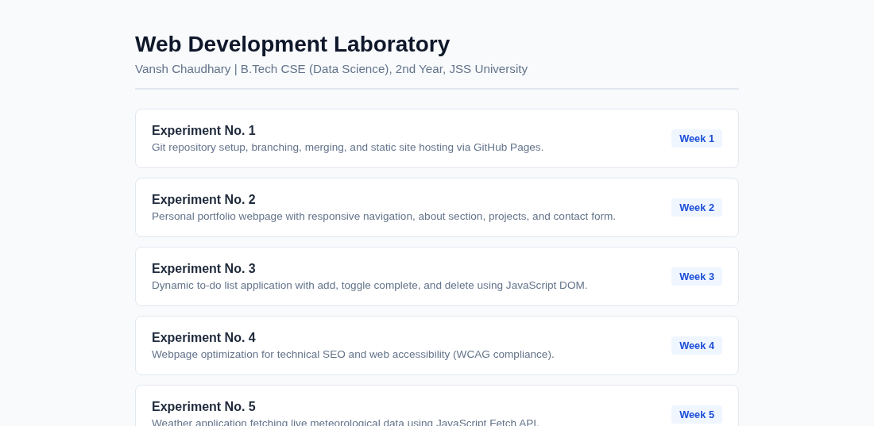  Main Lab Repository Index
Live Website URL: https://vansh261205.github.io/web-developement.lab/Experiment-1/index.html
Github Repo URL: https://github.com/Vansh261205/web-developement.lab

