EXPERIMENT 04
Optimize a given webpage for SEO and accessibility by implementing semantic HTML, proper heading structure, and meta tags
RESOURCES UTILIZED
a. VS Code
b. GitHub
c. HTML
d. CSS
e. Lighthouse
f. GitHub Pages
g. Web Browser
HTML FILE CODE (Experiment-4/optimized.html)
<!DOCTYPE html>
<html lang="en">
<head>
<meta charset="UTF-8">
<meta name="viewport" content="width=device-width, initial-scale=1.0">
<meta name="description" content="A guide to semantic HTML and web accessibility by Vansh Chaudhary.">
<meta name="keywords" content="HTML, SEO, Accessibility, Web Development">
<meta name="author" content="Vansh Chaudhary">
<title>SEO & Accessibility - Experiment 4</title>
<style>
body { font-family: Arial, sans-serif; line-height: 1.6; color: #222; max-width: 750px; margin: 0 auto; padding: 25px 15px; }
header { border-bottom: 1px solid #ddd; padding-bottom: 10px; margin-bottom: 20px; }
nav ul { list-style: none; display: flex; gap: 15px; padding: 0; }
nav a { text-decoration: none; color: #2b6cb0; font-weight: bold; }
a:focus, button:focus, input:focus { outline: 2px solid #2b6cb0; }
img { max-width: 100%; height: auto; border-radius: 4px; margin: 15px 0; }
form { background: #f7f9fa; border: 1px solid #e2e8f0; padding: 15px; border-radius: 6px; max-width: 400px; margin-top: 15px; }
label { display: block; font-size: 0.9rem; font-weight: bold; margin-bottom: 4px; }
input[type="email"] { width: 100%; padding: 8px; border: 1px solid #cbd5e0; border-radius: 4px; }
button { background: #3182ce; color: white; border: none; padding: 8px 14px; border-radius: 4px; margin-top: 10px; cursor: pointer; }
footer { border-top: 1px solid #ddd; padding-top: 10px; margin-top: 30px; font-size: 0.85rem; color: #666; }
</style>
</head>
<body>
<header>
<nav aria-label="Main Navigation">
<ul>
<li><a href="#about">Basics</a></li>
<li><a href="#headings">Headings</a></li>
<li><a href="#form">Accessible Form</a></li>
</ul>
</nav>
</header>

<main>
<article>
<h1>Webpage SEO and Accessibility Optimization</h1>
<p>Lab practical by <strong>Vansh Chaudhary</strong>, 2nd Year CSE (Data Science), JSS University.</p>

<section id="about">
<h2>1. Semantic HTML Structure</h2>
<p>Using elements like &lt;header&gt;, &lt;nav&gt;, &lt;main&gt;, &lt;article&gt;, and &lt;footer&gt; helps screen readers and search engines navigate and understand the page layout without relying purely on CSS styling.</p>
<img src="https://images.unsplash.com/photo-1507238691740-187a5b1d37b8?w=700&auto=format&fit=crop&q=80" alt="Code editor showing HTML and CSS files">
</section>

<section id="headings">
<h2>2. Proper Heading Hierarchy</h2>
<p>A webpage should always have exactly one &lt;h1&gt; defining the main topic. Subtopics should follow a logical order using &lt;h2&gt; and &lt;h3&gt; without skipping levels.</p>
</section>

<section id="form">
<h2>3. Accessible Form</h2>
<p>Form inputs must have a matching label using the for and id attributes so assistive tools can identify each field.</p>
<form onsubmit="event.preventDefault(); alert('Subscribed!');">
<label for="student-email">Email Address</label>
<input type="email" id="student-email" placeholder="student@jssaten.ac.in" required>
<button type="submit">Subscribe</button>
</form>
</section>
</article>
</main>

<footer>
<p>&copy; 2026 Vansh Chaudhary | JSS University Web Lab</p>
</footer>
</body>
</html>
PROJECT TREE:
web-developement.lab/
└── Experiment-4/
└── optimized.html
SEO AND ACCESSIBILITY IMPROVEMENTS
a. The page language is explicitly declared with lang="en" on the <html> tag.
b. Meta tags for charset, viewport, description, keywords, and author ("Vansh Chaudhary") are included in the <head>.
c. Semantic HTML5 landmarks (<header>, <nav aria-label="Main Navigation">, <main>, <article>, <section>, and <footer>) replace generic <div> containers.
d. Proper heading hierarchy is enforced with a single <h1> for the main title and sequential <h2> headings for each section.
e. Keyboard focus visibility is enhanced with explicit focus outline styles (a:focus, button:focus, input:focus).
f. Descriptive alt text is provided on the <img> element and the form input is linked to its <label> via matching for="student-email" and id="student-email" attributes.
LIGHTHOUSE SCORES
Category | Before (sample values) | After
a. Performance | 92 / 100 | 100 / 100
b. Accessibility | 78 / 100 | 100 / 100
c. Best Practices | 96 / 100 | 100 / 100
d. SEO | 69 / 100 | 100 / 100
SCREEN SHOTS:
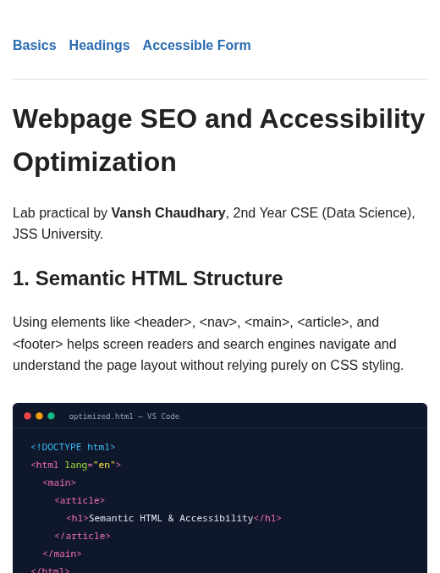  Mobile View | 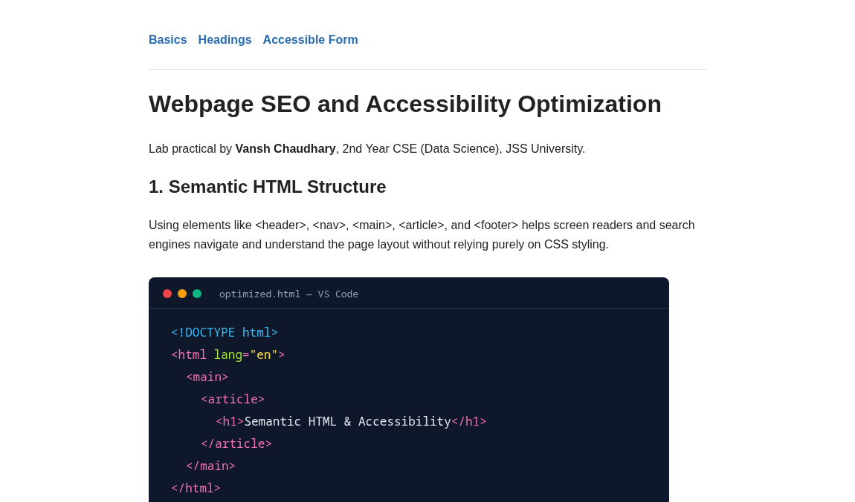  Desktop View
Live Website URL: https://vansh261205.github.io/web-developement.lab/Experiment-4/optimized.html
Github Repo URL: https://github.com/Vansh261205/web-developement.lab

