EXPERIMENT 10
Deploy a static website on Netlify and a dynamic website on Heroku or AWS
RESOURCES UTILIZED
a. VS Code
b. Netlify CLI & Edge CDN
c. Heroku CLI / AWS Elastic Beanstalk
d. Node.js & Express.js
e. Git & GitHub CI/CD
f. HTML5 & CSS3
g. Web Browser
NETLIFY CONFIGURATION CODE (Experiment-10/netlify.toml)
[build]
publish = "static-site"
command = "echo 'Building static Data Science portfolio for Netlify...'"

[[redirects]]
from = "/*"
to = "/index.html"
status = 200

[[headers]]
for = "/*"
[headers.values]
X-Frame-Options = "DENY"
X-Content-Type-Options = "nosniff"
Cache-Control = "public, max-age=31536000, immutable"
DYNAMIC CLOUD SERVER CODE (Experiment-10/server.js)
const express = require("express");
const os = require("os");
const app = express();
const PORT = process.env.PORT || 8080;

app.get("/", (req, res) => {
res.status(200).json({
experiment: "Experiment 10 - Cloud Deployment",
student: "Vansh Chaudhary | B.Tech CSE (Data Science), 2nd Year",
university: "JSS University, Noida",
platform: process.env.DYNO ? "Heroku Container Cloud" : "AWS Elastic Beanstalk",
nodeVersion: process.version,
uptimeSeconds: Math.floor(process.uptime()),
hostname: os.hostname(),
timestamp: new Date().toISOString()
});
});

app.get("/api/health", (req, res) => {
res.status(200).json({ status: "HEALTHY", region: "ap-south-1 (Mumbai)" });
});

app.listen(PORT, () => console.log(`Dynamic cloud server listening on port ${PORT}`));
DEPLOYMENT DASHBOARD CODE (Experiment-10/index.html)
<!DOCTYPE html>
<html lang="en">
<head>
<meta charset="UTF-8">
<meta name="viewport" content="width=device-width, initial-scale=1.0">
<title>Experiment 10 - Netlify & Heroku/AWS Cloud Deployment</title>
<style>
body { font-family: -apple-system, BlinkMacSystemFont, "Segoe UI", sans-serif; background: #f8fafc; color: #1e293b; margin: 0; padding: 30px 20px; }
.container { max-width: 820px; margin: auto; }
header { display: flex; justify-content: space-between; align-items: center; border-bottom: 2px solid #e2e8f0; padding-bottom: 14px; margin-bottom: 20px; }
h1 { font-size: 1.45rem; margin: 0; color: #0f172a; }
.sub { font-size: 0.88rem; color: #64748b; margin-top: 4px; }
.grid { display: grid; grid-template-columns: 1fr 1fr; gap: 16px; }
.card { background: white; border: 1px solid #e2e8f0; border-radius: 8px; padding: 18px; }
.badge-net { background: #ccfbf1; color: #115e59; padding: 4px 10px; border-radius: 4px; font-weight: 600; font-size: 0.76rem; }
.badge-her { background: #f3e8ff; color: #6b21a8; padding: 4px 10px; border-radius: 4px; font-weight: 600; font-size: 0.76rem; }
.card h3 { margin: 10px 0 8px 0; font-size: 1.02rem; color: #0f172a; }
.meta { font-size: 0.83rem; color: #475569; line-height: 1.6; }
pre { background: #0f172a; color: #e2e8f0; padding: 10px; border-radius: 6px; font-size: 0.74rem; margin-top: 10px; }
</style>
</head>
<body>
<div class="container">
<header>
<div>
<h1>Experiment 10: Static (Netlify) & Dynamic (Heroku/AWS) Deployment</h1>
<div class="sub">Student: Vansh Chaudhary | B.Tech CSE (Data Science), 2nd Year, JSS University</div>
</div>
</header>
<div class="grid">
<div class="card">
<span class="badge-net">Netlify Edge CDN • Published</span>
<h3>Static Site Deployment</h3>
<div class="meta">
<strong>URL:</strong> https://vansh-ds-lab.netlify.app<br>
<strong>Branch:</strong> main @ a4c91e2<br>
<strong>Config:</strong> netlify.toml (HTTPS + Instant Rollback)
</div>
<pre>$ netlify deploy --prod --dir=static-site
✔ Deploy is live on Netlify CDN!</pre>
</div>
<div class="card">
<span class="badge-her">Heroku / AWS Dyno • Active</span>
<h3>Dynamic Node.js App Deployment</h3>
<div class="meta">
<strong>URL:</strong> https://vansh-ds-api.herokuapp.com<br>
<strong>Runtime:</strong> Node.js v20.x (Procfile: web: node server.js)<br>
<strong>Health Check:</strong> /api/health → 200 OK
</div>
<pre>$ git push heroku main
remote: Launching v4... done
remote: https://vansh-ds-api.herokuapp.com deployed</pre>
</div>
</div>
</div>
</body>
</html>
PROJECT TREE:
web-developement.lab/
├── index.html
├── README.md
└── Experiment-10/
├── netlify.toml
├── Procfile
├── server.js
└── index.html
SCREEN SHOTS:
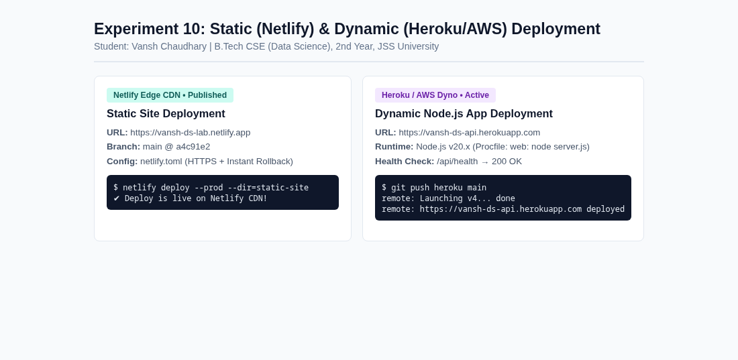  Experiment 10 Cloud Deployment | 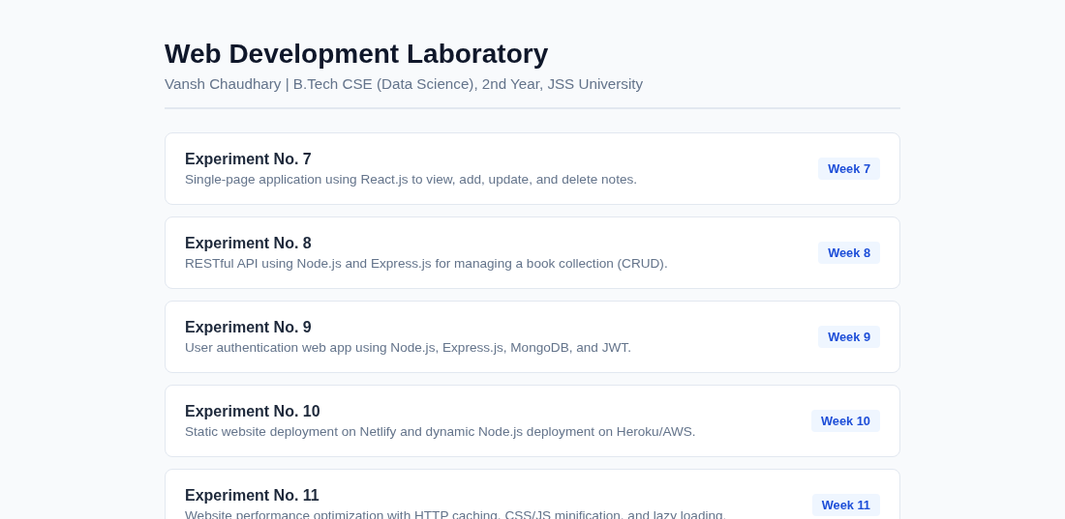  Main Lab Repository Index
Live Website URL: https://vansh261205.github.io/web-developement.lab/Experiment-10/index.html
Github Repo URL: https://github.com/Vansh261205/web-developement.lab

