EXPERIMENT 06
Design a responsive blog website using Bootstrap 5 grid system, cards, navigation bar, and custom CSS media queries
RESOURCES UTILIZED
a. VS Code
b. GitHub
c. HTML
d. CSS (Media Queries)
e. Bootstrap 5
f. GitHub Pages
g. Web Browser
HTML FILE CODE (Experiment-6/blog.html)
<!DOCTYPE html>
<html lang="en">
<head>
<meta charset="UTF-8">
<meta name="viewport" content="width=device-width, initial-scale=1.0">
<title>Vansh Chaudhary - Tech Blog</title>
<link href="https://cdn.jsdelivr.net/npm/bootstrap@5.3.3/dist/css/bootstrap.min.css" rel="stylesheet">
<style>
body { background-color: #f8f9fa; }
.banner { background: #212529; color: white; padding: 40px 0; }
.card-img-top { height: 170px; object-fit: cover; }
@media (max-width: 768px) {
.banner { text-align: center; padding: 25px 15px; }
.sidebar { margin-top: 25px; }
}
</style>
</head>
<body>
<nav class="navbar navbar-expand-lg navbar-dark bg-dark">
<div class="container">
<a class="navbar-brand" href="#">Vansh's Blog</a>
<button class="navbar-toggler" type="button" data-bs-toggle="collapse" data-bs-target="#navMenu">
<span class="navbar-toggler-icon"></span>
</button>
<div class="collapse navbar-collapse" id="navMenu">
<ul class="navbar-nav ms-auto">
<li class="nav-item"><a class="nav-link active" href="#">Home</a></li>
<li class="nav-item"><a class="nav-link" href="#">About</a></li>
</ul>
</div>
</div>
</nav>

<header class="banner">
<div class="container">
<h1 class="h3">Web Development Notes</h1>
<p class="mb-0 text-secondary">A simple blog documenting my web lab experiments and frontend learning.</p>
</div>
</header>

<div class="container my-4">
<div class="row">
<main class="col-lg-8">
<div class="row g-3">
<div class="col-md-6">
<div class="card h-100 shadow-sm">
<img src="https://images.unsplash.com/photo-1507238691740-187a5b1d37b8?w=500&auto=format&fit=crop&q=80" class="card-img-top" alt="Code editor">
<div class="card-body">
<span class="badge bg-primary mb-2">CSS</span>
<h2 class="h5 card-title">CSS Grid vs Flexbox</h2>
<p class="card-text small text-muted">When to use Flexbox for 1D navigation vs Grid for 2D card layouts in responsive web design.</p>
<a href="#" class="btn btn-sm btn-outline-primary">Read More</a>
</div>
</div>
</div>

<div class="col-md-6">
<div class="card h-100 shadow-sm">
<img src="https://images.unsplash.com/photo-1555066931-4365d14bab8c?w=500&auto=format&fit=crop&q=80" class="card-img-top" alt="JavaScript screen">
<div class="card-body">
<span class="badge bg-success mb-2">JavaScript</span>
<h2 class="h5 card-title">Using Fetch API</h2>
<p class="card-text small text-muted">How to make GET requests with async/await and update HTML elements using JSON responses.</p>
<a href="#" class="btn btn-sm btn-outline-primary">Read More</a>
</div>
</div>
</div>
</div>
</main>

<aside class="col-lg-4 sidebar">
<div class="p-3 bg-white rounded shadow-sm border mb-3">
<h5>About</h5>
<p class="small text-muted mb-0">Student blog by Vansh Chaudhary, 2nd Year CSE (Data Science) at JSS University.</p>
</div>
<div class="p-3 bg-white rounded shadow-sm border">
<h5>Categories</h5>
<ul class="list-unstyled mb-0 small">
<li><a href="#" class="text-decoration-none">HTML & CSS</a></li>
<li><a href="#" class="text-decoration-none">JavaScript DOM</a></li>
<li><a href="#" class="text-decoration-none">Bootstrap 5</a></li>
</ul>
</div>
</aside>
</div>
</div>

<footer class="py-3 bg-dark text-white text-center">
<div class="container"><small>&copy; 2026 Vansh Chaudhary | JSS University</small></div>
</footer>

<script src="https://cdn.jsdelivr.net/npm/bootstrap@5.3.3/dist/js/bootstrap.bundle.min.js"></script>
</body>
</html>
PROJECT TREE:
web-developement.lab/
└── Experiment-6/
└── blog.html
SCREEN SHOTS:
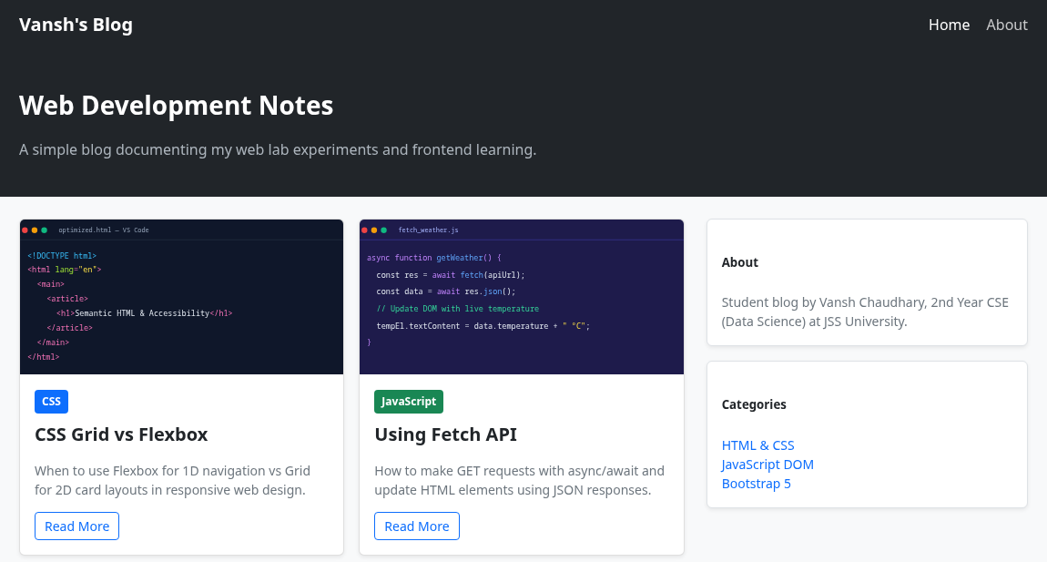  Desktop Responsive Grid View | 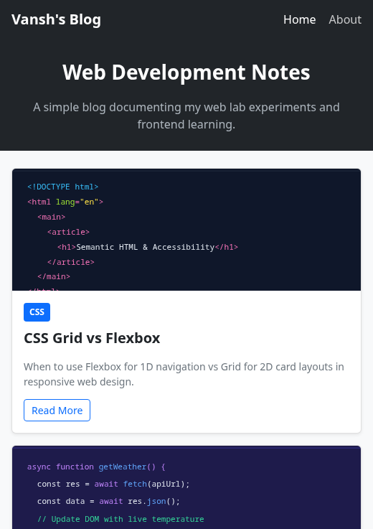  Mobile View (Media Query <= 768px)
Live Website URL: https://vansh261205.github.io/web-developement.lab/Experiment-6/blog.html
Github Repo URL: https://github.com/Vansh261205/web-developement.lab

