EXPERIMENT 03
Create a dynamic to-do list application where users can add, delete, and mark tasks as completed using JavaScript and DOM manipulation
RESOURCES UTILIZED
a. VS Code
b. GitHub
c. HTML
d. CSS
e. JavaScript (DOM Manipulation)
f. GitHub Pages
g. Web Browser
HTML FILE CODE (Experiment-3/todo.html)
<!DOCTYPE html>
<html lang="en">
<head>
<meta charset="UTF-8">
<meta name="viewport" content="width=device-width, initial-scale=1.0">
<title>To-Do List</title>
<style>
body { font-family: Arial, sans-serif; background: #edf2f7; display: flex; justify-content: center; padding: 40px 15px; margin: 0; }
.todo-app { background: #fff; width: 100%; max-width: 380px; padding: 20px; border-radius: 6px; box-shadow: 0 1px 4px rgba(0,0,0,0.1); }
h2 { font-size: 1.25rem; margin-top: 0; }
.input-row { display: flex; gap: 6px; margin-bottom: 15px; }
input[type="text"] { flex: 1; padding: 8px; border: 1px solid #cbd5e0; border-radius: 4px; }
button.add-btn { background: #3182ce; color: white; border: none; padding: 8px 14px; border-radius: 4px; cursor: pointer; }
ul { list-style: none; padding: 0; margin: 0; }
li { display: flex; justify-content: space-between; align-items: center; padding: 8px 6px; border-bottom: 1px solid #edf2f7; cursor: pointer; }
li.done span { text-decoration: line-through; color: #a0aec0; }
.del-btn { background: #e53e3e; color: white; border: none; padding: 3px 7px; border-radius: 3px; cursor: pointer; font-size: 0.75rem; }
</style>
</head>
<body>
<div class="todo-app">
<h2>My To-Do List</h2>
<div class="input-row">
<input type="text" id="taskInput" placeholder="Add a task...">
<button class="add-btn" id="addBtn">Add</button>
</div>
<ul id="taskList"></ul>
</div>

<script>
const taskInput = document.getElementById("taskInput");
const addBtn = document.getElementById("addBtn");
const taskList = document.getElementById("taskList");

function addTask() {
const text = taskInput.value.trim();
if (!text) return;

const li = document.createElement("li");
const span = document.createElement("span");
span.textContent = text;

li.addEventListener("click", function() {
li.classList.toggle("done");
});

const delBtn = document.createElement("button");
delBtn.textContent = "Delete";
delBtn.className = "del-btn";
delBtn.addEventListener("click", function(e) {
e.stopPropagation();
li.remove();
});

li.appendChild(span);
li.appendChild(delBtn);
taskList.appendChild(li);

taskInput.value = "";
taskInput.focus();
}

addBtn.addEventListener("click", addTask);
taskInput.addEventListener("keydown", function(e) {
if (e.key === "Enter") addTask();
});
</script>
</body>
</html>
PROJECT TREE:
web-developement.lab/
└── Experiment-3/
└── todo.html
SCREEN SHOTS:
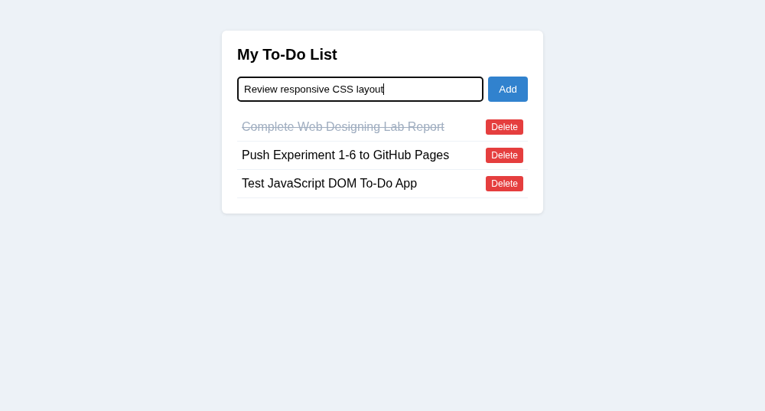
Live Website URL: https://vansh261205.github.io/web-developement.lab/Experiment-3/todo.html
Github Repo URL: https://github.com/Vansh261205/web-developement.lab

