EXPERIMENT 02
Develop a personal portfolio webpage using HTML and CSS, including a navigation menu, an about section, a projects section, and a contact form
RESOURCES UTILIZED
a. VS Code
b. GitHub
c. HTML5
d. CSS3
e. GitHub Pages
f. Web Browser
HTML FILE CODE (Experiment-2/index.html)
<!DOCTYPE html>
<html lang="en">
<head>
<meta charset="UTF-8">
<meta name="viewport" content="width=device-width, initial-scale=1.0">
<title>Vansh Chaudhary | Portfolio</title>
<link rel="stylesheet" href="style.css">
</head>
<body>
<header>
<nav class="navbar">
<div class="logo">Vansh Chaudhary</div>
<ul class="nav-links">
<li><a href="#about">About</a></li>
<li><a href="#skills">Skills</a></li>
<li><a href="#projects">Projects</a></li>
<li><a href="#contact">Contact</a></li>
</ul>
</nav>
</header>

<section class="hero">
<h1>Hi, I am Vansh Chaudhary</h1>
<p class="subtitle">B.Tech CSE (Data Science) - 2nd Year, JSS University</p>
<p>Interested in web development, Python, and working with data structures. Welcome to my lab portfolio.</p>
<a href="#projects" class="btn">My Projects</a>
</section>

<section id="about" class="container">
<h2>About Me</h2>
<p>I am a 2nd year student at JSS University studying Computer Science with a specialization in Data Science. I am currently learning front-end web development with HTML, CSS, JavaScript, and Bootstrap.</p>
</section>

<section id="skills" class="container">
<h2>Skills</h2>
<div class="skills-box">
<span>HTML5</span>
<span>CSS3</span>
<span>JavaScript</span>
<span>Bootstrap</span>
<span>Git & GitHub</span>
<span>C++</span>
<span>Python</span>
</div>
</section>

<section id="projects" class="container">
<h2>Lab Projects</h2>
<div class="project-list">
<div class="card">
<h3>Weather App</h3>
<p>A simple app that takes a city name and fetches real-time temperature and wind speed using Open-Meteo API.</p>
<a href="../Experiment-5/weather.html">View App &rarr;</a>
</div>

<div class="card">
<h3>To-Do List</h3>
<p>A dynamic task manager built using vanilla JavaScript DOM methods to add, complete, and remove tasks.</p>
<a href="../Experiment-3/todo.html">View App &rarr;</a>
</div>

<div class="card">
<h3>Tech Blog</h3>
<p>A responsive blog layout created with Bootstrap 5 grid classes and custom media queries for mobile view.</p>
<a href="../Experiment-6/blog.html">View App &rarr;</a>
</div>
</div>
</section>

<section id="contact" class="container">
<h2>Contact Me</h2>
<form class="contact-form" onsubmit="event.preventDefault(); alert('Message submitted!');">
<label for="name">Name</label>
<input type="text" id="name" required>

<label for="email">Email</label>
<input type="email" id="email" required>

<label for="msg">Message</label>
<textarea id="msg" rows="4" required></textarea>

<button type="submit" class="btn">Submit</button>
</form>
</section>

<footer>
<p>&copy; 2026 Vansh Chaudhary | JSS University</p>
</footer>
</body>
</html>
CSS FILE CODE (Experiment-2/style.css)
* {
margin: 0;
padding: 0;
box-sizing: border-box;
}

body {
font-family: Arial, sans-serif;
color: #222;
background-color: #f7f9fa;
line-height: 1.6;
}

.container {
max-width: 850px;
margin: 0 auto;
padding: 35px 20px;
}

/* Navbar */
.navbar {
display: flex;
justify-content: space-between;
align-items: center;
background: #1a202c;
padding: 15px 25px;
}

.navbar .logo {
color: #fff;
font-weight: bold;
font-size: 1.1rem;
}

.nav-links {
list-style: none;
display: flex;
gap: 15px;
}

.nav-links a {
color: #cbd5e0;
text-decoration: none;
font-size: 0.95rem;
}

.nav-links a:hover {
color: #fff;
}

/* Hero */
.hero {
background: #fff;
border-bottom: 1px solid #e2e8f0;
padding: 45px 20px;
text-align: center;
}

.hero h1 {
font-size: 2rem;
margin-bottom: 8px;
}

.subtitle {
color: #2b6cb0;
font-weight: 600;
margin-bottom: 12px;
}

.btn {
display: inline-block;
background: #3182ce;
color: #fff;
padding: 8px 18px;
text-decoration: none;
border-radius: 4px;
border: none;
cursor: pointer;
margin-top: 15px;
font-size: 0.95rem;
}

.btn:hover {
background: #2b6cb0;
}

h2 {
font-size: 1.4rem;
margin-bottom: 12px;
border-bottom: 2px solid #e2e8f0;
padding-bottom: 5px;
}

/* Skills */
.skills-box {
display: flex;
flex-wrap: wrap;
gap: 8px;
}

.skills-box span {
background: #edf2f7;
padding: 5px 12px;
border-radius: 15px;
font-size: 0.85rem;
}

/* Projects */
.project-list {
display: grid;
grid-template-columns: repeat(auto-fit, minmax(240px, 1fr));
gap: 15px;
}

.card {
background: #fff;
border: 1px solid #e2e8f0;
border-radius: 6px;
padding: 16px;
}

.card h3 {
font-size: 1.1rem;
margin-bottom: 6px;
}

.card p {
font-size: 0.9rem;
color: #4a5568;
margin-bottom: 10px;
}

.card a {
color: #3182ce;
text-decoration: none;
font-weight: 600;
font-size: 0.85rem;
}

/* Form */
.contact-form {
background: #fff;
border: 1px solid #e2e8f0;
padding: 20px;
border-radius: 6px;
max-width: 480px;
}

.contact-form label {
display: block;
font-size: 0.85rem;
font-weight: bold;
margin-top: 10px;
}

.contact-form input,
.contact-form textarea {
width: 100%;
padding: 8px;
margin-top: 4px;
border: 1px solid #cbd5e0;
border-radius: 4px;
font-family: inherit;
}

footer {
text-align: center;
padding: 20px;
background: #1a202c;
color: #a0aec0;
font-size: 0.85rem;
margin-top: 30px;
}
PROJECT TREE:
web-developement.lab/
└── Experiment-2/
├── index.html
└── style.css
SCREEN SHOTS:
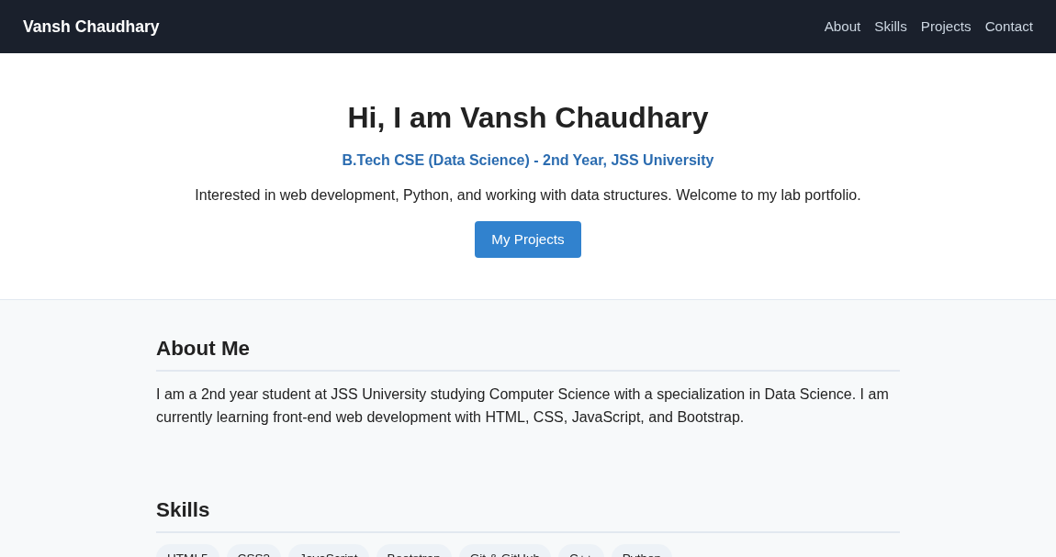  Hero, About & Skills Sections | 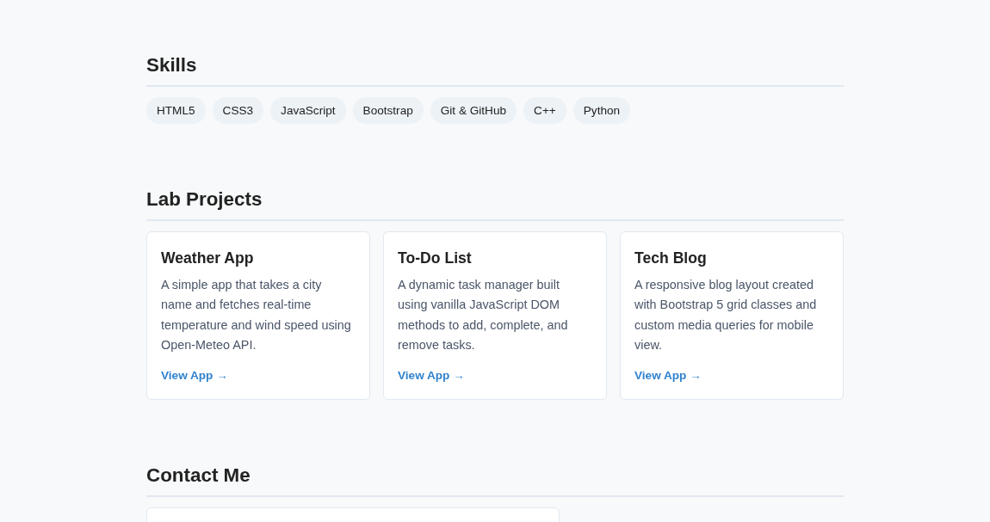  Projects & Contact Form Sections
Live Website URL: https://vansh261205.github.io/web-developement.lab/Experiment-2/index.html
Github Repo URL: https://github.com/Vansh261205/web-developement.lab

