EXPERIMENT 05
Create a weather app using Fetch API or Axios that fetches real-time weather data based on user input
RESOURCES UTILIZED
a. VS Code
b. GitHub
c. HTML
d. CSS
e. JavaScript
f. Fetch API
g. Open-Meteo API
h. GitHub Pages
i. Web Browser
HTML FILE CODE (Experiment-5/weather.html)
<!DOCTYPE html>
<html lang="en">
<head>
<meta charset="UTF-8">
<meta name="viewport" content="width=device-width, initial-scale=1.0">
<title>Weather App</title>
<style>
body { font-family: Arial, sans-serif; background: #ebf8ff; display: flex; justify-content: center; align-items: center; min-height: 100vh; margin: 0; }
.box { background: white; padding: 24px; border-radius: 6px; width: 100%; max-width: 320px; box-shadow: 0 2px 8px rgba(0,0,0,0.1); text-align: center; }
h2 { margin-top: 0; font-size: 1.25rem; }
.search-row { display: flex; gap: 6px; margin-bottom: 15px; }
input { flex: 1; padding: 8px; border: 1px solid #bee3f8; border-radius: 4px; }
button { background: #3182ce; color: white; border: none; padding: 8px 12px; border-radius: 4px; cursor: pointer; }
.res { margin-top: 15px; display: none; }
.temp { font-size: 2rem; font-weight: bold; color: #2b6cb0; margin: 6px 0; }
.info { font-size: 0.85rem; color: #718096; }
.msg { font-size: 0.85rem; color: #718096; margin-top: 10px; }
</style>
</head>
<body>
<div class="box">
<h2>Weather App</h2>
<div class="search-row">
<input type="text" id="cityInput" placeholder="Enter city (e.g. Noida)">
<button id="searchBtn">Search</button>
</div>
<div id="msg" class="msg">Enter a city to check weather.</div>
<div id="res" class="res">
<div id="loc" style="font-weight: bold;"></div>
<div id="temp" class="temp"></div>
<div id="wind" class="info"></div>
</div>
</div>

<script>
const searchBtn = document.getElementById("searchBtn");
const cityInput = document.getElementById("cityInput");
const msg = document.getElementById("msg");
const res = document.getElementById("res");

async function getWeather() {
const city = cityInput.value.trim();
if (!city) {
msg.textContent = "Please enter a city name.";
return;
}

msg.textContent = "Loading...";
res.style.display = "none";

try {
const geoUrl = `https://geocoding-api.open-meteo.com/v1/search?name=${encodeURIComponent(city)}&count=1&language=en&format=json`;
const geoRes = await fetch(geoUrl);
const geoData = await geoRes.json();

if (!geoData.results || geoData.results.length === 0) {
msg.textContent = "City not found.";
return;
}

const { latitude, longitude, name, country } = geoData.results[0];
const weatherUrl = `https://api.open-meteo.com/v1/forecast?latitude=${latitude}&longitude=${longitude}&current_weather=true`;
const weatherRes = await fetch(weatherUrl);
const data = await weatherRes.json();

msg.textContent = "";
document.getElementById("loc").textContent = `${name}, ${country}`;
document.getElementById("temp").textContent = `${data.current_weather.temperature} °C`;
document.getElementById("wind").textContent = `Wind: ${data.current_weather.windspeed} km/h`;
res.style.display = "block";

} catch (err) {
msg.textContent = "Error fetching weather.";
}
}

searchBtn.addEventListener("click", getWeather);
cityInput.addEventListener("keydown", function(e) {
if (e.key === "Enter") getWeather();
});
</script>
</body>
</html>
PROJECT TREE:
web-developement.lab/
└── Experiment-5/
└── weather.html
API DETAILS
a. API used: Open-Meteo (free meteorological API requiring no API key).
b. Geocoding API: https://geocoding-api.open-meteo.com/v1/search — accepts the user-entered city name and returns latitude, longitude, city name, and country.
c. Weather Forecast API: https://api.open-meteo.com/v1/forecast?latitude=...&longitude=...&current_weather=true — returns real-time temperature (°C) and wind speed (km/h).
d. Asynchronous requests are handled using JavaScript async/await and fetch() with try/catch error handling.
SCREEN SHOTS:
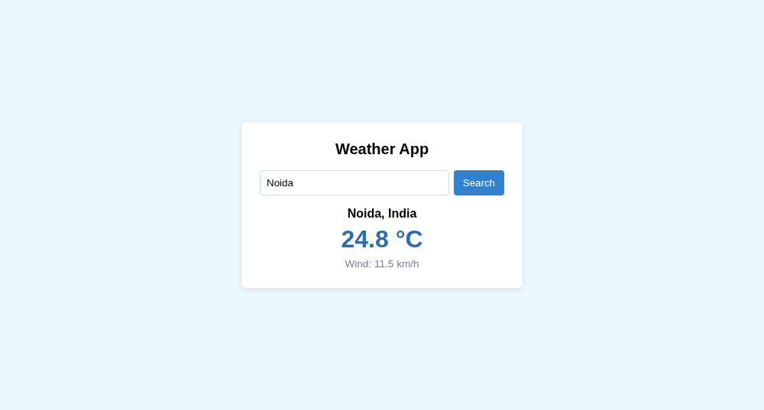
Live Website URL: https://vansh261205.github.io/web-developement.lab/Experiment-5/weather.html
Github Repo URL: https://github.com/Vansh261205/web-developement.lab

