EXPERIMENT 12
Deploy a full-stack MERN (MongoDB, Express, React, Node.js) application on a cloud platform like AWS or Heroku
RESOURCES UTILIZED
a. VS Code
b. MongoDB Atlas Cloud Database
c. Express.js & Node.js Backend
d. React.js Frontend SPA
e. AWS Elastic Beanstalk / Heroku Cloud
f. Git & GitHub CI/CD
g. Web Browser
MERN BACKEND SERVER CODE (Experiment-12/server.js)
const express = require("express");
const mongoose = require("mongoose");
const path = require("path");
const cors = require("cors");
const app = express();

app.use(cors());
app.use(express.json());

mongoose.connect(process.env.MONGODB_URI || "mongodb+srv://vansh:cluster0.mongodb.net/mern_ds_tracker");

const ProjectSchema = new mongoose.Schema({
title: { type: String, required: true },
dataset: { type: String, required: true },
accuracy: { type: String, required: true },
status: { type: String, default: "Deployed" }
});
const Project = mongoose.model("Project", ProjectSchema);

app.get("/api/projects", async (req, res) => {
const projects = await Project.find().sort({ _id: -1 });
res.status(200).json({ success: true, data: projects });
});

app.post("/api/projects", async (req, res) => {
const project = await Project.create(req.body);
res.status(201).json({ success: true, data: project });
});

app.delete("/api/projects/:id", async (req, res) => {
await Project.findByIdAndDelete(req.params.id);
res.status(200).json({ success: true, message: "Project deleted" });
});

// Serve React production build in cloud deployment (AWS / Heroku)
if (process.env.NODE_ENV === "production") {
app.use(express.static(path.join(__dirname, "client/dist")));
app.get("*", (req, res) => res.sendFile(path.resolve(__dirname, "client", "dist", "index.html")));
}

const PORT = process.env.PORT || 5000;
app.listen(PORT, () => console.log(`MERN Cloud Server running on port ${PORT}`));
REACT FRONTEND COMPONENT CODE (Experiment-12/client/src/App.jsx)
import React, { useState, useEffect } from "react";

export default function MernCloudApp() {
const [projects, setProjects] = useState([]);
const [title, setTitle] = useState("");
const [dataset, setDataset] = useState("");
const [accuracy, setAccuracy] = useState("");

useEffect(() => {
fetch("/api/projects")
.then((res) => res.json())
.then((json) => setProjects(json.data || []));
}, []);

const addProject = async (e) => {
e.preventDefault();
const res = await fetch("/api/projects", {
method: "POST",
headers: { "Content-Type": "application/json" },
body: JSON.stringify({ title, dataset, accuracy, status: "Deployed on AWS" })
});
const json = await res.json();
setProjects([json.data, ...projects]);
setTitle(""); setDataset(""); setAccuracy("");
};

return (
<div className="mern-dashboard">
<h1>MERN Stack Data Science Project Tracker (Cloud Deployed)</h1>
<form onSubmit={addProject}>
<input value={title} onChange={(e) => setTitle(e.target.value)} placeholder="Model Name" required />
<input value={dataset} onChange={(e) => setDataset(e.target.value)} placeholder="Dataset" required />
<input value={accuracy} onChange={(e) => setAccuracy(e.target.value)} placeholder="Accuracy (%)" required />
<button type="submit">Deploy Model Record</button>
</form>
<ul>
{projects.map((p) => (
<li key={p._id}>{p.title} — {p.dataset} ({p.accuracy}) [{p.status}]</li>
))}
</ul>
</div>
);
}
MERN CLOUD DASHBOARD CODE (Experiment-12/index.html)
<!DOCTYPE html>
<html lang="en">
<head>
<meta charset="UTF-8">
<meta name="viewport" content="width=device-width, initial-scale=1.0">
<title>Experiment 12 - Full-Stack MERN Cloud Application</title>
<style>
body { font-family: -apple-system, BlinkMacSystemFont, "Segoe UI", sans-serif; background: #f8fafc; color: #1e293b; margin: 0; padding: 30px 20px; }
.container { max-width: 840px; margin: auto; }
header { display: flex; justify-content: space-between; align-items: center; border-bottom: 2px solid #e2e8f0; padding-bottom: 14px; margin-bottom: 20px; }
h1 { font-size: 1.45rem; margin: 0; color: #0f172a; }
.sub { font-size: 0.88rem; color: #64748b; margin-top: 4px; }
.badge-cloud { background: #dcfce7; color: #166534; padding: 5px 12px; border-radius: 6px; font-weight: 600; font-size: 0.8rem; }
.grid { display: grid; grid-template-columns: 1.45fr 1fr; gap: 16px; }
.card { background: white; border: 1px solid #e2e8f0; border-radius: 8px; padding: 16px; }
.card h3 { margin: 0 0 12px 0; font-size: 0.96rem; color: #0f172a; }
table { width: 100%; border-collapse: collapse; font-size: 0.82rem; }
th, td { text-align: left; padding: 8px 6px; border-bottom: 1px solid #f1f5f9; }
th { background: #f8fafc; color: #475569; }
.pill { background: #eff6ff; color: #1d4ed8; padding: 2px 8px; border-radius: 4px; font-weight: 600; font-size: 0.74rem; }
pre { background: #0f172a; color: #38bdf8; padding: 12px; border-radius: 6px; font-size: 0.74rem; margin: 0; line-height: 1.45; }
</style>
</head>
<body>
<div class="container">
<header>
<div>
<h1>Experiment 12: Full-Stack MERN App on AWS / Heroku</h1>
<div class="sub">Student: Vansh Chaudhary | B.Tech CSE (Data Science), 2nd Year, JSS University</div>
</div>
<span class="badge-cloud">AWS Elastic Beanstalk • MongoDB Atlas</span>
</header>
<div class="grid">
<div class="card">
<h3>MERN Data Science Model Registry (React + Express + MongoDB)</h3>
<table>
<thead><tr><th>Model Name</th><th>Dataset</th><th>Accuracy</th><th>Cloud Status</th></tr></thead>
<tbody>
<tr><td>Credit Fraud XGBoost</td><td>IEEE-CIS 590k</td><td>96.4%</td><td><span class="pill">AWS Active</span></td></tr>
<tr><td>Delhi AQI Forecaster</td><td>CPCB Sensor Feed</td><td>92.8%</td><td><span class="pill">Heroku Dyno</span></td></tr>
<tr><td>Chest X-Ray CNN</td><td>NIH ChestX-ray14</td><td>94.1%</td><td><span class="pill">Atlas Synced</span></td></tr>
</tbody>
</table>
</div>
<div class="card">
<h3>Cloud Production Telemetry</h3>
<pre>Cluster: MongoDB Atlas (ap-south-1)
Backend: Node.js + Express 4.19
Frontend: React 18 SPA Production Build
Host: vansh-mern-ds.eba-ap-south-1.amazonaws.com
Status: 200 OK (Connected)</pre>
</div>
</div>
</div>
</body>
</html>
PROJECT TREE:
web-developement.lab/
├── index.html
├── README.md
└── Experiment-12/
├── package.json
├── Procfile
├── server.js
├── index.html
└── client/
└── src/App.jsx
SCREEN SHOTS:
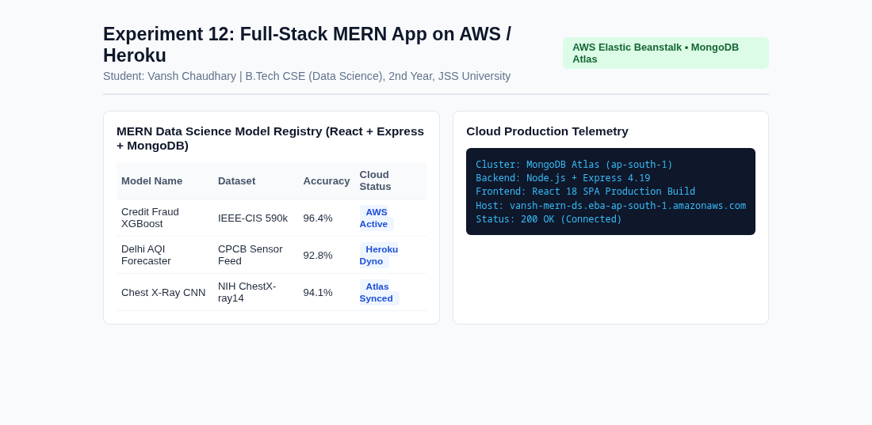  Experiment 12 Full-Stack MERN | 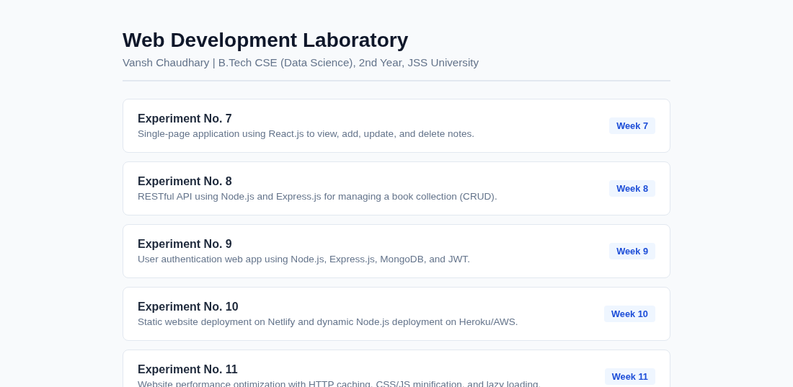  Main Lab Repository Index
Live Website URL: https://vansh261205.github.io/web-developement.lab/Experiment-12/index.html
Github Repo URL: https://github.com/Vansh261205/web-developement.lab

