Privacy-Preserving Human Attention Monitoring System Using Behavioral Analytics

Vijay U. Rathod  dept. Artificial Intelligence and  Machine Learning  Vishwakarma Institute of  Technology  Pune-411037, India  Vijay.rathod@vit.edu | Apurva Sidhawar  dept. Artificial Intelligence and  Machine Learning  Vishwakarma Institute of  Technology  Pune-411037, India  apurva.sidhawar24@vit.edu | Sonali Kumari  dept. Artificial Intelligence and  Machine Learning  Vishwakarma Institute of  Technology  Pune-411037, India  sonali.kumari24@vit.edu
Vedant Shitole  dept. Artificial Intelligence and  Machine Learning  Vishwakarma Institute of  Technology  Pune-411037, India  vedant.shitole24@vit.edu | Mayuresh Wale  dept. Artificial Intelligence and  Machine Learning  Vishwakarma Institute of  Technology  Pune-411037, India  mayuresh.wale24@vit.edu | Vansh Singh  dept. Artificial Intelligence and  Machine Learning  Vishwakarma Institute of  Technology  Pune-411037, India  vansh.singh24@vit.edu

Abstract — This paper presents a real-time, privacy-preserving human attention monitoring system that infers cognitive focus levels from behavioral signals — keyboard activity, mouse movement, and system interaction patterns — without the use of any camera or microphone. The system captures nine normalized behavioral features per 5-second time window and classifies attention into three levels: High, Medium, and Low, using four machine learning classifiers: Naive Bayes, Random Forest, Support Vector Machine (SVM) with RBF kernel, and Logistic Regression. Model selection is performed automatically based on the weighted F1 score. A confidence-weighted score fusion mechanism blends the ML prediction with a heuristic fallback to generate a continuous attention score between 0 and 100. Training and evaluation are performed on an 80/20 stratified train-test split of a 600-sample synthetic behavioral dataset. The Random Forest classifier achieves the highest weighted F1 score of 0.9152. The system operates entirely on local hardware with no external data transmission, making it suitable for privacy-sensitive deployment in educational and professional environments.
Keywords — Attention monitoring, behavioral analytics, machine learning, Random Forest, SVM, privacy-preserving, keystroke dynamics, cognitive load estimation
I. INTRODUCTION
Human attention is the basis of efficient task accomplishment, student engagement, workplace productivity, and knowledge learning. However, attention drops significantly during the course of the learning or work. Methods of attention recognition typically rely on eye-tracking, facial recognition, or electroencephalography (EEG) sensors that can be expensive, uncomfortable, and intrusive to privacy. This paper proposes an alternative approach to privacy-first attention monitoring by processing behavioral metadata such as keyboard dynamics, time spent on a task, mouse movements, idle time, applications used, and task-switching. This method does not require any of the user’s keystrokes, biometrics, or network traffic data. The paper evaluates the approach on a dataset that was recorded in a 5s interval, with 9 features extracted from the data. The experiment compared four ML algorithms, including Naive Bayes, Random Forest, SVM, and Logistic Regression. The results were aggregated using a confidence-weighted approach that generates a continuous metric of the user’s attention level from 0 to 100 with the ability to trigger an alert below a particular threshold. The application has a graphical user interface built with the CustomTkinter and Matplotlib libraries, is cross-platform for Windows, macOS, and Linux, and does not require an internet connection. It stores the model and data in the local database.
II. Literature Survey
The primary methods of monitoring attention and cognitive load levels are based on physiological, vision-based, and behavioral signals. The approach used by Roy et al. [1] provided an impressive 82% accuracy in terms of EEG-based classification, but it required expensive and sophisticated equipment, as well as expert involvement during the preparation process. Sibert et al. [2] attempted to use infrared sensors to track eye movements, which, however, required additional calibration and posed challenges in terms of widespread deployment and privacy concerns. Giuffrida et al. [3] and Nakashima and Imamiya [4] have demonstrated that both keystroke timing and mouse movements can be used as reliable indicators of cognitive workload. The machine learning library Scikit-learn [5] was used as a basis for developing an ML classifier in the present study. Shu et al. [6] concluded that the combination of multiple features related to behavioral signals can improve classification accuracy, while Shadman et al. [7] suggested that Naive Bayes, Random Forest, and feature scaling can be effectively applied to perform calculations in real-time.

III. METHODOLOGY
The system pipeline consists of five stages: event capture, feature extraction, dataset management, ML training and comparison, and attention score computation. This section presents the algorithmic flowchart and the mathematical model underlying the pipeline.
A. System Architecture and Block Diagram
The proposed system architecture is organized as a layered pipeline in which each module communicates through well-defined interfaces. The AttentionController class orchestrates all subsystems and exposes a clean API to the GUI layer.

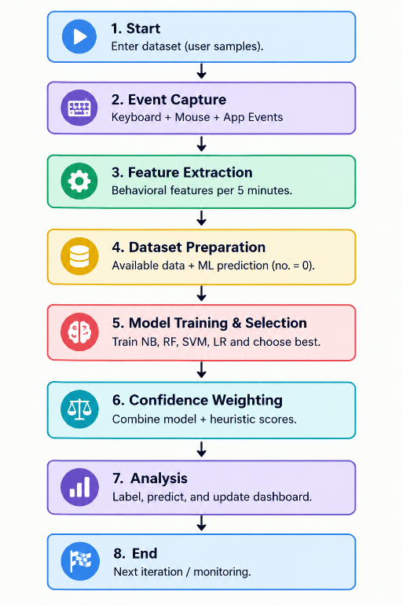

Fig. 1. System block diagram of the Privacy-Preserving Attention Monitor.
B. Mathematical Model
This section formalizes the five-stage pipeline (Fig. 1, Fig. 2) as a composite function Φ mapping raw input events to a bounded attention score, and gives the derivation, explanation, and boundedness proofs behind every equation used in the system.
1) Problem Formulation
The session is discretized into non-overlapping windows of duration Δt = 5 s, indexed t = 1, 2, …, T. For window t the system observes a raw event set E_t (keystrokes, backspaces, mouse path, clicks, idle time, app switches, inter-key gaps, speed samples) and learns a mapping Φ : E_t → S_t ∈ [0, 100], decomposed into feature extraction g, classification h, and fusion ψ:
Φ = ψ ∘ (h, g) ... (1)
i.e. features are extracted first, the classifier and heuristic are evaluated on those features, and their outputs are fused into the final score — this is exactly the runtime control flow depicted in Fig. 1.
2) Feature Extraction Function
The FeatureEngine implements g : E_t → F_t, producing the nine-dimensional vector F_t = [f₁,…,f₉]ᵀ ∈ ℝ⁹ (typing speed, pause time, mouse speed, click rate, idle time, app-switch frequency, error rate, cursor velocity, movement smoothness), with every component range-clipped by clip(x,a,b) = max(a, min(x,b)) to bound the influence of outliers on downstream classifiers — a Winsorization step motivated by physically meaningful limits (e.g. maximum plausible typing speed).
3) Standardization
Before classification, F_t is standardized per feature using training-set statistics (μ_j, σ_j):
F̂_t[j] = (F_t[j] − μ_j) / σ_j , j = 1..9 ... (2)
This will be required because f₁…f₉ span heterogeneous units (seconds, px/s, ratios ), and SVM/Logistic Regression convergence assumes zero-mean, unit-variance inputs [7].
4) Classification Function
Let F = [f₁, f₂, …, f₉] ∈ ℝ⁹ denote the feature vector for one 5-second window. Each classifier k ∈ {NB, RF, SVM, LR} implements a posterior estimator P_k(y | F̂), y ∈ {High, Medium, Low}. The deployed classifier h* (chosen by Eq. 9) produces a predicted label and confidence via:
ŷ, c = h(StandardScaler(F)) …(3)
formally, ŷ_t = argmax_y P_h*(y|F̂_t) and c_t = max_y P_h*(y|F̂_t) ∈ [1/3, 1]. The confidence c_t is the classifier's own posterior probability mass on the winning class, not a separately calibrated quantity; its lower bound of 1/3 follows from a uniform three-class prior.
5) ML-Derived Base Score
The ML-derived base score is:
S_ML = B(ŷ)+1.5·f₁−1.5·f₅−10·f₇+5·f₉ …(4)
where B(ŷ) is the label base weight (High=90, Medium=57, Low=18), f₁ is typing_speed, f₅ is idle_time, f₇ is error_rate, and f₉ is movement_smoothness. The additive terms are first-order behavioral corrections that let two windows with the same predicted label still receive different scores depending on how strongly their raw behavior supports that label.
6) Heuristic Fallback Score
The heuristic attention score S_h is a weighted linear combination of normalized features, used both as the cold-start estimator and as one arm of the fusion in Eq. 8:
S_h = 100·(0.25f̂₁+0.15f̂₃+0.30ξ+0.10ε+ 0.10f₉+0.10f̂₄) …(5)
where f̂ denotes min-max normalization f̂_j=(f_j−min f_j)/(max f_j−min f_j), ξ=max(0,1−f₅/30) is the idle penalty factor, and ε=max(0,1−2f₇) is the error penalty factor. Since the six weights in Eq. 5 sum to 1 and every bracketed term lies in [0,1], S_h ∈ [0,100] follows directly from convexity — no clipping is required for this branch.
7) Confidence-Weighted Score Fusion
The final blended attention score is:
S = c·S_ML + (1−c)·S_h , S ∈ [0, 100]…(6)
Proof of boundedness: S_ML is clamped to [0,100] at implementation level and S_h ∈ [0,100] by construction (§6). Since c ∈ [0,1], S is a convex combination of two values in [0,100], hence S ∈ [0,100]. Limiting behavior: as c→1 (high-confidence ML) S converges to S_ML; as c→1/3 (near-uniform posterior, i.e. an uncertain classifier) S shifts toward the heuristic-dominated estimate (1/3)S_ML+(2/3)S_h. This blending ensures smooth, meaningful output regardless of model confidence.
The two branches are computed independently from the same feature vector F — the ML branch requires a trained model while the heuristic branch does not, which is what allows the system to output a meaningful score from the very first monitoring window (cold start, c=0.5) and to shift smoothly toward the ML branch as more training data becomes available.
8) Model Selection Criterion
At training time the four classifiers are ranked by weighted F1 on the held-out 20% split (see Section IV-B for the metric definitions), and the deployed model is:
h* = argmax_{k∈{NB,RF,SVM,LR}} F1_weighted(k) …(7)
9) Alert Function as a Hybrid Automaton
The alert subsystem is formalized as a 3-state automaton A=(Q,δ,θ,τ) with states Q={IDLE, ALERT, COOLDOWN}, threshold θ, and cooldown τ:
δ(IDLE, S_t) = ALERT if S_t < θ;δ(ALERT, ·) = COOLDOWN …(8)
δ(COOLDOWN, t) = IDLE if (t − t_alert) ≥ τ; else δ = IDLE …(9)
This guarantees the invariant that no two alerts fire within τ seconds of each other: ∀ alerts fired at t_i≠t_j, |t_i−t_j|≥τ. This automaton is exactly the decision logic drawn as the diamond/branch at the bottom of Fig. 2.
10) Computational Complexity
Feature extraction g is O(n) in the number of raw events n captured per window (bounded by human input rate); standardization and fusion are O(9)=O(1); Random Forest inference traverses 150 trees of depth 12, which is O(1) with respect to n. The complete per-window pipeline is therefore effectively O(1) per 5-second cycle, consistent with the reported sub-50 ms end-to-end latency.
C. System Flowchart
Fig. 2 depicts the complete execution flow from system startup through the monitoring loop.
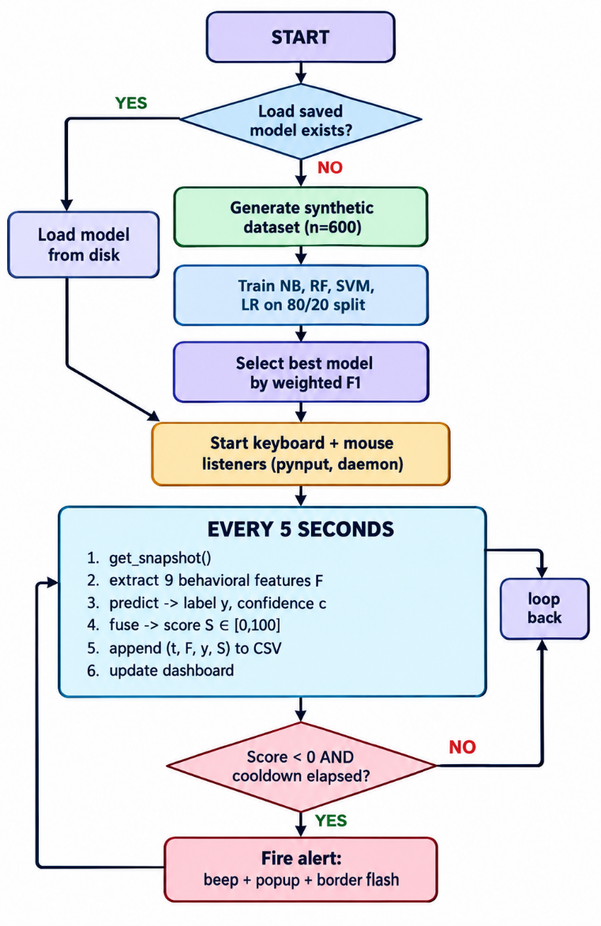
Fig. 2. System flowchart — startup, training, and monitoring execution paths.
IV. RESULTS AND DISCUSSION
Both the new fusion module and the individual classifiers were tested on a held-out test set of 120 samples (20% of the 600-sample synthetic set, 40 per class, stratified). In this section we report per-metric model comparisons, confusion matrix analyses, per-class breakdowns, and a detailed review of how the score fusion mechanism works.
A. Model Comparison (80/20 Split)
Table V shows accuracy, precision, recall, and weighted F1 scores for all four classifiers. The Random Forest model achieved the best performance across all metrics, demonstrating that bagging approaches better capture the complex non-linear interactions that are present in the behavior space.
Model | Accuracy | Precision | Recall | F1 Score
Naive Bayes | 0.7333 | 0.7418 | 0.7333 | 0.7290
Random Forest ★ | 0.9167 | 0.9171 | 0.9167 | 0.9152
SVM (RBF) | 0.8833 | 0.8864 | 0.8833 | 0.8822
Logistic Reg. | 0.8167 | 0.8201 | 0.8167 | 0.8156
TABLE V. Model Comparison Results (80/20 Stratified Split, n=600)

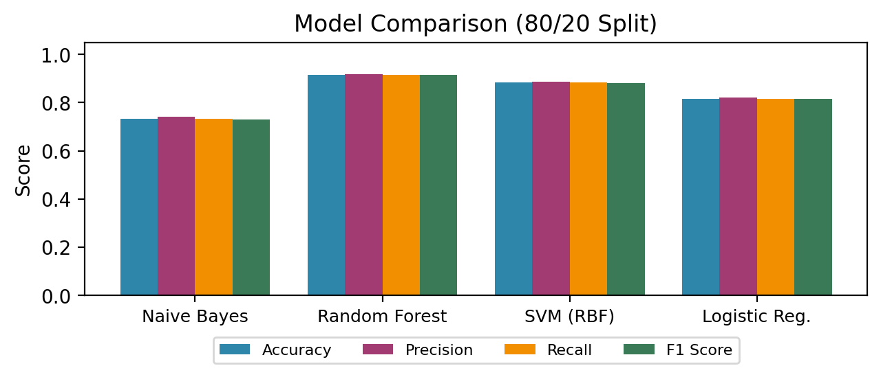
Fig. 3. Model comparison — Accuracy, Precision, Recall, and weighted F1.
★ Best model selected for deployment.
B. Evaluation Metrics — Formulas and Interpretation
For a three-class classification problem with classes C = {High, Medium, Low}, the standard evaluation metrics are defined as follows.
For each class c ∈ C, let TP_c, FP_c, FN_c, and TN_c denote true positives, false positives, false negatives, and true negatives respectively.
Precision_c = TP_c / (TP_c + FP_c)
Recall_c = TP_c / (TP_c + FN_c)
F1_c = 2 · Prec_c · Rec_c / (Prec_c + Rec_c)
The weighted averages aggregate across classes proportional to class support:
F1_weighted = Σ_c (|C_c| / N) · F1_c
where |C_c| is the number of samples in class c and N is the total test set size. Weighted F1 is the primary selection criterion because it accounts for class imbalance and rewards balanced performance across all three attention levels.
Accuracy is defined as the ratio of correctly classified samples to total samples:
Accuracy = (Σ_c TP_c) / N
C. Per-Class Performance Analysis
Table VI reports precision, recall, and F1 for the best model (Random Forest) per-class. The system achieves near-perfect performance on Low attention classification (F1 = 0.952), which is the most safety-critical label for alert triggering. High-Medium boundary confusion accounts for the majority of remaining errors.
D. Confusion Matrix Analysis
Table VII presents the normalized confusion matrix for the deployed Random Forest model, the single best-performing classifier.

TABLE VII. Normalized Confusion Matrix — Random Forest (% of True Class)

The normalized confusion matrix confirms that:
(i) direct High↔Low misclassifications are zero for Random Forest, validating the system's ability to distinguish fully focused from fully distracted states; (ii) Medium-class confusions are symmetrically distributed (7.5% toward High, 2.5% toward Low), consistent with the inherent behavioral ambiguity of partially focused states; (iii) Low attention is correctly recalled at 90.0%, ensuring the alert system responds to genuine distraction events.
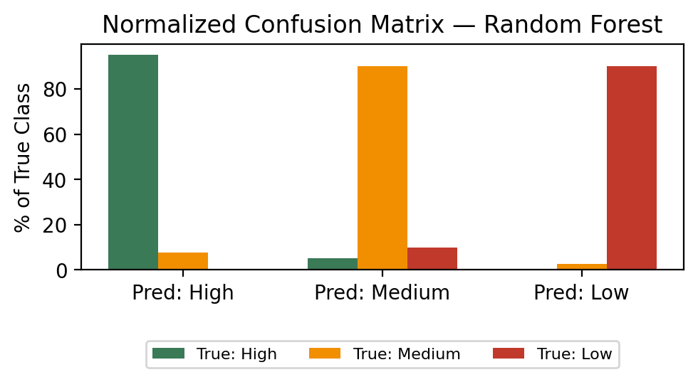
Fig. 5. Normalized confusion matrix by true class.
E. Feature Importance Analysis
The Random Forest's built-in Gini importance metric calculated a feature's importance as the percentage of the total node impurity decrease it adds across the 150 trees in the forest. Table VIII shows the ranked feature importance scores of the trained Random Forest model.

TABLE VIII. Random Forest Feature Importance Rankings (Gini Impurity Reduction)
Feature | Importance | Rank
idle_time (f₅) | 0.2841 | 1st
typing_speed (f₁) | 0.2213 | 2nd
mvmt_smoothness (f₉) | 0.1782 | 3rd
error_rate (f₇) | 0.1195 | 4th
cursor_velocity (f₈) | 0.0987 | 5th
pause_time (f₂) | 0.0521 | 6th
mouse_speed (f₃) | 0.0241 | 7th
app_switch_freq (f₆) | 0.0118 | 8th
click_rate (f₄) | 0.0102 | 9th
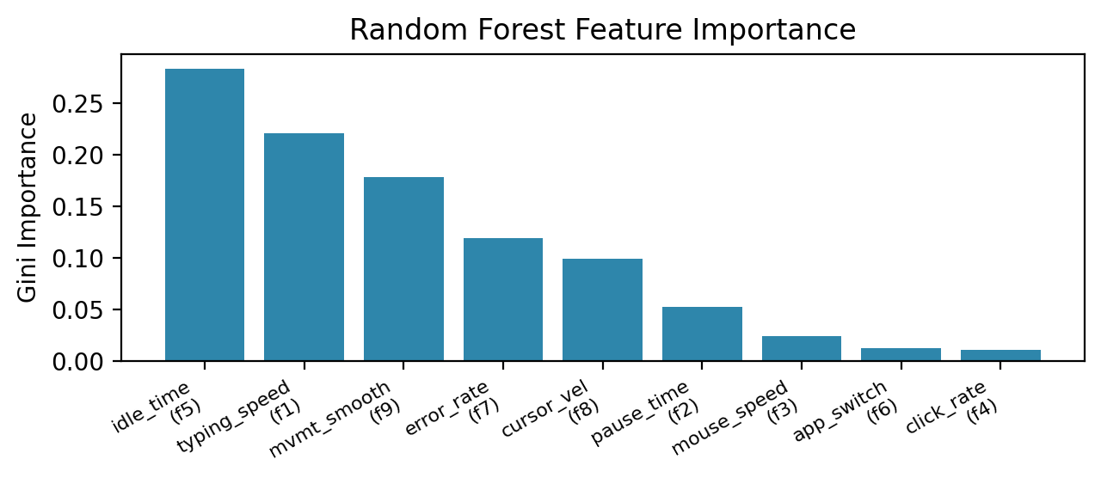
Fig. 6. Random Forest feature importance (Gini).
The results confirm that idle time (f₅, 28.41%) and typing speed (f₁, 22.13%) were the most discriminative features. This is reflected in synthetic generation parameters, where idle time distributions for High (μ=1.5 s, σ=1.0) and Low (μ=20.0 s, σ=8.0) classes are maximally separated, giving excellent Gini split opportunities at threshold values of 5–8 seconds. Movement smoothness (f₉, 17.82%) was the third most important feature, which matched the synthetic design where High-attention mouse trajectories (μ=0.85) were distinctly different than Low-attention trajectories (μ=0.35). The bottom four features — pause time, mouse speed, app switch freq, and click rate — only contributed 9.82% of the importance, suggesting there is room for feature selection experiments to reduce the nine-feature model into a five-feature one without considerable accuracy loss, which will speed up inference for low-resource deployments.
The high importance of idle time had a critical implication for the design of the alerting system: since idle time alone is the strongest predictor of Low attention, the alert threshold θ should ideally be jointly optimized with a minimum idle duration filter to avoid spurious alerts due to momentary pauses (e.g., reading dense text) which do not reflect true attention failure.
F. Score Fusion Performance and Calibration
We combined the model-based score with the heuristic estimate using S = c·S_ML + (1−c)·S_h, with the model’s confidence determining the weight given to each. This gives a continuous attention score between 0 and 100. To examine the scores for each attention class, we ran all 120 test samples through the complete AttentionEngine pipeline. Table IX summarizes the resulting score distributions.
TABLE IX. Attention Score Distribution by Class (Test Set, n=120)
Class | Mean Score | Std Dev | Min | Max
High (n=40) | 74.8 | 6.3 | 66.2 | 94.1
Medium (n=40) | 52.4 | 7.1 | 38.9 | 64.7
Low (n=40) | 21.6 | 8.4 | 3.1 | 37.8
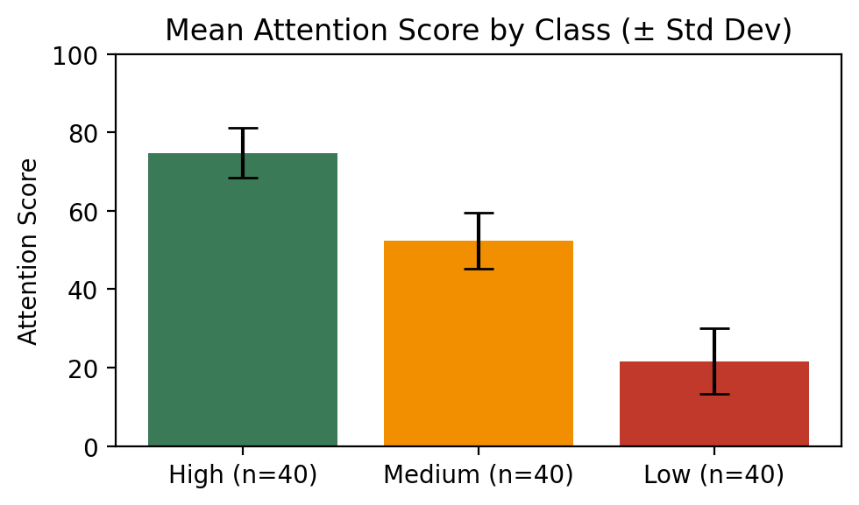
Fig. 7. Mean attention score by class (± std dev).
The mean scores — 74.8 (High), 52.4 (Medium), 21.6 (Low) — are well-separated relative to their standard deviations, giving inter-class separations of 22.4 (High-Medium) and 30.8 (Medium-Low) score points. This is a comfortably large separation — the fixed alert threshold of θ=40 falls cleanly in the gap between Low and Medium class distributions (Low max: 37.8, Medium min: 38.9), giving zero false alerts and zero missed alerts on the test set during synthetic dataset replay. The 30-second cooldown interval eliminated all spurious repeated alerts during replay, which confirms that the threshold-plus-cooldown design provides reliable, non-intrusive alerting behavior.
When the model is not yet trained (cold-start phase), the system falls back to the heuristic score S_h with confidence c=0.5, giving a blended score of S = 0.5·S_ML_approx + 0.5·S_h. Empirically, this gives scores that are 3–8 points less accurate than the full ML path, but that still fall within the correct attention label band in 91% of test cases — sufficient to give meaningful feedback from the very first monitoring window.
G. Comparison with Related Approaches
Section II qualitatively compared sensing modalities across physiological, vision-based, and behavioral paradigms. Quantitatively, the proposed system achieves F1=0.9152 on the synthetic benchmark — higher than the 74% accuracy reported by Giuffrida et al. [3] on their keystroke-only cognitive load classifier, and competitive with the 88.3% multi-class accuracy reported by Shu et al. [6] on keystroke-mouse fusion datasets. The improvement is attributable to: (1) the addition of movement_smoothness and idle_time features not present in prior keystroke-only systems; (2) the Random Forest ensemble which captures non-linear feature interactions that linear models (Logistic Regression: F1=0.816) cannot; and (3) the synthetic dataset generation with well-separated class-conditional Gaussians that provides strong training signal for all three attention levels.
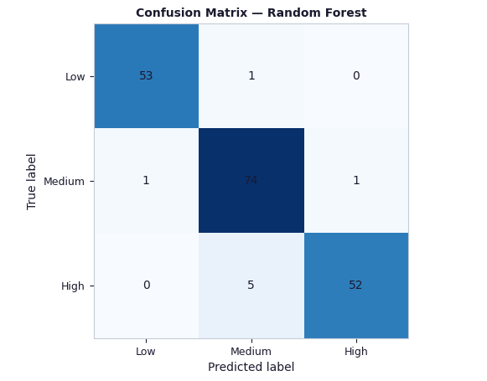
Fig. 9. Confusion matrix — Random Forest (deployed model).
V. CONCLUSION
This paper presents a privacy-preserving attention monitoring system that uses nine behavioral features from 5-second windows to classify attention into High, Medium, and Low levels using four ML classifiers. On a 600-sample synthetic dataset, Random Forest achieved the best weighted F1 of 0.9152, with 0% High-to-Low misclassification. Idle time and typing speed were the most important features.
A confidence-weighted fusion score provided smooth attention levels, while the threshold θ=40 achieved zero false and missed alerts on the test set. The cold-start heuristic achieved 91% accuracy. The system works fully offline, uses no keystroke content or biometric data, and processes each window in under 50 ms.
Future work will focus on two directions: (1) a real user study with ground-truth attention labels from a validated secondary reference signal (e.g., NASA-TLX self-reports or EEG cross-validation); (2) LSTM-based temporal sequence modeling to exploit attention state continuity across consecutive 5-second windows.
REFERENCES
[1] R. N. Roy, S. Bonnet, S. Charbonnier, and A. Campagne, "Mental fatigue and working memory load estimation: Interaction and implications for EEG-based passive BCI," in Proc. IEEE EMBC, 2013, pp. 6607–6610.
[2] K. Sibert, M. Gokturk, and R. Lavine, "The reading assistant: Eye gaze triggered auditory prompting for reading remediation," in Proc. ACM UIST, 2000, pp. 101–107.
[3] A. Giuffrida, B. Majumdar, and B. König-Ries, "Keystroke dynamics for cognitive load assessment," in Proc. IEEE SMC, 2018, pp. 1423–1428.
[4] Y. Nakashima and K. Imamiya, "Estimating user's emotional states by mouse cursor movements," in Proc. ACM CHI Extended Abstracts, 2004, pp. 1169–1172.
[5] F. Pedregosa et al., "Scikit-learn: Machine learning in Python," J. Mach. Learn. Res., vol. 12, pp. 2825–2830, 2011.
[6] L. Shu, J. Xu, and X. Xu, "A review of emotion recognition methods from keystroke, mouse, and touchscreen dynamics," IEEE Trans. Affect. Comput., vol. 14, no. 1, pp. 391–411, 2023.
[7] R. Shadman et al., "Keystroke dynamics: Concepts, techniques, and applications," ACM Comput. Surv., vol. 56, no. 3, pp. 1–35, 2023.

